Attachment L-1:

Details of Example Interventions

Powered Hand Truck:  The Powered Hand Truck (PHT) intervention is a powered stair-climbing hand truck designed to move large products (such as appliances up to l,500 lbs.) up/down stairs, on/off delivery vehicles, loading docks, and in/ out of buildings. Photos courtesy of Power Mate. | 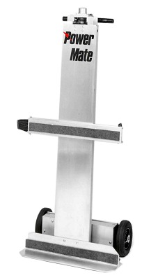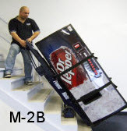
Truck Lift Gate:  The Truck Lift Gate (TLG) intervention is a powered platform that attaches to the rear of a delivery truck. The powered platform raises/lowers large products (such as appliances etc.) on/off delivery vehicles. Photo courtesy of Tommy Gate. | 