The DPRP Evaluation Data Submission screenshots
The DPRP Organization Verification screenshot
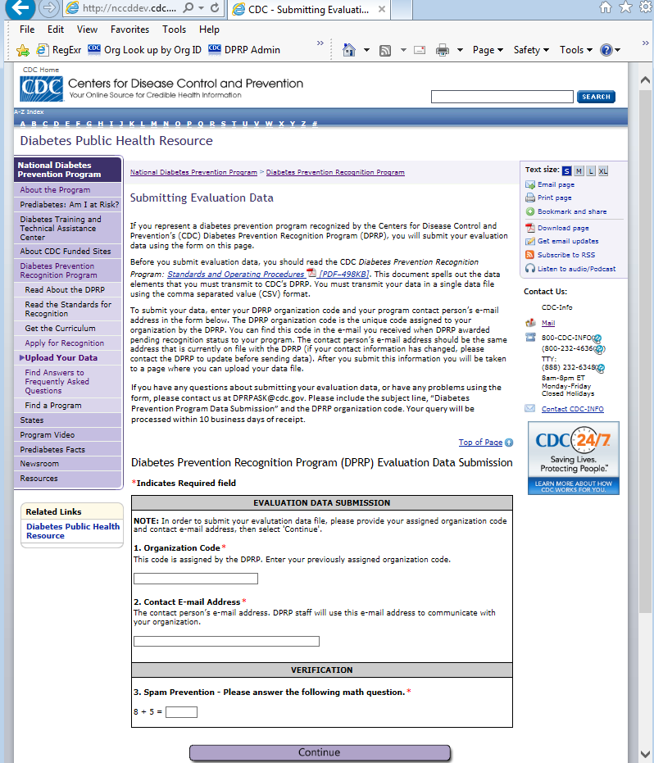

The Data File submission Page UI screenshot
