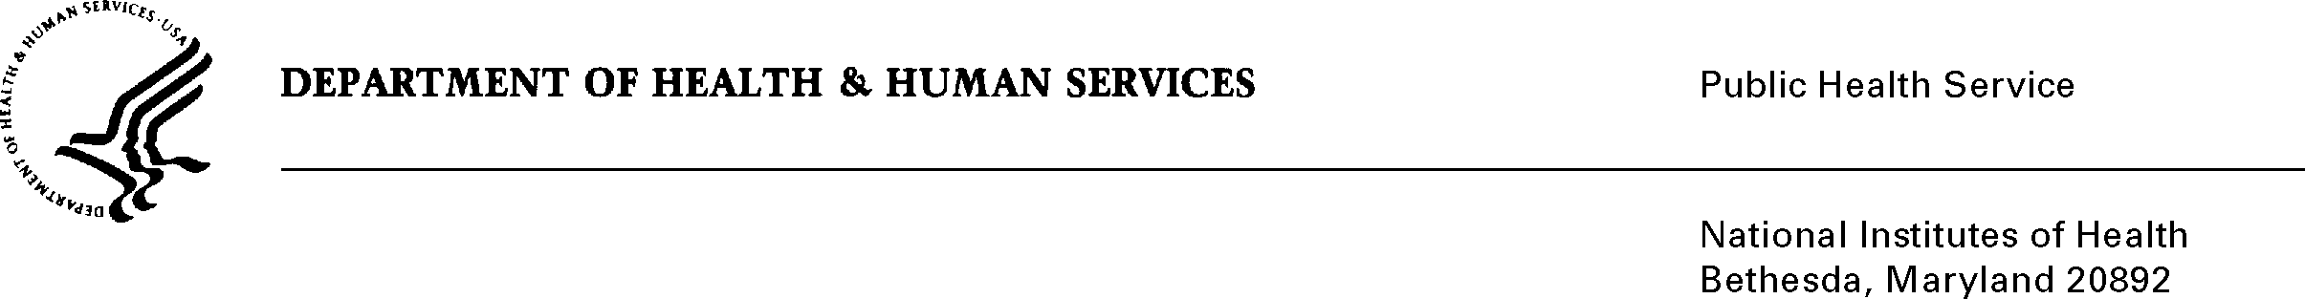

Date: May 1, 2014

To: Harvey Fort, Policy Analyst, OMB

Through: Darius Taylor, Reports Clearance Officer, DHHS
Seleda M. Perryman Chief, Project Clearance Officer, NIH

Subject: Change Request for OMB# 0925-0001 Expiration: 8/31/2015 “Fellowship Applicant Biographical Sketch” Format page

In August 2012 NIH received approval of the Fellowship Applicant Biographical Sketch instructions however, the program inadvertently omitted the actual format page and sample in the submission that serves as part of the NIH-wide SF 424 (Research and Related) Applications and Electronic Submission Forms and the Research Performance Progress Report (RPPR).

The “Fellow Applicant Biographical Sketch” form is a suggested format page. The actual data collection requirement is described in the instructions currently approved in the 2012 submission. We do not require the respondents to use this specific format page, it is provided for their convenience. However, since using the form is an option and has the potential to be used by many grantees we want to make sure that it part of the official ICR docket.

Your full consideration is appreciated.

