Appendix A – Data collection instruments

Appendix A, Part 1: Invitation to participate in taxonomy tree test study

The following general bulletin will be issued:

Subject: 15 Minute Survey on Healthcare Terms
Dear Newsletter Recipient:
At AHRQ we are continually updating our web site to make it easier for people like you to use. We have just created a new taxonomy with the goal of making information on the site easier to find, and we’d like your help in testing it!
We’d like you to do a survey that will take approximately 15 minutes. You will be asked 12 questions such as “where would you find information about Long-term Care Facilities?” You will be presented with a list of category and subcategory names from which you can select the category and subcategory most likely to contain the information requested. When you locate the spot, you’ll select the “I’d find it here” button.
All responses will be anonymous. To protect your privacy, a random number will be assigned to your survey when you go to the survey site. Your email address will not be recorded, or associated in any way with your responses.
If you have any questions or concerns please email cassandra.moore@ahrq.hhs.gov for a prompt reply.
The study will be open for only two weeks or less to hit our target of 400 respondents. We look forward to hearing what you think! Click the link below to ensure your voice is heard.
Take me to the survey.

Best regards,
The AHRQ Office of Communications and Knowledge Transfer.

Appendix A, Part 2: Sequence of Screens seen by the Participant

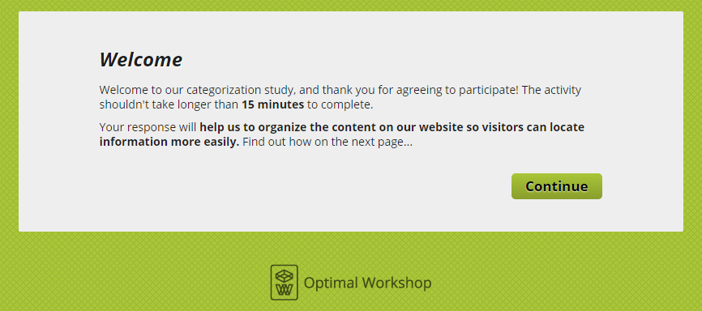
Figure 1: Page participant sees after clicking link “Take me to the survey.”

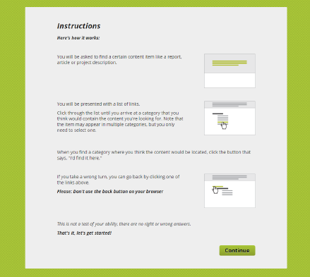
Figure 2: Page participant sees after clicking “Continue” in Figure 1.
Figure 3: Page participant sees after clicking “Continue” in Figure 2. The pre-test questions enable segmentation of audience groups for analysis of results.
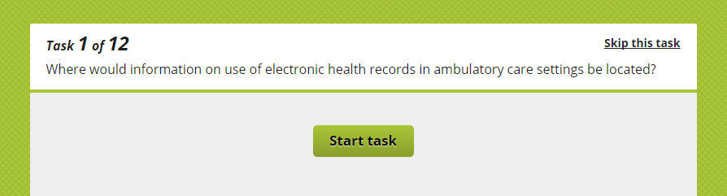
Figure 4: Page participant sees after clicking “Continue” in Figure 3. Task is described. Note that participant can elect to skip the task.

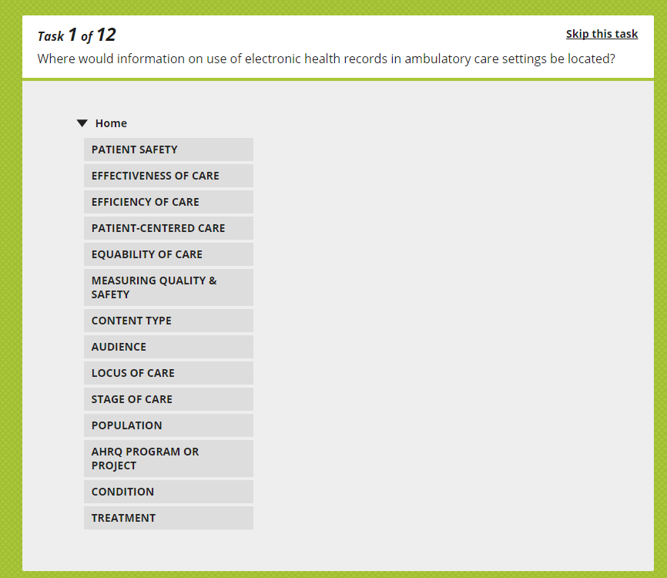
Figure 5: Page participant sees after clicking “Start Task” in Figure 4. Task description remains at the top of the page and the top level of taxonomic hierarchy is displayed. Participants select a category.
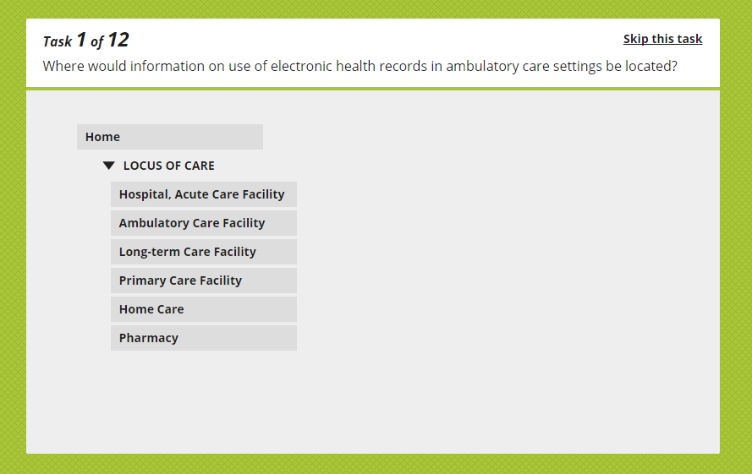
Figure 6: Page participant sees after clicking one of the categories in Figure 4. Note that the participant can go back up the hierarchy if they are not satisfied with the category they’ve selected. Participants select a sub-category.

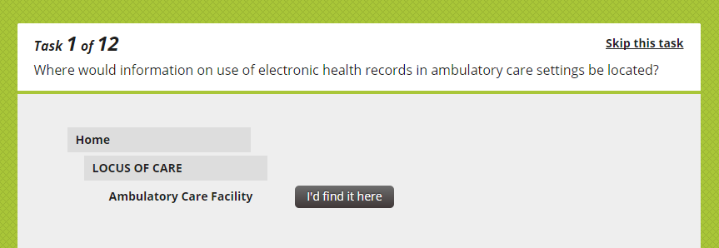
Figure 7: Page participant sees after clicking one of the sub-categories in Figure 5. Note that the participant can go back up the hierarchy if they are not satisfied with the sub-category they’ve selected. Clicking “I’d find it here” ends task 1 and the participant is shown task 2 which looks like Figure 4.

Appendix A, Part 3: All possible questions and correct answers

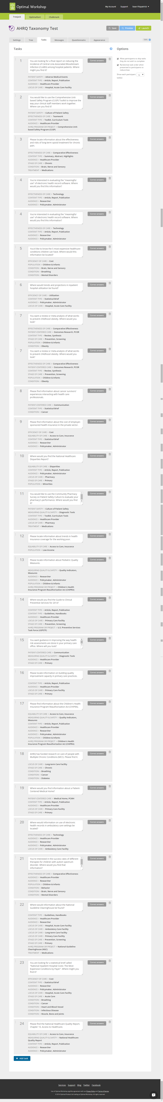
Figure 8: Questions 1-4
Figure 9: Questions 5-10
Figure 10: Questions 11-16

Figure 11: Questions 17-21

Figure 12: Questions 22-24

Appendix A, Part 4: Post-study questions and thank you

Figure 13: Screen seen by participant after having viewed 12 of the 24 possible questions.

Figure 14: Screen seen by participant after clicking “Continue” in Figure 13.

