0960-0696
i1020
Screen Shots
Table of Contents

1. Pages Error! Bookmark not defined.
1.1. Welcome 12
1.1.1. User Interface 12
1.2. Welcome 13
1.2.1. User Interface 13
1.3. Should You Use This Application? 14
1.3.1. User Interface 14
1.4. Welcome Back 15
1.4.1. User Interface 15
1.5. Save & Exit 16
1.5.1. User Interface 16
1.6. You Are Not Eligible For The Extra Help 17
1.6.1. User Interface 17
1.7. Go Ahead 18
1.7.1. User Interface 18
1.8. Preparing To Find Out If You Qualify 19
1.8.1. User Interface 19
1.9. Preparing To Use This Application 20
1.9.1. User Interface 20
1.10. (Apply Now) 21
1.11. About You and Your Spouse 21
1.11.1. User Interface 21
1.12. About You and Your Spouse - With 22
1.12.1. User Interface 22
1.13. About You 23
1.13.1. User Interface 23
1.14. About the Person Completing 24
1.14.1. User Interface 24
1.15. About the Person Completing 25
1.15.1. User Interface 25
1.16. Reentry Number Issued Normal Process 26
1.16.1. User Interface 26
1.17. About You And Your Spouse's Living Situation - Married 27
1.17.1. User Interface 27
1.18. About Your Living Situation - Single 28
1.18.1. User Interface 28
1.19. Wages And Earnings - Married 29
1.19.1. User Interface 29
1.20. Wages And Earnings - Married 30
1.20.1. User Interface 30
1.21. Wages And Earnings - Single (WITHOUT) 31
1.21.1. User Interface 31
1.22. Wages And Earnings - Single (WITH) 32
1.22.1. User Interface 32
1.23. Income Other Than Wages And Earnings - Married 33
1.23.1. User Interface 33
1.24. Income Other Than Wages And Earnings - Single 34
1.24.1. User Interface 34
1.25. Resources - Married 35
1.25.1. User Interface 35
1.26. Resources - Single 36
1.26.1. User Interface 36
1.27. Tool: Add Up Your Accounts 37
1.27.1. User Interface 37
1.28. Tool: Add Up Your Investments 38
1.28.1. User Interface 38
1.29. Tool: Add Up Your Other Pensions And Annuities 39
1.29.1. User Interface 39
1.30. Tool: Add Up Your Types Of Income 40
1.30.1. User Interface 40
1.31. (Find Out if You Qualify) 41
1.32. Find Out If You And Your Spouse Qualify (Married) Part 1 (WITHOUT) 42
1.32.1. User Interface 42
1.33. Find Out If You And Your Spouse Qualify (Married) Part 1 (WITH) 43
1.33.1. User Interface 43
1.34. Find Out If You Qualify (Single) Part 1 44
1.34.1. User Interface 44
1.35. Find Out If You Qualify (Married) Part 3 (WITH) 45
1.35.1. User Interface 45
1.36. Find Out If You Qualify (Single) Part 3 (WITHOUT) 46
1.36.1. User Interface 46
1.37. Find Out if You Qualify (Single) Part 3 (WITH) 47
1.37.1. User Interface 47
1.38. Find Out If You Qualify (Married) Part 2 48
1.38.1. User Interface 48
1.39. Find Out If You Qualify (Single) Part 2 49
1.39.1. User Interface 49
1.40. Find Out If You Qualify (You Should Apply) 50
1.40.1. User Interface 50
1.41. Find Out If You Qualify (You Probably Do Not Qualify) 51
1.41.1. User Interface 51
1.42. Review and Send 52
1.43. Review Your Information 53
1.43.1. User Interface 53
1.44. Review Your Information 54
1.44.1. User Interface 54
1.45. Ready to Submit 55
1.45.1. User Interface 55
1.46. Ready to Submit 56
1.46.1. User Interface 56
1.47. Ready to Submit 57
1.47.1. User Interface 57
1.48. Ready to Submit 58
1.48.1. User Interface 58
1.49. Ready to Submit 59
1.49.1. User Interface 59
1.50. Ready to Submit 60
1.50.1. User Interface 60
1.51. Successful Submission - Print Or Save Your Receipt 61
1.51.1. User Interface 61
1.52. Unsuccessful Submission 62
1.52.1. User Interface 62
1.53. Next Steps 63
1.53.1. User Interface 63
1.54. Missing Information (Fix Errors) 64
1.54.1. User Interface 64
1.55. Successful Submission - Print Or Save Yoour Receipt (print) 65
1.55.1. User Interface 65
1.56. Unsuccessful Submission 66
1.56.1. User Interface 66
1.57. Message Pages 67
1.58. Authentication - Medicare Part D Database Not Eligible Or SSI Recipient 68
1.58.1. User Interface 68
1.59. Check The Social Security Number You Entered 69
1.59.1. User Interface 69
1.60. How The Online Application Works 70
1.60.1. User Interface 70
1.61. Privacy Act Statement 71
1.61.1. User Interface 71
1.62. Internet Security Policy 72
1.62.1. User Interface 72
1.63. Limit Number Of Restarts 73
1.63.1. User Interface 73
1.64. Limit Number Of Starts For A New Application 74
1.64.1. User Interface 74
1.65. Limit On The Number Of Tries To Start An Application 75
1.65.1. User Interface 75
1.66. Name Check Mismatch 76
1.66.1. User Interface 76
1.67. Not Eligible For The Prescription Drug Plan 77
1.67.1. User Interface 77
1.68. Off Hours Message 78
1.68.1. User Interface 78
1.69. Other Ways To Apply 79
1.69.1. User Interface 79
1.70. Paperwork Reduction Act Statement 80
1.70.1. User Interface 80
1.71. Print/Save/View Guide 81
1.71.1. User Interface 81
1.72. Processing Alert 82
1.72.1. User Interface 82
1.73. Sign-In Problem 83
1.73.1. User Interface 83
1.74. Special Instructions For Blind Users 84
1.74.1. User Interface 84
1.75. System Failure 85
1.75.1. User Interface 85
1.76. There Is A Pending Application For This Social Security Number 86
1.76.1. User Interface 86
1.77. Warning System Shutdown 87
1.77.1. User Interface 87
1.78. We Cannot Process Your Request 88
1.78.1. User Interface 88
1.79. What You Will Need 89
1.79.1. User Interface 89
1.80. You Do Not Live In One Of The 50 States Or DC 90
1.80.1. User Interface 90
1.81. You Have Already Sent Us An Application 91
1.81.1. User Interface 91
1.82. Your Session Has Expired 92
1.82.1. User Interface 92
1.83. Help Pages 93
1.84. Main Help Pages 94
1.84.1. User Interface 94
1.85. Help: Are you assisting someone (other than your spouse who lives with you) with this application? 95
1.85.1. User Interface 95
1.86. Help: Did you (or your spouse, if married and living together) get an application in the mail from us? 96
1.86.1. User Interface 96
1.87. Help: Do you (or your spouse, if married and living together) have Medicare? 97
1.87.1. User Interface 97
1.88. Help: Are you (or your spouse, if married and living together) 64 years and 9 months old or older? 98
1.88.1. User Interface 98
1.89. Help: Have you (or your spouse, if married and living together) received: 99
1.89.1. User Interface 99
1.90. Help: In which state do you (or your spouse, if married and living together) live? 100
1.90.1. User Interface 100
1.91. Help: What is your marital status? 101
1.91.1. User Interface 101
1.92. Help: Do you have combined savings, investments, and real estate worth more than: 102
1.92.1. User Interface 102
1.93. Help: Have you worked in 2010 or 2011? 103
1.93.1. User Interface 103
1.94. Help: Has your spouse worked in 2010 or 2011? 104
1.94.1. User Interface 104
1.95. Help: Have you worked this calendar year? 105
1.95.1. User Interface 105
1.96. Help: Has your spouse worked this calendar year? 106
1.96.1. User Interface 106
1.97. Help: Are you UNDER age 65? 107
1.97.1. User Interface 107
1.98. Help: Is your spouse UNDER age 65? 108
1.98.1. User Interface 108
1.99. Help: Not counting your spouse, how many other relatives live in your household? 109
1.99.1. User Interface 109
1.100. Help: How many relatives live in your household and receive at least one-half of their financial support from you? 110
1.100.1. User Interface 110
1.101. Help: Do you have to pay for things related to a disability or blindness that enable you to work? 111
1.101.1. User Interface 111
1.102. Help: Does your spouse have to pay for things that enable him or her to work? 112
1.102.1. User Interface 112
1.103. Help: Do you expect to earn wages this calendar year? 113
1.103.1. User Interface 113
1.104. Help: Does your spouse expect to earn wages this calendar year? 114
1.104.1. User Interface 114
1.105. Help: What do you expect your net earnings from self-employment to be this calendar year? 115
1.105.1. User Interface 115
1.106. Help: What does your spouse expect the net earnings from self-employment to be this calendar year? 116
1.106.1. User Interface 116
1.107. Help: Have you stopped working in 2010 or 2011, or plan to stop working in 2011 or 2012? 117
1.107.1. User Interface 117
1.108. Help: Has you your spouse stopped working in 2010 or 2011, or plan to stop working in 2011 or 2012? 118
1.108.1. User Interface 118
1.109. Help: Do you receive Social Security benefits? 119
1.109.1. User Interface 119
1.110. Help: Does your spouse receive Social Security benefits? 120
1.110.1. User Interface 120
1.111. Help: Do you receive Railroad Retirement benefits? 121
1.111.1. User Interface 121
1.112. Help: Does your spouse receive Railroad Retirement benefits? 122
1.112.1. User Interface 122
1.113. Help: Do you receive Veterans benefits? 123
1.113.1. User Interface 123
1.114. Help: Does your spouse receive Veterans benefits? 124
1.114.1. User Interface 124
1.115. Help: Do you receive income from other pensions or annuities? 125
1.115.1. User Interface 125
1.116. Help: Does your spouse receive income from other pensions or annuities? 126
1.116.1. User Interface 126
1.117. Help: Do you receive other income not listed above, including alimony, net rental income, workers' compensation, etc.? 127
1.117.1. User Interface 127
1.118. Help: Does your spouse receive other income not listed above, including alimony, net rental income, workers' compensation, etc.? 128
1.118.1. User Interface 128
1.119. Help: Your Name 129
1.119.1. User Interface 129
1.120. Help: Your Social Security Number 130
1.120.1. User Interface 130
1.121. Help: What is your date of birth? 131
1.121.1. User Interface 131
1.122. Help: Spouse's Name 132
1.122.1. User Interface 132
1.123. Help: Spouse's Social Security Number 133
1.123.1. User Interface 133
1.124. Help: What is your spouse's date of birth? 134
1.124.1. User Interface 134
1.125. Help: Your Mailing Address 135
1.125.1. User Interface 135
1.126. Help: Your Phone Number 136
1.126.1. User Interface 136
1.127. Help: If your spouse has Medicare (or expects to have it in the next three months), does he or she also wish to apply? 137
1.127.1. User Interface 137
1.128. Help: Do you have combined savings, investments, and real estate worth more than $25,260? 138
1.128.1. User Interface 138
1.129. Help: OPTIONAL: (contact person) 139
1.129.1. User Interface 139
1.130. Help: Contact's Phone Number 140
1.130.1. User Interface 140
1.131. Help: Do you have combined savings, investments, and real estate worth more than $12,640? 141
1.131.1. User Interface 141
1.132. Help: Relationship to Applicant 142
1.132.1. User Interface 142
1.133. Help: Form Completer's Phone Number 143
1.133.1. User Interface 143
1.134. Help: Form Completer's Address 144
1.134.1. User Interface 144
1.135. Help: Primary Applicant's Name 145
1.135.1. User Interface 145
1.136. Help: Primary Applicant's Social Security Number 146
1.136.1. User Interface 146
1.137. Help: What is the primary applicant's date of birth? 147
1.137.1. User Interface 147
1.138. Help: Has the primary applicant worked in 2010 or 2011? 148
1.138.1. User Interface 148
1.139. Help: If the spouse has Medicare (or expects to have it in the next three months), does he or she also wish to apply? 149
1.139.1. User Interface 149
1.140. Help: Do the applicants have combined savings, investments, and real estate worth more than $25,260? 150
1.140.1. User Interface 150
1.141. Help: Spouse's Name 151
1.141.1. User Interface 151
1.142. Help: Spouse's Security Number 152
1.142.1. User Interface 152
1.143. Help: What is the spouse's date of birth? 153
1.143.1. User Interface 153
1.144. Help: Has the applicant's spouse worked in 2010 or 2011? 154
1.144.1. User Interface 154
1.145. Help: Mailing Address 155
1.145.1. User Interface 155
1.146. Help: Phone Number 156
1.146.1. User Interface 156
1.147. Help: Applicant's Name 157
1.147.1. User Interface 157
1.148. Help: Applicant's Social Security Number 158
1.148.1. User Interface 158
1.149. Help: What is the applicant's date of birth? 159
1.149.1. User Interface 159
1.150. Help: Has the applicant worked in 2010 or 2011? 160
1.150.1. User Interface 160
1.151. Help: Does the applicant have combined savings, investments, and real estate worth more than $12,640? 161
1.151.1. User Interface 161
1.152. Help: Have these wages or self-employment earnings decreased in the last two years? 162
1.152.1. User Interface 162
1.153. Help: Have these wages or self-employment earnings decreased in the last two years? 163
1.153.1. User Interface 163
1.154. Help: Has any of the income from these sources decreased in the last two years? 164
1.154.1. User Interface 164
1.155. Help: Has any of the income from these sources decreased in the last two years? 165
1.155.1. User Interface 165
1.156. Help: Do you or your spouse have bank accounts (checkings, savings and certificates of deposit)? 166
1.156.1. User Interface 166
1.157. Help: Do you or your spouse have stocks, bonds, savings bonds, mutual funds, Individual Retirement Accounts or other similar investments? 167
1.157.1. User Interface 167
1.158. Help: Do you or your spouse have any other cash at home or anywhere else? 168
1.158.1. User Interface 168
1.159. Help: Do you have bank accounts (checkings, savings and certificates of deposit)? 169
1.159.1. User Interface 169
1.160. Help: Do you have stocks, bonds, savings bonds, mutual funds, Individual Retirement Accounts or other similar investments? 170
1.160.1. User Interface 170
1.161. Help: Do you have any other cash at home or anywhere else? 171
1.161.1. User Interface 171
1.162. Help: Will some money from any of the sources listed above be used to pay for your funeral or burial expenses? 172
1.162.1. User Interface 172
1.163. Help: Will some money from any of the sources listed above be used to pay for your spouse's funeral or burial expenses? 173
1.163.1. User Interface 173
1.164. Help: Other than your home and the property on which it is located, do you or your spouse own any real estate? 174
1.164.1. User Interface 174
1.165. Help: Other than your home and the property on which it is located, do you own any real estate? 175
1.165.1. User Interface 175
1.166. Help: Ready to submit 176
1.166.1. User Interface 176

Explanation of Changes

Revision to the Collection Instrument

Change 1: We added “life insurance” to the list of assets in the “self screener” resource question. We do not count life insurance as a resource. We also simplified the question by changing “the home you live in” to “your home.” We are changing the question from:

If you are married and living with your spouse, do you have savings, investments or real estate worth more than $25,260? If you are not married or you do not live with your spouse, is the value more than $12,640? Do NOT count the home you live in, vehicles, personal possessions, burial plots, irrevocable burial contracts or back payments from Social Security or SSI.

to:

If you are married and live with your spouse, do you have savings, investments or real estate worth more than $25,260? If you are not married or you do not live with your spouse, is the value more than $12,640? Do NOT count your home, vehicles, personal possessions, life insurance, burial plots, irrevocable burial contracts or back payments from Social Security or SSI.

Justification 1:
Effective January 1, 2010, we no longer count the value of any life insurance policy as a resource for Extra Help. We also streamlined the wording in the question so that “life insurance” would not affect optical sensor formatting when we translate to Spanish. Finally, we simplified language regarding the applicant’s home.

Change 2: We are adding the word “unemployment” to the “Other income” category. We are changing the question from:

Other income not listed above, including alimony, net rental income, workers compensation, private or state disability payments, etc. (Specify):_______

to:

Other income not listed above, including alimony, net rental income, workers compensation, unemployment, private or state disability payments, etc. (Specify):_______

Justification 2: SSA’s Office of Quality Performance conducted a Low Income Subsidy Awards review and found that a number of application errors are due to unreported unemployment income. We revised the language in an effort to reduce these errors.

Change 3: We are changing the years in wage and self- employment questions to reflect the form’s renewal date.

If you or your spouse, stopped working in 2010 or 2011, or plan to stop working in 2011 or 2012, enter the month and year:

to:

If you or your spouse, stopped working in 2011 or 2012, or plan to stop working in 2012 or 2013, enter the month and year:

Justification 3: We are renewing the form for use beginning in February 2012, so we would like to update the years in which we ask about changes in income as well as the example for ease of use by the public.

A.2. Welcome
A.2.1. User Interface
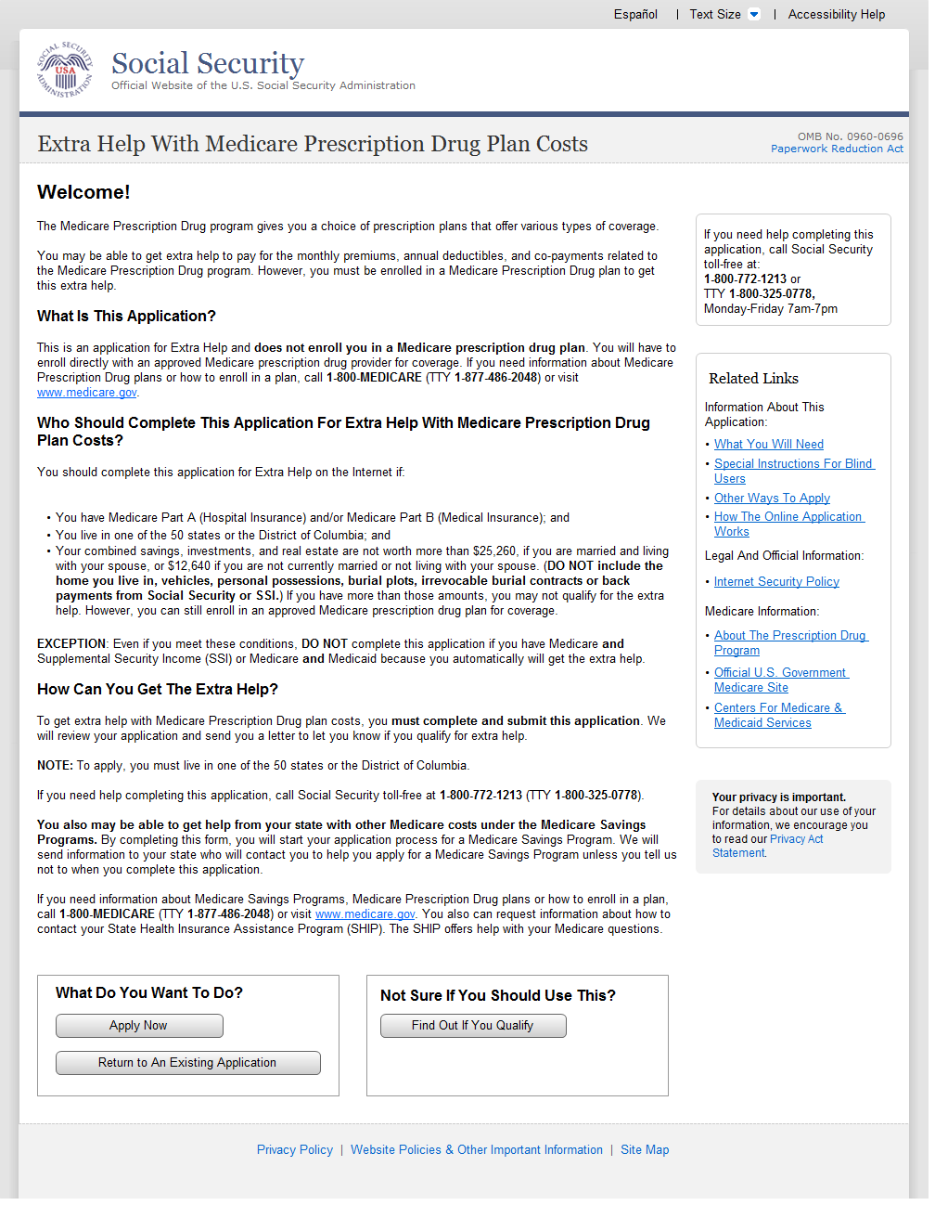

Welcome
- We corrected the SHIP acronym to State Health Insurance Counseling and Assistance Program.
- We capitalized each occurrence of the letter “S” in the word state.

A.3.1. User Interface
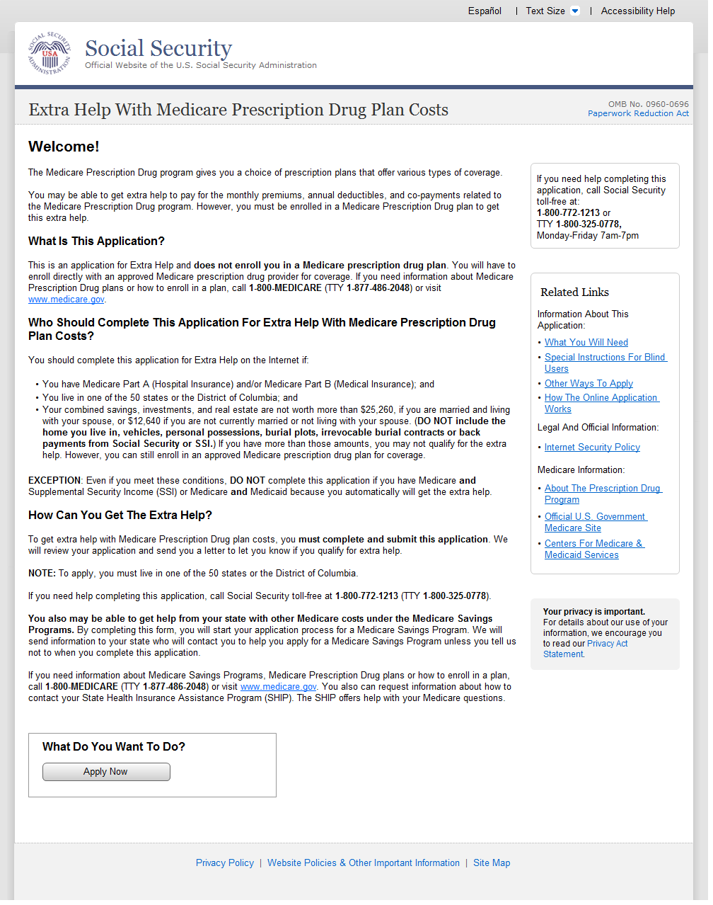

Should You Use This Application?
- We corrected the SHIP acronym to State Health Insurance Counseling and Assistance Program.
- We capitalized each occurrence of the letter “S” in the word state.

A.4.1. User Interface
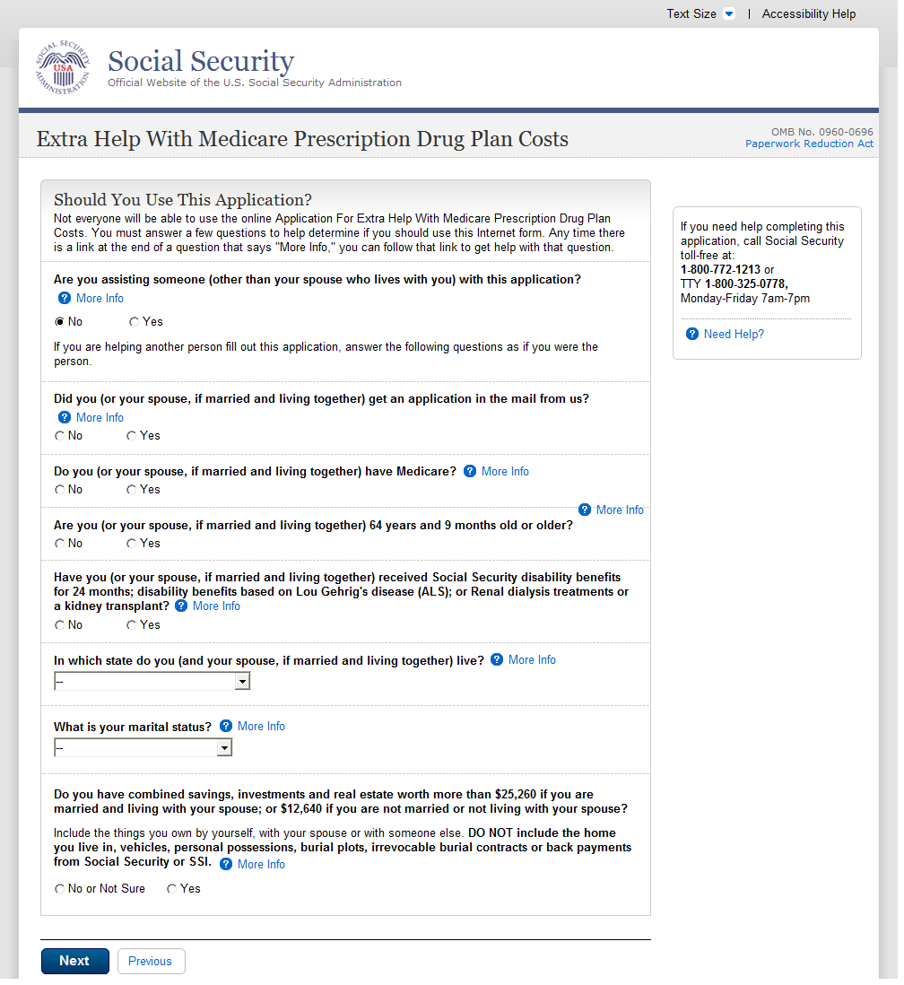

Welcome Back
- We added “life insurance” to the list of assets that we do not count
- We simplified language regarding the applicant’s home.

A.5.1. User Interface
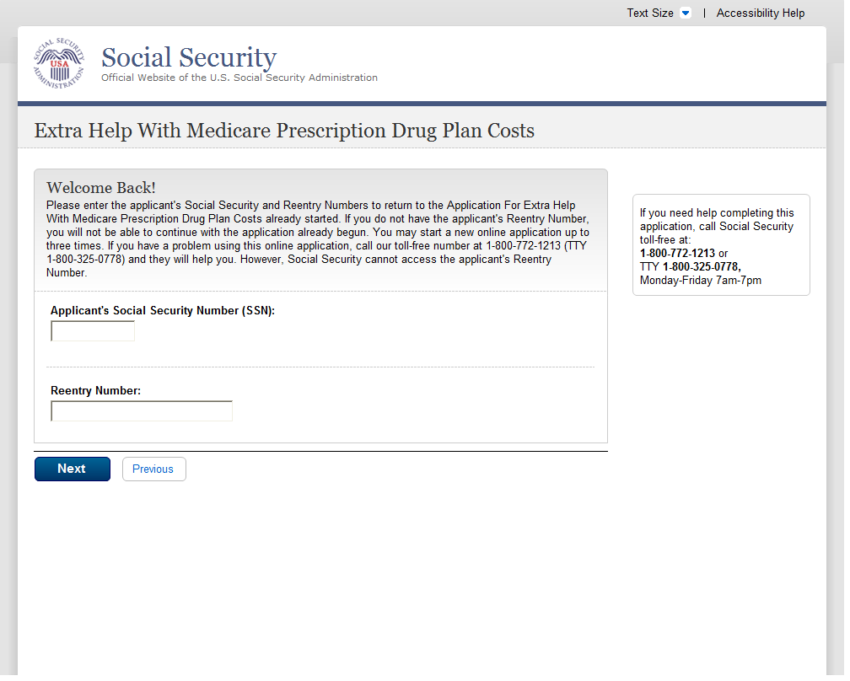
Save & Exit

A.6.1. User Interface
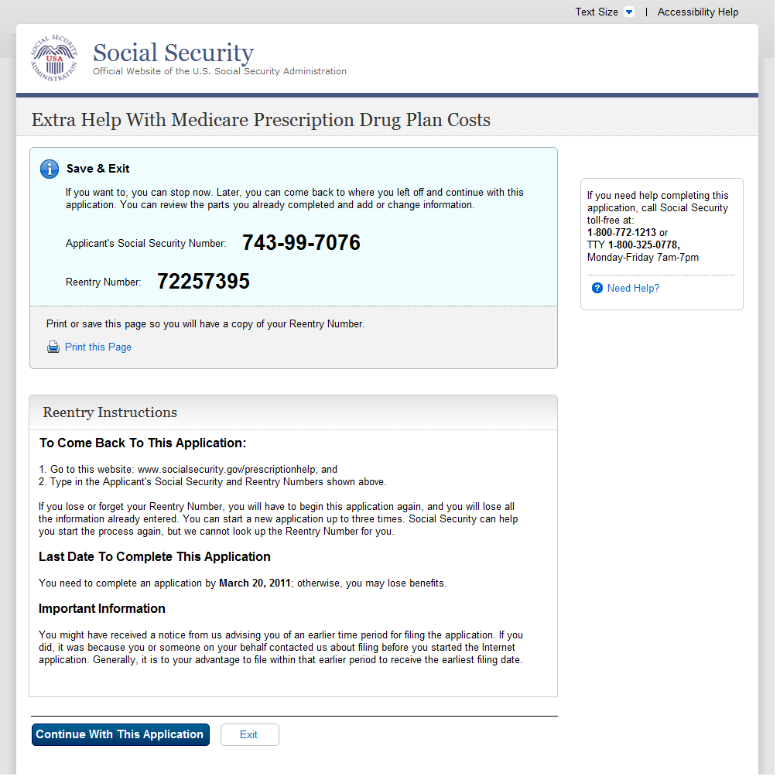

You Are Not Eligible For The Extra Help
A.7.1. User Interface
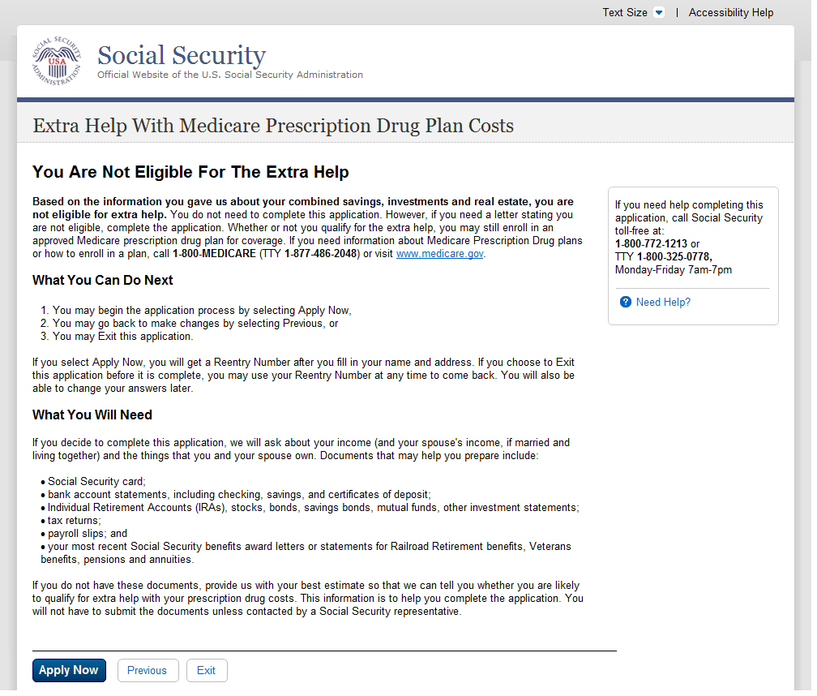
A.8. Go Ahead
A.8.1. User Interface
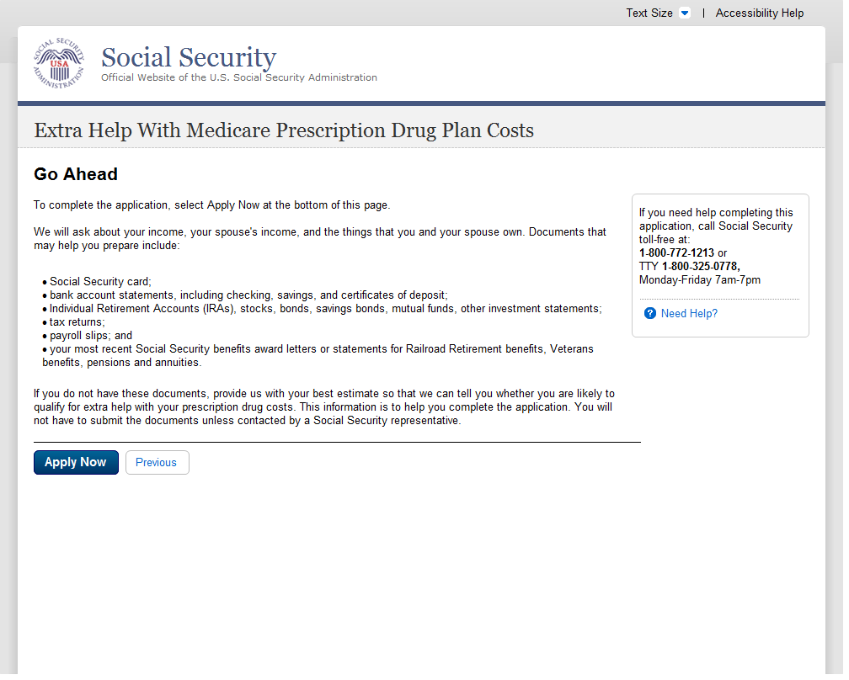
A.9. Preparing To Find Out If You Qualify
A.9.1. User Interface
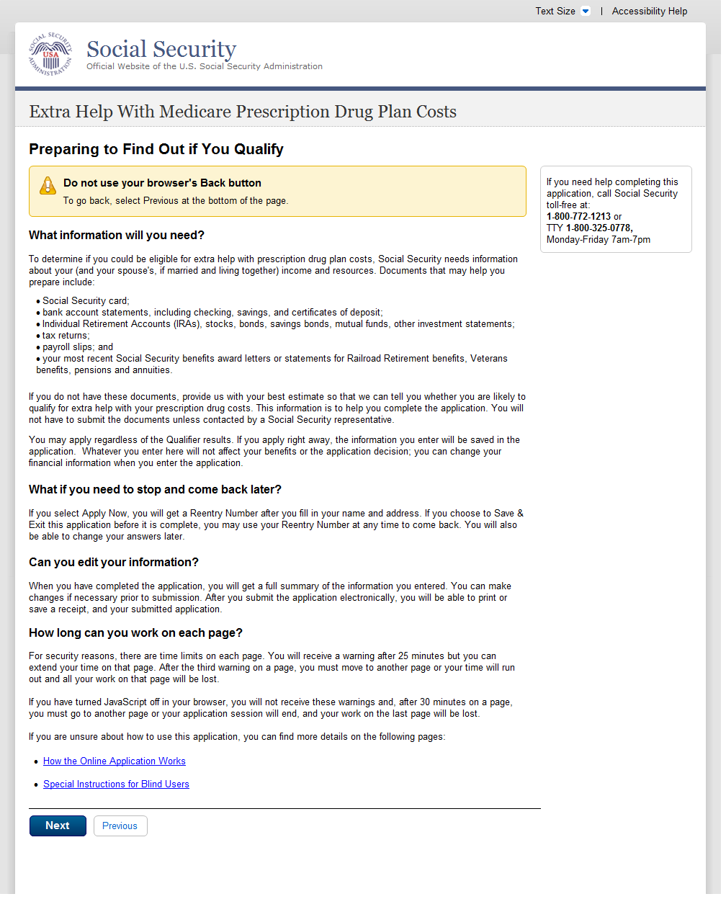

Preparing To Use This Application
A.10.1. User Interface
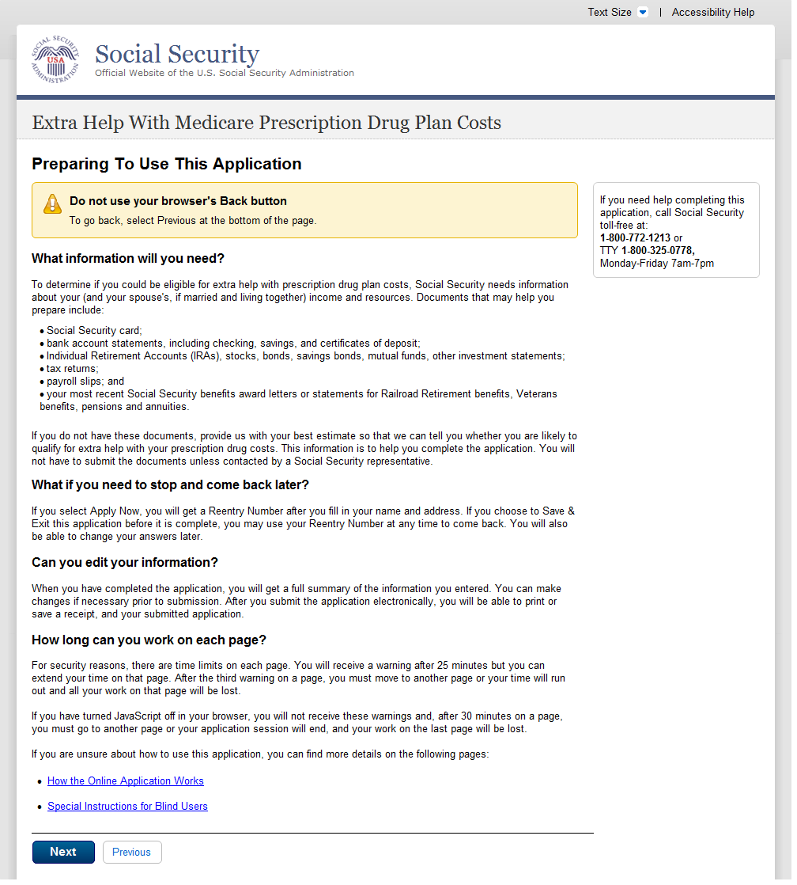

(Apply Now)
A.11. About You and Your Spouse
A.11.1. User Interface
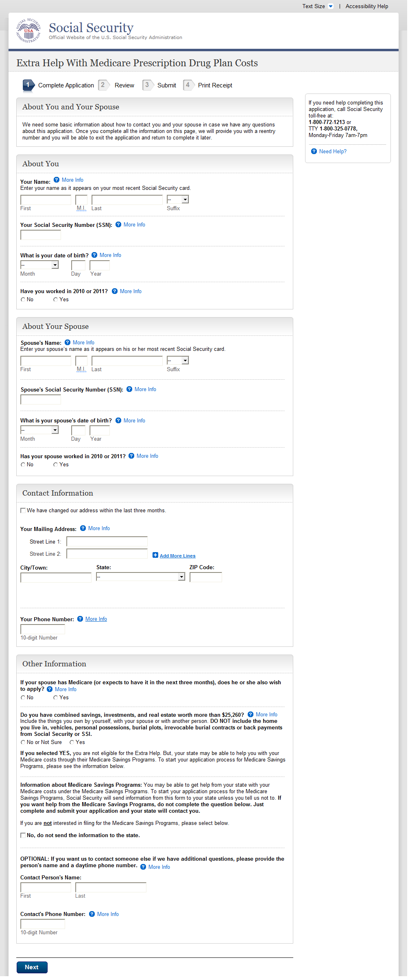
A.12. About You and Your Spouse - With
A.12.1. User Interface
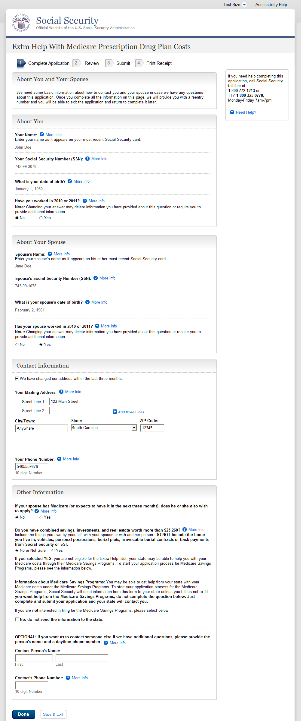

About You
A.13.1. User Interface
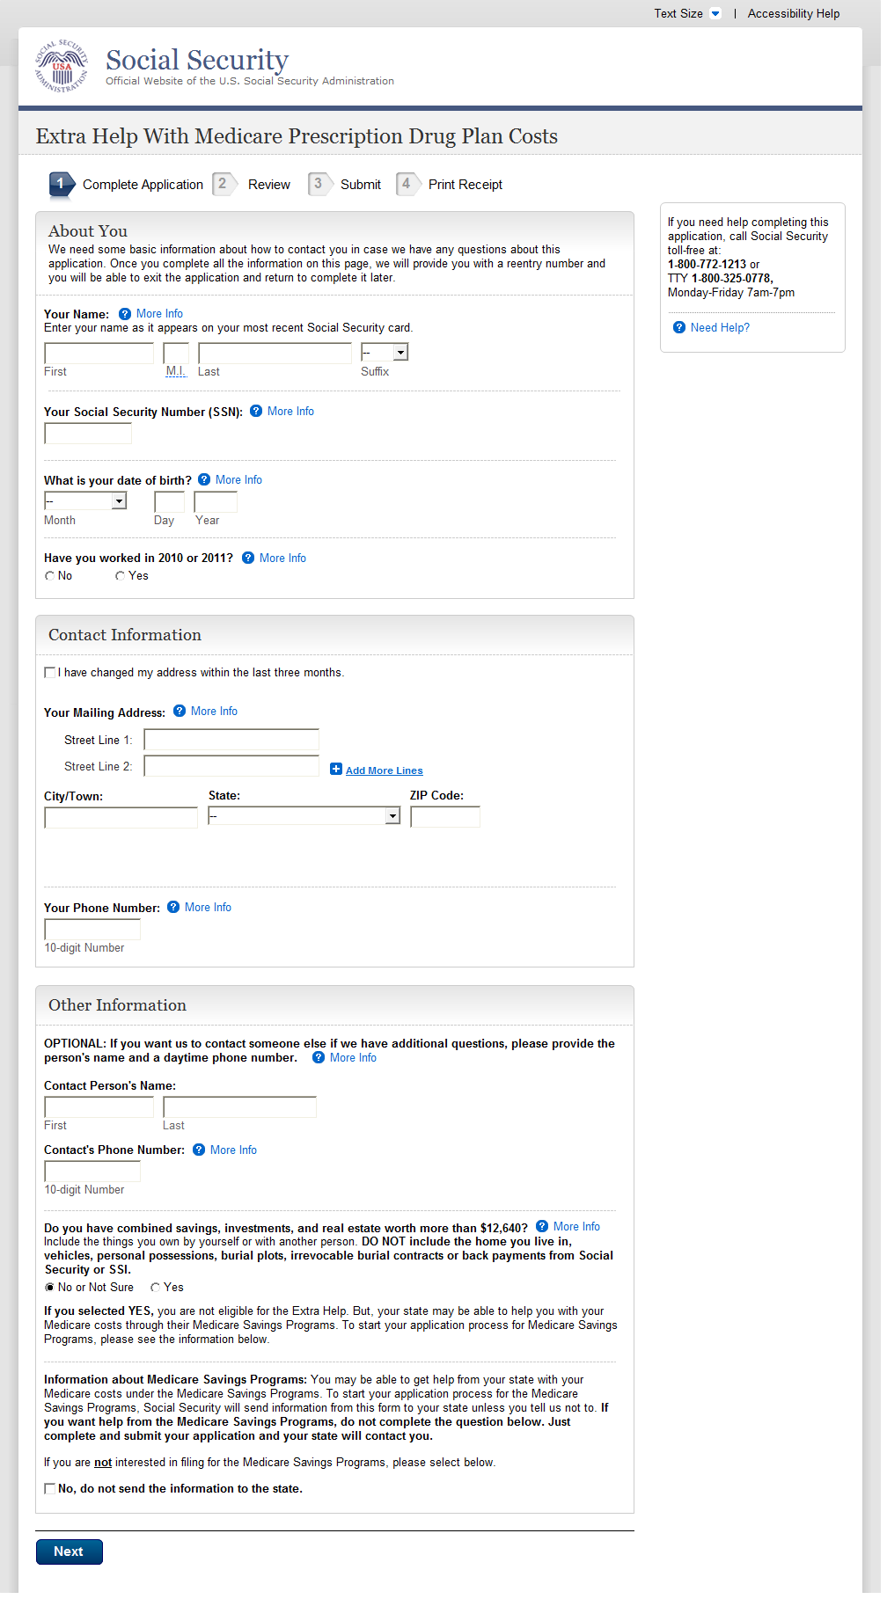
About the Person Completing
A.14.1. User Interface
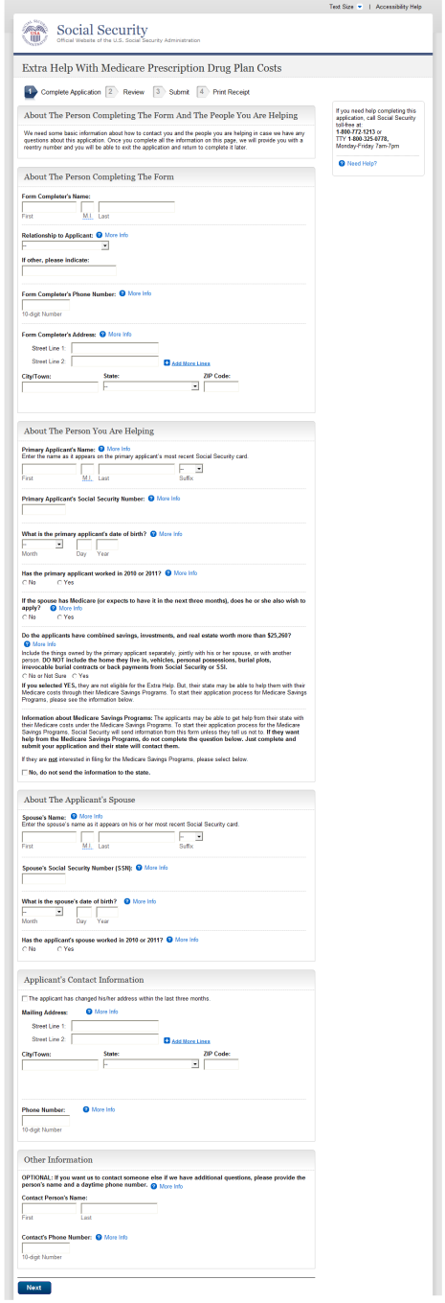

A.15. About the Person Completing
A.15.1. User Interface
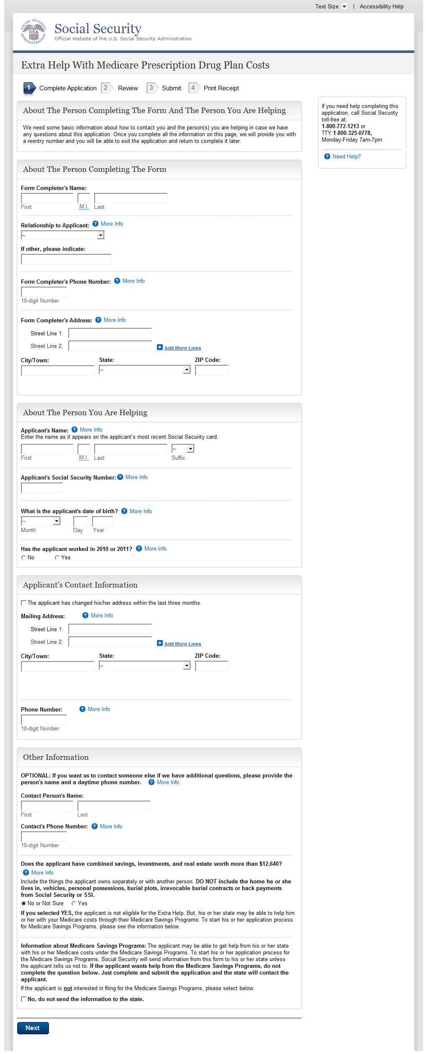

Reentry Number Issued Normal Process
A.15.2. User Interface
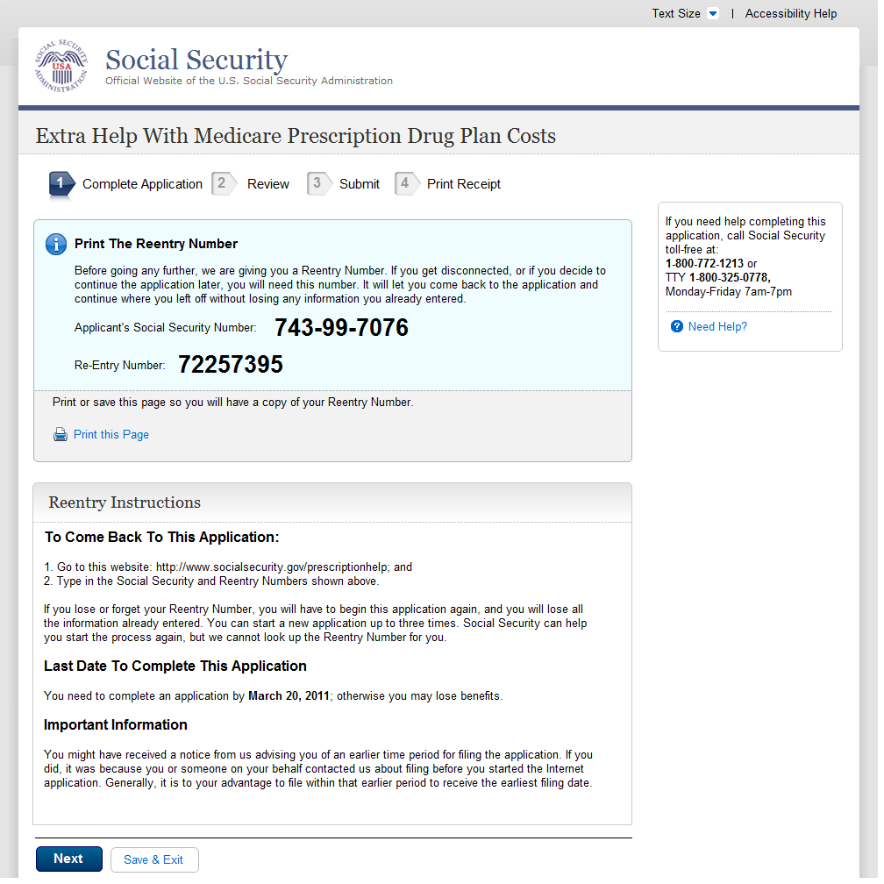
A.16. About You And Your Spouse's Living Situation - Married
A.16.1 User Interface
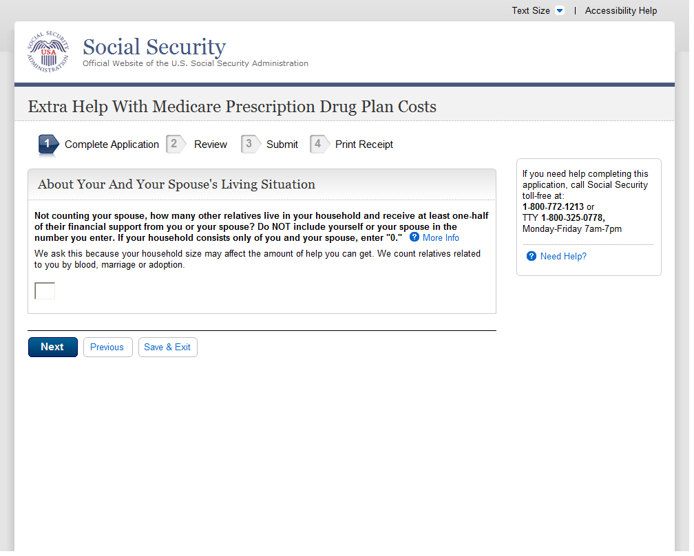
About Your Living Situation - Single

A.17.1 User Interface
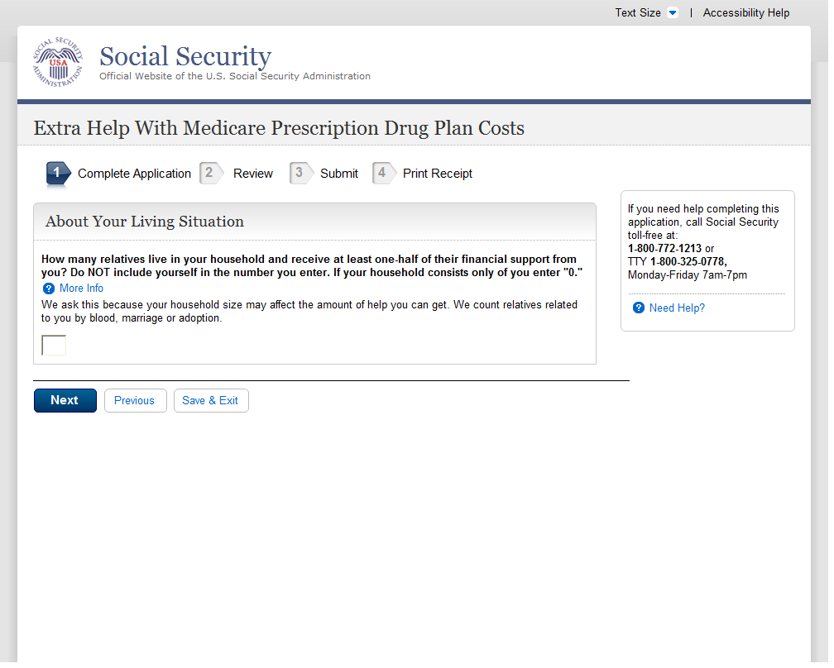
A.18. Wages And Earnings - Married
A.18.1. User Interface
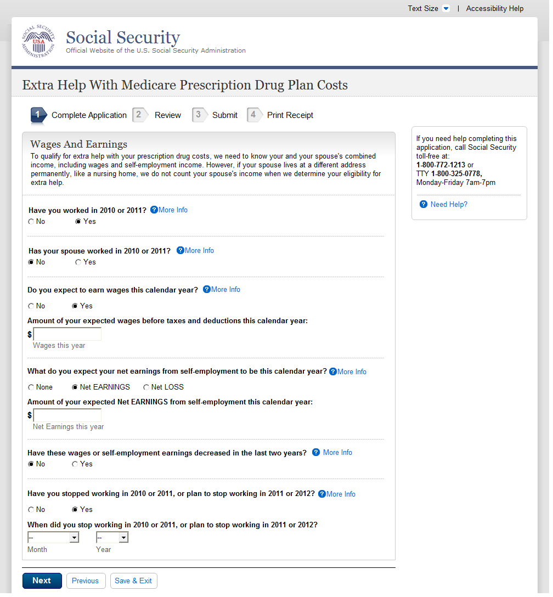

Wages And Earnings - Married

- We updated the years “2010 or 2011” to “2011 or 2012.”
- We updated the years “2011 or 2012” to “2012 or 2013.”

A.19.1. User Interface
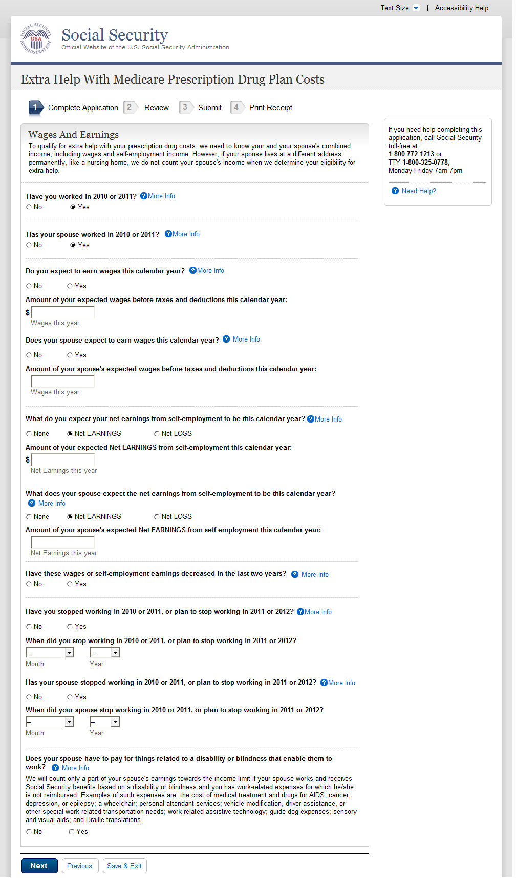

Wages And Earnings - Single (WITHOUT)
- We updated the years “2010 or 2011” to “2011 or 2012.”
- We updated the years “2011 or 2012” to “2012 or 2013”.

A.20.1. User Interface
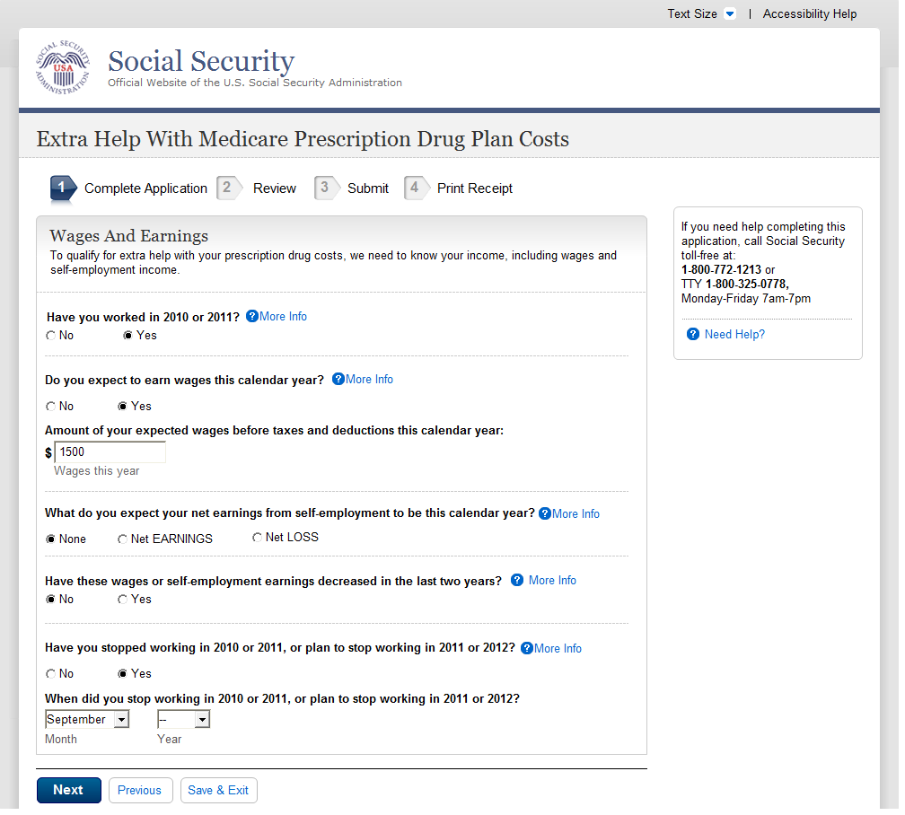

Wages And Earnings - Single (WITH)
- We updated the years “2010 or 2011” to “2011 or 2012.”
- We updated the years “2011 or 2012” to “2012 or 2013.”

A.21.1. User Interface
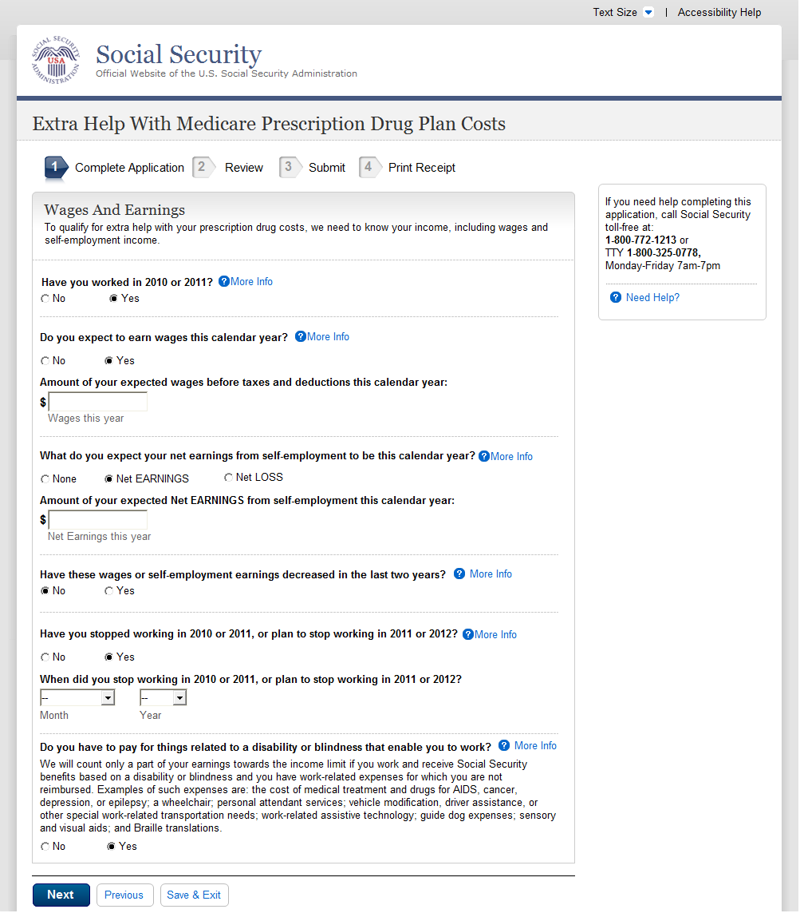

Income Other Than Wages And Earnings - Married
- We updated the years “2010 or 2011” to “2011 or 2012.”
- We updated the years “2011 or 2012” to “2012 or 2013.”

A.22.1. User Interface
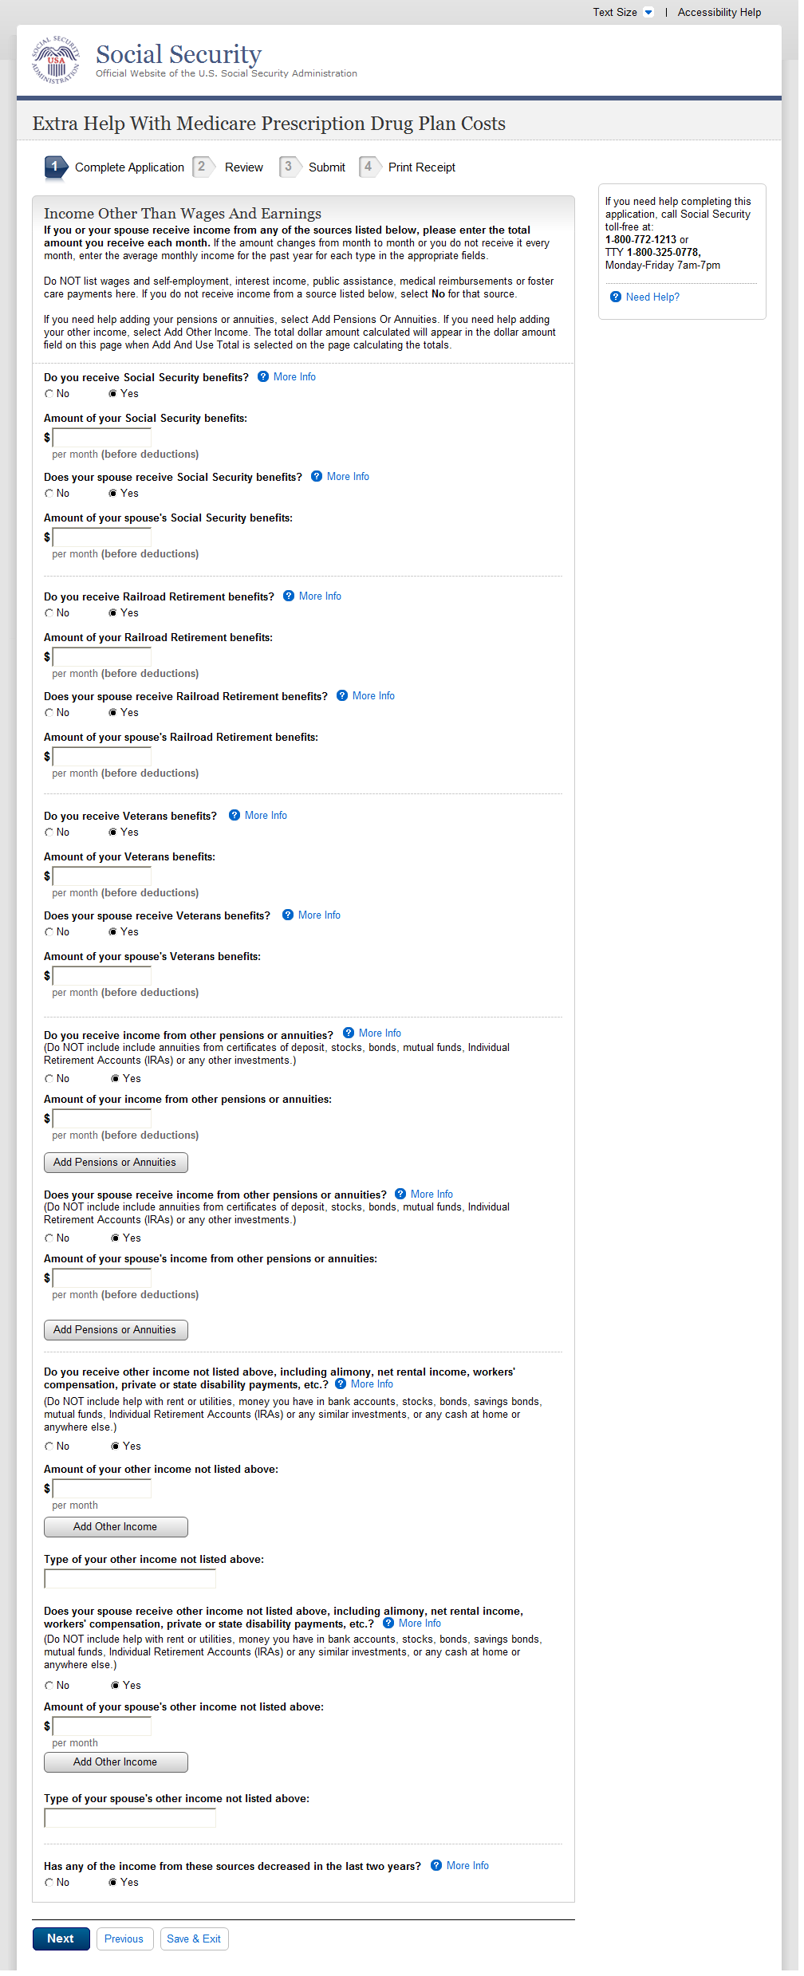
A.23. Income Other Than Wages And Earnings - Single
- We changed the “Other Income” question from:

“Other income not listed above, including alimony, net rental income, worker’s compensation, private or state disability payments, etc. (Specify):_____
to:
“Other income not listed above, including alimony, net rental income, worker’s compensation, unemployment, private or State disability payments, etc. (Specify):_____

A.23.1. User Interface
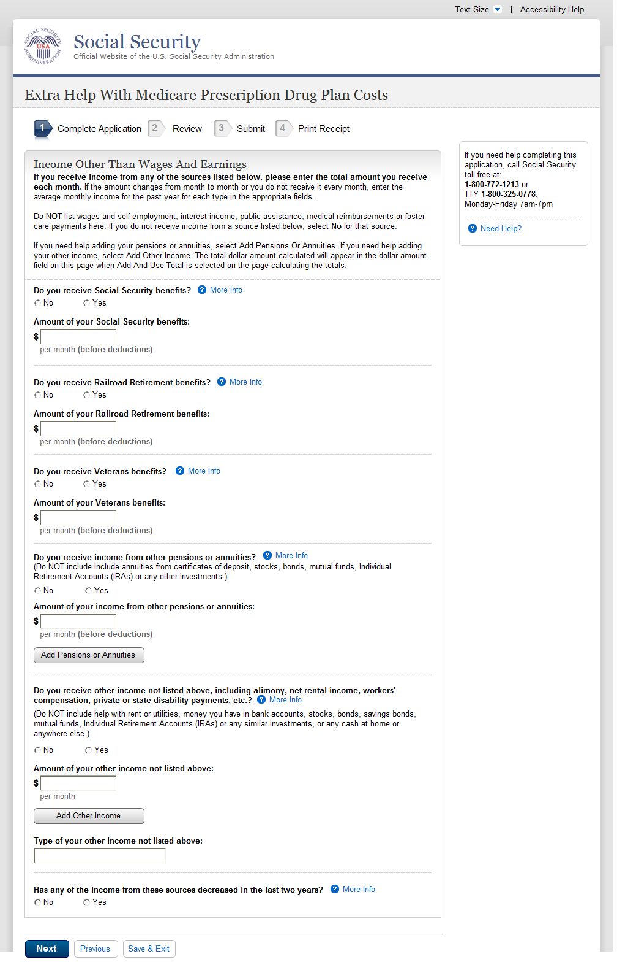

- We changed the “Other Income” question from:

“Other income not listed above, including alimony, net rental income, worker’s compensation, private or state disability payments, etc. (Specify):_____
to:
“Other income not listed above, including alimony, net rental income, worker’s compensation, unemployment, private or State disability payments, etc. (Specify):_____

A.24. Resources - Married
A.24.1. User Interface
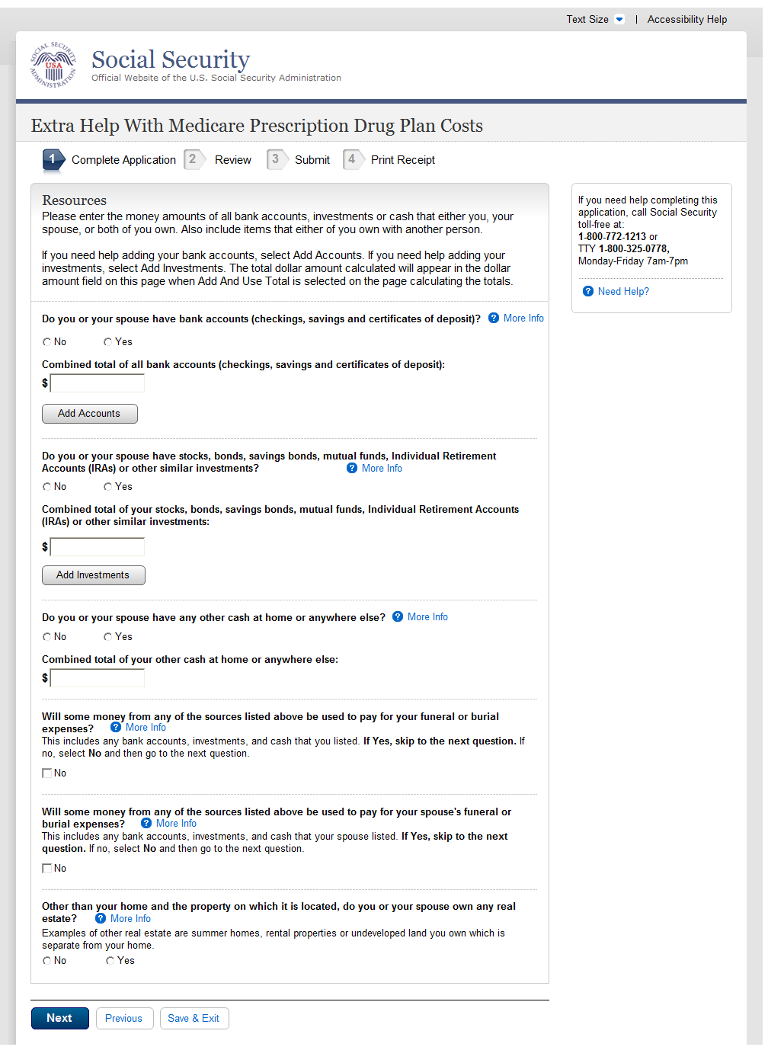

Resources - Single

A.25.1. User Interface
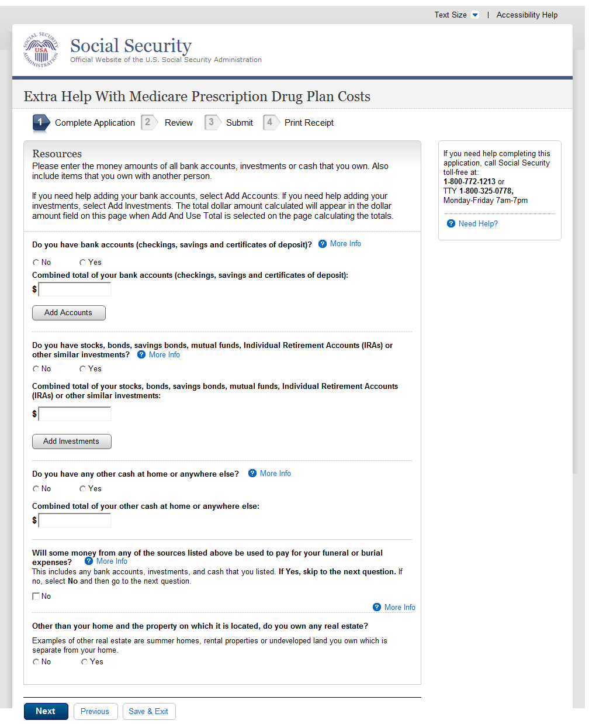

Tool: Add Up Your Accounts

A.26.1. User Interface
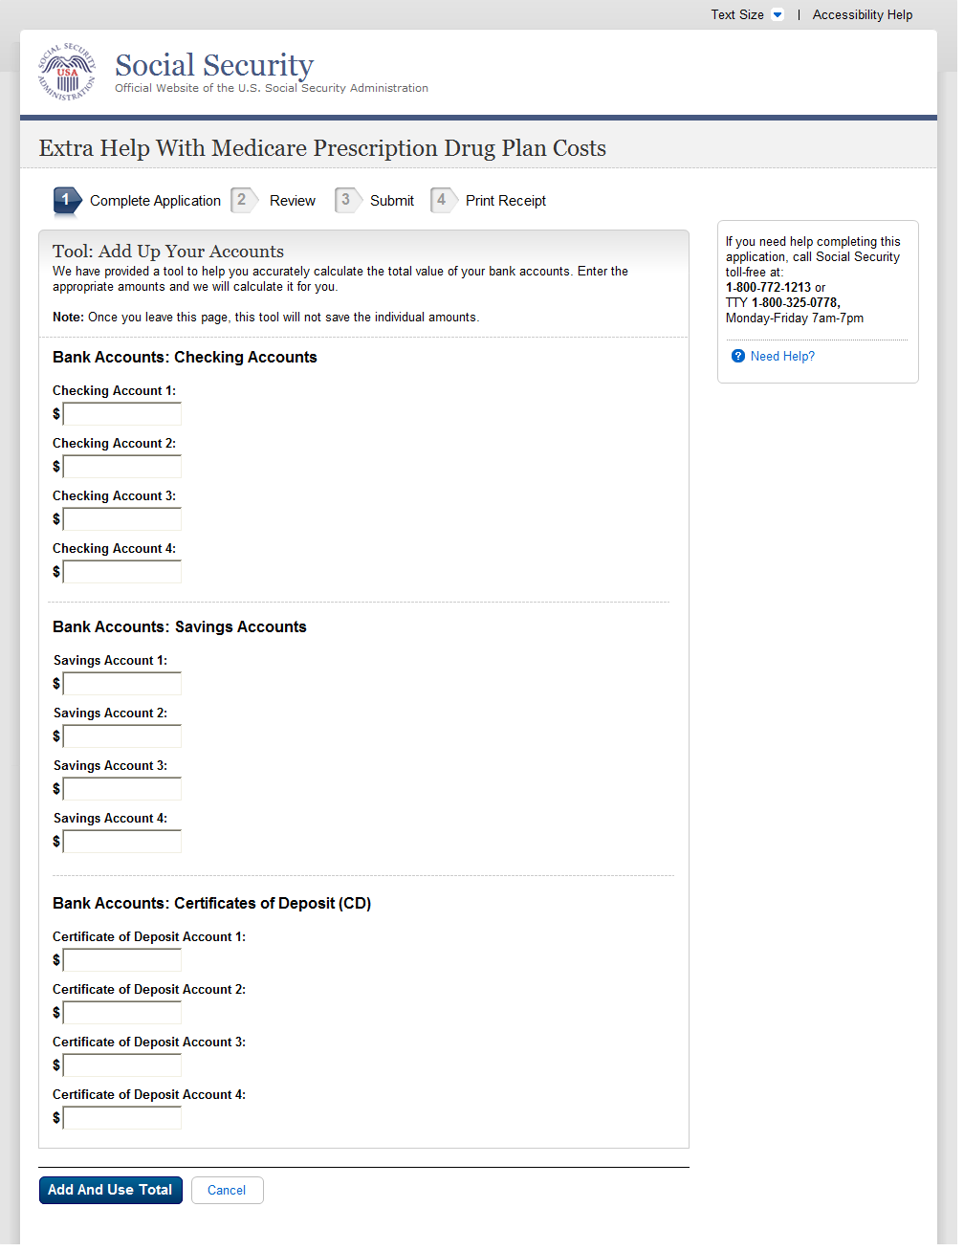
A.27. Tool: Add Up Your Investments
A.27.1. User Interface
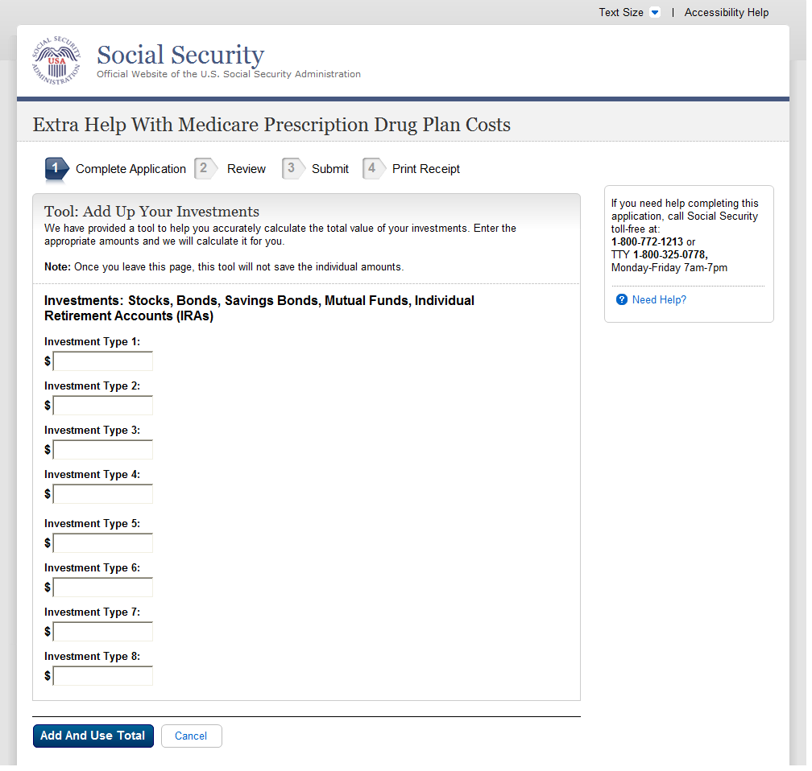
A.28. Tool: Add Up Your Other Pensions And Annuities
A.28.1. User Interface
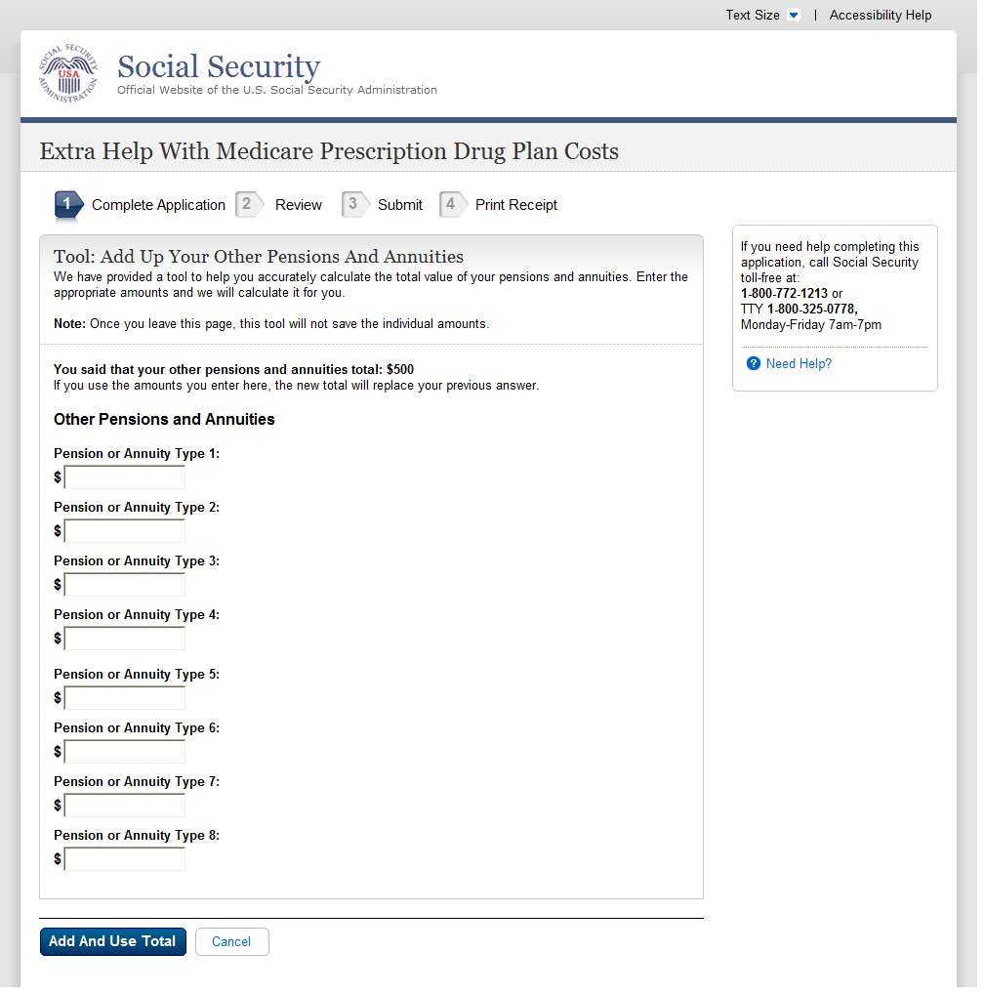
A.29. Tool: Add Up Your Types Of Income
A.29.1. User Interface
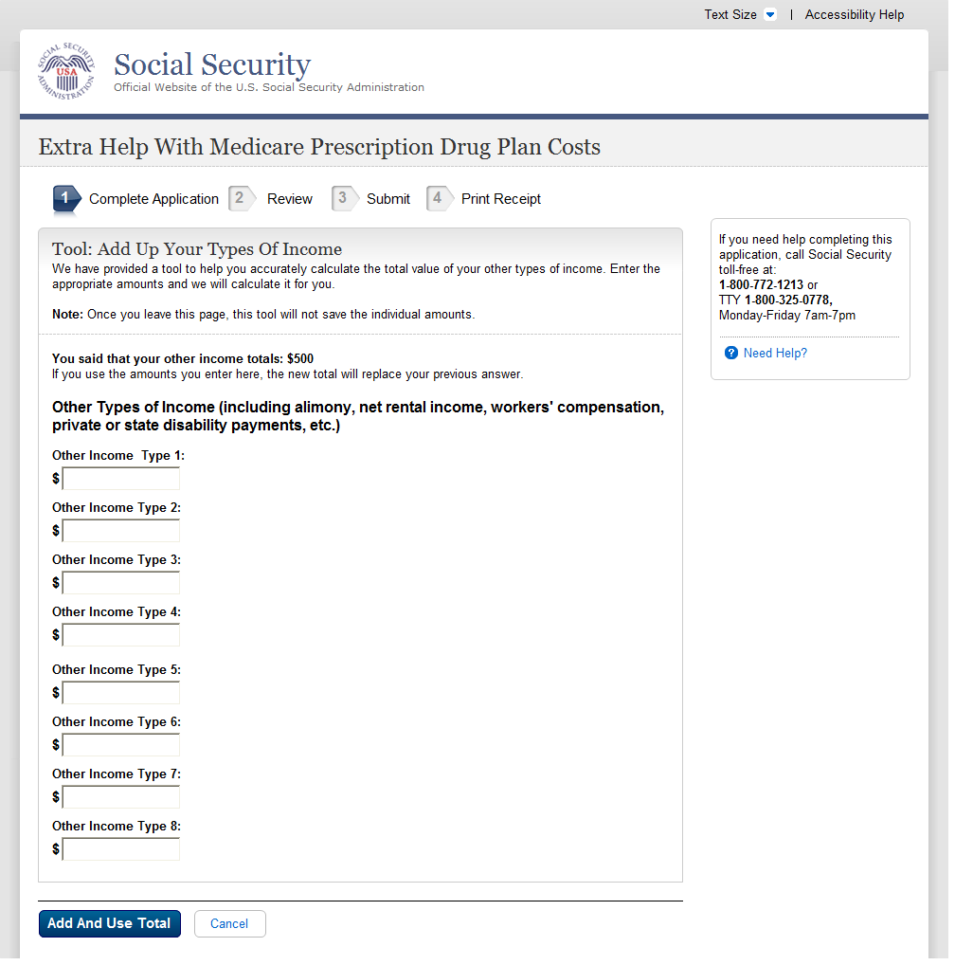
- We changed the “Other Income” question from:

“Other income not listed above, including alimony, net rental income, worker’s compensation, private or state disability payments, etc. (Specify):_____
to:
“Other income not listed above, including alimony, net rental income, worker’s compensation, unemployment, private or State disability payments, etc. (Specify):_____

A.30. (Find Out if You Qualify)
A.31. Find Out If You And Your Spouse Qualify (Married) Part 1 (WITHOUT)
A.31.1. User Interface
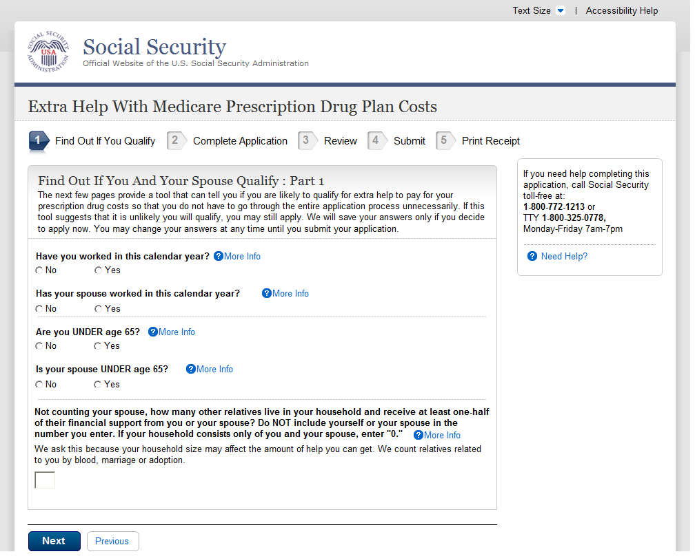

Find Out If You And Your Spouse Qualify (Married) Part 1 (WITH)

A.32.1. User Interface
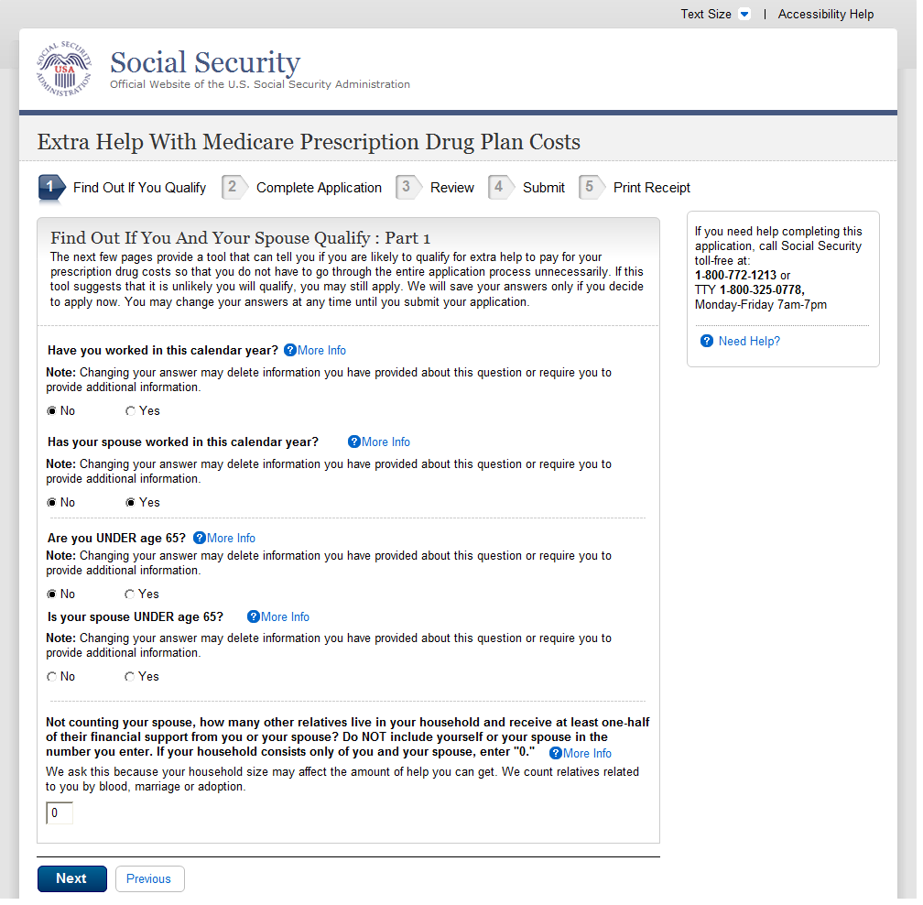

A.33. Find Out If You Qualify (Single) Part 1

A.33.1. User Interface
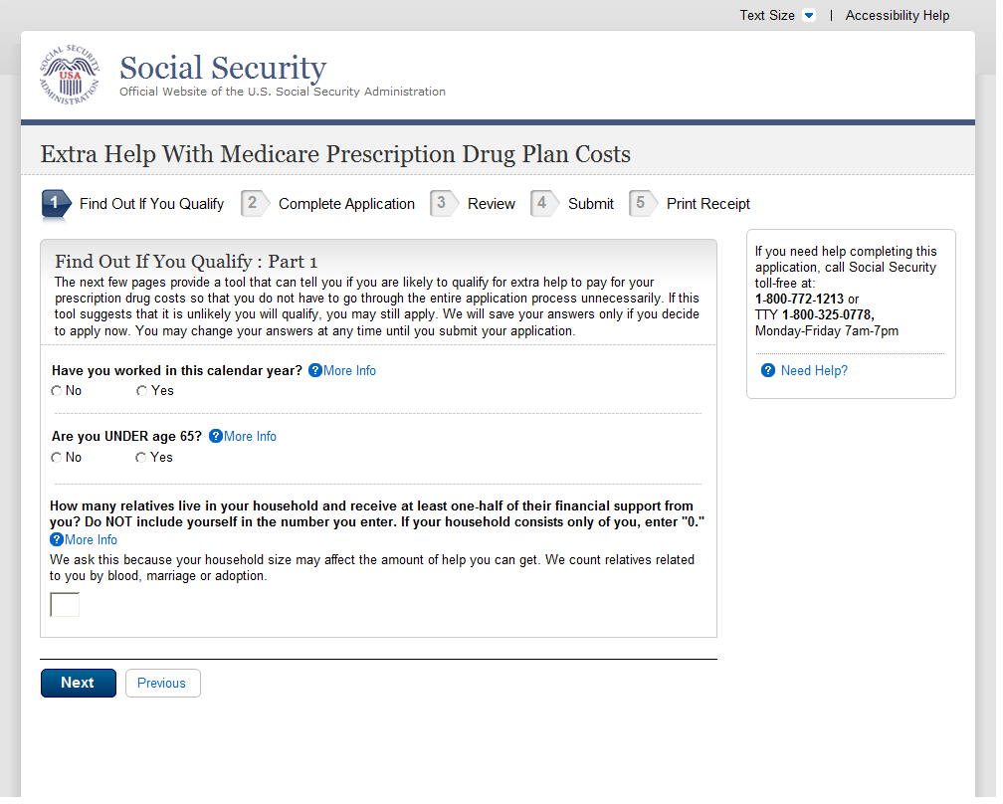
A.34. Find Out If You Qualify (Married) Part 3 (WITH)
A.34.1. User Interface
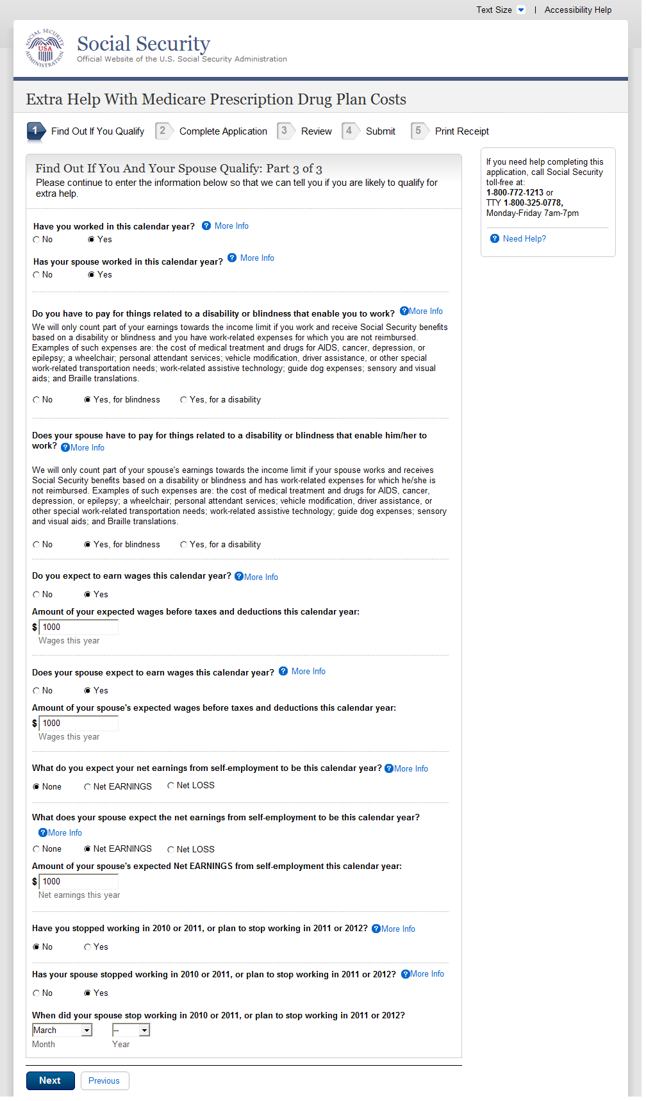

Find Out If You Qualify (Single) Part 3 (WITHOUT)
- We changed the years “2010 or 2011” to “2011 or 2012.”
- We changed the years “2011 or 2012” to “2012 or 2013.”

A.35.1. User Interface
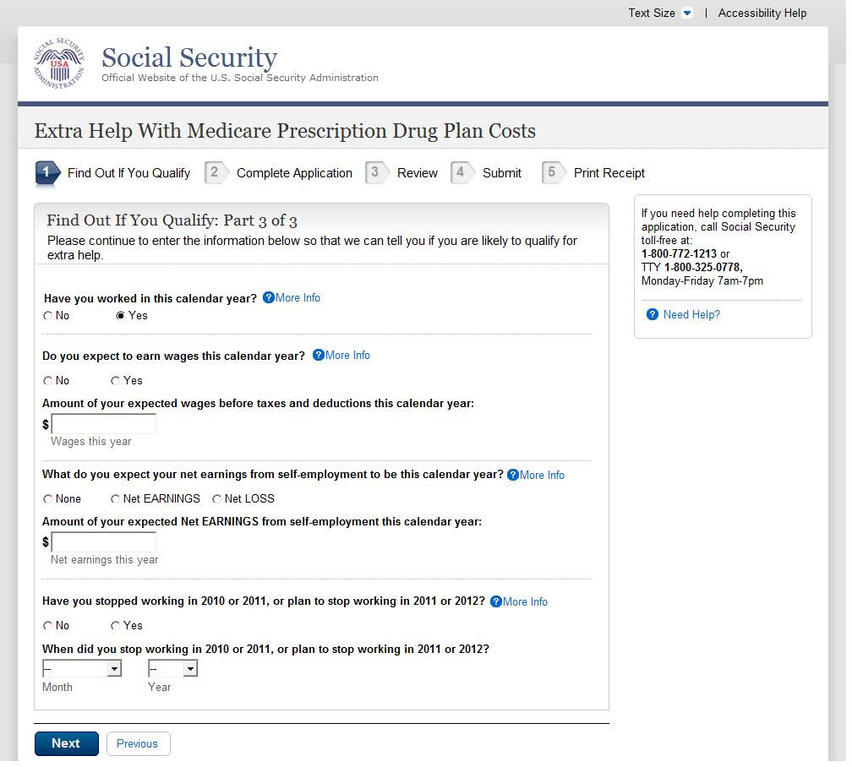

Find Out if You Qualify (Single) Part 3 (WITH)
- We changed the years “2010 or 2011” to “2011 or 2012.”
- We changed the years “2011 or 2012” to “2012 or 2013.”

A.36.1. User Interface
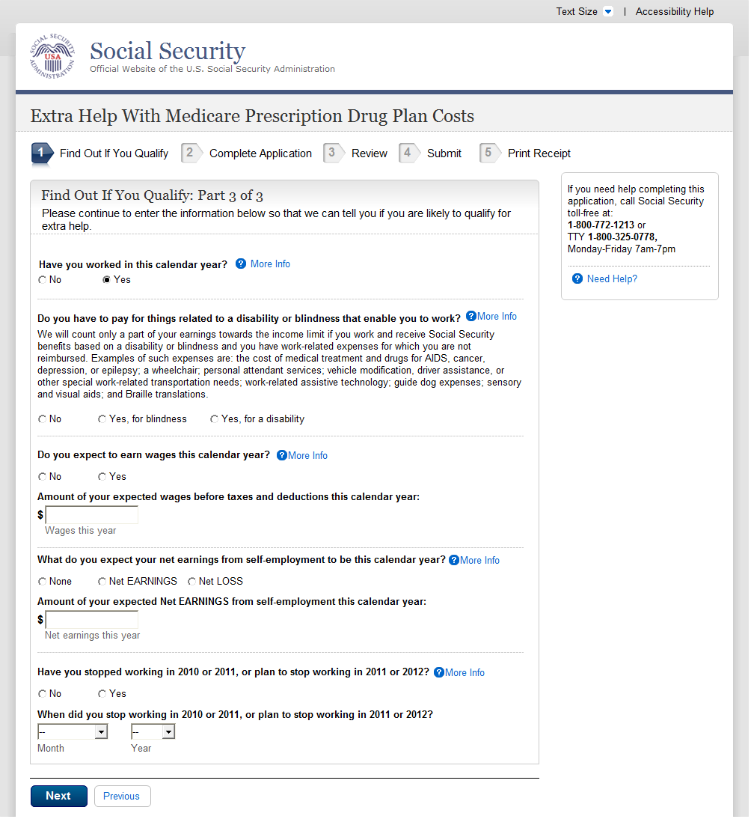

Find Out If You Qualify (Married) Part 2
- We changed the years “2010 or 2011” to “2011 or 2012.”
- We changed the years “2011 or 2012” to “2012 or 2013.”

A.37.1. User Interface
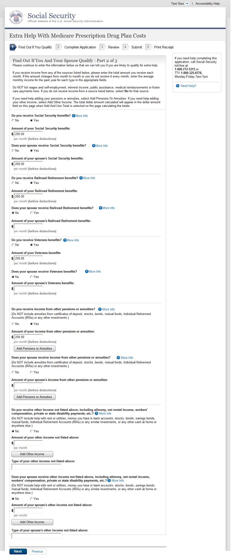

- We changed the “Other Income” question from:

“Other income not listed above, including alimony, net rental income, worker’s compensation, private or state disability payments, etc. (Specify):_____
to:
“Other income not listed above, including alimony, net rental income, worker’s compensation, unemployment, private or State disability payments, etc. (Specify):_____

A.38. Find Out If You Qualify (Single) Part 2
A.38.1. User Interface
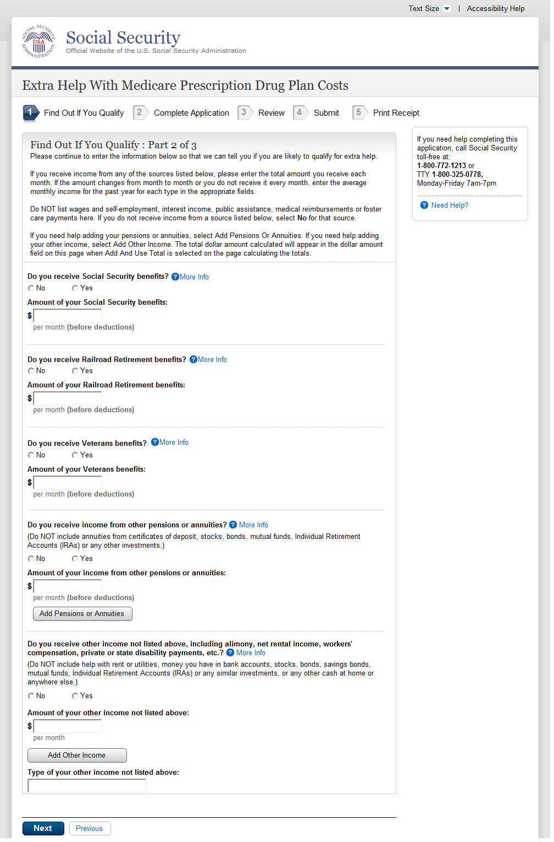

- We changed the “Other Income” question from:

“Other income not listed above, including alimony, net rental income, worker’s compensation, private or state disability payments, etc. (Specify):_____
to:
“Other income not listed above, including alimony, net rental income, worker’s compensation, unemployment, private or State disability payments, etc. (Specify):_____

A.39. Find Out If You Qualify (You Should Apply)
A.39.1. User Interface
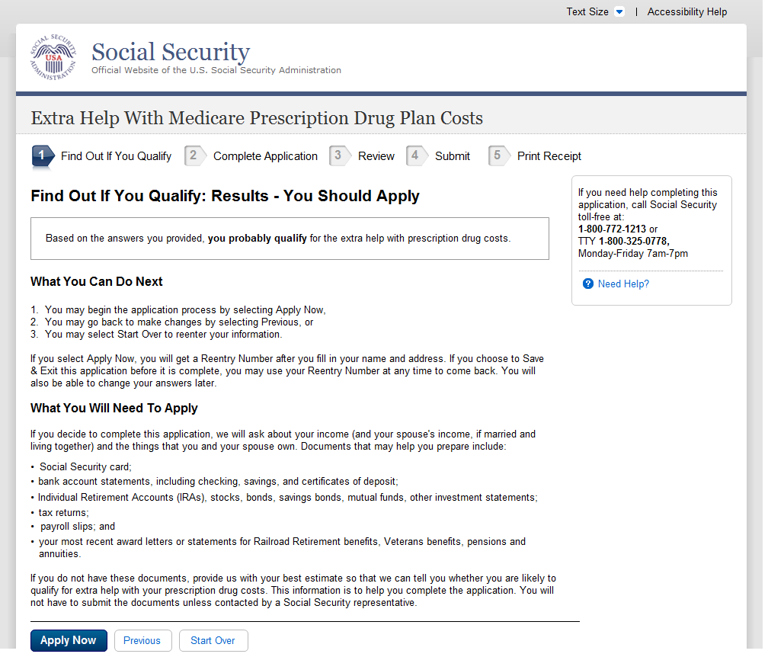
A.40. Find Out If You Qualify (You Probably Do Not Qualify)
A.40.1. User Interface
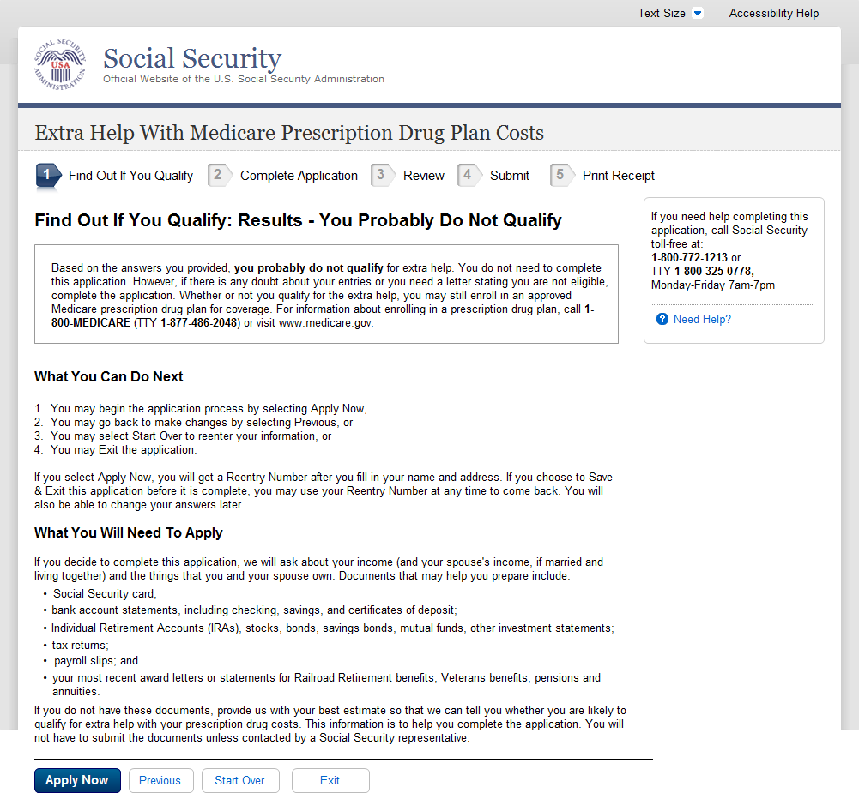
A.41. Review and Send
A.42. Review Your Information
A.42.1. User Interface
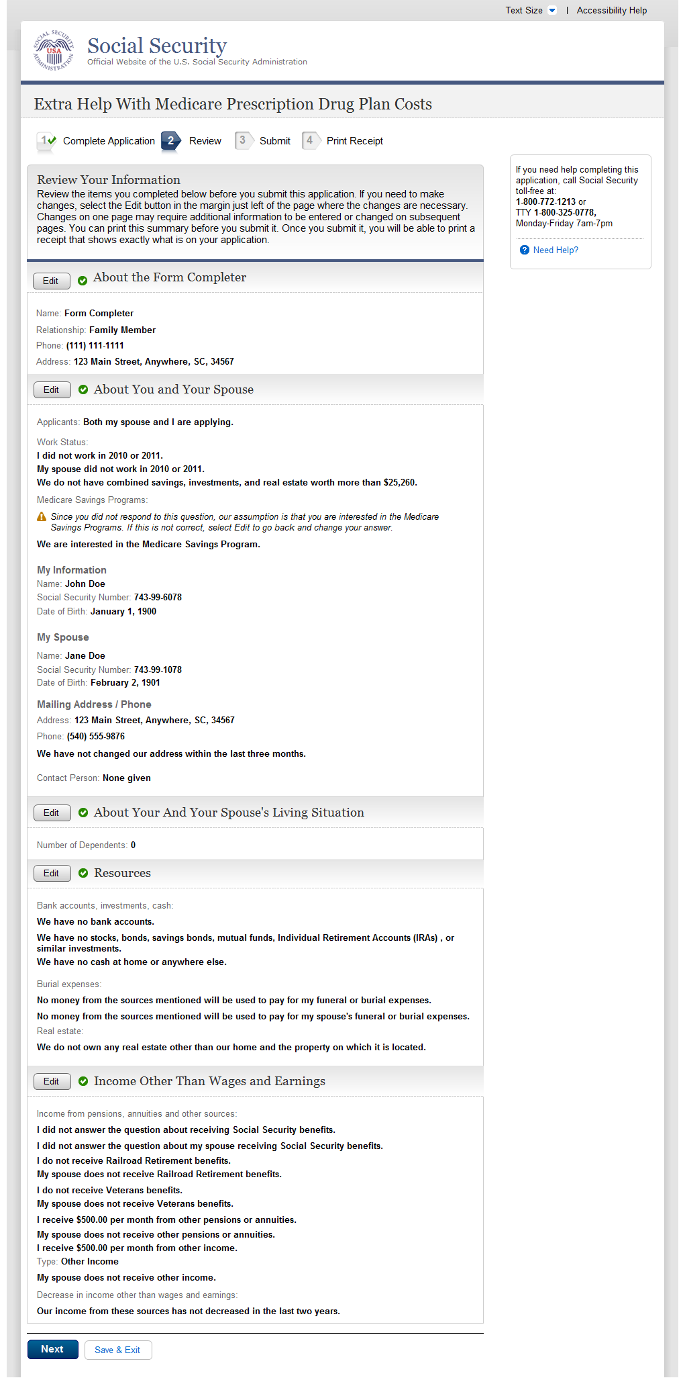
A.43. Review Your Information
A.43.1. User Interface
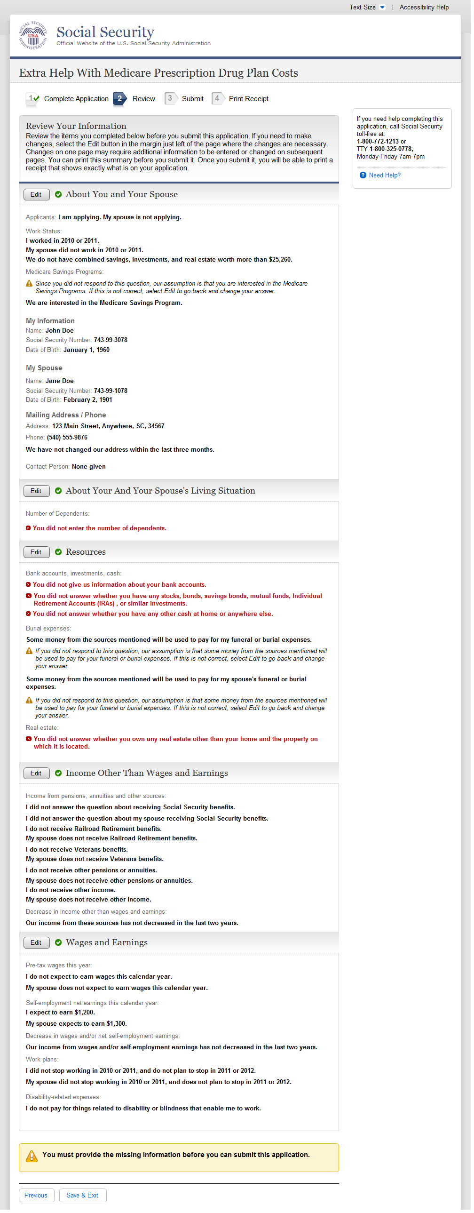

Ready to Submit

A.44.1. User Interface
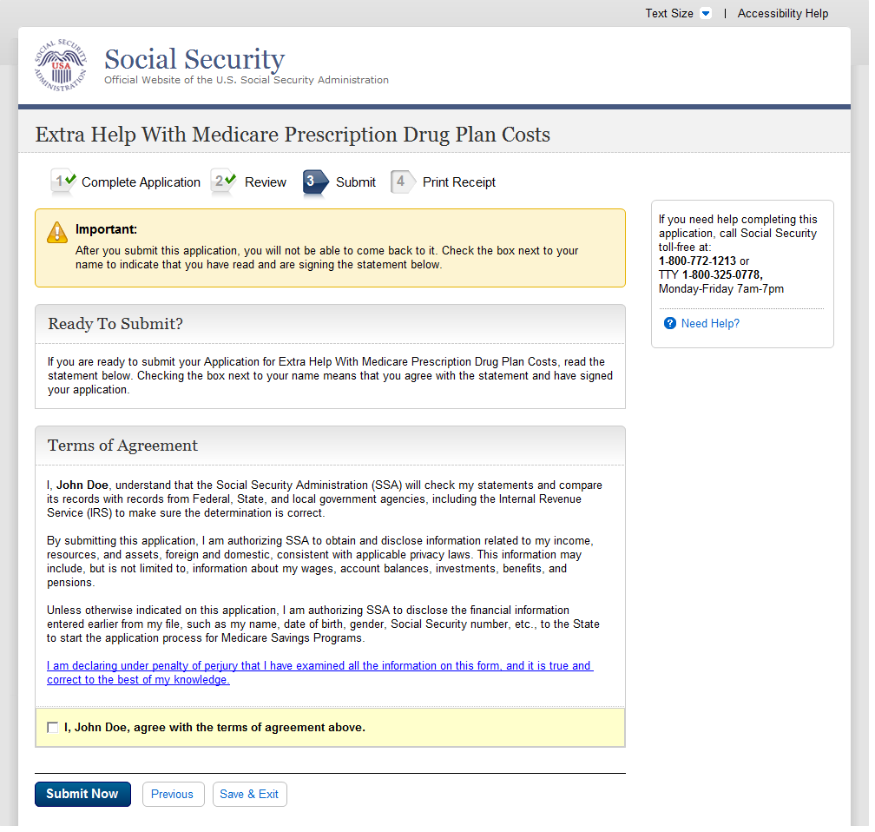

A.45. Ready to Submit
A.45.1. User Interface
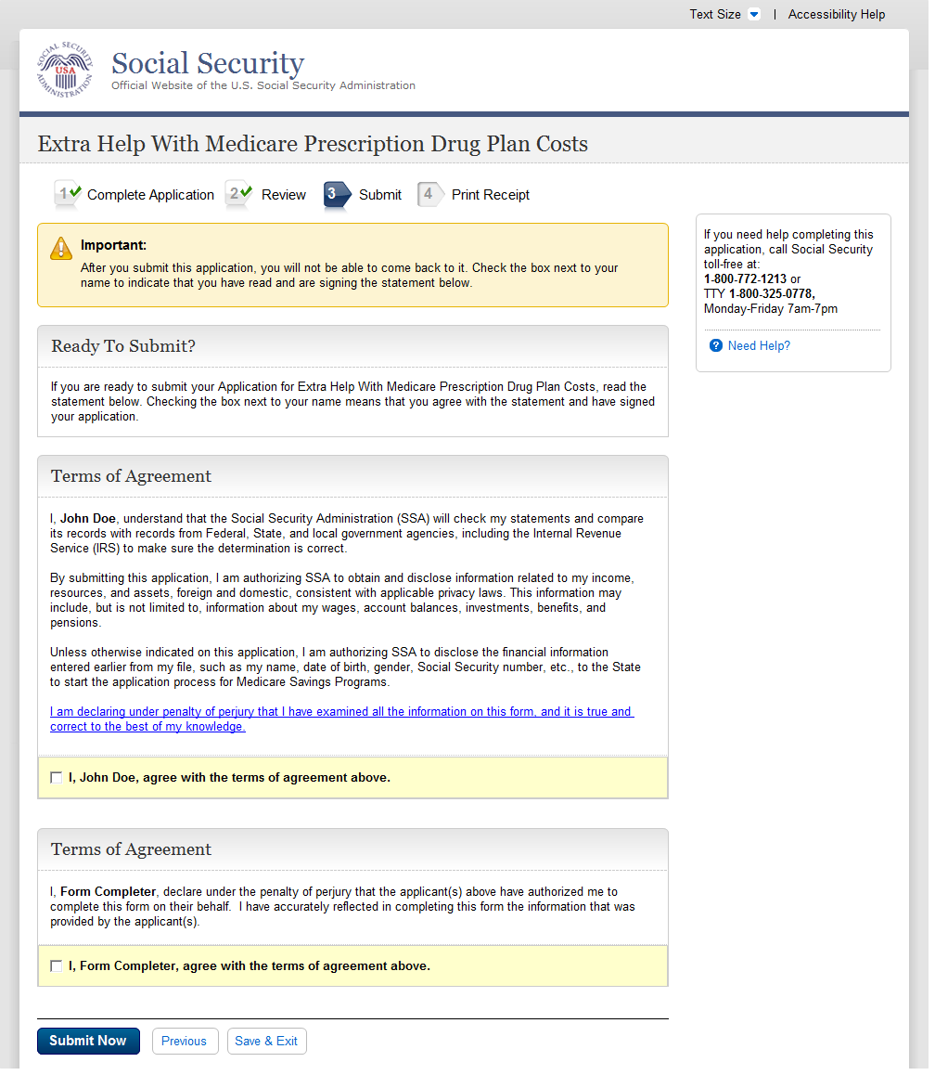

Ready to Submit

A.46.1. User Interface
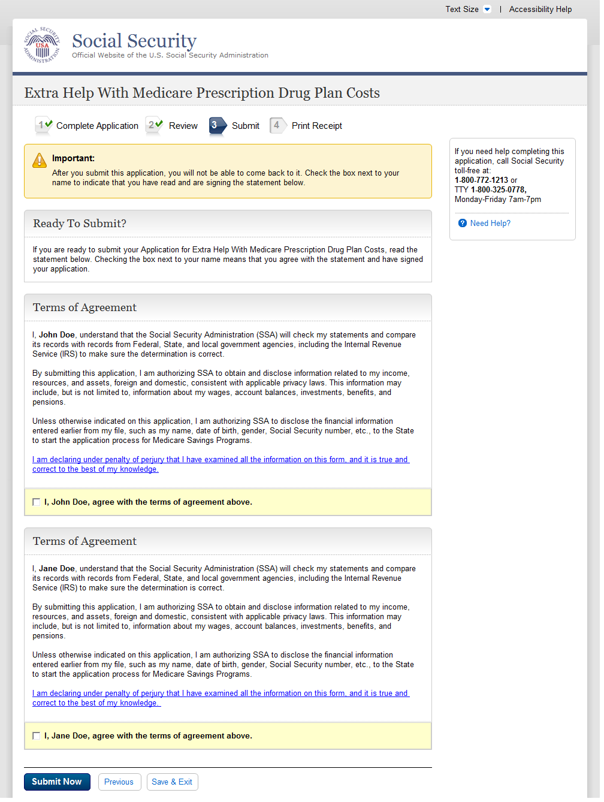

Ready to Submit

A.47.1. User Interface
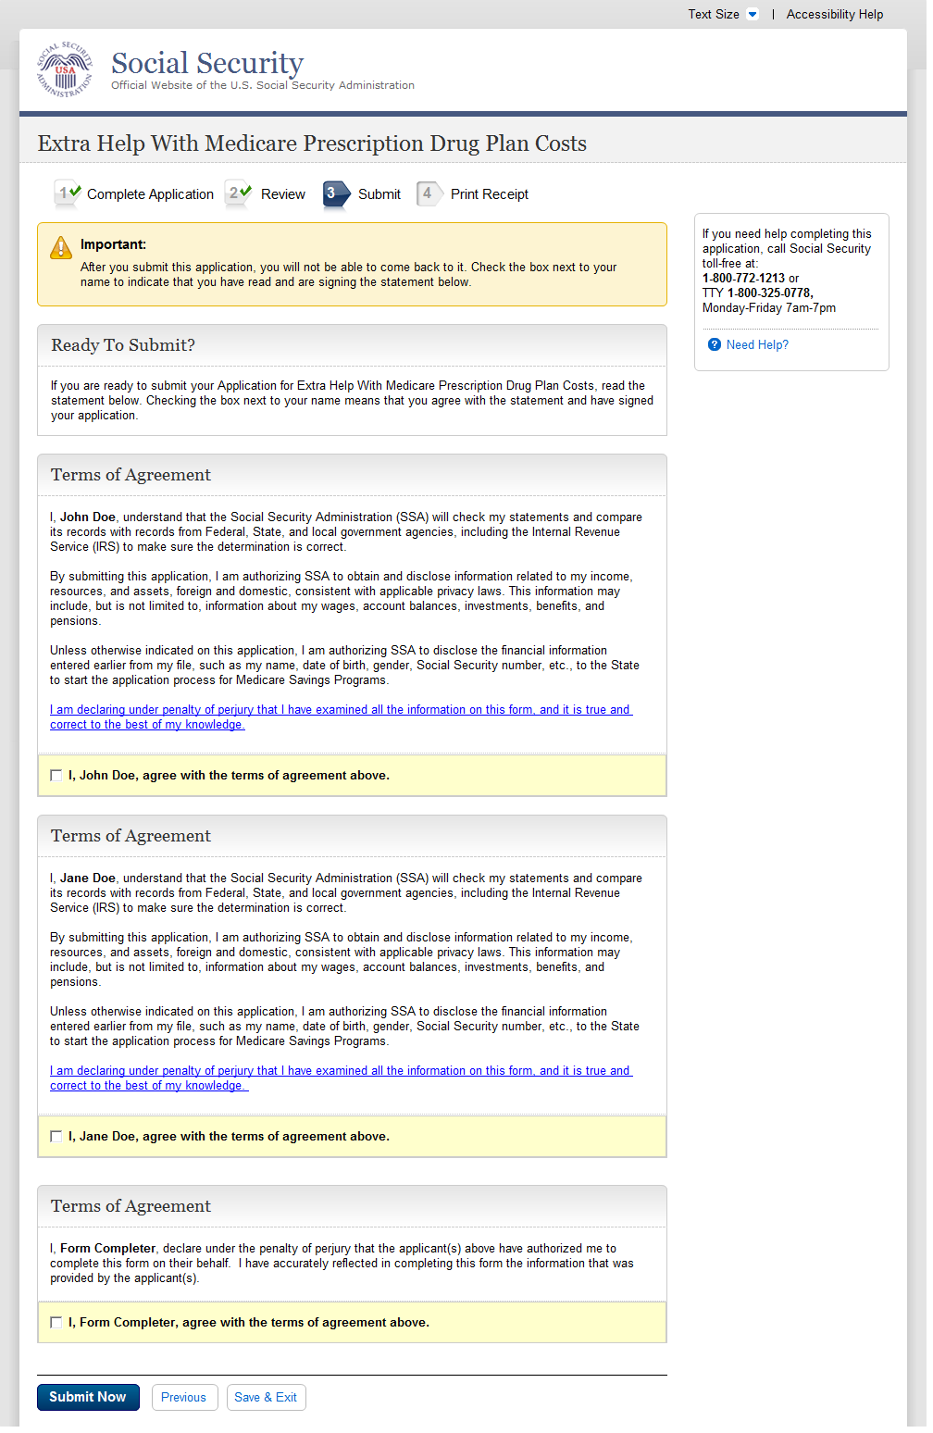

Ready to Submit

A.48.1. User Interface
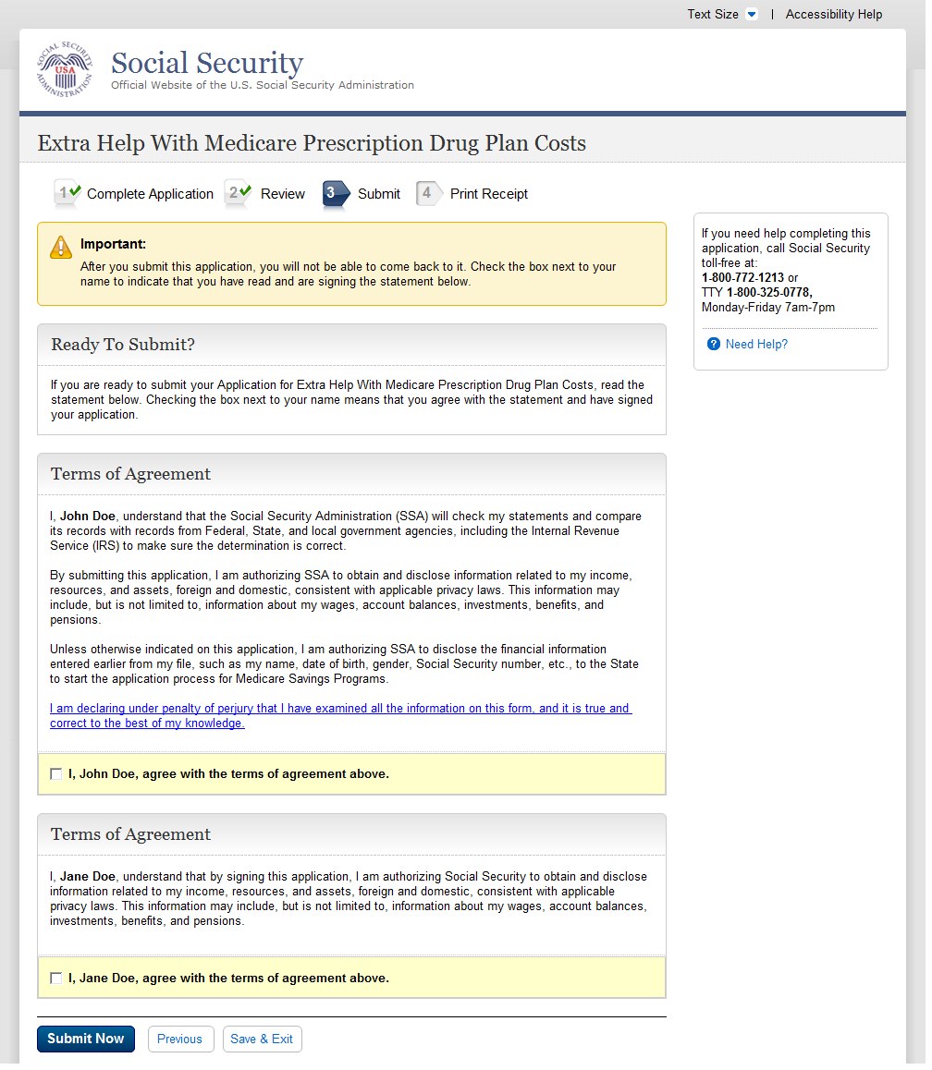

Ready to Submit

A.49.1. User Interface
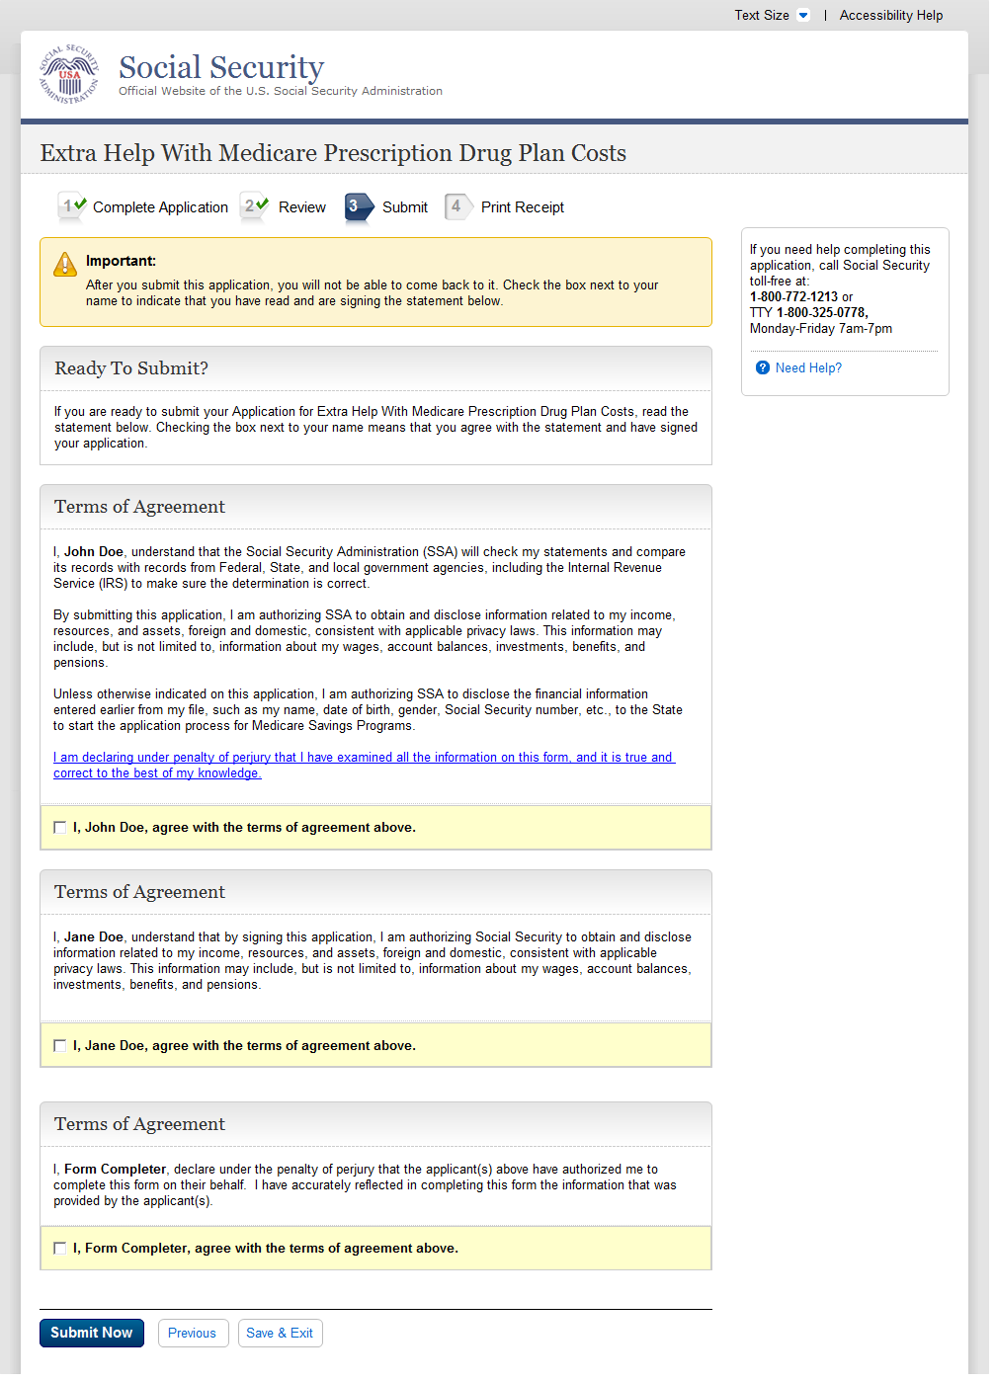

Successful Submission - Print Or Save Your Receipt

A.50.1. User Interface
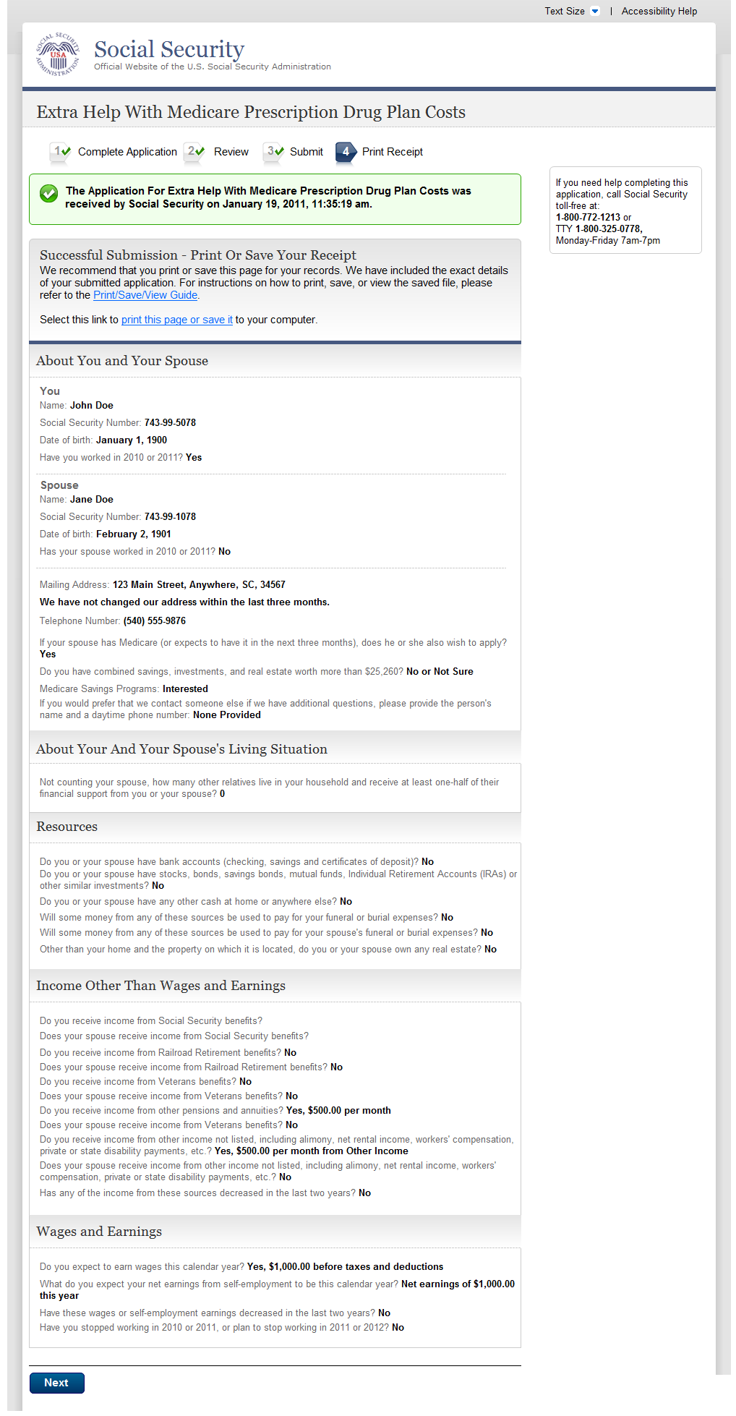
A.51. Unsuccessful Submission
A.51.1. User Interface
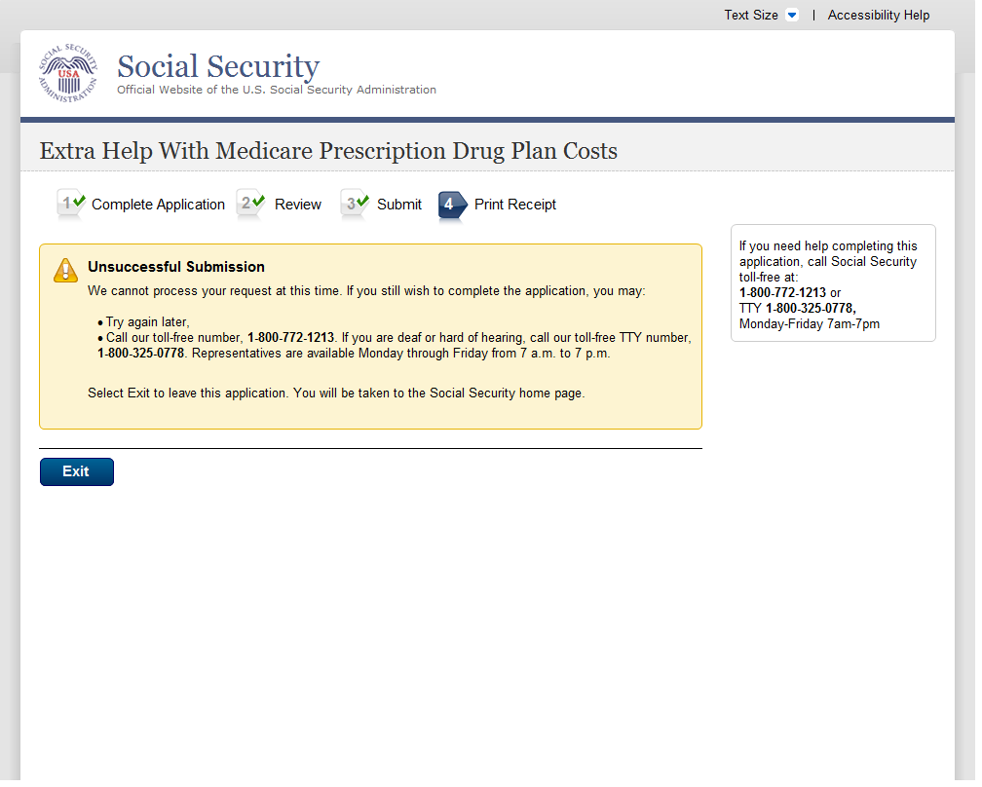

A.52. Next Steps
A.52.1. User Interface
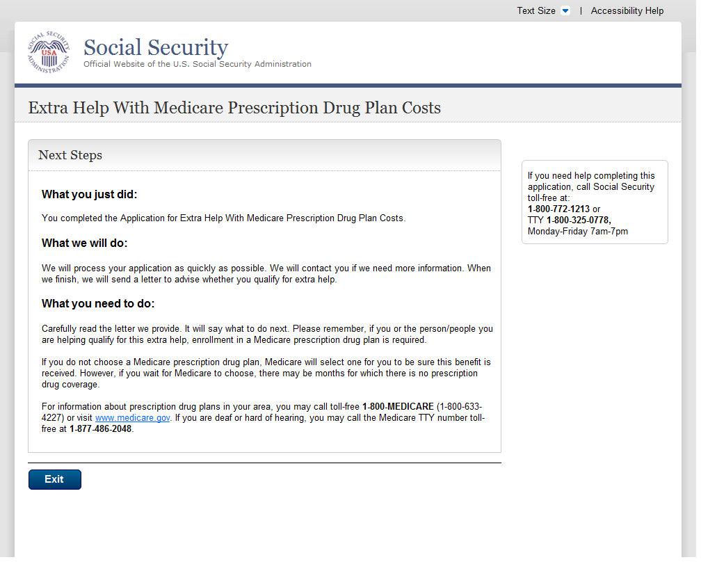
A.53. Missing Information (Fix Errors)
A.53.1. User Interface
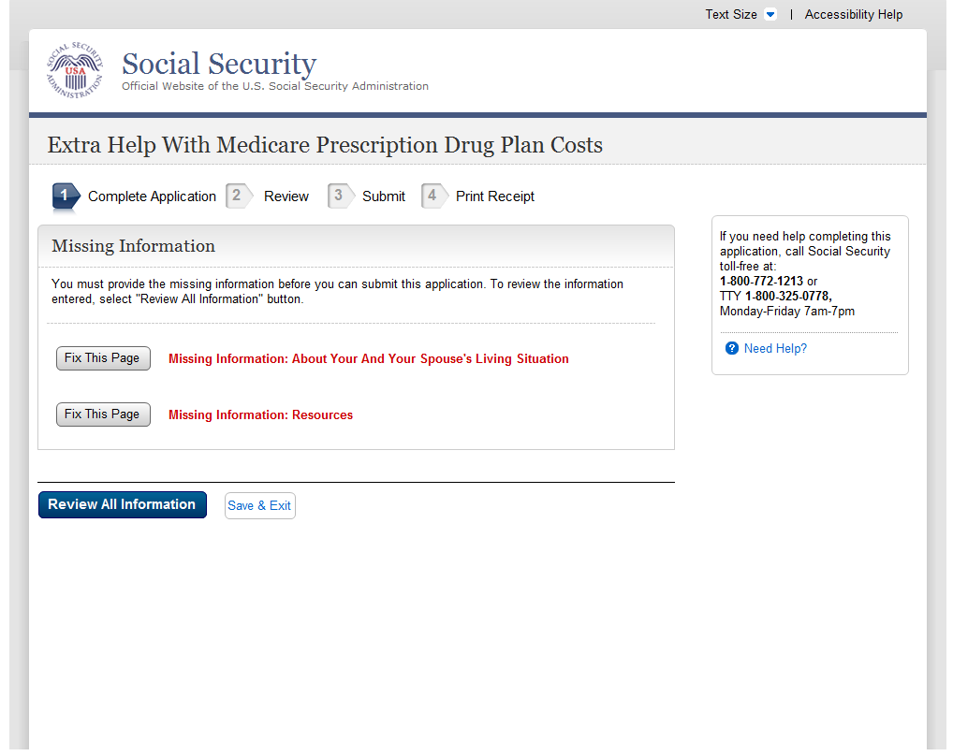
A.54. Successful Submission - Print Or Save Yoour Receipt (print)
A.54.1. User Interface
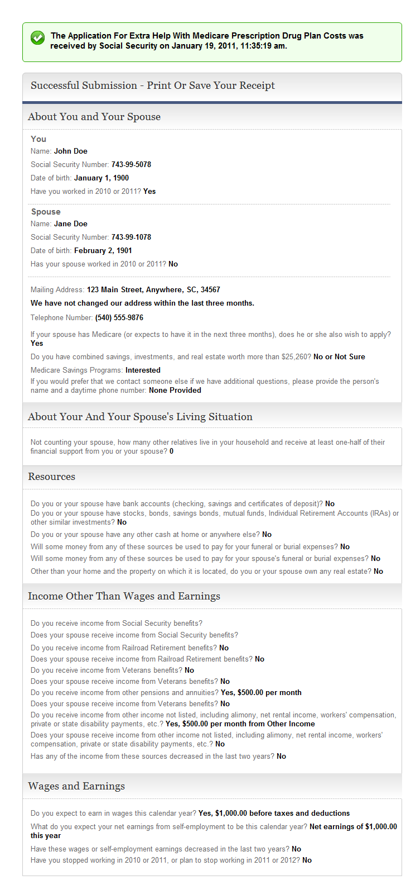

A.55. Unsuccessful Submission
A.55.1. User Interface
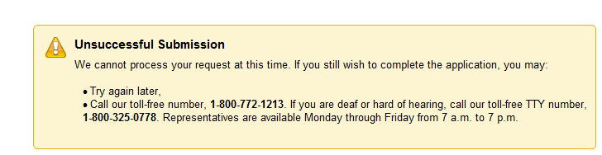

Message Pages
“Please Confirm” message pages have been removed as they are no longer required with the navigational changes.

Authentication - Medicare Part D Database Not Eligible Or SSI Recipient
A.56.1. User Interface
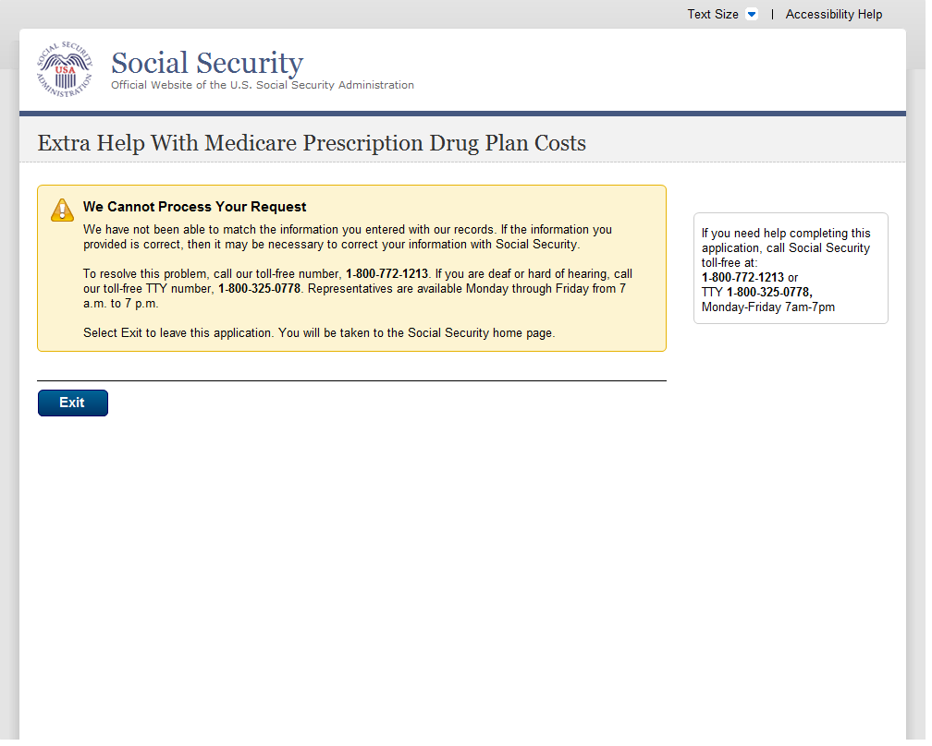
A.57. Check The Social Security Number You Entered
A.57.1. User Interface
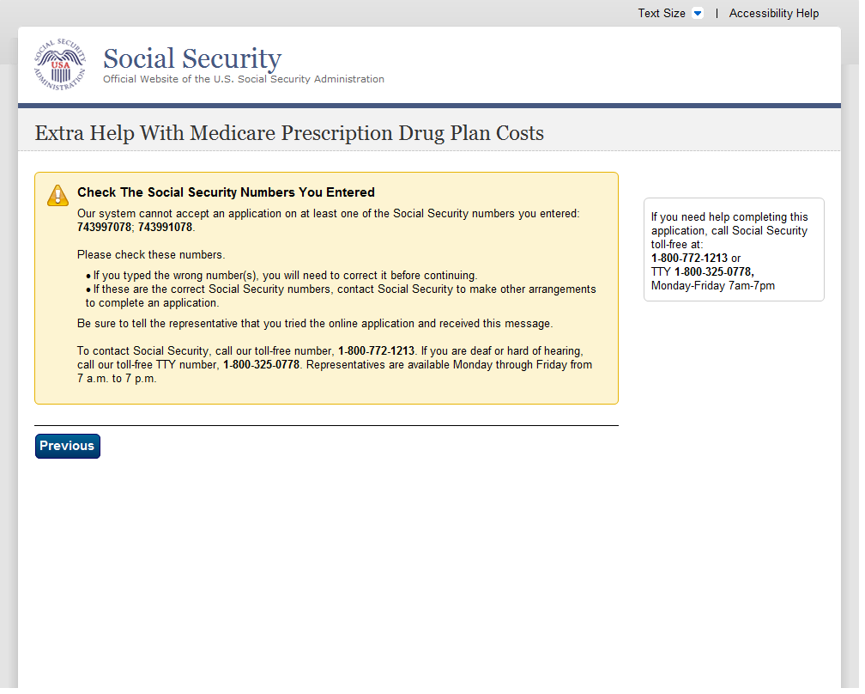
A.58. How The Online Application Works
A.58.1. User Interface
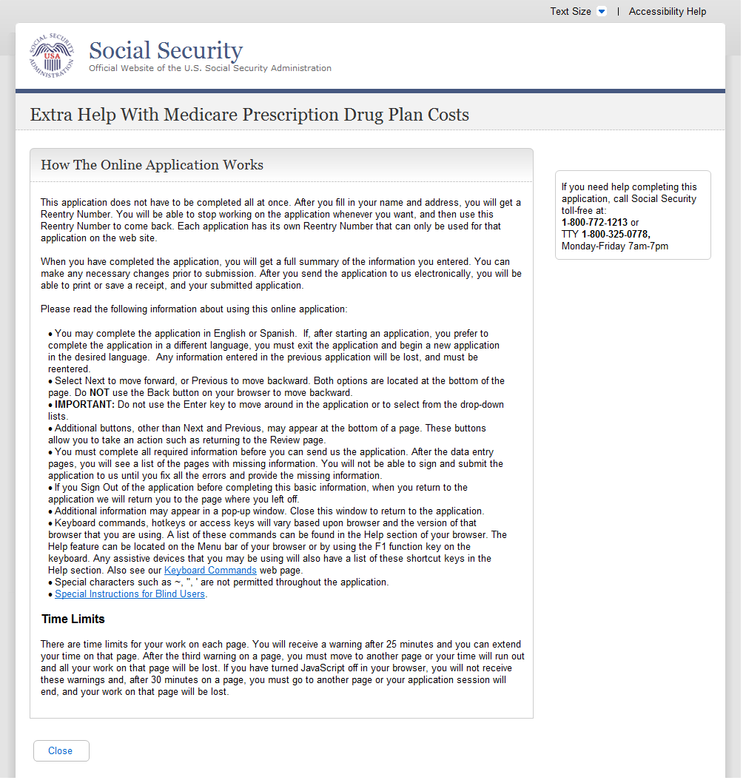

Privacy Act Statement
A.59.1. User Interface
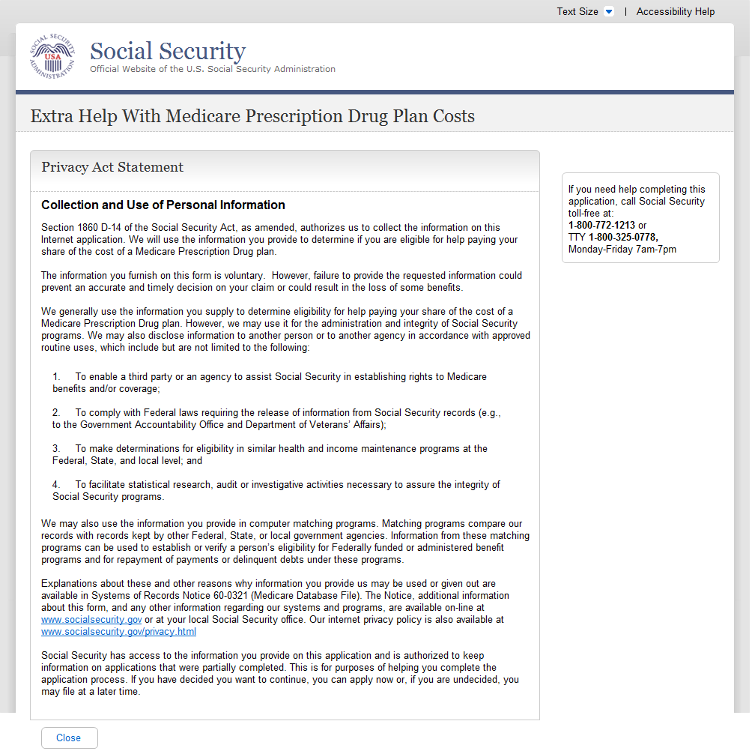
Internet Security Policy
A.61.1. User Interface
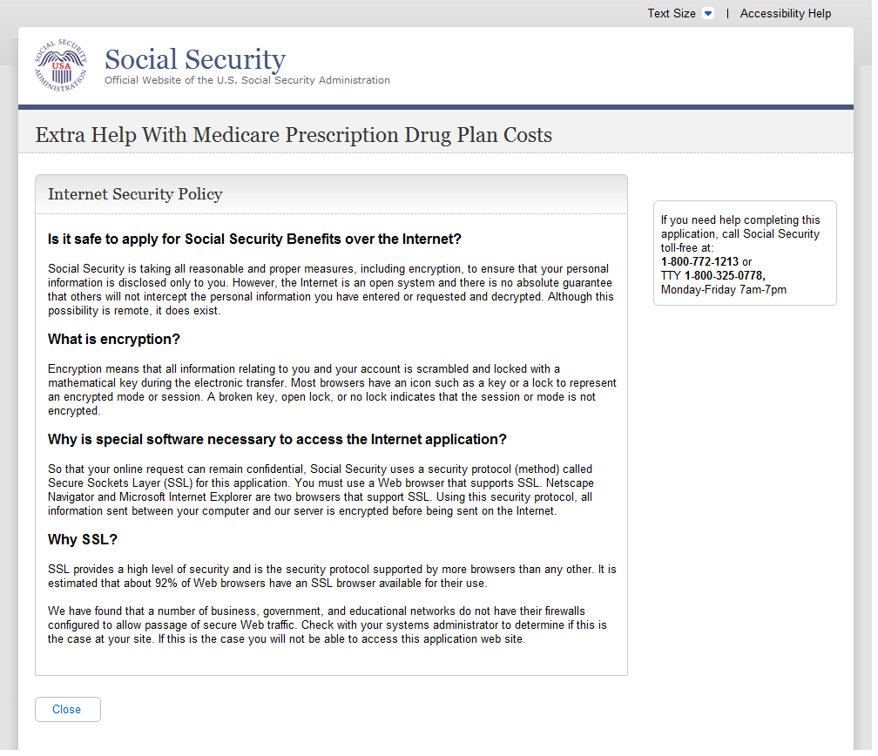

Limit Number Of Restarts
A.60.2. User Interface
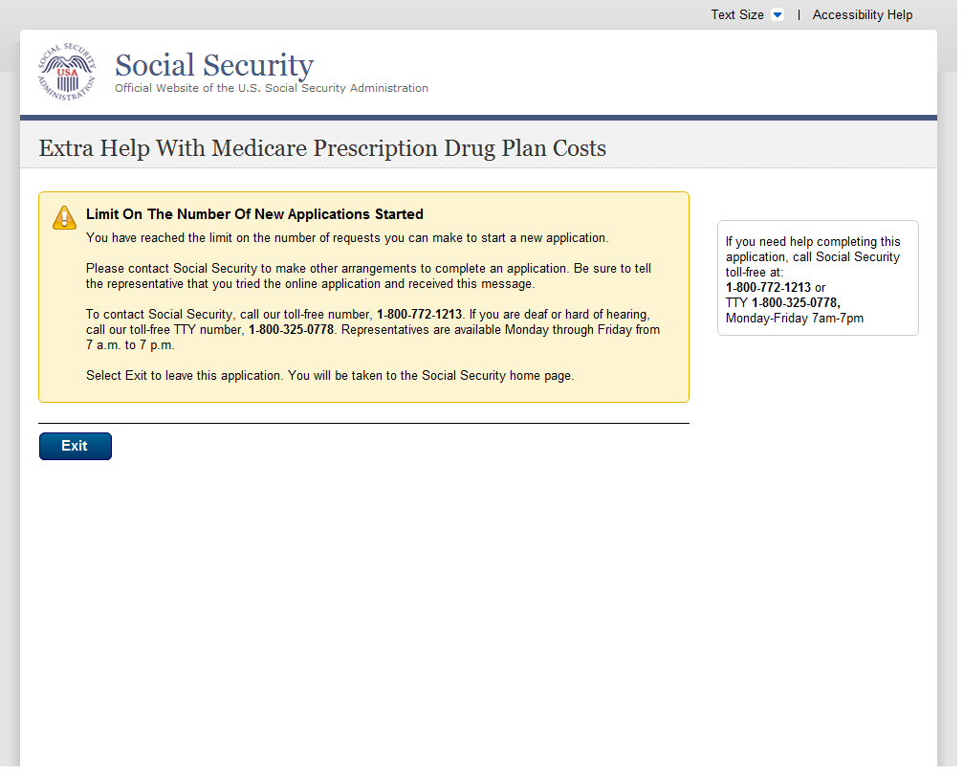
A.61. Limit Number Of Starts For A New Application
A.61.1. User Interface
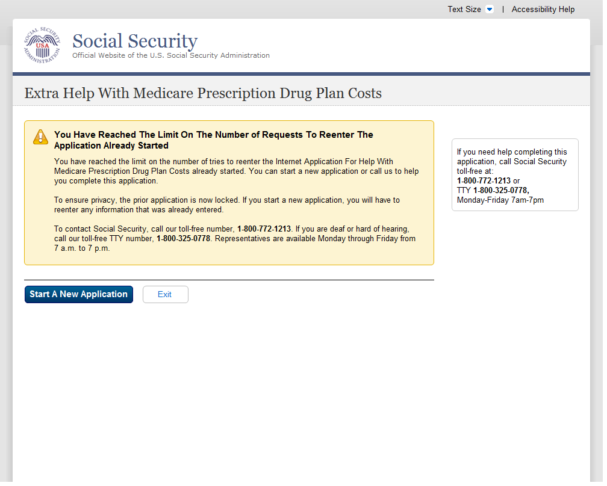
A.62. Limit On The Number Of Tries To Start An Application
A.62.1. User Interface
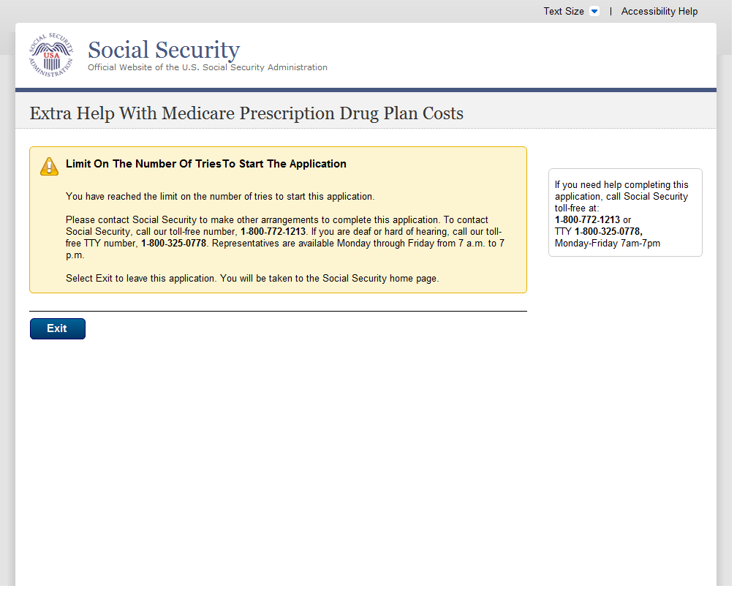
A.63. Name Check Mismatch
A.63.1. User Interface
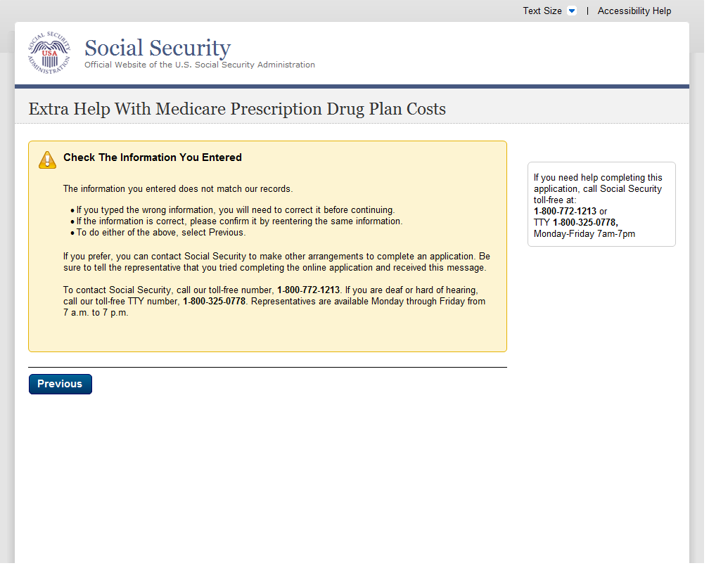
A.64. Not Eligible For The Prescription Drug Plan
A.64.1. User Interface
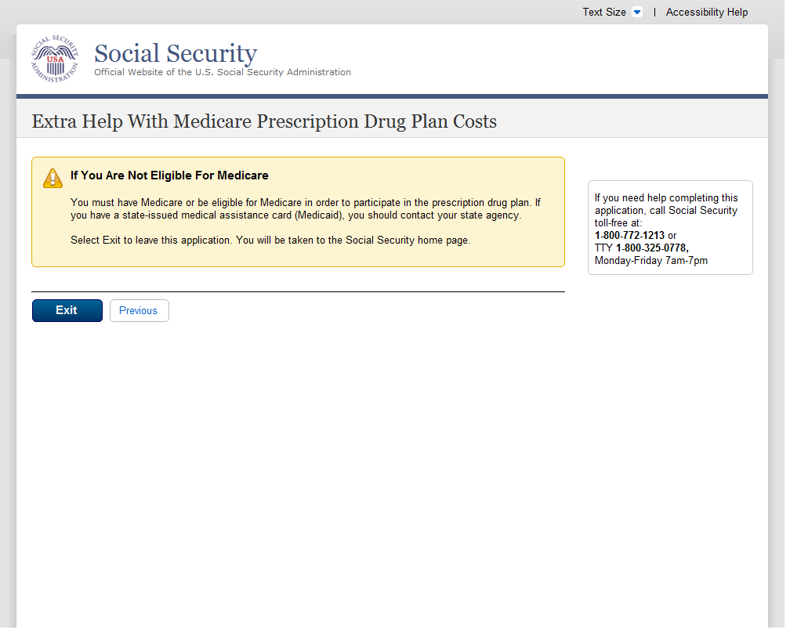
A.65. Off Hours Message
A.65.1. User Interface
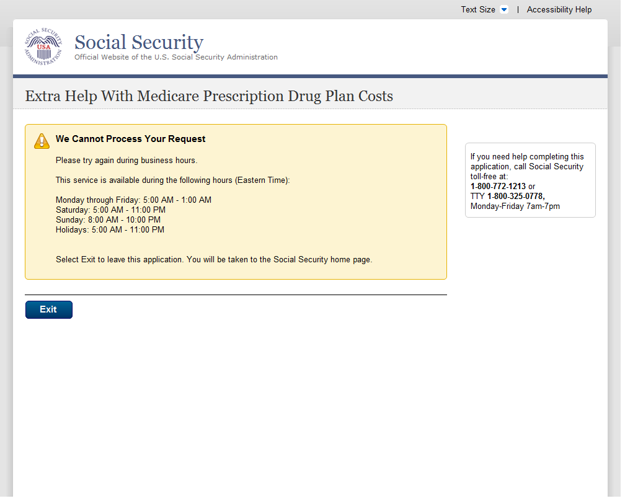
A.66. Other Ways To Apply
A.66.1. User Interface
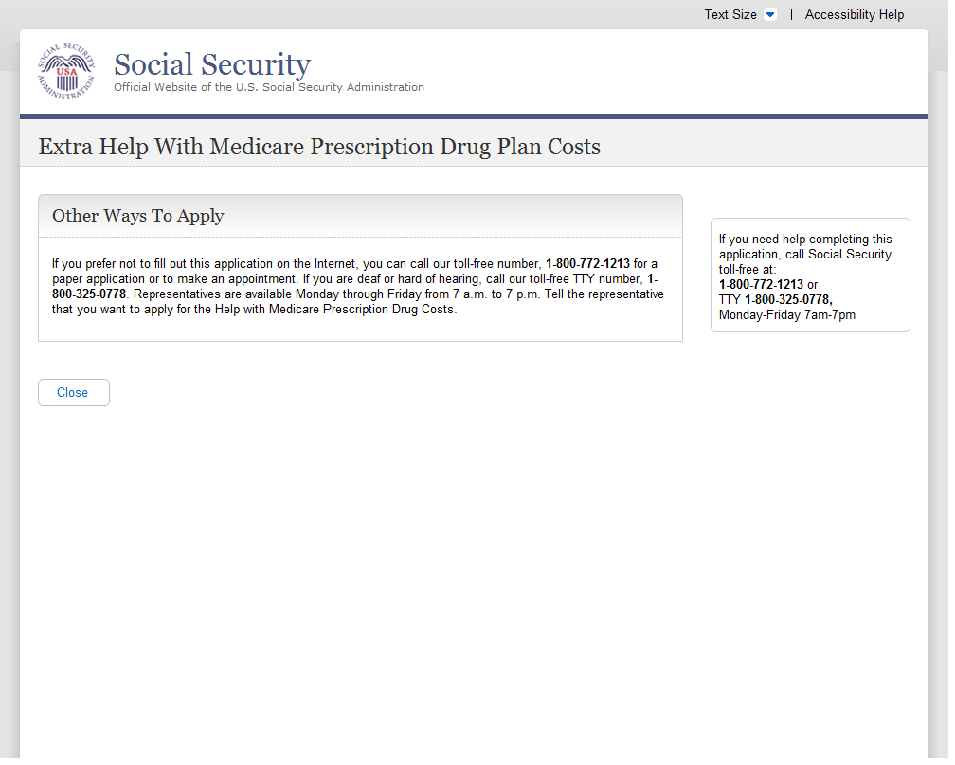
A.67. Paperwork Reduction Act Statement
A.67.1. User Interface
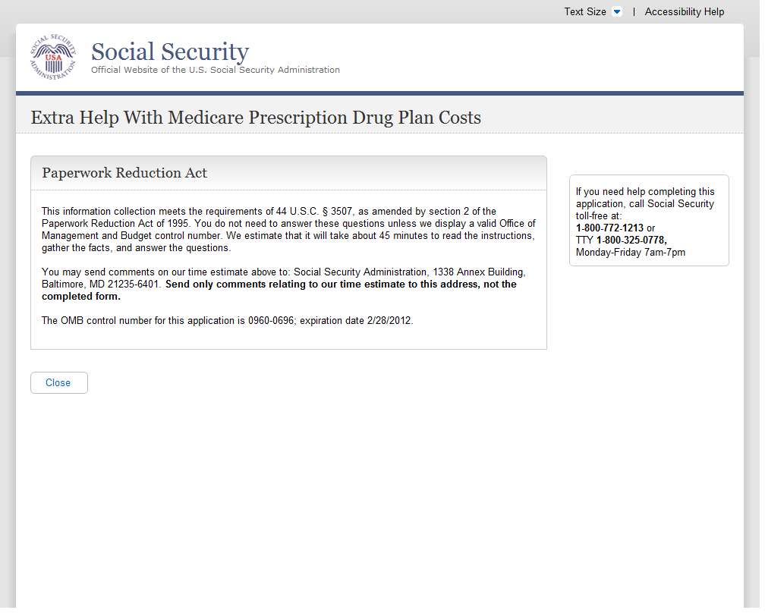
A.68. Print/Save/View Guide
A.68.1. User Interface
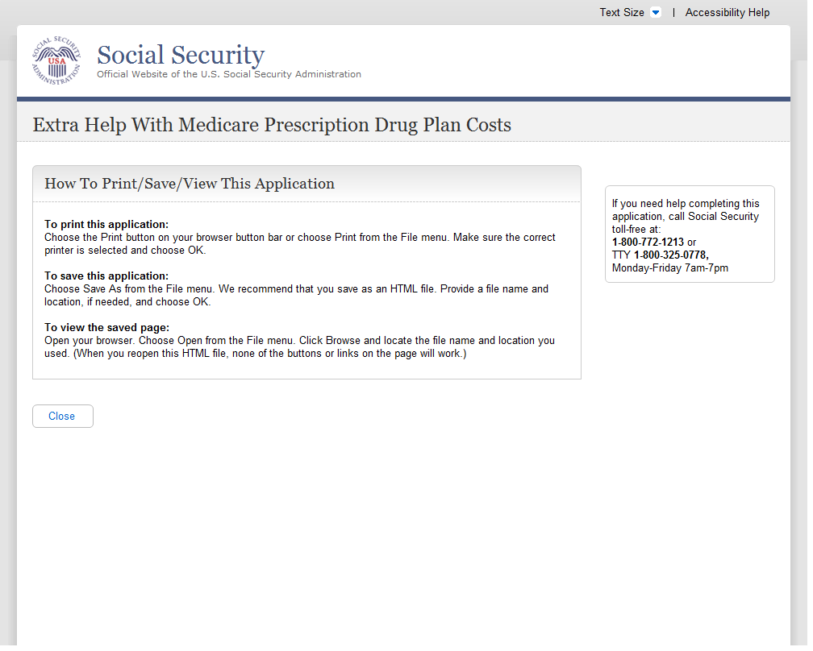
A.69. Processing Alert
A.69.1. User Interface
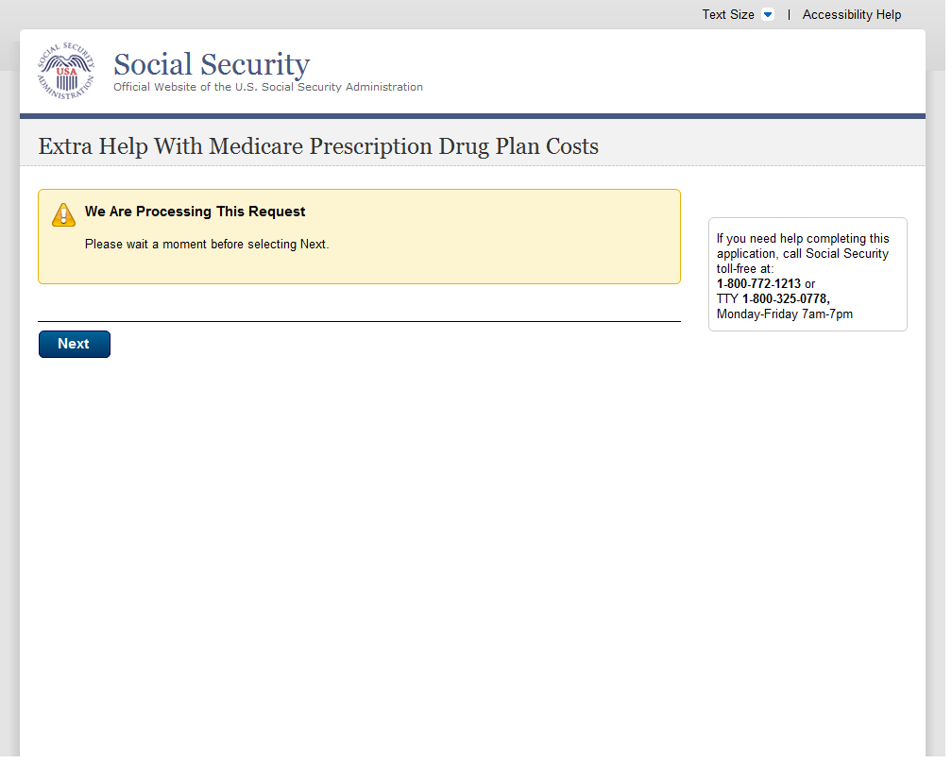

Sign-In Problem

A.70.1. User Interface
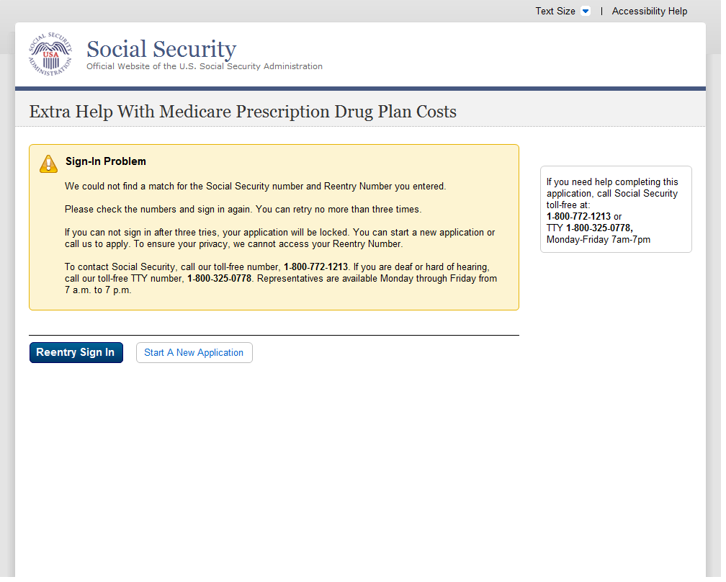
A.71. Special Instructions For Blind Users
A.71.1. User Interface
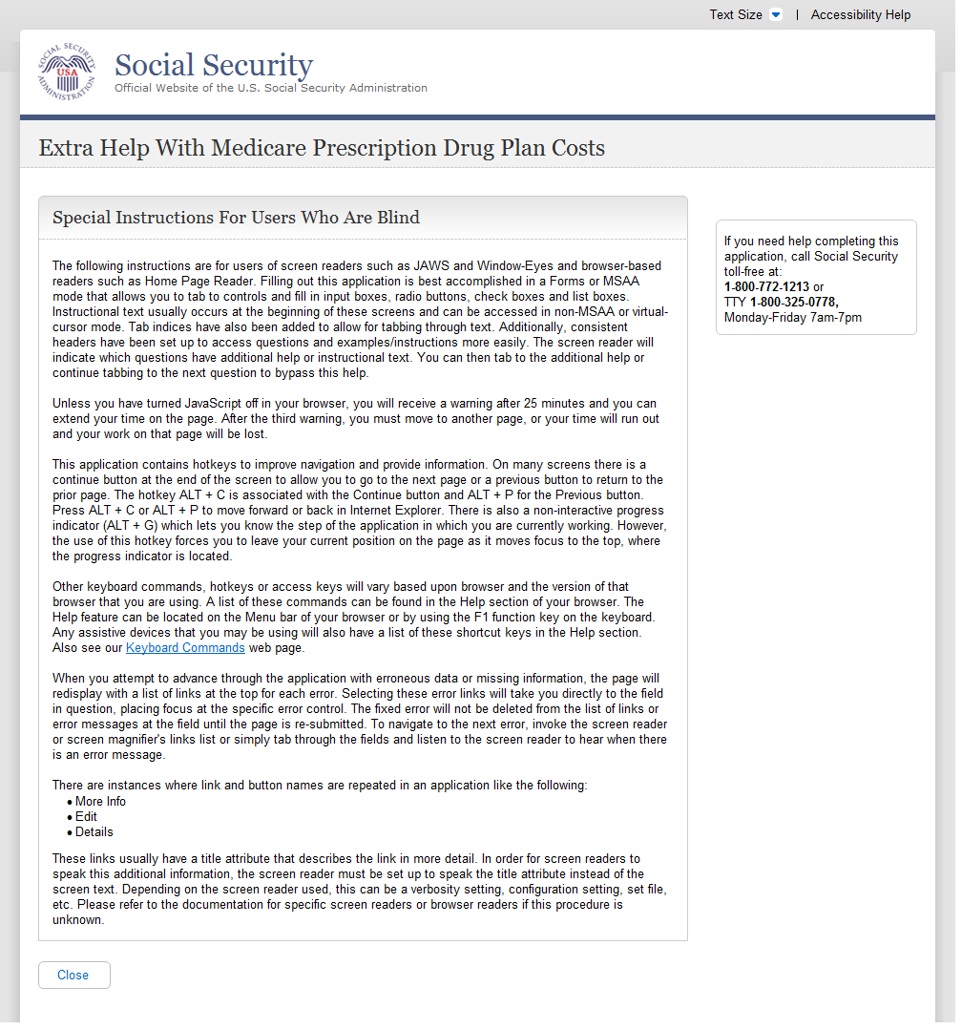
A.72. System Failure
A.72.1. User Interface
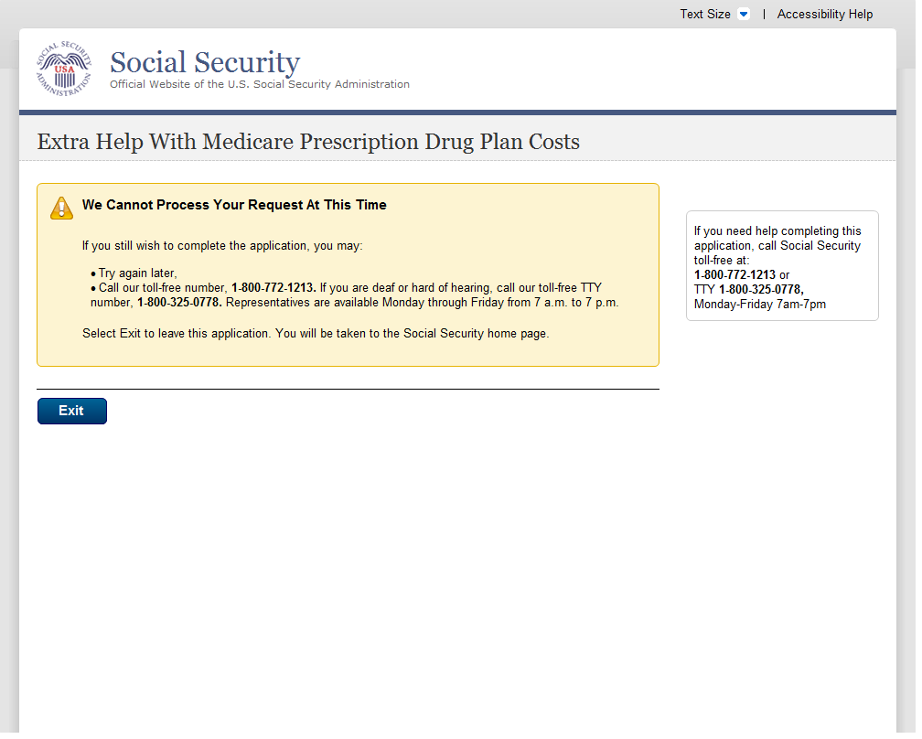
A.73. There Is A Pending Application For This Social Security Number
A.73.1. User Interface
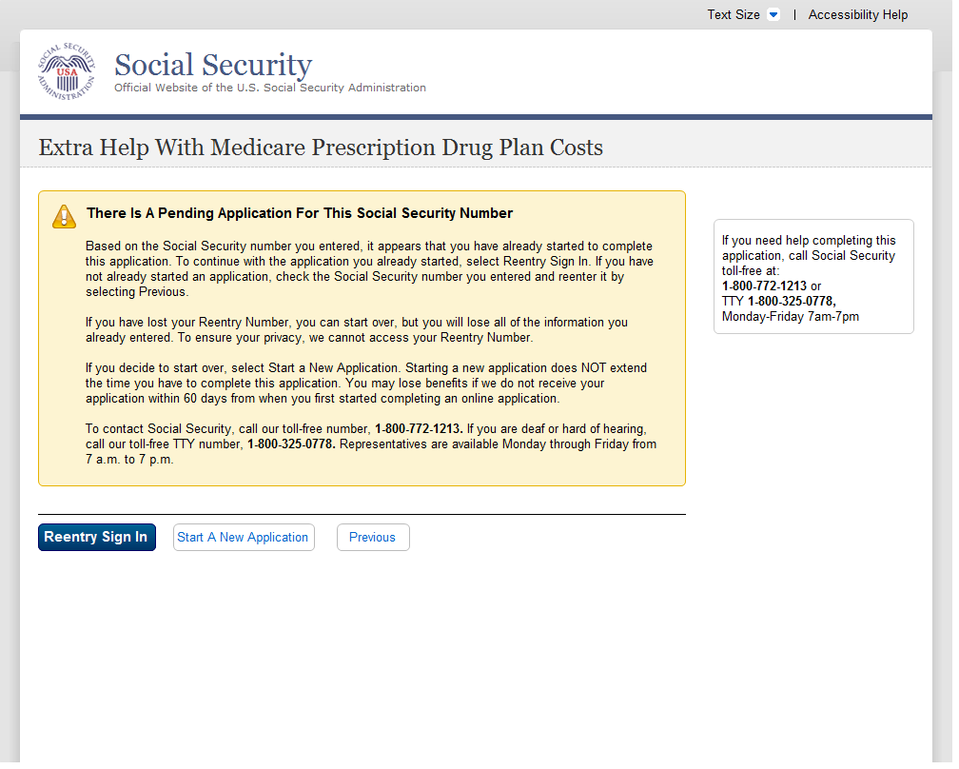
A.74. Warning System Shutdown
A.74.1. User Interface
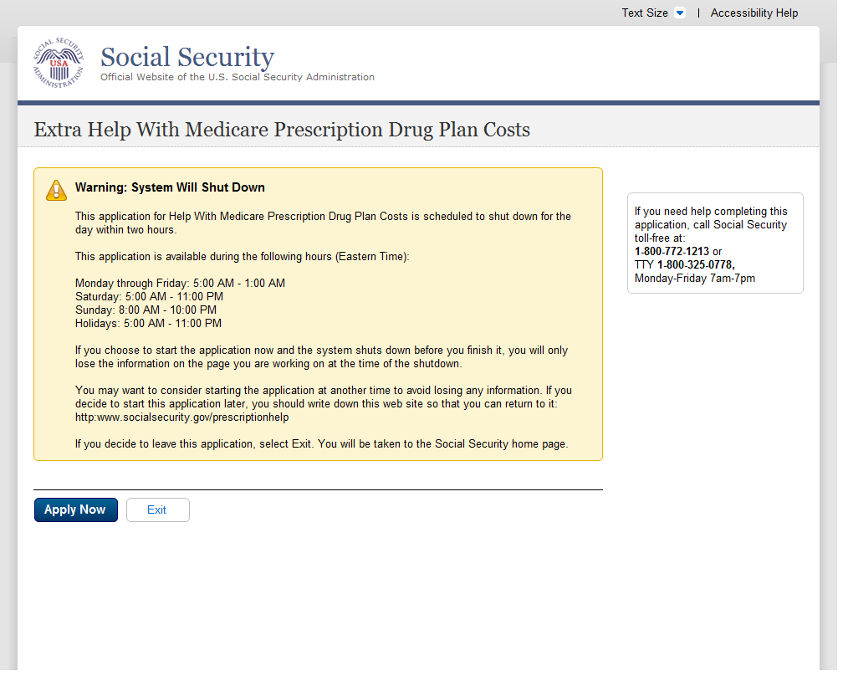
A.75. We Cannot Process Your Request
A.75.1. User Interface
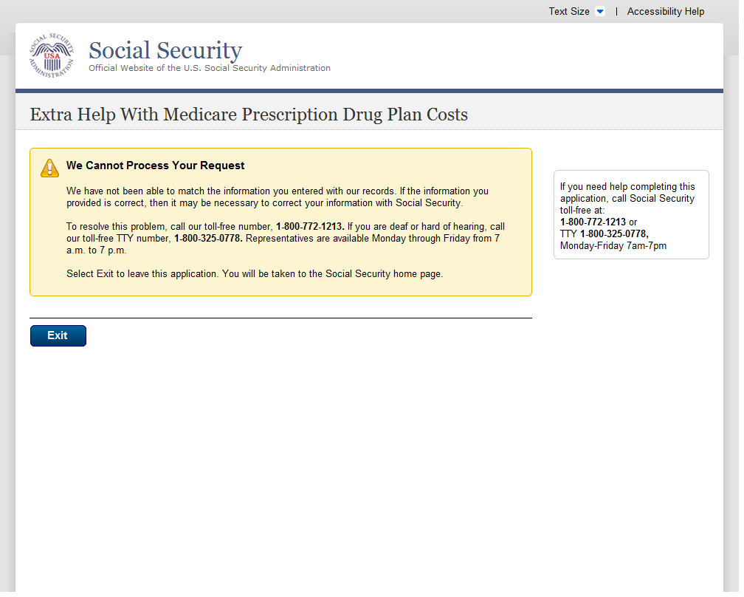
A.76. What You Will Need
A.76.1. User Interface
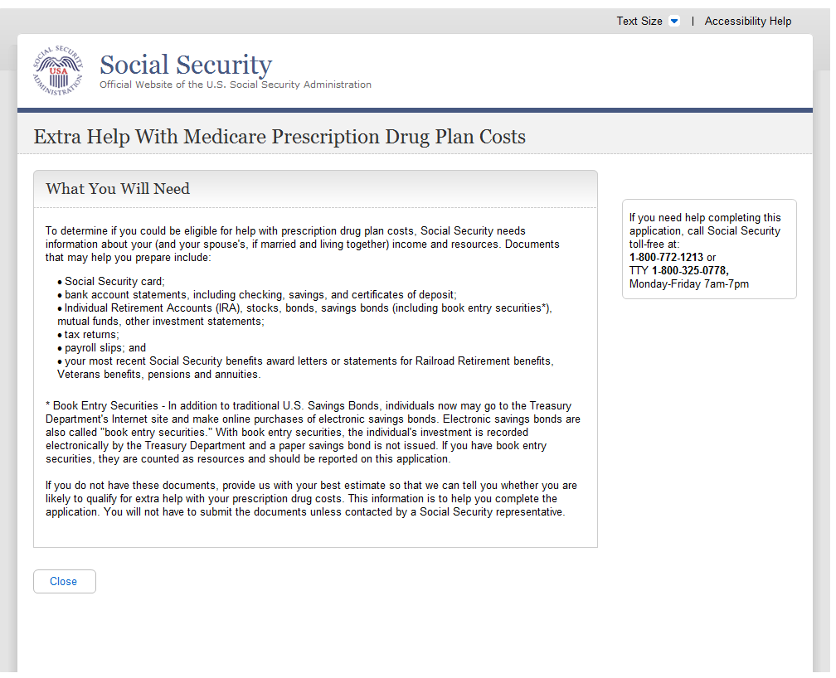
A.77. You Do Not Live In One Of The 50 States Or DC
A.77.1. User Interface
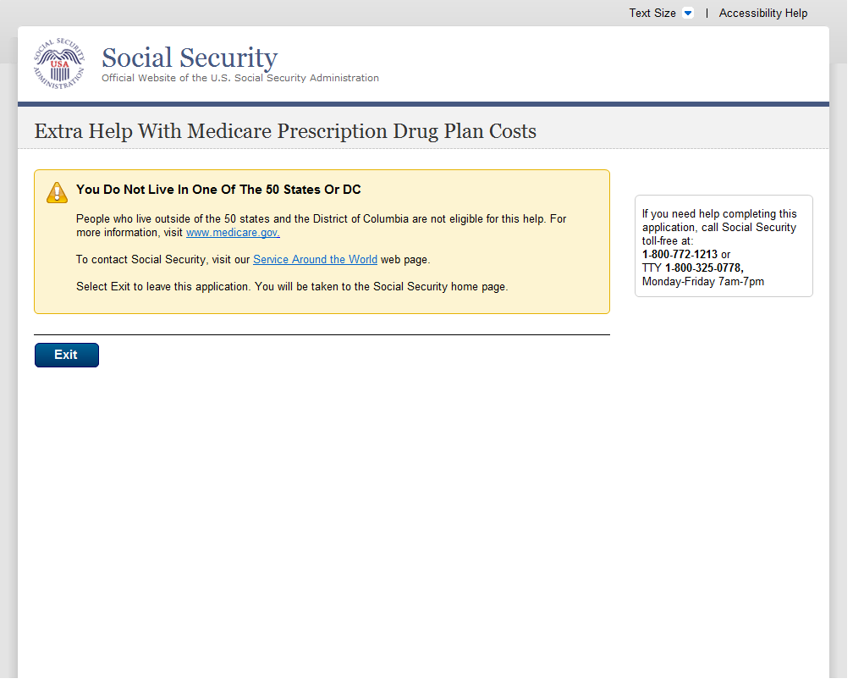
A.78. You Have Already Sent Us An Application
A.78.1 User Interface
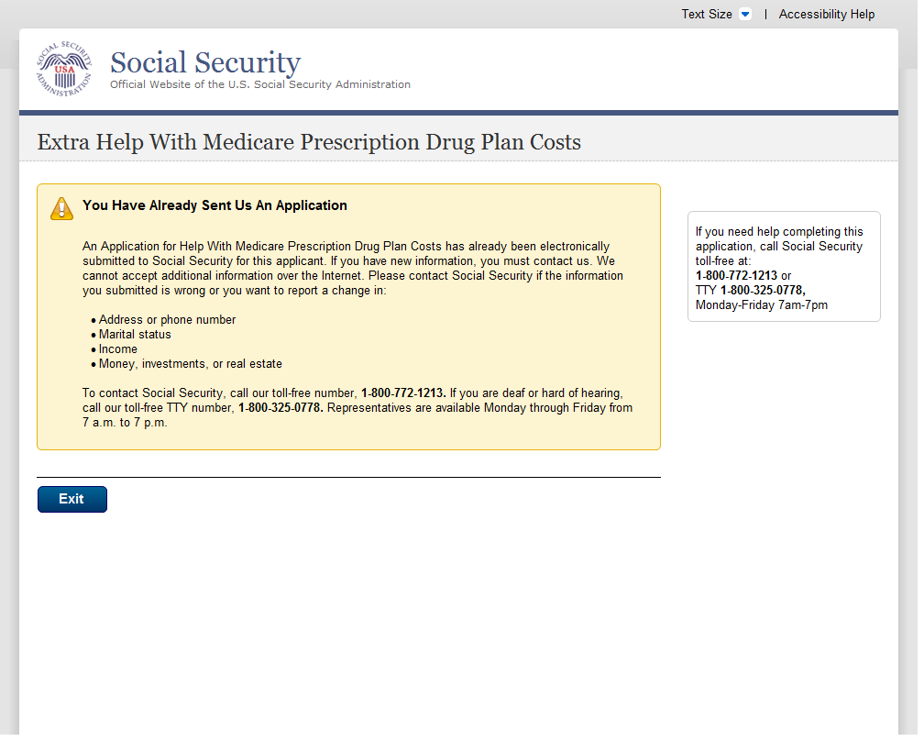
A.79. Your Session Has Expired
A.79.1. User Interface
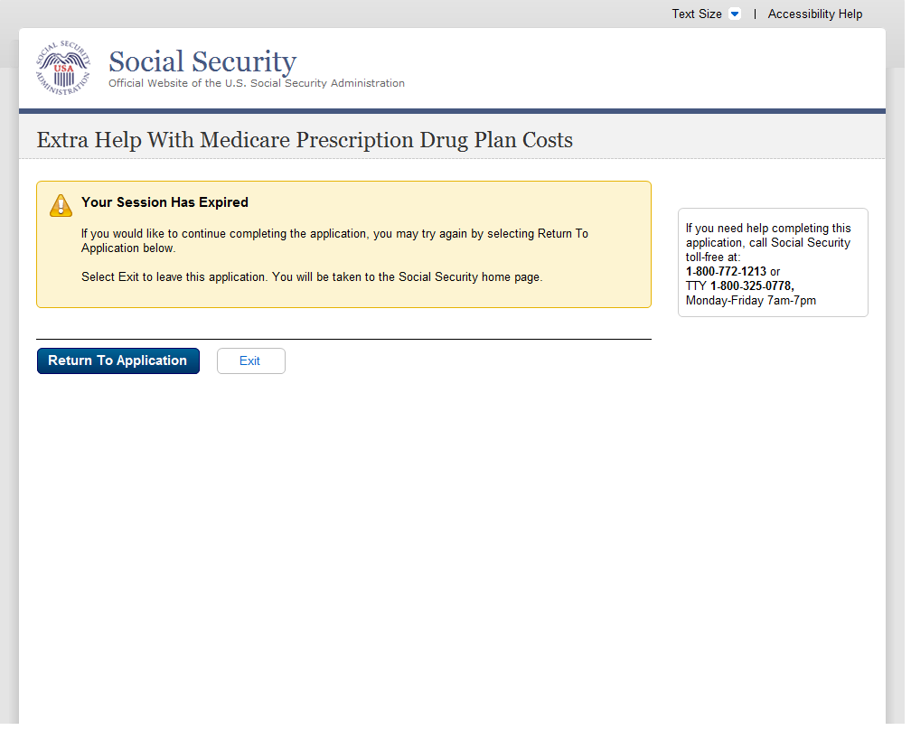
A.80. Help Pages
A.81. Main Help Pages
A.81.1. User Interface
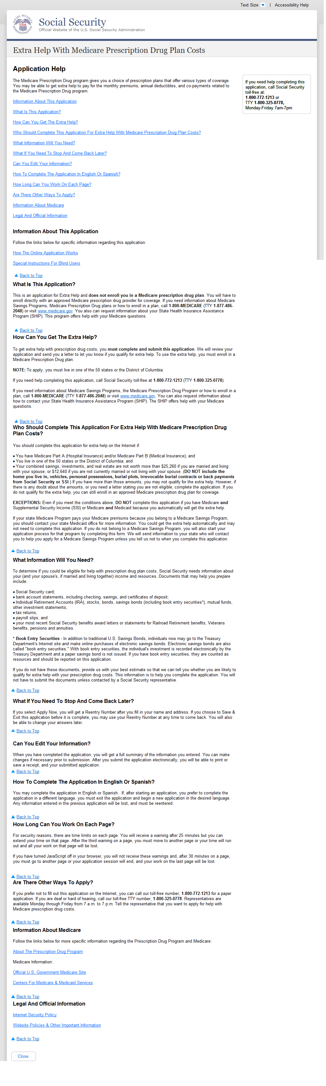

A
Help: Are you assisting someone (other than your spouse who lives with you) with this application?

A.82.1. User Interface

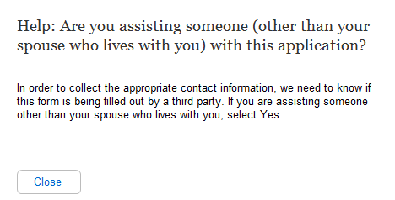
A.83. Help: Did you (or your spouse, if married and living together) get an application in the mail from us?
A.83.1. User Interface
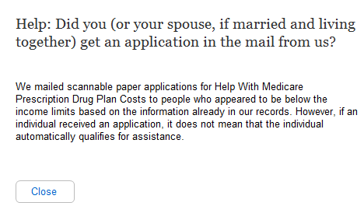
A.84. Help: Do you (or your spouse, if married and living together) have Medicare?
A.84.1. User Interface
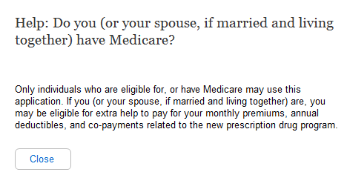
A.85. Help: Are you (or your spouse, if married and living together) 64 years and 9 months old or older?
A.85.1. User Interface
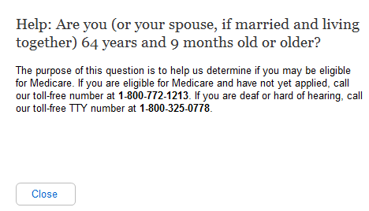
A.86. Help: Have you (or your spouse, if married and living together) received:
A.86.1. User Interface
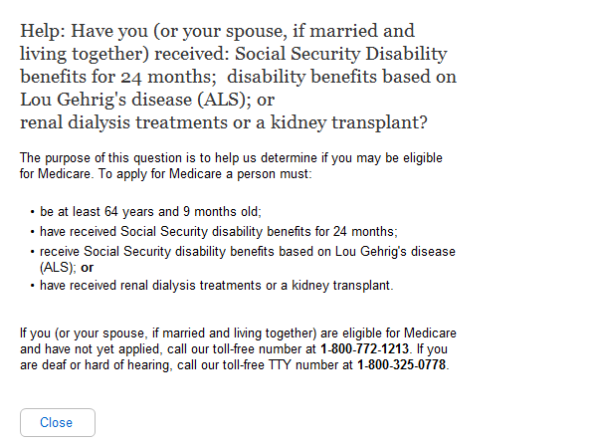

Help: In which state do you (or your spouse, if married and living together) live?

A.87.1. User Interface
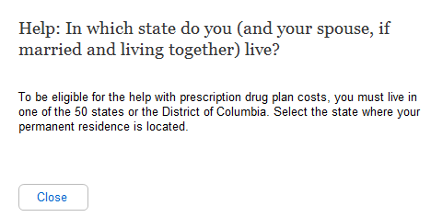
A.88. Help: What is your marital status?
A.88.1. User Interface
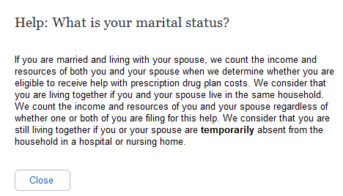
A.89. Help: Do you have combined savings, investments, and real estate worth more than:
A.89.1. User Interface
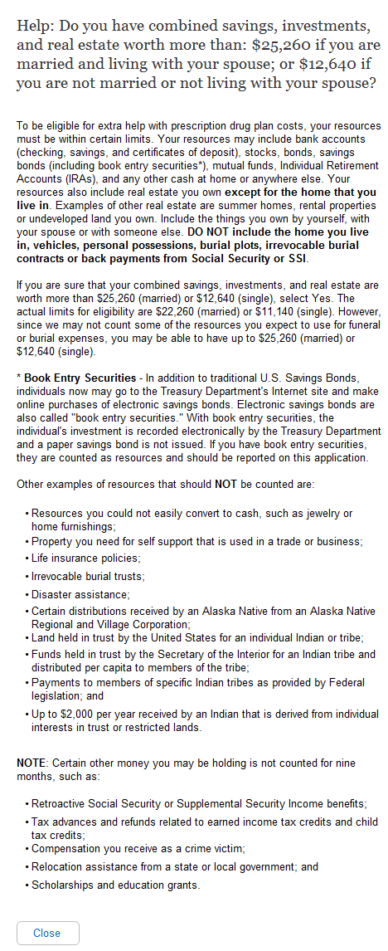
A.90. Help: Have you worked in 2010 or 2011?
A.90.1. User Interface
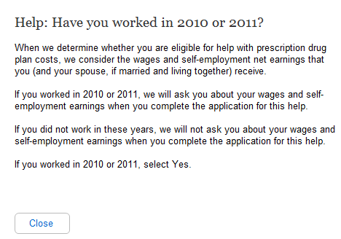

Help: Has your spouse worked in 2010 or 2011?
- We updated the years “2010 or 2011” to “2011 or 2012.”

A.91.1. User Interface
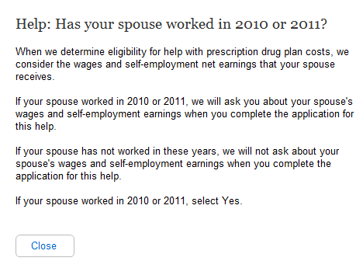
Help: Have you worked this calendar year?
- We updated the years “2010 or 2011” to “2011 or 2012.”

A.92.1. User Interface
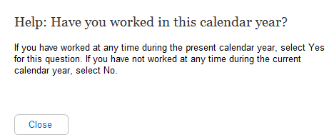
A.93. Help: Has your spouse worked this calendar year?
A.93.1. User Interface
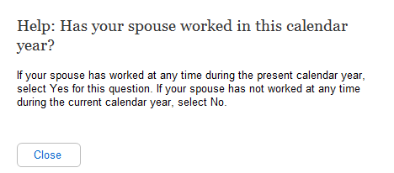
A.94. Help: Are you UNDER age 65?
A.94.1. User Interface
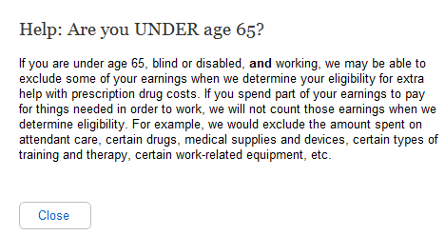
A.95. Help: Is your spouse UNDER age 65?
A.95.1. User Interface
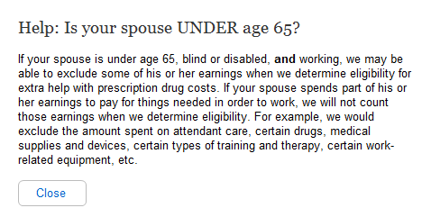
A.96. Help: Not counting your spouse, how many other relatives live in your household?
A.96.1. User Interface
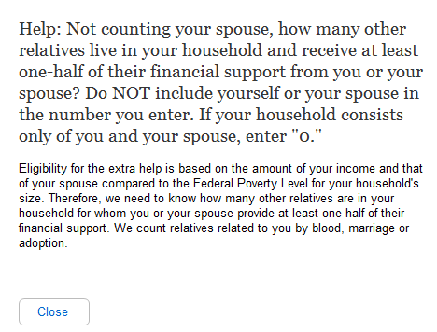
A.97. Help: How many relatives live in your household and receive at least one-half of their financial support from you?
A.97.1. User Interface
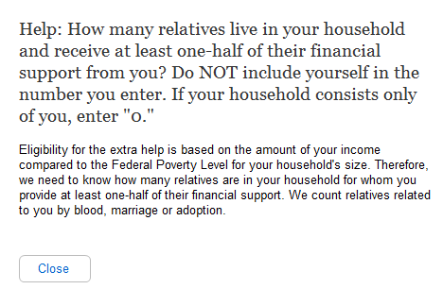
A.98. Help: Do you have to pay for things related to a disability or blindness that enable you to work?
A.98.1. User Interface

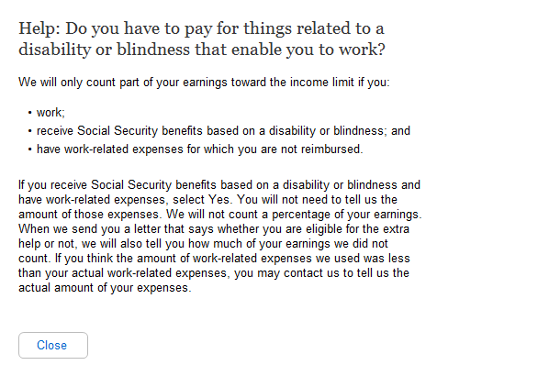
Help: Does your spouse have to pay for things that enable him or her to work?

A.99.1. User Interface
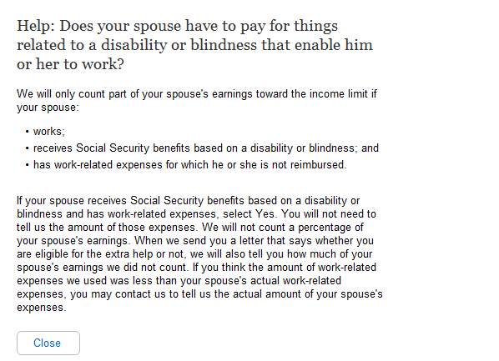

A.100. Help: Do you expect to earn wages this calendar year?
A.100.1. User Interface
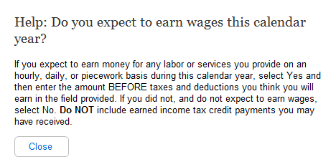

A.101. Help: Does your spouse expect to earn wages this calendar year?
A.101.1. User Interface
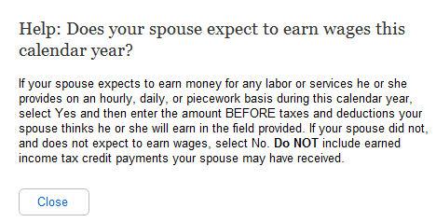
Help: What do you expect your net earnings from self-employment to be this calendar year?

A.102.1. User Interface

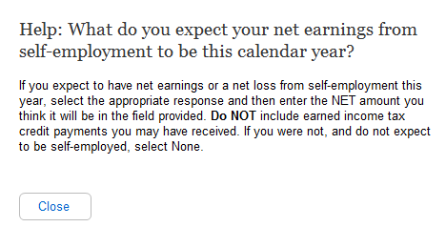

Help: What does your spouse expect the net earnings from self-employment to be this calendar year?

A.103.1. User Interface
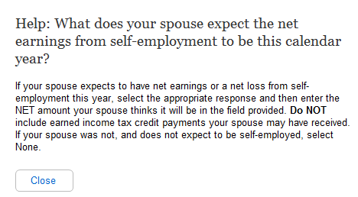
Help: Have you stopped working in 2010 or 2011, or plan to stop working in 2011 or 2012?

A.104.1. User Interface
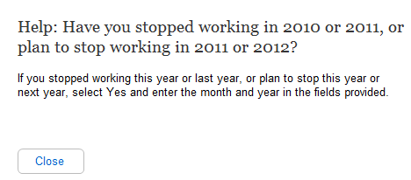

- We updated the years “2010 or 2011” to “2011 or 2012.”
- We updated the years “2011 or 2012” to “2012 or 2013.”

Help: Has you your spouse stopped working in 2010 or 2011, or plan to stop working in 2011 or 2012?
A.104.2. User Interface
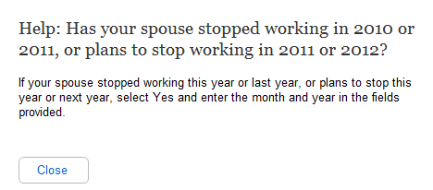
Help: Do you receive Social Security benefits?
- We updated the years “2010 or 2011” to “2011 or 2012.”
- We updated the years “2011 or 2012” to “2012 or 2013.”

105.1. User Interface

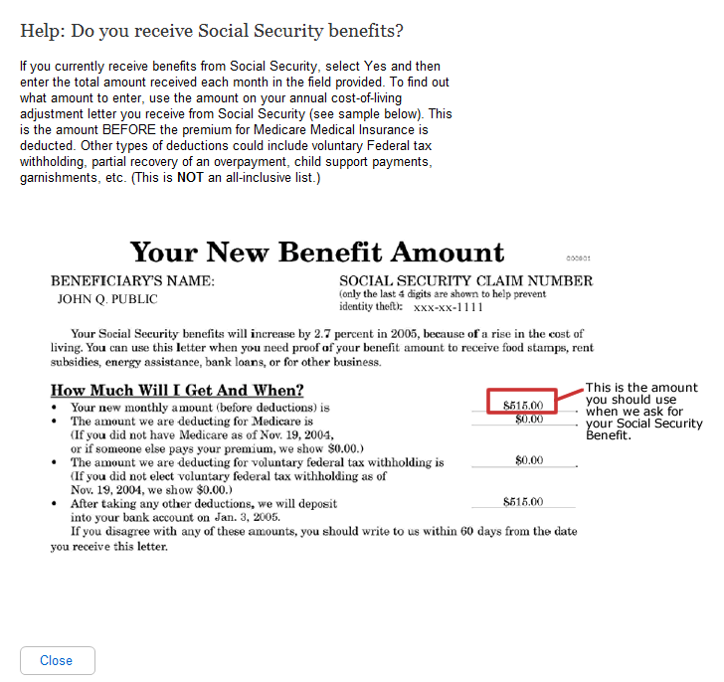

Help: Does your spouse receive Social Security benefits?

A106.1. User Interface
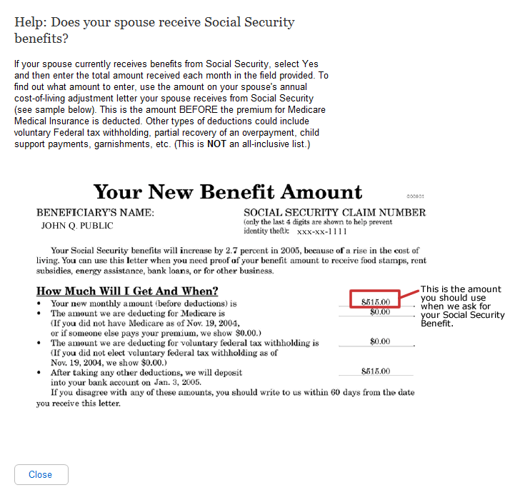
Help: Do you receive Railroad Retirement benefits?

A.407.1. User Interface

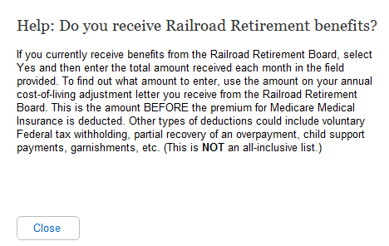

Help: Does your spouse receive Railroad Retirement benefits?

A.108.1. User Interface
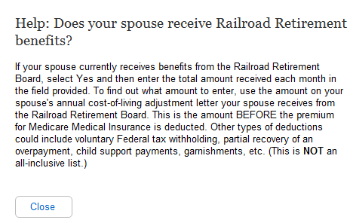
Help: Do you receive Veterans benefits?

A.109.1. User Interface
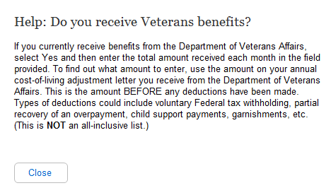

A110. Help: Does your spouse receive Veterans benefits?
A.110.1. User Interface
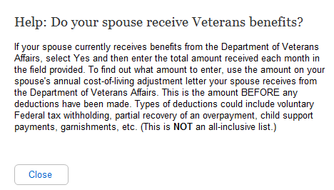
Help: Do you receive income from other pensions or annuities?

A.111.1. User Interface

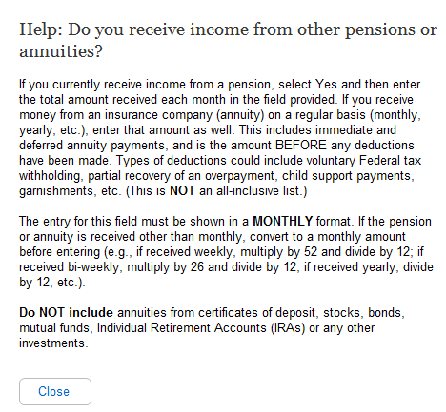

Help: Does your spouse receive income from other pensions or annuities?

A.112.1. User Interface
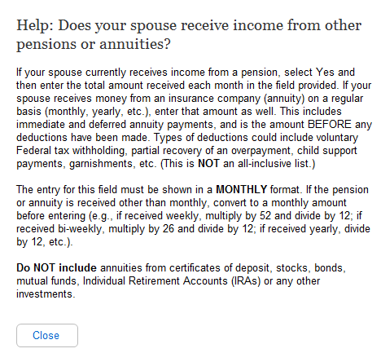
Help: Do you receive other income not listed above, including alimony, net rental income, workers' compensation, etc.?

A.113.1. User Interface
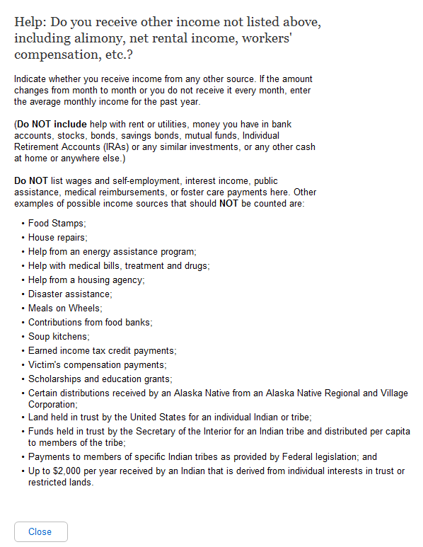

- We changed the “Other Income” question from:

“Other income not listed above, including alimony, net rental income, worker’s compensation, private or state disability payments, etc. (Specify):_____
to:
“Other income not listed above, including alimony, net rental income, worker’s compensation, unemployment, private or State disability payments, etc. (Specify):_____

A.114. Help: Does your spouse receive other income not listed above, including alimony, net rental income, workers' compensation, etc.?
A.114.1. User Interface
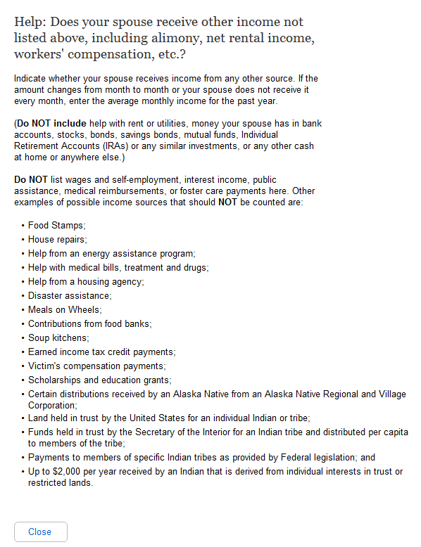
Help: Your Name
- We changed the “Other Income” question from:

“Other income not listed above, including alimony, net rental income, worker’s compensation, private or state disability payments, etc. (Specify):_____
to:
“Other income not listed above, including alimony, net rental income, worker’s compensation, unemployment, private or State disability payments, etc. (Specify):_____

A.115.1. User Interface
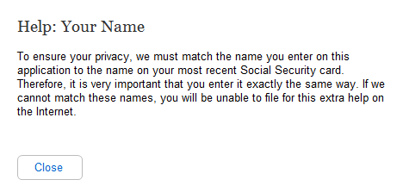
A.116. Help: Your Social Security Number
A.116.1. User Interface
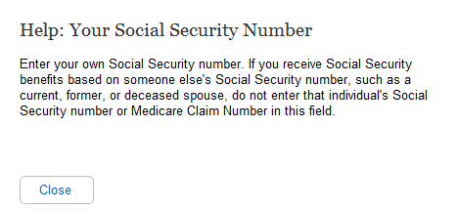
A.117. Help: What is your date of birth?
A.117.1. User Interface
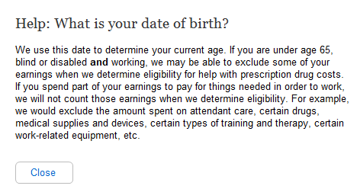
A.118. Help: Spouse's Name
A.118.1. User Interface
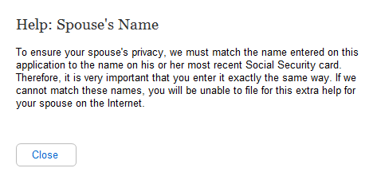
A.119. Help: Spouse's Social Security Number
A.119.1. User Interface
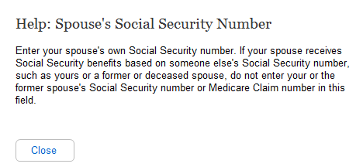
A.120. Help: What is your spouse's date of birth?
A.120.1. User Interface
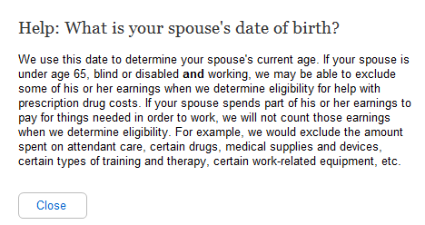
A.121. Help: Your Mailing Address
A.121.1. User Interface
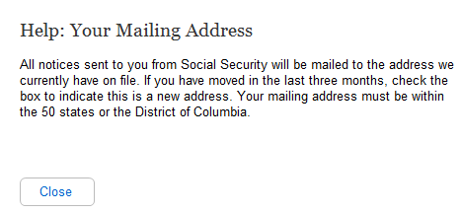
A.122. Help: Your Phone Number
A.112.1. User Interface
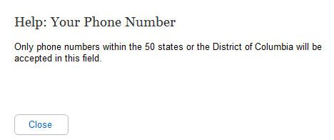
A.123. Help: If your spouse has Medicare (or expects to have it in the next three months), does he or she also wish to apply?
A.123.1. User Interface
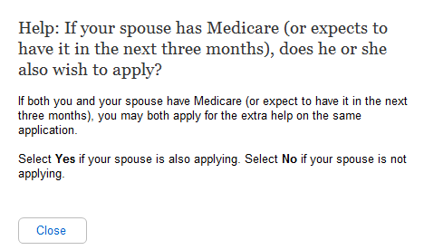
A.124. Help: Do you have combined savings, investments, and real estate worth more than $25,260?
A.124.1. User Interface
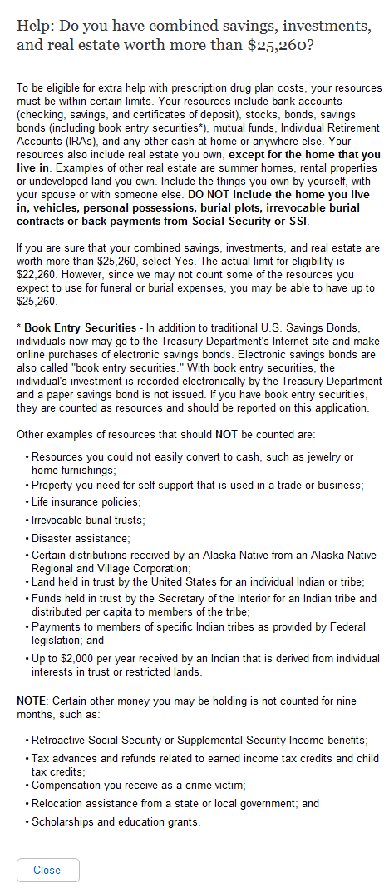
A.125. Help: OPTIONAL: (contact person)
A.125.1. User Interface
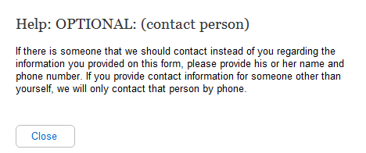
A.126. Help: Contact's Phone Number
A.126.1. User Interface
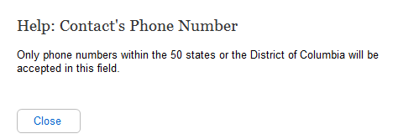
A.127. Help: Do you have combined savings, investments, and real estate worth more than $12,640?
A.127.1. User Interface
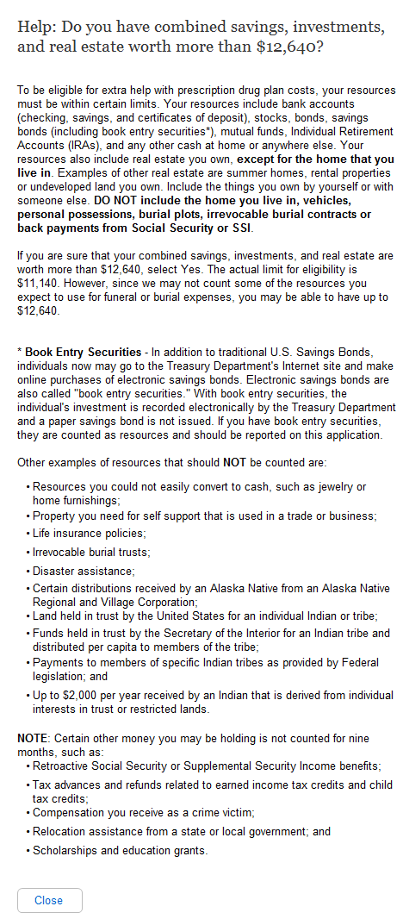
A.128. Help: Relationship to Applicant
A.128.1. User Interface
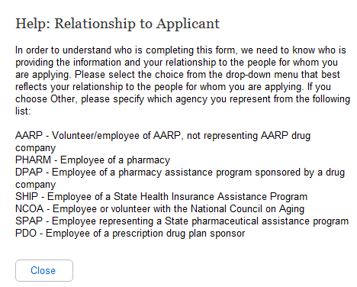
A.129. Help: Form Completer's Phone Number
A.129.1. User Interface
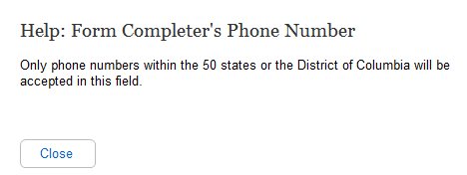
A.130. Help: Form Completer's Address
A.130.1. User Interface
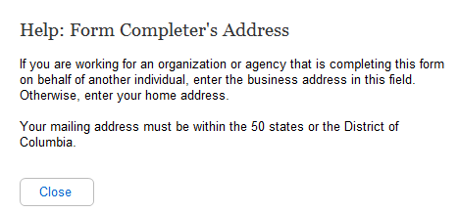
A.131. Help: Primary Applicant's Name
A.131.1. User Interface
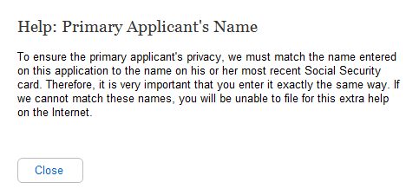
A.132. Help: Primary Applicant's Social Security Number
A.132.1. User Interface
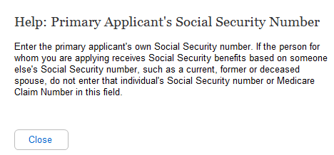
A.133. Help: What is the primary applicant's date of birth?
A.133.1. User Interface
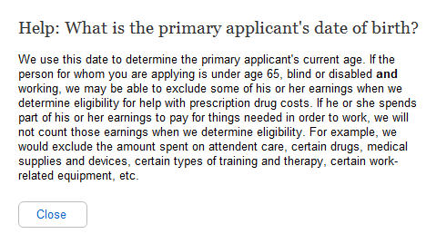
A.134. Help: Has the primary applicant worked in 2010 or 2011?
A.134.1. User Interface
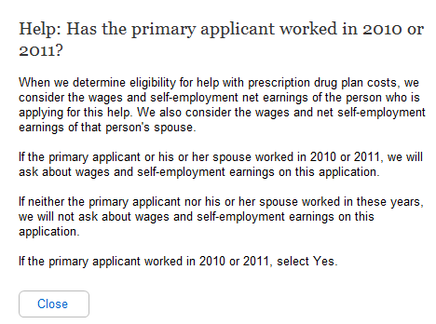
- We updated the years “2010 or 2011” to “2011 or 2012.”

A.135. Help: If the spouse has Medicare (or expects to have it in the next three months), does he or she also wish to apply?
A.135.1. User Interface
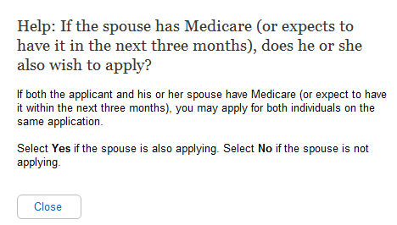
A.136. Help: Do the applicants have combined savings, investments, and real estate worth more than $25,260?
A.136.1. User Interface
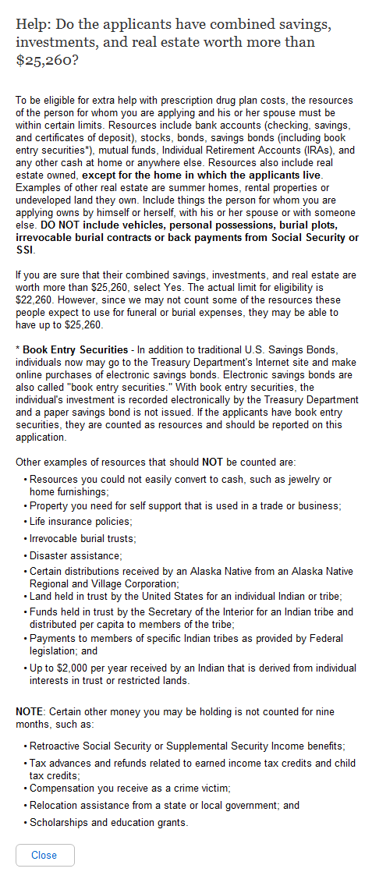
A.137. Help: Spouse's Name
A.137.1. User Interface
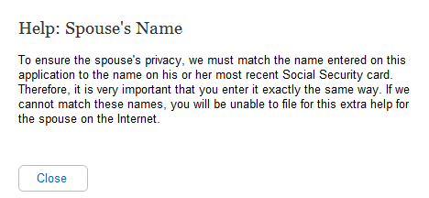
A.138. Help: Spouse's Security Number
A.138.1. User Interface
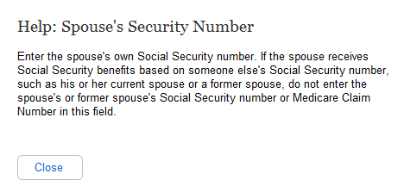
A.139. Help: What is the spouse's date of birth?
A.139.1. User Interface
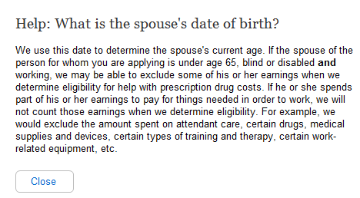
A.140. Help: Has the applicant's spouse worked in 2010 or 2011?
A.140.1. User Interface
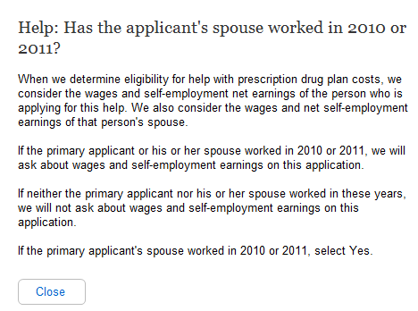
- We updated the years “2010 or 2011” to “2011 or 2012.”

A.141. Help: Mailing Address
A.141.1. User Interface
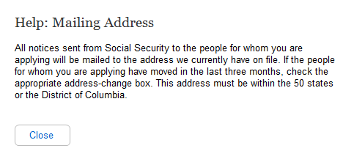
A.142. Help: Phone Number
A.142.1. User Interface
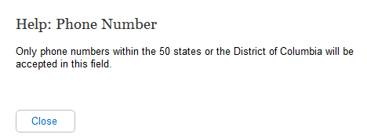
A.143. Help: Applicant's Name
A.143.1. User Interface
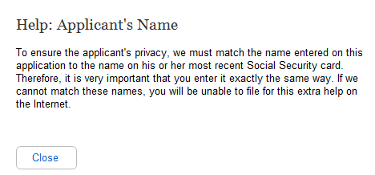
A.144. Help: Applicant's Social Security Number
A.144.1. User Interface
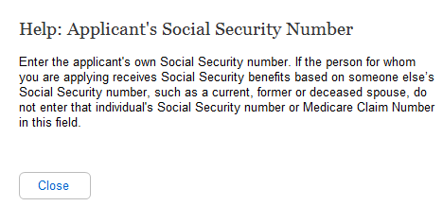
A.145. Help: What is the applicant's date of birth?
A.145.1. User Interface
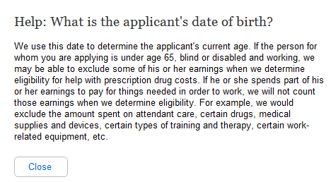
A.146. Help: Has the applicant worked in 2010 or 2011?
A.146.1. User Interface
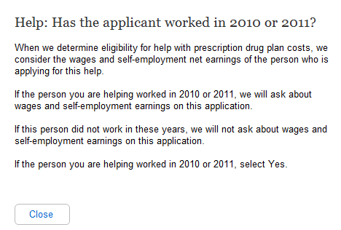

- We updated the years “2010 or 2011” to “2011 or 2012.”

A.147. Help: Does the applicant have combined savings, investments, and real estate worth more than $12,640?
A.147.1. User Interface
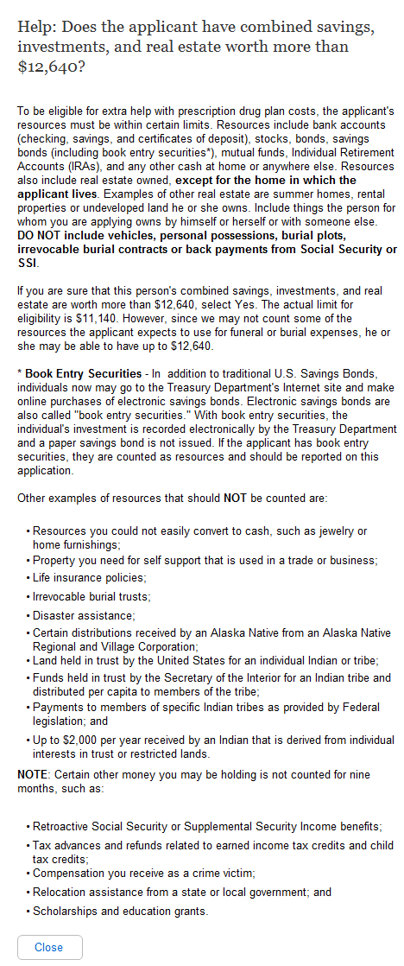
A.148. Help: Have these wages or self-employment earnings decreased in the last two years?
A.148.1. User Interface
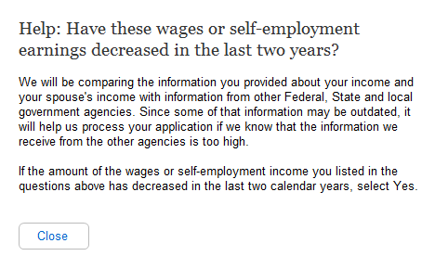
A.149. Help: Have these wages or self-employment earnings decreased in the last two years?
A.149.1. User Interface
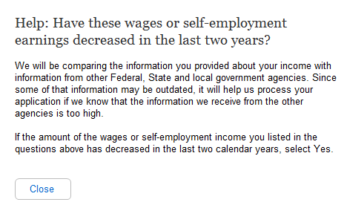
A.150. Help: Has any of the income from these sources decreased in the last two years?
A.150.1. User Interface
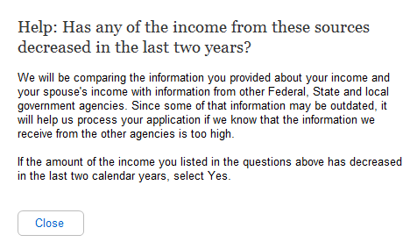
A.151. Help: Has any of the income from these sources decreased in the last two years?
A.151.1. User Interface
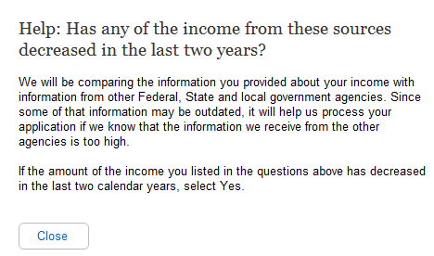
A.152. Help: Do you or your spouse have bank accounts (checkings, savings and certificates of deposit)?
A.152.1. User Interface

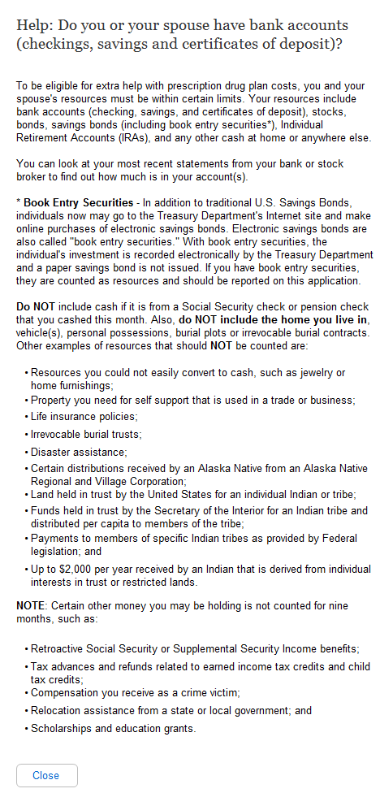

Help: Do you or your spouse have stocks, bonds, savings bonds, mutual funds, Individual Retirement Accounts or other similar investments?
A.153.1. User Interface

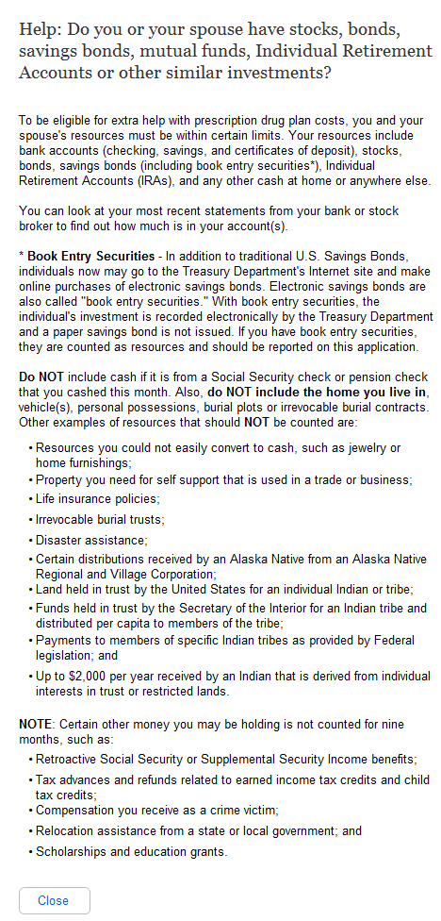

A.154. Help: Do you or your spouse have any other cash at home or anywhere else?
A.154.1. User Interface

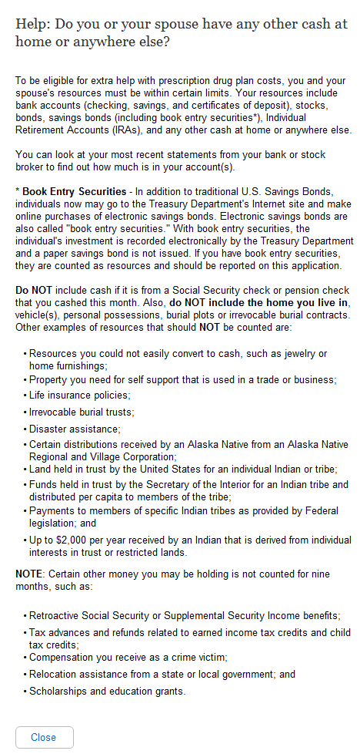

Help: Do you have bank accounts (checkings, savings and certificates of deposit)?
A.155.1. User Interface

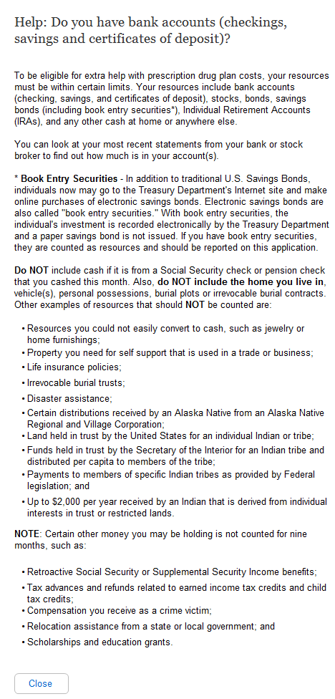

Help: Do you have stocks, bonds, savings bonds, mutual funds, Individual Retirement Accounts or other similar investments?
A.156.1. User Interface

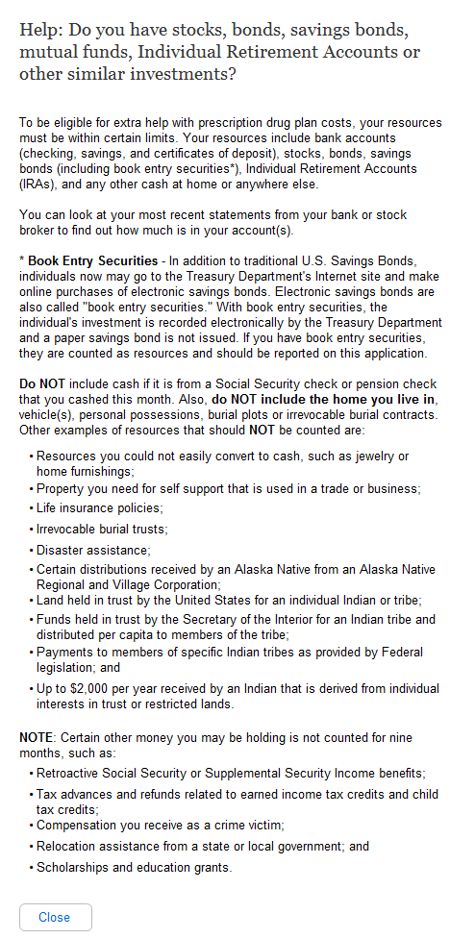
Help: Do you have any other cash at home or anywhere else?

A.157.1. User Interface

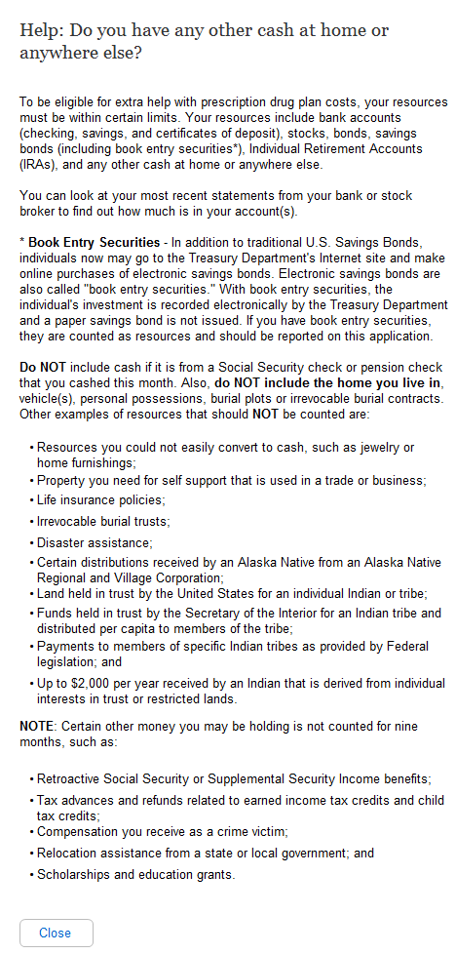
Help: Will some money from any of the sources listed above be used to pay for your funeral or burial expenses?

A.158.1. User Interface
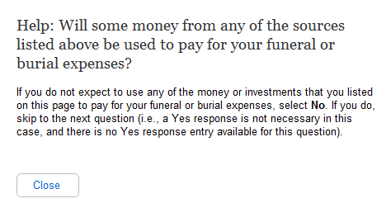
A.159. Help: Will some money from any of the sources listed above be used to pay for your spouse's funeral or burial expenses?
A.159.1. User Interface
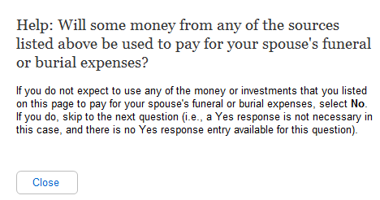
A.160. Help: Other than your home and the property on which it is located, do you or your spouse own any real estate?
A.160.1. User Interface
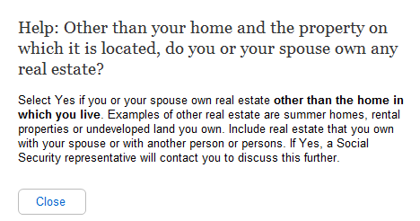
A.161. Help: Other than your home and the property on which it is located, do you own any real estate?
A.161.1. User Interface
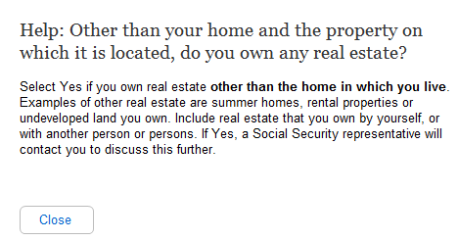
A.162. Help: Ready to submit
A.162.1. User Interface
