Attachment A. Example introductory letter for participation
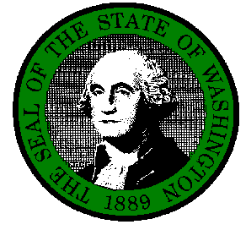
STATE OF WASHINGTON

DEPARTMENT OF LABOR AND INDUSTRIES
Insurance Services, SHARP, PO Box 44330, Olympia WA 98504-4330

The Department of Labor and Industries would like to thank you for your response to the [survey year] Bureau of Labor Statistics (BLS) Survey of Occupational Injuries and Illnesses. We appreciate your assistance in the collection of accurate information in the effort to make Washington’s workplaces safer and healthier.

The Safety and Health Assessment and Research for Prevention (SHARP) program at L&I is conducting interviews with businesses across the state to gather information about work-related injury and illness recordkeeping practices and policies for workplace safety. We would like to schedule a time to speak and discuss your thoughts and experiences with the BLS Survey, OSHA logs, and workers’ compensation claims. The one-time phone interview will last approximately thirty minutes. Your participation is entirely voluntary.

Although OSHA log recording practices are discussed, this is in no way an investigation, or audit. All information provided during the phone interview is confidential and will not be shared with anyone other than the research personnel and the US Bureau of Labor Statistics. Identifiers (your name, work address, or phone number) will not be included with your responses to the questions. If you do have questions about DOSH inspection or consultation services, we will be able to provide you with resources and refer you to a DOSH consultant. The information we collect will not be shared with DOSH inspection or consultation personnel.

These interviews are part of a larger study being conducted in multiple states in partnership with the United States Department of Labor Bureau of Labor Statistics. We hope you will participate in this study and help to refine efforts to accurately reflect the recordkeeping experiences of employers like yourself. We will contact you by telephone in about one week to discuss this research further and schedule a time to talk in greater detail. We thank you for your time and consideration.

Respectfully,

Sara Wuellner
Study Coordinator

The BLS, its employees, agents and partner statistical agencies will use the information you provide for statistical purposes only and will hold the information in confidence to the full extent permitted by law. In accordance with the Confidential Information Protection and Statistical Efficiency Act of 2002 (Title 5 of Public Law 107-347) and other applicable Federal laws, your responses will not be disclosed in identifiable form without your informed consent.
This survey is being conducted under OMB Control Number 1220-0141. This control number expires on February 28, 2015. Without OMB approval and this number, we would not be able to conduct this study.

