## *National Emergency Training Center*

**U.S. Department of Homeland Security**

16825 S. Seton Avenue

Emmitsburg, MD 21727-8998



January 15, 2014

<SUPERVISOR>

<ADDRESS>

<CITY>, <ST> <ZIP>

Dear <SUPERVISOR>:

Recently, you were listed as a supervisor of <STUDENT> who completed the National Fire Academy (NFA) course **R0123—Executive Leadership, 09/23/2013 – 10/4/2013.**

To help guide the NFA in the continuous improvement of its training programs, we would like to ask you to please complete a Long Term Evaluation (LTE) of this course. Your feedback is critical for the Academy to determine what training elements have been transferred to the job and ultimately are making a difference in helping to reduce the loss of life from fire-related incidents in local communities.

You can complete the LTE on the U.S. Fire Administration’s Web site. It will ask you to evaluate the benefits of your employee’s training to your department/organization and community.

To complete the evaluation, please visit the following page on our Web site:

<http://www.usfa.dhs.gov/applications/nfaeval/lte?u=L58R012313004-00005>

Your user name to access the survey is: **L58R012313004-00005**

Your password to access the survey is: **XXXXXXXX**

Please know that we appreciate you taking the time to complete this important evaluation.  Please know as well:  Your responses to the questions contain no names and will remain anonymous.  Additionally, individual data are never shared or reported out apart from aggregate government summaries.

If you have any questions about the evaluation survey, please contact the NFA Evaluation Center at 800-694-4262 or [NFA-Evaluation@dhs.gov](mailto:NFA-Evaluation@dhs.gov).

Sincerely,

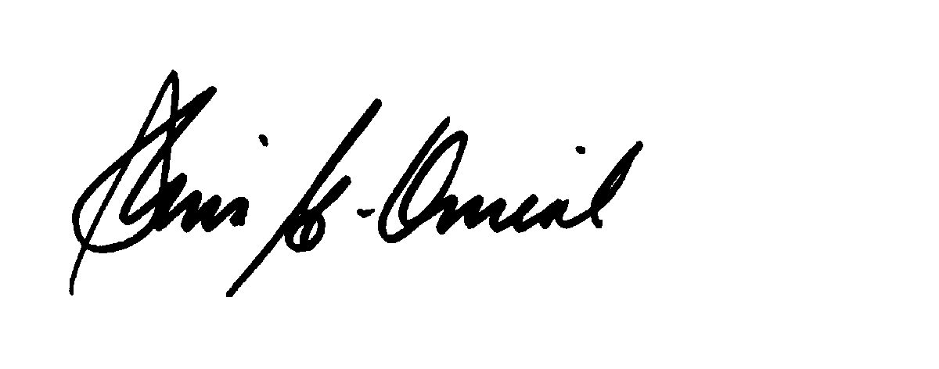

Dr. Denis Onieal

Superintendent

National Fire Academy