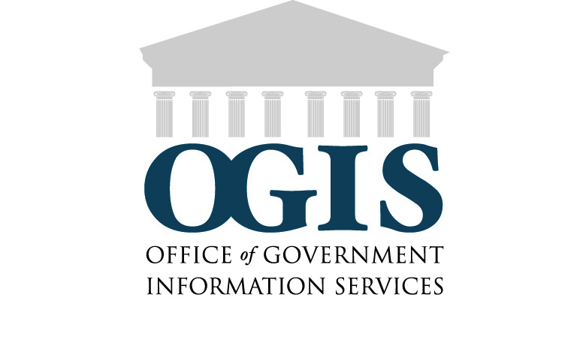

**OGIS Customer Service Assessment –**

Thank you for taking this survey about your experience working with OGIS. This short survey should take less than five minutes to complete.

Q1. I came to OGIS for assistance with (select all that apply):

* Filing a FOIA request
* Obtaining the status of a FOIA request/appeal
* Information about a Privacy Act request
* Resolving a dispute over my FOIA delay
* Resolving a dispute over my FOIA denial
* Resolving a dispute over FOIA fees
* Something else (please specify)

Q2. My experience with the OGIS staff was (choose one):

* Excellent
* Good
* Satisfactory
* Poor
* Very poor

Q3. The OGIS staff member I worked with (select all that apply):

* Was courteous
* Answered my questions fully
* Offered additional information
* Provided satisfactory customer service
* Responded to my inquiries in a timely manner
* Was not helpful

Q4. OGIS’s written communication to me was:

* Clear and easy to understand
* Somewhat clear
* Unclear and difficult to understand

Q5. Prior to coming to OGIS, did you visit the OGIS website?

* No
* Yes

Q6. What was most useful about the OGIS site?

Q7. What could be improved upon the OGIS site?

Q8. Overall, my experience with OGIS was:

* Excellent
* Good
* Satisfactory
* Poor
* Very poor

Q9. Please tell us about that OGIS experience

Q10. How did you learn about OGIS? (select all that apply)

* Agency correspondence
* Agency FOIA professional
* Agency website
* Word of mouth
* OGIS presentation/handout
* Other (please specify)

Q11. If you would like OGIS to contact you, please include your name and contact information.

Name

Address

Address 2

City/Town

State

ZIP

Country

Email Address

Thank you for providing us with feedback about your experience working with OGIS. As an office that works to build a bridge between Federal agencies and FOIA requesters, feedback is helpful to assist us in carrying out our mission. We appreciate your time and hope we can assist you in the future. Please feel free to contact OGIS at: 1-877-684-6448, [ogis@nara.gov](mailto:ogis@nara.gov), or by mail 8601 Adelphi Road, OGIS, College Park, MD, 20740

Paperwork Reduction Act Public Burden Statement

A Federal agency may not conduct or sponsor, and a person is not required to respond to a collection of information unless it displays a current valid OMB control number. The information requested on this form is being collected and used by the Office of Government Information Services to assess satisfaction with OGIS services. Public burden reporting for this collection of information is estimated to be one minute per response, including time for reviewing instructions and completing and reviewing the collection of information. Send comments regarding the burden estimate or any other aspect of the collection of information, including suggestions for reducing this burden, to National Archives and Records Administration (I-P), 8601 Adelphi Road, College Park, MD 20740-6001. DO NOT SEND COMPLETED SURVEY FORMS TO THIS ADDRESS. SEND COMPLETED FORMS TO THE ADDRESS SHOWN AT THE END OF THE SURVEY.