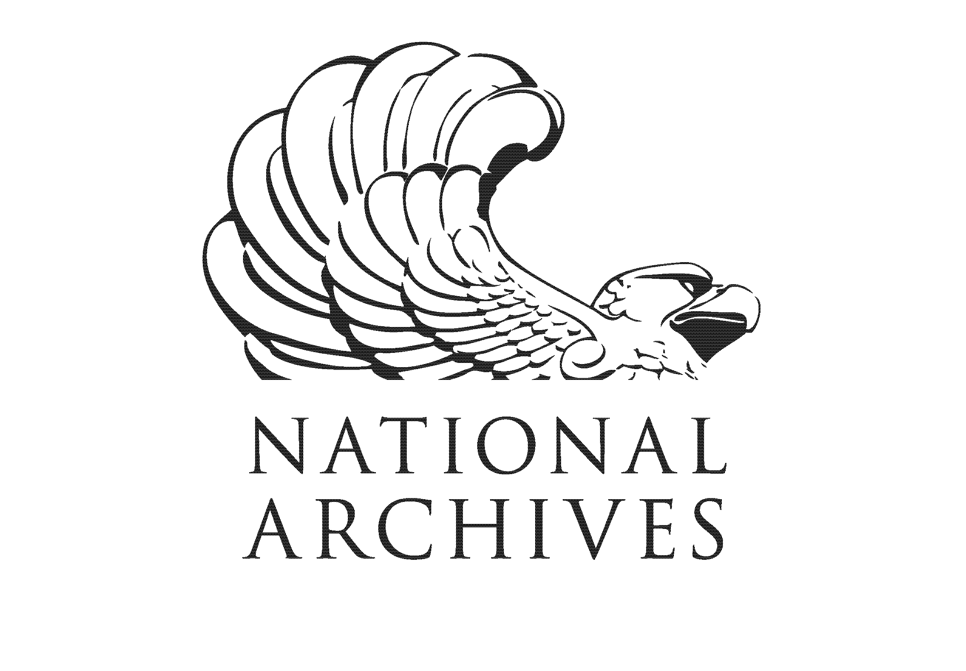 | National Archives and Records Administration
 | Fill in name of office, library or regional archives
 | Training and Event Evaluation

We value your opinion. Please take a few minutes to complete this evaluation. Your comments help us maintain the quality of our services and help us plan future programs.
Class Title:
Date: Click here to enter a date.
Instructor:
 | Use this scale to mark your rating:
The Course… | Strongly Agree/ Excellent | Agree/ Very Good | Disagree/Good | Strongly Disagree/Poor | No Basis to answer or N/A
a. Objectives were made clear.
b. Content is useful/important for my job and/or professional development.
c. Handouts were informative.
d. Overall, I was satisfied with the .
The Instructor… | Strongly Agree/ Excellent | Agree/ Very Good | Disagree/Good | Strongly Disagree/Poor | No Basis to answer or N/A
a. Was organized and prepared.
b. Encouraged participation.
c. Related subject matter to real life situation.
d. Kept discussion focused on relevant topics.
e. Overall, was very effective.
Customer Service | Strongly Agree/ Excellent | Agree/ Very Good | Disagree/Good | Strongly Disagree/Poor | No Basis to answer or N/A
a. Course (or event) description was informative.
b. Registration process was user-friendly.
c. Facilities were conveniently located.
Please tell us…
- How you will use the information from the class.

- Which one of the following categories best describes you…
Federal agency personnel, civilian or military
College or university staff or student, business employee, researcher
Educator or student for K-12 grades
Genealogist, family historian or genealogical researcher
Professional or non-profit educational organization
State or local government agency personnel
Foundation or Friends group associated with Fill in name of office, library or regional archives
General public
Other (please specify)
- How could this course/program be improved?
(continue on other side)
If you wish to direct additional comments to a supervisor, you may contact

