2014 Livestock Annual

1. Please rate your knowledge of the information contained in this report BEFORE reading it.
Not Applicable | Poor | Fair | Good | Very Good | Excellent

2. Overall, how helpful did you find this report?
Not Applicable | Very Unhelpful | Unhelpful | Neutral | Helpful | Very Helpful
Please explain your choice

3. How often will you use the information presented in this report?
Not Applicable | Never | Rarely | Occasionally | Often | Always

4. How important to your job is the information presented in this report?
Not Applicable | Useless | Slightly Useful | Useful | Very Useful | Essential

5. Who are you?
Meat/Poultry/Livestock/Dairy Industry  Grains/Oilseeds Industry  Produce Industry  Processed Products Industry  U.S. Government | Mexican Government  Other Government  Student/Researcher  Journalist
Other (Please specify)

6. Is there any particular type of report you would like us to provide?
If so, please comment below:

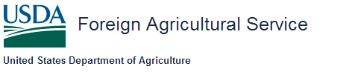
According to the Paperwork Reduction Act of 1995, an agency may not conduct or sponsor, and a person is not required to respond to, a collection of information unless it displays a valid OMB control number. The valid OMB control number for this information collection is 0503-0021. The time required to complete this information collection is estimated to average 30 minutes per response, including the time for reviewing instructions, searching existing data sources, gathering and maintaining the data needed, and completing and reviewing the collection of information.

