Form Approved OMB No. 0920-1011
Exp. Date 03/31/2017

Chikungunya Investigation - Individual Interview Form

Team #: Interviewer: Date of interview: /_ /_

Individual ID (e.g., SJ-1-A-1): - - -

- Name: First (given) Initial Paternal Maternal
- Gender: □ Male □Female 3. Date of Birth (MM/DD/YYYY): / /

- How long have you been living in Puerto Rico? years

- Have you been told by a clinician that you have any of the following medical conditions?
- Diabetes | - High blood pressure | - Heart disease | - High cholesterol
- Stroke  - Asthma | - Kidney disease  - Lung disease | - Liver disease  - Joint disease/arthritis | - Thyroid disease  - Cancer

- Do you take any of the following medications daily:
  - NSAID (e.g., aspirin, Iburpofen) □ Corticosteroids □ Antibiotics
- Have you experiencing any new illnesses in the past 3 months? □Yes □ No
(If more than one illness episode, detail each additional episode in Notes.)

7a. If yes, first day of illness (MM/DD/YYYY): / / _

7b. What symptoms did you have (check all that apply)?
- Fever □ Chills □ Nausea/Vomiting □ Diarrhea
- Muscle pain □ Joint pain □ Skin rash □ Red eyes
- Headache □ Pain behind eyes □ Abdominal pain □ Cough
- Runny nose □ Sore throat □ Calf pain □ Arthritis (red, swollen joints)
- Minor bleeding (e.g., petechia, gum bleed, nosebleed, severe bruising)
- Major bleeding (e.g., vomiting blood, coughing up blood, blood in stool, heavy menses)

Public reporting burden of this collection of information is estimated to average 15 minutes per response, including the time for reviewing instructions, searching existing data sources, gathering and maintaining the data needed, and completing and reviewing the collection of information. An agency may not conduct or sponsor, and a person is not required to respond to a collection of information unless it displays a currently valid OMB control number. Send comments regarding this burden estimate or any other aspect of this collection of information including suggestions for reducing this burden to CDC/ATSDR Reports Clearance Officer; 1600 Clifton Road NE, MS D-74 Atlanta, Georgia 30333; ATTN: PRA (0920-1011)

- 7b-1. If you had joint pain, indicate the locations where you had the pain

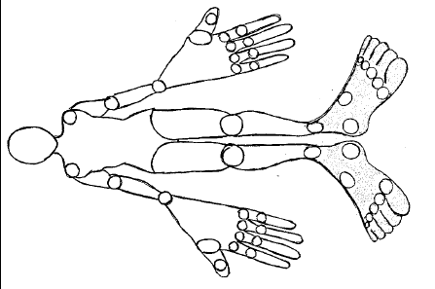
7c. How long did this illness last? days
7d. Did you go to the doctor because of this illness? □ Yes □ No
7d-1. If yes, Name of hospital/clinic: 7d-2. What was the diagnosis? □Chikungunya □ Dengue
  - Viral syndrome □ I don’t know □ Other: 7d-3. Were you hospitalized for this illness? □ Yes □ No
7d-3a. If yes, Hospital Name:

7d-3b. Days in the hospital: days

- Have you used mosquito repellent in the past month? □ Daily □ Weekly □ Never
- Have you slept under a bednet in the past month? □ Yes □ No
- Have you traveled outside of Puerto Rico in the past 3 months? □ Yes □ No
10a. If yes, specify where and date of return to Puerto Rico for the most recent trip:

  - United States (excluding USVI) □ Dominican Republic □Caribbean cruise
□Other:

Date of return to PR (MM/DD/YYYY): / /

NOTES:

