Process Overview
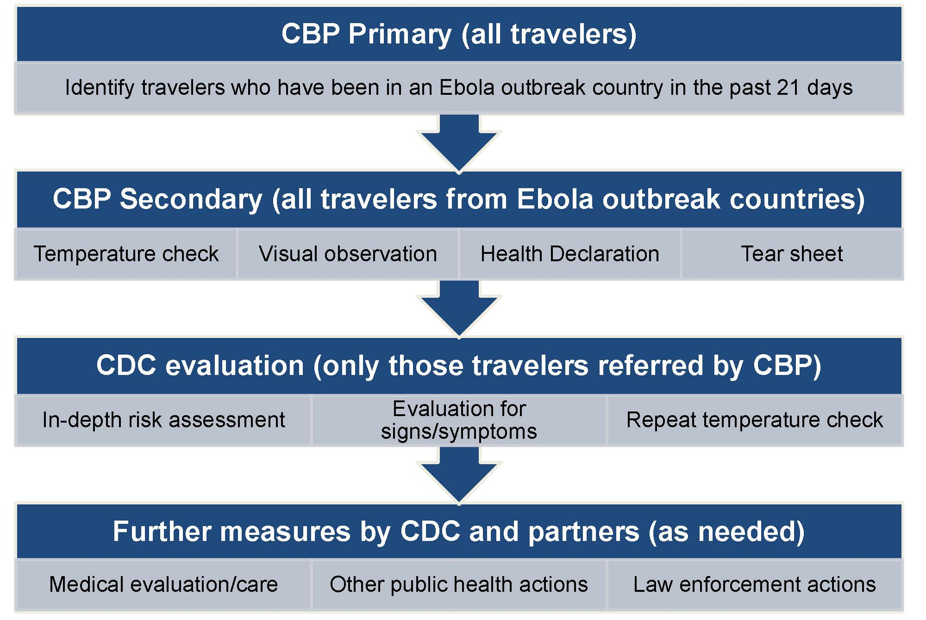

Actions to take when referring a traveler to CDC (CDC will come to traveler’s location)
- Separate traveler at least 6 feet from yourself and others.
- Avoid direct contact.
- Follow DHS/OHA/CBP protocols for using personal protective equipment if you must have physical contact with ill travelers, their blood, or body fluids.
- Wash your hands with soap and water after any contact with an ill traveler or after removing gloves.

See reverse side of page for step-by-step instructions

Step-by-Step Guide
NOTE: If traveler refuses any component of screening call CDC immediately.
CBP Primary
- Identify travelers arriving from Guinea, Liberia, and Sierra Leone based on travel itineraries.
- Ask traveler to confirm whether he/she originated the itinerary in the country listed.
  - Itinerary did not originate in outbreak country: Process traveler according to usual CBP protocols.
  - Itinerary originated in outbreak country: Escort traveler to CBP Secondary. Provide the itinerary-origin country to the Officer in CBP Secondary.
    - If traveler is visibly ill (appears flushed, has glassy eyes or has chills; is vomiting; has diarrhea, or is visibly bleeding), call CDC to CBP Primary.
CBP Secondary
- Get itinerary-origin country information from DHS Officer escorting traveler.
- Complete the Traveler Health Declaration form as you conduct your assessment of the traveler. Please write legibly.
- Write your name and airport code at the bottom of the form.
- Complete Traveler Information section of form.
  - Ask traveler whether he or she has been in any of the 3 outbreak countries in the past 21 days. Document all Ebola-outbreak countries traveler has been in during the last 21 days.
  - Enter traveler’s identifying information.
  - Enter arrival date, airline, flight number, and seat number. Check boarding pass if possible (ask if traveler sat in assigned seat). If seat number is unknown or if traveler moved seats, document this on form.
  - Collect contact information. Be as complete as possible.
- Take traveler’s temperature with a non-contact thermometer and write temperature in box on top right corner of the Health Declaration form.
  - Temperature 101.5°F/38.6°C or higher: Call CDC to CBP Secondary. Check the box for “referred traveler to CDC” at bottom of form. Give CDC the Health Declaration form.
  - Temperature below 101.5°F/38.6°C: Continue to next step.
- Visually observe traveler for any signs of vomiting, diarrhea, or visible bleeding.
  - Traveler has any of these signs: Check “yes” box for the question “Have you observed vomiting, diarrhea, or visible bleeding?” on the Health Declaration form. Call CDC to CBP Secondary. Check the box for “referred traveler to CDC” at bottom of form. Give CDC the Health Declaration form.
  - Traveler does not have any of these signs: Continue to next step.
- Read Questions A-E from the Health Declaration form out loud to the traveler. Write traveler’s answers on Health Declaration form.
  - Traveler answers any question with a YES: Call CDC to CBP Secondary. Check the box for “referred traveler to CDC” at bottom of form. Give CDC the Health Declaration form.
  - Traveler answers NO to all questions, continue to next step.
- If traveler was not referred for CDC evaluation based on Steps 2-4, traveler is cleared from a public health standpoint and can continue travel.
  - Give traveler tear sheet and CDC educational materials.
  - Check three boxes on Health Declaration form:
    - “Gave traveler tear sheet”
    - “CDC health materials” AND
    - “Released traveler”
  - Place traveler’s Health Declaration in designated bin for CDC to collect later.
  - If you have questions about this procedure, contact CDC Quarantine Station.

