Informed consent document for homebuyer survey cognitive testing interviews
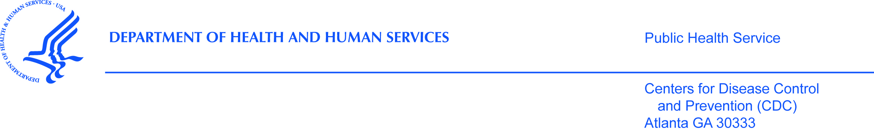

PURPOSE
The CDC, state health department, and their partners are interviewing people by phone who have bought a home meant for a single family in the last 12 months. We are carrying out this research to find out what home buyers know about environmental issues sometimes found in homes and how policies affect their decisions. The purpose of our phone interview is to find out from home buyers if we are asking the right questions about your understanding of these issues. You are being asked to participate because you recently bought a home.

PROCEDURES
If you are eligible and agree to be interviewed, please email (study email address here) or call us (phone number here) to set up a time to talk. On the call you will be asked to review each question. We also want to know about how you thought the survey was arranged. If you qualify and take part, you will receive a $15 pre-paid credit card as a token of appreciation.
RISKS
We are not aware of any risks to you if you choose to be in this study.
BENEFITS
The results we collect during the study may not help you directly. Your answers will help us refine the survey so we can send it out to other homebuyers.
VOLUNTARY PARTICIPATION
Your participation in this study is voluntary. You do not have to answer questions that you don’t wish to answer. You may quit the study at any time during the interview.
PRIVACY AND ACCESS TO DATA
Anything you say here will remain private to the extent allowed by law. Your name, address, and phone number will not be given to anyone. No one will contact you about this interview after we are done talking, except to send you the $15 pre-paid credit card. When we write our report, we will not refer to you by name.
Only staff at each agency who are involved in the study or who need to make sure the study is being done correctly will see the data.

PEOPLE TO CONTACT
If you have questions about the call or feel you may have been harmed by your participation you can call, Dr. Antonio Neri, at 770-488-3288, or email him at ANeri@cdc.gov. If you have any questions or concerns about your rights in this study please contact CDC’s Human Research Protection Office toll-free at 1-800-584-8814.
To see if you can take part in this survey, please email (study email address here) or call us (phone number here) to set up an appointment.
If you are selected, please DO NOT open the enclosed envelope until you are told to do so by the interviewer.
Thank you for your time and we look forward to hearing from you.
Sincerely,

Antonio Neri, MD, MPH on behalf of the study team
IRB/OMB Note: Reading grade level 8.6 assessed using the Flesch-Kincaid analysis in MS Word.

