Recruitment postcard for homebuyer survey
Dear recent homebuyer,
We will soon be sending you a survey that asks questions about environmental issues sometimes found in homes. This study will look at how laws meant to identify and address these issues affect people’s choices during the home buying or selling process. The results of this study will help us develop programs that help people make informed choices when buying a home. If you would like to take the survey online please go to www.surveymonkey.com/linkhere and use the code “______”. If you would prefer a paper survey, we will send you one soon.
Sincerely,

Antonio Neri MD, MPH
Principal Study Investigator
Phone: 770-488-3288
E-mail: ANeri@cdc.gov

IRB/OMB Note: Reading grade level 8.6 assessed using the Flesch-Kincaid analysis in MS Word.

Appendix 8b. Recruitment letter for homebuyer survey
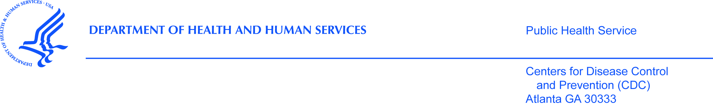

Dear recent homebuyer,
The Centers for Disease Control and Prevention (CDC), [Name of State or local HD], and our partners are sending surveys to people in your area. We are looking for people who have bought homes meant for a single family in the last 12 months.
We noted your house was sold in the last 12 months from the county or city tax office records. People who bought homes in areas with homeowners association rules related to buying a home, townhomes, or condominiums are not eligible. If you are not the person who bought the home, please send this packet to the person who bought the home.
Your replies will help us learn more about what people know about and do in regard to environmental issues found in some homes. If you are eligible and would like to take part in the study please read the next pages.

Sincerely,

Antonio Neri MD, MPH
Principal Study Investigator
Division of Cancer Prevention and Control
Centers for Disease Control and Prevention (CDC)
4770 Buford Hwy. MS F-76
Atlanta, GA 30341
Phone: 770-488-3288
E-mail: ANeri@cdc.gov

IRB/OMB Note: Reading grade level 9.1 assessed using the Flesch-Kincaid analysis in MS Word.

