**Informed consent document for homebuyer survey**

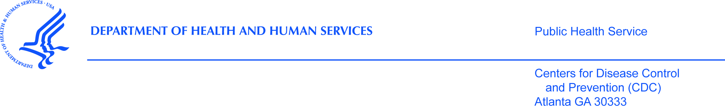

**PURPOSE**

The CDC, state health department, and our partners are sending a survey to people who have bought a home meant for a single family in the last 12 months. This research will help us find out what home buyers know about environmental issues found in some homes and how policies related to these issues affect their decisions. You are being asked to participate because you recently bought a home.

**PROCEDURES**

If you agree to be in the study and are eligible, please fill out the enclosed survey and return it in the pre-paid envelope. You can enter your replies online instead at [www.surveymonkey.com/xxx](http://www.surveymonkey.com/xxx) using this number (**unique ID here**).

**RISKS**

We are not aware of any risks to you if you choose to be in this study.

**BENEFITS**

The results we collect during the study may not help you directly. Your replies will help us learn more about what people know about and do in regard to environmental issues found in some homes.

**VOLUNTARY PARTICIPATION**

Your participation in this study is voluntary. You do not have to answer questions that you don’t wish to answer. You may end your participation in the study at any time.

**PRIVACY AND ACCESS TO DATA**

All of your replies will remain private to the extent allowed by law. Your name, address, and phone number will not be given to anyone. No one will contact you about this interview.We will not refer to you by name when we write our report.

Only staff who are involved in the survey or who need to make sure the survey is being done correctly will see the data.

**PEOPLE TO CONTACT**

If you have questions about the call or feel you may have been harmed by being in the study you can call, Dr. Antonio Neri, at 770-488-3288, or email him at ANeri@cdc.gov. If you have any questions or concerns about your rights in this study please contact CDC’s Human Research Protection Office toll-free at 1-800-584-8814.

To take part please fill out the enclosed survey and return it in the pre-paid envelope or enter your responses online at [www.surveymonkey.com/xxx](http://www.surveymonkey.com/xxx) using this number (unique ID here).

Thank you for your time and we look forward to hearing from you.

Sincerely,

Antonio Neri, MD, MPH on behalf of the study team

IRB/OMB Note: Reading grade level 9.4 assessed using the Flesch-Kincaid analysis in MS Word.