Pre-notification postcard for real estate agent focus groups

Dear Agent,
We will soon be sending your office an invitation to be a part of a focus group. This group will talk about how laws meant to identify and address issues sometimes found in homes affect your and your client’s choices during the home buying or selling process. The results of this study will help us develop programs that help you and your clients make informed choices when buying a home. We value your help with this so please watch for this invitation.
Sincerely,

Antonio Neri MD, MPH
Principal Study Investigator
Phone: 770-488-3288
E-mail: ANeri@cdc.gov

IRB/OMB Note: Reading grade level 8.5 assessed using the Flesch-Kincaid analysis in MS Word.

Appendix 9b. Recruitment letter for real estate agent focus groups
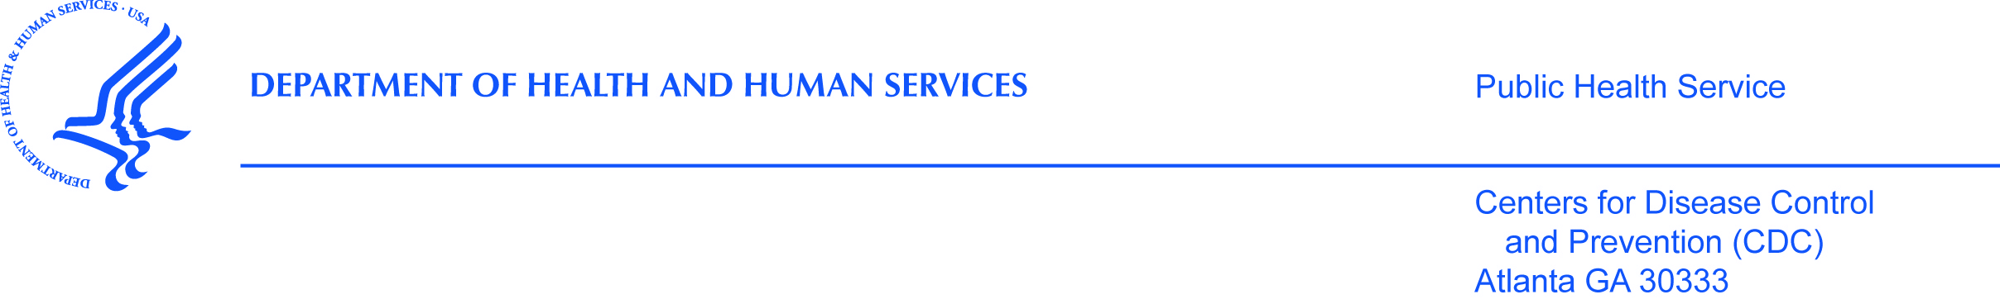

Dear Agent,
The Centers for Disease Control and Prevention (CDC), [Name of State or local HD], and our partners are putting on a study of people who buy or sell homes meant for a single family. We are going to have focus groups with full-time real estate agents as part of this study. These focus groups will help us see how policies related to environmental issues sometimes found in homes affect full-time real estate agents and their clients. We noted your agency helps clients buy and sell homes meant for a single family.
We were writing to see if XX of your agents would like to be in a focus group. Agents must be members of the National Association of Realtors or its local chapter. Agents who focus on areas with association rules related to sales of homes, townhomes, or condominiums are not eligible. If you have full-time agents who are eligible and would like to take part please read the attached page.
Sincerely,

Antonio Neri MD, MPH
Principal Study Investigator
Division of Cancer Prevention and Control
Centers for Disease Control and Prevention (CDC)
4770 Buford Hwy. MS F-76
Atlanta, GA 30341
Phone: 770-488-3288
E-mail: ANeri@cdc.gov

IRB/OMB Note: Reading grade level 9.5 assessed using the Flesch-Kincaid analysis in MS Word.

