**Informed consent form for participation in the real estate agent focus group**

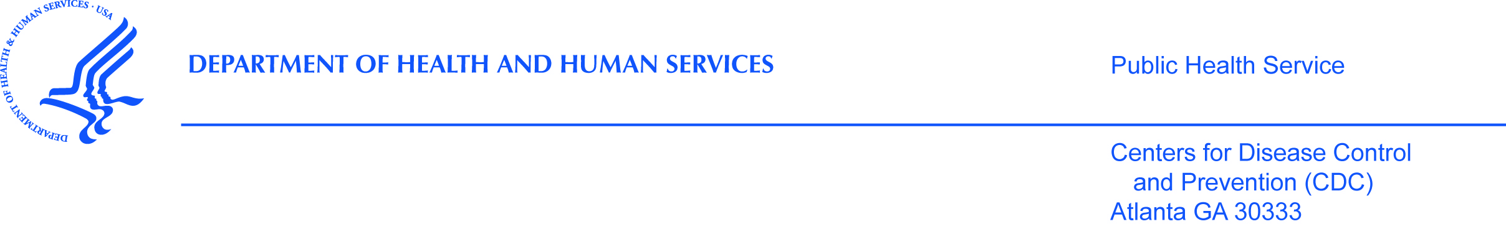

**PURPOSE**

The CDC, state health department, and our partners are inviting full-time real estate agents who focus on selling or buying homes meant for a single family to take part in focus groups. This research will help us find out what agents and their clients know about environmental issues found in some homes and how policies related to these issues affect their decisions. Agents from your office are being invited because we noted your office mainly sell homes meant for a single family.

**PROCEDURES**

If you have agents who agree to be in the focus group and are eligible, email (study email address here) or call us (phone number here) to find a focus group day and time that work for you. Everyone who takes part in the focus group will receive a $30 pre-paid credit card at the end of the focus group as a token of appreciation.

**RISKS**

We are not aware of any risks to you if you choose to be in this study.

**BENEFITS**

The results we collect during the study may not help you directly. Your replies will help us learn more about what agents and their clients know about and do in regard to environmental issues found in some homes.

**VOLUNTARY PARTICIPATION**

Your participation in this study is voluntary. You do not have to answer questions that you don’t wish to answer. You may end your participation in the focus group at any time.

**PRIVACY AND ACCESS TO DATA**

All of your replies will remain private to the extent allowed by law. Your name, address, and phone number will not be given to anyone. No one will contact you about this interview. We will not refer to you or your office by name when we write our report.

Only staff who are involved in the survey or who need to make sure the survey is being done correctly will see the data.

**PEOPLE TO CONTACT**

If you have questions about the focus group or feel you may have been harmed by being in the study you can call Dr. Antonio Neri at 770-488-3288 or email him at ANeri@cdc.gov. If you have any questions or concerns about your rights in this study please contact CDC’s Human Research Protection Office toll-free at 1-800-584-8814.

To see if you are eligible to be in the study, email (study email address here) or call us (phone number here) to find a focus group day and time that work for you.

Thank you for your time and we look forward to hearing from you.

Sincerely,

Antonio Neri, MD, MPH

Project Director

IRB/OMB Note: Reading grade level 9.3 assessed using the Flesch-Kincaid analysis in MS Word.