**Attachment 13**

**IRB Approval Letters**

1. **NIH**
2. **Westat**

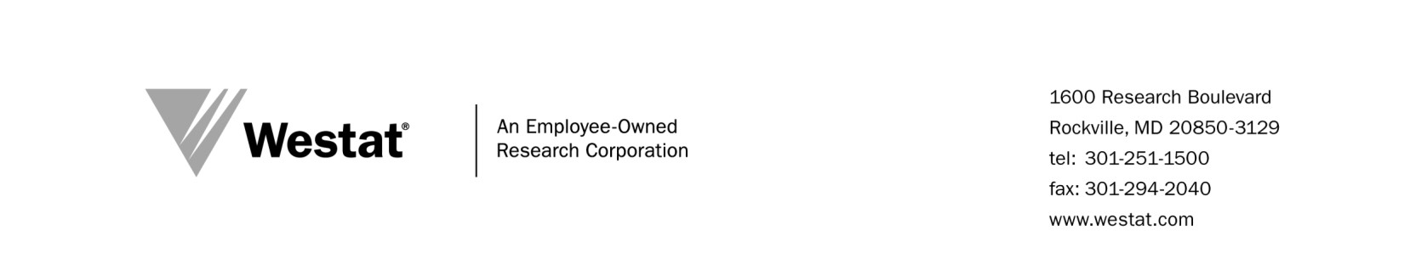

Date: February 5, 2014

To: Sophia Tsakraklides, Project Director

From: Sharon Zack, IRB Administrator, Westat IRB

Subject: Exemption of Study of the SCTC EVALUATION, Project 6048.06.01

FWA 00005551

As Chair of the Westat Institutional Review Board (IRB), I reviewed the materials submitted for the following: Study of the SCTC EVALUATION, Project 6048.06.01. The Westat IRB reviews all studies involving research on human subjects. This study is sponsored by the National Cancer Institute.

The purpose of this research is to conduct an evaluation of the State and Community Tobacco Control Research (SCTC) Initiative. This initiative investigates under-studied aspects of tobacco control policy and media interventions, including the following areas:

* Secondhand smoke policies,
* Tobacco tax and pricing policies,
* Mass media countermeasures and community and social norms, and
* Tobacco industry practices.

Data collection will include a web survey instrument, telephone interviews and focus groups, in conjunction with archival analysis.

Per [45 CFR 46.101(b5)] and a letter received from Elizabeth M. Ginexi, Ph.D., Program Director/Health Scientist, Tobacco Control Research Initiative, NCI; this research involves a program evaluation and therefore is exempt from IRB review.

The Project Director is required to notify the Board only if there are changes to the protocol or procedures regarding this project. In addition, notify the IRB Office as soon as possible if there are any injuries to the subjects or problems with the study that relate to human subjects.

cc: Institutional Review Board

Nancy Weinfield