Attachment 9

Expert Panel Informed Consent

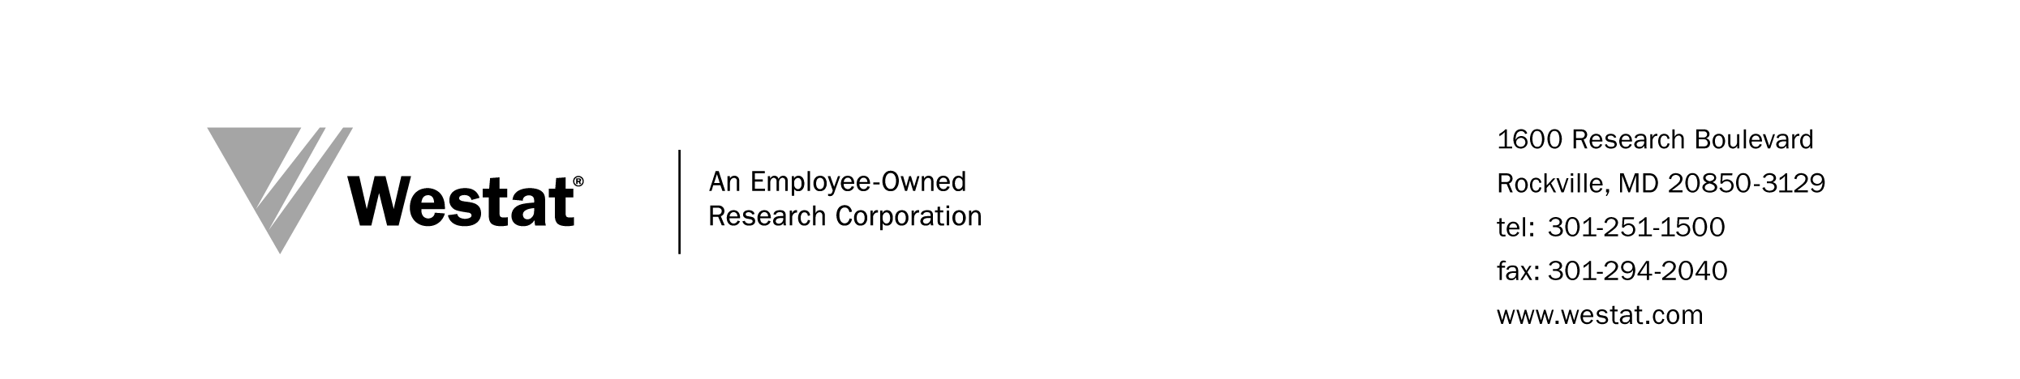

OMB No: 0925-XXXX
Expiration Date: xx/xx/20xx

Collection of this information is authorized by The Public Health Service Act, Section 411 (42 USC 285a). Rights of study participants are protected by The Privacy Act of 1974. Participation is voluntary, and there are no penalties for not participating or withdrawing from the study at any time. Refusal to participate will not affect your benefits in any way. The information collected in this study will be kept private to the extent provided by law. Names and other identifiers will not appear in any report of the study. Information provided will be combined for all study participants and reported as summaries. You are being contacted to participate in this data collection so that we can evaluate the State and Community Tobacco Control (SCTC) Research Initiative.

Public reporting burden for this collection of information is estimated to average 5 minutes per response, including the time for reviewing instructions, searching existing data sources, gathering and maintaining the data needed, and completing and reviewing the collection of information. An agency may not conduct or sponsor, and a person is not required to respond to, a collection of information unless it displays a currently valid OMB control number. Send comments regarding this burden estimate or any other aspect of this collection of information, including suggestions for reducing this burden to: NIH, Project Clearance Branch, 6705 Rockledge Drive, MSC 7974, Bethesda, MD 20892-7974, ATTN: PRA (0925-XXXX). Do not return the completed form to this address.

EXPERT PANEL INFORMED CONSENT

EVALUATION OF THE NCI STATE AND COMMUNITY TOBACCO CONTROL RESEARCH INITIATIVE

April 2015

Westat, an independent social science research company in Rockville, Maryland is working with the NCI to conduct an evaluation of the State and Community Tobacco Control Research (SCTC) Initiative. Westat is conducting several expert panels to learn about a selection of topics relevant to the SCTC, including collaboration, infrastructure and development of dissemination products.

Participation in the expert panel is voluntary, but through your involvement you can contribute to this important effort and help ensure that SCTC is successful. Information shared in the expert panel will be kept private to the extent provided by law; no reports will identify you by name or affiliation. Additionally, the information obtained during the expert panel will be shared only with the sponsoring agency personnel and staff authorized to work on this study. The session will be audio-taped to assist with analysis but only the Westat staff present will have access to this recording. The tape will be destroyed immediately after analysis.

Please print your name in the following paragraph and sign at the bottom of this form. Return this form to the Westat staff member who is conducting the expert panel.

I, _____________________________________, have agreed to participate in the expert panel component of the NCI SCTC Evaluation. I understand that my participation is voluntary; that a temporary audio-recording will be made of the session; and that the resulting report will not identify me by name.

I have read this informed consent form and understand the proposed study.

______________________________
Participant’s Signature

____/____/____
Date

