Table B. Recruitment Matrix: Complex Families
 | Round 1 | Actual | Round 2 | Actual | Round 3 | Actual | Total
Gender
Male | Min. 3 |  | Min. 3 |  | Min. 3
Female | Min. 3 |  | Min. 3 |  | Min. 3
Age
18-24
25-34
35+
Has Child with Previous Partner
Yes | Min. 3 |  | Min. 3 |  | Min. 3
No | N/A |  | N/A |  | N/A
Geographic (TBD-based on locations targeted through Craigslist ads)
1 | Min. 2 |  | Min. 2 |  | Min. 2
2 | Min. 2 |  | Min. 2 |  | Min. 2
3 | Min. 2 |  | Min. 2 |  | Min. 2
4 | Min. 2 |  | Min. 2 |  | Min. 2
Ethnicity
Black | Min. 2 |  | Min. 2 |  | Min. 2
Hispanic | Min. 2 |  | Min. 2 |  | Min. 2
White | Max. 3 |  | Max. 3 |  | Max. 3
Other | N/A |  | N/A |  | N/A
Household Income
Under or at 200% FPL | Min. 3
Over 200% FPL | Min. 3
Total | 6-9 |  | 6-9 |  | 6-9 |  | 27

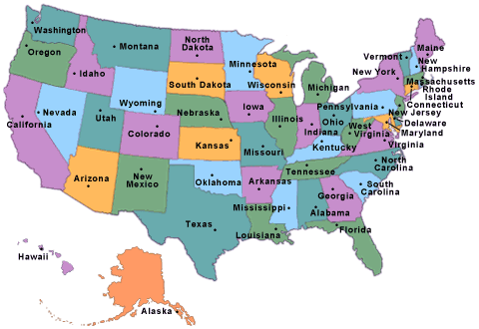
Region 1: Maine, New Hampshire, Vermont, Massachusetts, Rhode Island, Connecticut, New Jersey, Delaware, Maryland, Pennsylvania, DC

Region 2: Ohio, Michigan, Ohio, Wisconsin, Illinois, Indiana, Iowa, South Dakota, North Dakota, Nebraska, Kansas, Missouri, Minnesota

Region 3: Washington, Oregon, Idaho, Nevada, California, Utah, Colorado, Nebraska, South Dakota, North Dakota, Wyoming, Montana, Alaska, Hawaii

Region 4: Texas, Mississippi, Louisiana, Alabama, Georgia, Florida, Arkansas, Oklahoma, Tennessee, North Carolina, South Carolina, Virginia, Kentucky, West Virginia

FPL will be based on family size and determined during the screener interview

