Table A. Recruitment Matrix: High School Aged Adolescents
 | Round 1 | Actual | Round 2 | Actual | Round 3 | Actual | Total
Gender
Male | Min. 3 |  | Min. 3 |  | Min. 3
Female | Min. 3 |  | Min. 3 |  | Min. 3
Age
14-15 | Min. 3 |  | Min. 3 |  | Min. 3
16-17 | Min. 3 |  | Min. 3 |  | Min. 3
Geographic (TBD-based on locations targeted through Craigslist ads)
1 | Min. 2 |  | Min. 2 |  | Min. 2
2 | Min. 2 |  | Min. 2 |  | Min. 2
3 | Min. 2 |  | Min. 2 |  | Min. 2
4 | Min. 2 |  | Min. 2 |  | Min. 2
In a current relationship (for longer than 3 months) or in a relationship that lasted 3+ months at some point in the last year
Yes | Min. 3 |  | Min. 3 |  | Min. 3
No | Min. 3 |  | Min. 3 |  | Min. 3
Family Income
Under or at 200% FPL | Min. 3 |  | Min. 3 |  | Min. 3
> 200% FPL | Min. 3 |  | Min. 3 |  | Min. 3
Ethnicity
Black | Min. 2 |  | Min. 2 |  | Min. 2
Hispanic | Min. 2 |  | Min. 2 |  | Min. 2
White | Max. 3 |  | Max. 3 |  | Max. 3
Other | N/A |  | N/A |  | N/A
Total | 6-9 |  | 6-9 |  | 6-9

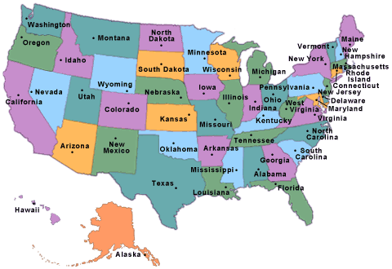
Region 1: Maine, New Hampshire, Vermont, Massachusetts, Rhode Island, Connecticut, New Jersey, Delaware, Maryland, Pennsylvania, DC

Region 2: Ohio, Michigan, Ohio, Wisconsin, Illinois, Indiana, Iowa, South Dakota, North Dakota, Nebraska, Kansas, Missouri, Minnesota

Region 3: Washington, Oregon, Idaho, Nevada, California, Utah, Colorado, Nebraska, South Dakota, North Dakota, Wyoming, Montana, Alaska, Hawaii

Region 4: Texas, Mississippi, Louisiana, Alabama, Georgia, Florida, Arkansas, Oklahoma, Tennessee, North Carolina, South Carolina, Virginia, Kentucky, West Virginia

These are suggested targets. During recruitment and fielding we may adjust targets and cut points. For example, if 14-15 year olds have no problems with measures but 16-17 year olds have more issues with the measures, we may increase targets for 16-17 year olds (in current round and for future rounds). Additionally, if we recruit fewer Hispanic youth (for example) in round one, we may increase target for later rounds.
FPL will be based on family size and determined during the screener interview.
N/A means there is no minimum or maximum recruitment target for this group; it does not mean this group is not eligible

