Wage and Hour Division (WHD)
Instructions for Form WH-530: Application for a Farm Labor Contractor or Farm Labor Contractor Employee Certificate of Registration
Registration Requirement Under The Migrant and Seasonal Agricultural Worker Protection Act (MSPA)
The Migrant and Seasonal Agricultural Worker Protection Act (MSPA) covers such things as safety and health standards for migrant worker housing, transportation safety, disclosing the terms and conditions of employment to migrant and seasonal agricultural workers, properly paying covered workers, and making and keeping accurate payroll records. Generally, the MSPA applies to any person (or business) who recruits, solicits, hires, employs, furnishes, or transports migrant or seasonal agricultural workers (the MSPA refers to these activities as "farm labor contracting activities").
Under the MSPA, migrant agricultural workers are those employed in agricultural work of a seasonal or temporary nature who cannot return to their permanent residence at night because of the distance involved. Seasonal agricultural workers also are employed in agricultural work of a seasonal or temporary nature, but who are able to return to their permanent residence at night.
Before performing any "farm labor contracting activities," farm labor contractors are required to apply to the U.S. Department of Labor for a Certificate of Registration authorizing the applicant to engage in "farm labor contracting activities." Persons employed by farm labor contractors (farm labor contractor employees) to perform such activities on behalf of the contractor are also required to register with the Department. Application for a Certificate of Registration is made by completing and submitting the required application form (Form WH-530). Form WH-530 can be obtained electronically from this site or by contacting the nearest office of the Wage and Hour Division. The form can also be obtained from any local office of the state workforce agency or employment service.
Certain persons and organizations, such as small businesses meeting the exemption criteria of 29 U.S.C. § 213(a)(6)(A), are exempt from the Act and are not required to register as farm labor contractors. In addition, establishments meeting the MSPA definition of an "agricultural association" or "agricultural employer," are not required to register as a farm labor contractor. Contact the Wage and Hour Division at 1-866-4US-WAGE (1-866-487-9243), TTY: 1-877-889-5627, if you have any questions as to whether you must register with the U.S. Department of Labor as a farm labor contractor. An instructional and information guide for completing Form WH-530 is attached.
IMPORTANT: Submitting the application form does not authorize you to engage in farm labor contracting activities. If the application is approved, you will be issued either a Farm Labor Contractor (FLC) or a Farm Labor Contractor Employee (FLCE) Certificate of Registration, at which time you may begin to engage in the authorized activities.
In addition, depending upon the specific activities you are seeking authorization for (i.e., housing, transporting, or driving covered workers) you may have to submit additional forms/documentation with your application. This additional documentation may consist of one or more of the forms listed below:
- Fingerprint Card, FD-258
- Copy of Alien Registration Card
- Copy of Driver’s License
- Doctor's Certificate, WH-515
- Vehicle Mechanical Inspection Report for Transportation Subject to Department of Transportation Requirement, WH-514
- Vehicle Mechanical Inspection Report for Transportation Subject to Department of Labor Requirement, WH-514a
- Proof of Automobile Liability Insurance
- Workers' Compensation Information or Certificate of Workers' Compensation Insurance
- Insurance Cancellation Agreement under MSPA
- Housing Occupancy Certificate
The Wage and Hour Division of the U.S. Department of Labor administers and enforces the MSPA. For more information contact either the nearest office of State Workforce Agency (or State Employment Service), listed in most telephone directories under State Government, or the Wage and Hour Division at 1-866-4US-WAGE (1-866-487-9243), TTY: 1-877-889-5627. The federal regulations implementing MSPA appear in 29 C.F.R. Part 500.
- WH-530
OMB Control No. 1235-0016, Expires 08/31/2015.
Persons are not required to respond to the collection of information unless it displays a currently valid OMB control number.
Please provide as much of the requested information as possible. Attach additional sheets if you need additional space to respond to a question. If you do not understand a term, or need assistance in the completion of this form, please contact the Wage and Hour Division of the U.S. Department of Labor. After you submit the form, a representative from the Department of Labor may contact you if further information is necessary to initiate an investigation.
Submission of Application
If the applicant’s permanent place of residence is in Alaska, Arkansas, Arizona, American Samoa, California, Colorado, Guam, Hawaii, Idaho, Louisiana, Montana, Nevada, New Mexico, North Dakota, Oklahoma, Oregon, South Dakota, Texas, Utah, Washington, or Wyoming, the application should be sent to:
U.S. Department of Labor
Wage Hour Division
Western Farm Labor Certificate Processing
90 Seventh Street Suite 13-100
San Francisco, CA 94103
If the applicant’s permanent place of residence is anywhere else in the country, then the application should be sent to one of the following two addresses:
Send first class mail, certified mail, and USPS Express Mail to:
U.S. Department of Labor
Wage Hour Division
Southeast Farm Labor Certificate Processing
P. O. Box 56447
Atlanta, GA 30343-0447
Send all other ground and express courier services to:
U.S. Department of Labor
Wage Hour Division
Southeast Farm Labor Certificate Processing
233 Peachtree Street NE, Suite 610
Atlanta, GA 30303
What if I have questions as I complete the application?
The WH-530, WH-514, WH-514a and the WH-515 include detailed instructions. Read them carefully. However, if you still have questions, you may wish to contact the Certification Team member who covers your state. The California Certification Team can be contacted at (415) 625-7700. The Atlanta Certification Team can be contacted at (404) 893-6030.
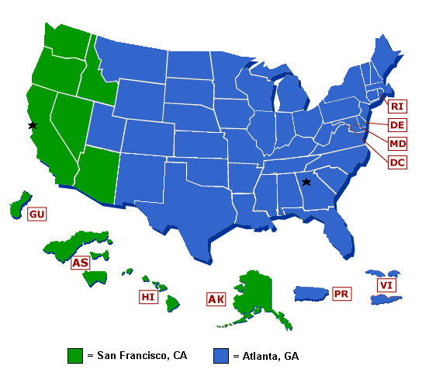
Note: In order to view, fill out, and print PDF forms, you need Adobe- Acrobat- Reader- version 5 or later, which you may download for free at www.adobe.com/products/acrobat/readstep2.html. To save the completed forms on your workstation, you need to use the "Save..As" method to save the file.
For example, move your mouse curser over the PDF link and click on your "RIGHT" mouse button. This will cause a menu to be displayed, from which you will select the proper save option -- depending upon which browser you are using:
- For Microsoft IE users, select "Save Target As"
- For Netscape Navigator users, select "Save Link As"
Once you've selected the proper save option for your browser, and have saved the file to a location you specified, go to your program menu and start the Adobe Acrobat- Reader. Once open, locate the PDF file you saved and open it directly in Acrobat-.
to:

U.S. Department of Labor
Wage Hour Division
Western Farm Labor Certificate Processing
90 Seventh Street Suite 13-100
San Francisco, CA 94103

If the applicant’s permanent place of residence is anywhere else in the country, then the application should be sent to one of the following two addresses:

Send first class mail, certified mail, and USPS Express Mail to:
U.S. Department of Labor
Wage Hour Division
Southeast Farm Labor Certificate Processing
P. O. Box 56447
Atlanta, GA 30343-0447

Send all other ground and express courier services to:
U.S. Department of Labor
Wage Hour Division
Southeast Farm Labor Certificate Processing
233 Peachtree Street NE, Suite 610
Atlanta, GA 30303

What if I have questions as I complete the application?

The WH-530, WH-514, WH-514a and the WH-515 include detailed instructions. Read them carefully. However, if you still have questions, you may wish to contact the Certification Team member who covers your state. The California Certification Team can be contacted at (415) 625-7700. The Atlanta Certification Team can be contacted at (404) 893-6030.

Send to California office if in Alaska, Arizona, American Samoa, California, Guam, Hawaii, Idaho, Nevada, Oregon, or Washington. Everywhere else, send to Atlanta.
Note: In order to view, fill out, and print PDF forms, you need Adobe- Acrobat- Reader- version 5 or later, which you may download for free at www.adobe.com/products/acrobat/readstep2.html. To save the completed forms on your workstation, you need to use the "Save..As" method to save the file.
For example, move your mouse curser over the PDF link and click on your "RIGHT" mouse button. This will cause a menu to be displayed, from which you will select the proper save option -- depending upon which browser you are using:

For Microsoft IE users, select "Save Target As"
For Netscape Navigator users, select "Save Link As"
Once you've selected the proper save option for your browser, and have saved the file to a location you specified, go to your program menu and start the Adobe Acrobat- Reader. Once open, locate the PDF file you saved and open it directly in Acrobat-.

