DRAFT COLLECTION OF INFORMATION

Retirement Savings Module of the Household Financial Survey

Current Retirement Saving Status
- Do YOU personally have a retirement account (money set aside that you intend to use when you retire)?
  - Yes
  - No [Skip to 13]
  - I don’t know [Skip to 13]

- (If YES selected in 1) In what kind(s) of accounts do you save for retirement? Select all that apply.
  - Defined contribution plan, such as a 401(k) or 403(b) plan
  - Defined benefit pension
  - IRA, either traditional IRA or Roth IRA
  - Saving for retirement in your savings or checking account
  - Savings Bonds
  - Other (please specify): ____________________
  - I don't know

2a. (If NO selected in 1) You indicated that you do not currently have a retirement account. Have you EVER had a retirement account, but no longer have one because you withdrew the funds?
- Yes
- No

2b. (If YES selected in 2a) For what reason(s) did you withdraw funds from your retirement account? Select all that apply:
- To cover emergency or short-term needs
- To make a major purchase, such as car or home
- To invest the money elsewhere
- Other (please specify): ____________________

2c. (IF NO selected in 1) You indicated that you do not currently have a retirement account. Which of the following are your reasons for not saving in a retirement account? Select all that apply.
- Too much risk involved
- I am unfamiliar with how they work or where to enroll
- My employer does not offer one
- I don’t trust investors
- The fees are too high
- I don’t have enough money to set aside any for retirement
- Bad experience with a retirement account I used to have
- I expect to rely on Social Security
- Other (please specify): _____________

- (If A-C selected in 2) Is one or more of the retirement savings accounts you told us about offered to you through a former employer?
  - Yes
  - No

- (If A-C selected in 2) Is one or more of the retirement savings accounts you told us about offered to you through your current employer?
  - Yes
  - No

- (If B or C selected in 1, or NOT A or B in 2) In your current job, do you qualify for a retirement savings plan offered by your employer, such as 401(k) or 403(b)?
  - Yes
  - No
  - I don’t know

- (If YES in 4 or 5) Does your employer offer any contributions to your retirement account(s)?
  - Yes
  - No
  - I don’t know

Depositing Behavior
- (If YES in 1) Do you currently make deposits to your retirement account(s) through your paycheck (i.e., using automatic deductions)?
- Yes
- No

- (If A or B in 7) Other than from your paycheck, how often would you say you make deposits to your retirement account(s)?
- Once a month or more often
- A few times per year
- Once a year
- Less than once a year
- Never

- (If A-F selected in 2) Have you ever used part of your tax refund to make a deposit to your retirement account?
  - Yes
  - No

- (If YES selected in 9) Have you ever directly deposited a portion of your tax refund into your retirement account? In other words, did you enter your retirement account routing number in the tax form at the time of filing to have the refund sent directly there?
- Yes
- No

Withdrawing Behavior
- (If A-F selected in 2) Have you ever withdrawn funds from your retirement account(s) for something other than retirement?
- Yes
- No

11a. (If A selected in 11) When you withdrew funds from your retirement account(s), were you ever penalized (for example, taxes or fees)?
  - Yes
  - No
  - I don’t know

11b. (If A selected in 11) When you withdrew funds from your retirement account(s), what did you use the funds for? Select all that apply:

      - To make a major purchase, such as a car or home
      - To cover an emergency or short-term need
      - To invest the money elsewhere
      - Other (please specify): _______________________

Retirement Planning
- Do you plan to retire some day?
- Yes
- No [Skip to 18]
- I don’t know

- (If YES in 13) I am confident in my ability to make wise decisions about saving and investing money so I will have enough for my retirement.
  - Strongly disagree
  - Disagree
  - Neutral
  - Agree
  - Strongly agree

- (If YES in 13) How much to you agree with the following statement: “I am confident that I can meet my long-term goals for being financially secure in my retirement”?
  - Strongly disagree
  - Disagree
  - Neutral
  - Agree
  - Strongly agree

- (If YES in 13) At what age do you think you expect to retire?
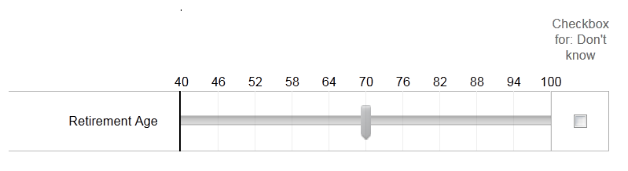

- (If YES in 13) How do you plan to support yourself financially when you retire? Select all that apply.
  - Withdraw from account(s) I saved in (such as savings account, IRA, or 401(k))
  - Cash out stocks, mutual funds, or similar investments
  - Sell my home
  - Financial support from family or friends
  - Social Security
  - Reverse mortgage / home equity line of credit (HELOC)
  - Open a business / Become self-employed
  - Move to a more affordable town

  - Other: _________________

Risk Tolerance
- Which of the following statements comes closest to the amount of financial risk that you are willing to take when you save or make investments?
  - Take substantial financial risks expecting to earn substantial returns
  - Take above average financial risks expecting to earn above average returns
  - Take average financial risks expecting to earn average returns
  - Not willing to take any financial risks

Response to Hypothetical New Retirement Account
For the next series of questions, please imagine that a new kind of retirement savings account is made available for you with these features:

2% to 3% interest rate
Guaranteed by the government to have no risk of losses
Low minimum monthly contribution ($5)
Contribute up to $5,500 per year
Can withdraw all deposited funds without penalty at any time
Can deposit up to $15,000 total, keep the account open for up to 30 years, and can convert the account into another form of retirement account at any time

- How likely would you be to open and make deposits to this type of retirement savings account, if your employer offered it?
  - Using a rating scale of 1 – 5; 5 = Very likely, 1 = Not at all likely

- How likely would you be to open and make deposits to this type of retirement savings account, if you could do so without your employer? (using a rating scale of 1 – 5)
  - Using a rating scale of 1 – 5; 5 = Very likely, 1 = Not at all likely

- Some people prefer accounts with flexibility to withdraw at any time, while other people prefer accounts with rules that make the money harder to spend, which helps ensure that the money will be there later.

Imagine there are three types of retirement accounts that are the same in every way exceptas shown on the illustrartion below:
Using the slide bars, how likely would you be to open and contribute to such a retirement account?

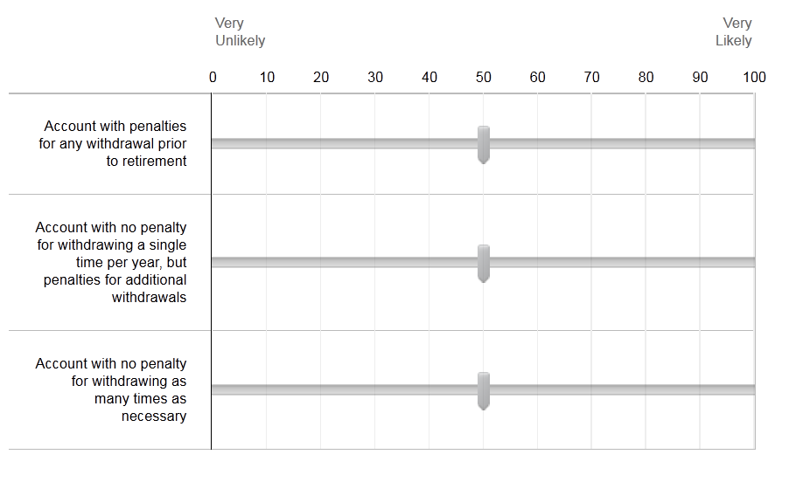

(at top of screen for 21 – 23) Imagine you are offered a retirement account with these features:
2% to 3% interest rate
Guaranteed by the government to have no risk of losses
Low minimum monthly contribution ($5)
Contribute up to $5,500 per year
Can withdraw funds without penalty at any time
Can deposit up to $15,000 total, keep the account open for up to 30 years, and can convert the account into another form of retirement account at any time

- If you were able to open this type of account, about how much money do you think you would deposit into it every month, counting money deposited directly from your paycheck and other deposits you would make? (Open response)

- If you opened this new kind of account, how likely would you want to use it to save for short term needs, rather than only to save for retirement?
  - Using a rating scale of 1 – 5; 5 = Very likely, 1 = Not at all likely

- If you opened this new kind of account, how likely would you want to use it to save for emergency expenses, such as for medical bills or a car repair?
  - Using a rating scale of 1 – 5; 5 = Very likely, 1 = Not at all likely

- What percentage of monthly deposits would be directed to the following saving goals (Responses must equal 100%. If you do not envision using deposits for one or more of the possible saving goals, mark 0 in the associated answer box):
  - Retirement
  - Shorter-term needs, such as a home down payment or new appliance
  - Emergency expenses, such as medical bills or car repairs

Reallocating Debt Payments to Saving
- If you have student loans, once you’ve repaid your student loans in full, would you be interested in saving more for retirement by regularly contributing what once was a student loan payment to a retirement account instead?
  - Yes
  - No
  - Not applicable

- If you have a mortgage, once you’ve repaid your mortgage in full, would you be interested in saving more for retirement by regularly contributing what once was a mortgage payment to a retirement account instead?
- Yes
- No
- Not applicable

