Spring 2016 School Leader Survey
[[Version: On-line administration. Wave 2.]]

Understanding Your Participation in the Study

Welcome to the spring 2016 survey for school leaders about the feedback you give to teachers’ regarding their instruction as a part of the NM TEACH Educator Effectiveness System. This is a follow-on to our fall 2015 survey to learn about the feedback you have provided to teachers this school year.

Study Purpose. With funding from the federal Department of Education as a part of the Southwest Regional Educational Lab, this study is intended to learn about the feedback principals give to teachers under the NM TEACH Educator Effectiveness System, and teachers’ perceptions of that feedback. For more information about the study, please see {REL Southwest website}. In {month, year} REL Southwest researchers asked all New Mexico’s public school principals to participate in a study about evaluation feedback to teachers. Results will be used to provide New Mexico Public Education Department feedback regarding how to improve the NM TEACH Educator Effectiveness System training for principals and teachers.

Survey Purpose. This survey is intended to gather information on the provision of feedback after formal observations by school leaders to teachers about their performance. Survey results will not be used to evaluate you, other teachers, or school leaders.

Procedures. Online completion of the survey should take approximately 30 minutes. By using your personal survey link provided in the invitation email, you will be able to complete the survey in multiple sessions; responses will be saved as you enter them. However, once you click “submit” at the very end of the survey, you will no longer be able to return.

Confidentiality. REL Southwest will keep all survey responses confidential and will only use them for the purpose of the study. Our reports will contain summaries, and responses will never be presented in any way that would permit readers to identify you or your school. No one at your school, district, or the state will have access to survey responses that include respondents’ names, school names, or other information that could potentially be used to identify individuals or schools.

Participants. REL Southwest originally invited all New Mexico public school school-based principals to participate in this study. Only those principals who completed surveys in spring 2015 are being sent this survey now in spring 2016.

Benefits. Your completion of this survey gives you the opportunity to reflect on and share your perspective about the teacher evaluation system. You will be providing valuable information that may help New Mexico Public Education Department improve the NM TEACH Educator Effectiveness System.

Compensation. Within two weeks of completion of the online survey, you will receive via email a link to your $25 online gift card for completing the survey.

Risks. The risks associated with your participation in this study are minimal.

Voluntary Participation. Your participation in this survey is completely voluntary. You can decide not to participate or to discontinue your participation at any time. A few survey questions, marked with a red asterisk, are required for routing to later questions.

PRA Burden Statement. According to the Paperwork Reduction Act of 1995, no persons are required to respond to a collection of information unless such collection displays a valid OMB control number. The valid OMB control number for this information collection is 1850-xxxx. Public reporting burden for this collection of information is estimated to average 30 minutes per response, including time for reviewing instructions, searching existing data sources, gathering and maintaining the data needed, and completing and reviewing the collection of information. The obligation to respond to this collection is voluntary. If you have comments or concerns regarding the status of your individual submission of this form, application or survey, please contact Chris Boccanfuso at (202) 219-1674, or at Institute of Education Sciences, 555 New Jersey Ave., NW, Suite 506D, Washington, DC 20001, directly. [Note: Please do not return the completed instrument, form, application or survey to this address.]

Questions? If you have any questions about this survey or the study as a whole, please feel free to call us toll-free at {XXX}. You can also contact {XX}, the survey coordinator, at {email} or by phone at {XX}. If you have concerns or questions about your rights as a participant, contact the REL Southwest at SEDL (which is responsible for the protection of project participants): {email}, toll free at {XX}, or c/o IRB, {address}.

[Required question] Informed Consent. By clicking the box below, you are indicating that you have read and understood the information provided to you about your participation in this survey.

- I have read and understood the information and choose to participate.

Thank you very much for your help in this important study!

---------------------------------------[NEW SURVEY PAGE]---------------------------------------------

Using This Survey

Here are some tips that may help you navigate and complete this survey.

Returning to previous pages. Be sure to use the survey “go back to previous page” button at the bottom of the page. Do not use your browser’s back button—it will not work.

Returning to the survey itself. If you would like to complete the survey in multiple sessions—or if you accidentally get disconnected from the survey—you can return to your previous responses by clicking on the link that was in your invitation email. This will take you to where you left off (through the last full page you completed). You can keep returning until you click on the “submit” button on the final page of the survey.

Saving your responses. Your responses on any given survey page are saved when you click on either button at the bottom of the page (“save and go to next page” or “go back to previous page”).

Adding optional comments. Toward the bottom of each survey page is a space where you can write in any comments you may have pertaining to the questions on the page. This is completely optional.

----------------------------------------[NEW SURVEY PAGE]-----------------------------------------------

Your Position and Job Responsibilities

We would like to update our information about your position.

[q1] Which of the following best describes your position as a school leader this school year (2015-2016)?
- If you are not a school leader, you may have received this survey in error. Please reply to the invitation email or call {XXX}.
- principal
- vice principal/assistant principal
- director
- dean
- other: _______________________

[q2x]Including this school year (2015-2016), how many years have you been a school administrator? (Fill in each box.)
- “School administrator” includes principal, assistant principal, and other equivalent titles.

[q2xa]Years as a school administrator in your current school
[q2xb]Years as a school administrator in your current district (including current school)
[q2xc]Years as a school administrator, total, in any location (including other districts and current district)

[q3]In addition to your administrative responsibilities, do you currently (2015-2016) have official teaching responsibilities (that is, formally instruct K-12 students as the teacher of record in one or more classes)?
- Yes
- No

[q4]Do you play a role in filling teaching positions at your school (for example, recruiting, interviewing, and/or hiring)?
- Yes
- No

----------------------------------------[NEW SURVEY PAGE]-----------------------------------------------

Your Perceptions of the Quality of Your School’s Teaching Staff This Year

[q5] Use the slider to indicate your level of agreement with the following statement: “Overall, I was satisfied with the quality of the whole teaching staff in my school this year (2015-2016).”

[insert slider graphic here. Tick marks at disagree strongly, disagree somewhat, agree somewhat, agree strongly.]

[q6x] Use the slider to answer the following items. During this school year (2015-2016), how many teachers in your school...
 | None or almost none | A few | About half | Most | All or nearly all
[q6a] Are highly effective instructional leaders. | [insert slider graphic here]
[q6b] Are struggling and/or ineffective instructional leaders. | [insert slider graphic here]
[q6c] Had a good grasp of the subject matter they teach | [insert slider graphic here]
[q6d] Engaged in collaborative conversations about teaching and learning on a weekly or biweekly basis | [insert slider graphic here]

-----------------------------------------------------[NEW SURVEY PAGE]----------------------------------

Your Practices When Observing Teachers This Year (SY 2015-2016) for Evaluation Purposes
[q7] Thinking about the entire school year 2014-2015, please estimate the number of teachers you will formally evaluate yourself using the NM TEACH Observation Rubric {link}.

[enter number here that ranges from 0 – 50]

[q8] Thinking about the entire school year 2014-2015, how many other school leaders besides yourself will formally evaluate teachers using the NM TEACH Observation Rubric {link}?

[enter number here that ranges from 0 – 5]

[q9] Thinking about the entire school year 2015-2016, how often did you personally formally observe teachers in your school building using the NM TEACH Observation Rubric {link}?
- I or another school leader formally observed (for 15+ minutes using the NM TEACH Observation Rubric) all teachers 3 or more times.
- I or another school leader formally observed (for 15+ minutes using the NM TEACH Observation Rubric) all teacher 2 times.
- I or another school leader formally observed (for 15+ minutes using the NM TEACH Observation Rubric) some teachers 2 times and other teachers 3 times or more.
- Other: ________________________________

[q10] Estimate how long post-observation conferences typically took you during school year 2014-2015. Think only of conferences after formal observations; do not include informal feedback from classroom walk-throughs.

[insert slider graphic here. Tick marks for 0 minutes to 60 minutes with 10 minute intervals

[q11] Thinking about the entire school year 2014-2015, how frequently did you provide informal feedback about teaching and learning to individual teachers—e.g. walk-throughs, wows and wonders.
- At least once a week.
- At least once a month.
- At least once per semester.
- Other: ___________________
- Optional comment here:

[q12x] Thinking about all your formal observations from school year 2015-2016 using the NM TEACH Observation Rubric, use the slider to indicate how much you agree or disagree with the following statements about your post- formal observation conferences with teachers.

 | Disagree Strongly | Disagree Somewhat | Agree Somewhat | Agree Strongly
[q12a] The feedback session itself, separate from professional development I may have recommended, helped teachers improve instruction. | [insert slider graphic here]
[q12b] In each conference, the teacher brought documents to the conference, documents such as the lesson plan, PDP. | [insert slider graphic here]
[q12c] In each conference, I brought documents to conference such as the teacher’s report card and the most recent PDP. | [insert slider graphic here]
[q12d] In each conference, I identified at least one positive practice that the teacher does well. | [insert slider graphic here]
[q12e] In each conference, I identified at least one challenge facing the teacher. | [insert slider graphic here]
[q12f] In each conference, I used my scores on the NM TEACH Observation Rubric for that teacher to determine which instructional practices to praise or criticize with the teacher. | [insert slider graphic here]
[q12g] In each conference, I used my scores on the NM TEACH Observation Rubric for that teacher to determine what professional development to recommend to the teacher. | [insert slider graphic here]
[q12h] In each conference, I ended the conference on a positive note. | [insert slider graphic here]
[q12i]Each conference followed a predictable format. | [insert slider graphic here]
[q12j] In each conference, the teacher and I mutually developed next steps for their instruction. | [insert slider graphic here]
[q12k] In each conference I provided specific feedback to teachers about their performance. | [insert slider graphic here]
[q12l] In each conference I provided actionable feedback to teachers about their performance. | [insert slider graphic here]
[q12m] In each conference, teachers committed to specific set of next steps to improve their instruction. | [insert slider graphic here]
[q12n] In each conference, I spoke for almost all of the time during the conference. | [insert slider graphic here]
[q12o] There was a high level of collaboration in feedback conferences. | [insert slider graphic here]
[q12p] There was a high level of conflict in feedback conferences. | [insert slider graphic here]
[q12q] It was hard to provide negative feedback to teachers about their performance. | [insert slider graphic here]
[q12r] The large majority of teachers seemed to trust and accept my feedback. | [insert slider graphic here]
[q12s] I feel positive about the feedback I gave teachers in conferences. | [insert slider graphic here]
[q12t] I enjoyed most of the post-observation feedback conferences. | [insert slider graphic here]
[q12u] I provided all teachers I reviewed with a written or online summary of the observation with my comments on it. | [insert slider graphic here]

[q13a] Have you ever received the “Checklist for New Mexico Principals’ Provision of Feedback to Teachers” , a guide to conducting formal feedback sessions? The first page of the Conversation Checklist looks like this:

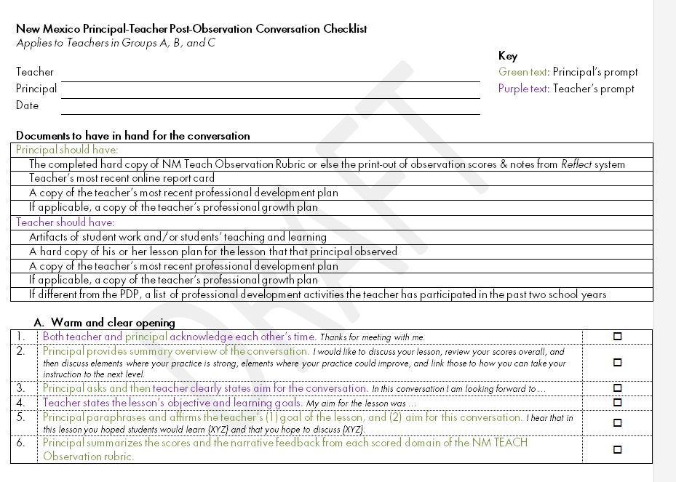
- Yes
- No

[q13b] Have you ever used the “Checklist for New Mexico Principals’ Provision of Feedback to Teachers” when conducting the formal feedback conference in the 2015-2016 school year?

- Yes
- No

[q13c] [If q11b = yes)] With how many of your teachers, if any, have you used the “Conversation Checklist”?
- None
- A few
- About half
- Most
- All or nearly all

[q13d] [If treatment=1| (if treatment = 0 & q13a = yes)] Did you view the testimonial video that was distributed along with the Conversation Checklist?
- Yes
- No
- I don’t know

[q13e] Have you ever received the “Guidance for New Mexico Principals’ About Provision of Feedback to Teachers” document? It looks like this:

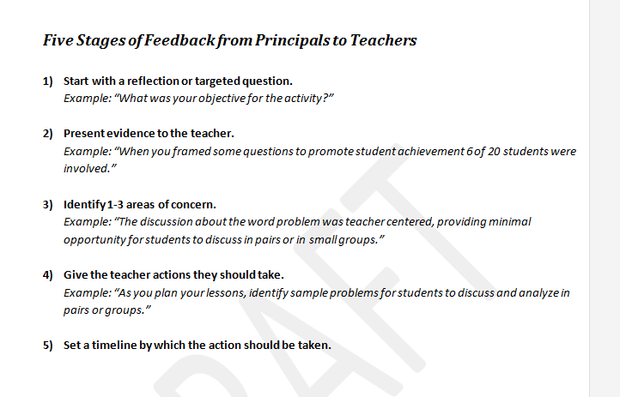

- Yes
- No

[q13f] If q13e = yes)] With how many of your teachers, if any, have you used the advice included in the “Recommended Practices” document?
- None
- A few
- About half
- Most
- All or nearly all

[q13g][If q13c = none] Please select all of the reasons you have not used the Conversation Checklist.
- [q13ga]I have never seen the Conversation Checklist.
- [q13gb]I haven’t yet used the Conversation Checklist, but I plan to.
- [q13gc]I got the Conversation Checklist too late for me to use in teacher conferences.
- [q13gd]The Conversation Checklist looks burdensome—e.g., too long, too hard.
- [q13ge]I don’t need it; I already have a way of holding feedback conversations with teachers that works well.
- [q13gf]I’ve read the Conversation Checklist and am using some concepts, but I’m not following the checklist.
- [q13gg]Other: ______________________________________________________

[q13h][If q13c ~= all & q13c ~= none] Which type of teachers did you use the “Conversation Checklist” with? Select all that apply.
- [q13ha] Only highly effective teachers
- [q13h b] Only satisfactory teachers
- [q13h c] Only struggling teachers
- [q13h d] Only new teachers
- [q13h e] Only experienced teachers
- [q13h h] Other: _________________________________________________________

[q14a] [if 13C ~= none] Use the slider to estimate how long post-observation conferences typically took you during school year 2015-2016 when you used the “Conversation Checklist.” Think only of conferences after formal observations; do not include informal feedback from classroom walk-throughs.

[insert slider graphic here. Tick marks for 0 minutes, 15 min, 30 min., 45 min., 60 min, 75 min, 90 min]

[q14b] [if q13f~= none] Use the slider to estimate how long post-observation conferences typically took you during school year 2015-2016 after you reviewed the “Guidance for New Mexico Principals’ About Provision of Feedback to Teachers”. Think only of conferences after formal observations; do not include informal feedback from classroom walk-throughs.

[insert slider graphic here. Tick marks for 0 minutes, 15 min, 30 min., 45 min., 60 min, 75 min, 90 min]

[q15x] If 13C ~= none ] Use the slider to indicate how much you agree or disagree with the following statements about your opinions about the Conversation Checklist this year (school year 2015-2016).

 | Disagree Strongly | Disagree Somewhat | Agree Somewhat | Agree Strongly
[q15a] The Conversation Checklist is easy to use. | [insert slider graphic here]
[q15b] The Conversation Checklist takes too much time to use. | [insert slider graphic here]
[q15c] The Conversation Checklist makes the feedback conversation feel formulaic. | [insert slider graphic here]
[q15d] The Conversation Checklist provided me and teachers a helpful structure for feedback. | [insert slider graphic here]
[q15e] I provided more critical feedback to teachers than I had in prior conferences where I didn’t use the Conversation Checklist. | [insert slider graphic here]
[q15f] The Conversation Checklist helps teachers commit to specific set of next steps to improve their instruction. | [insert slider graphic here]
[q15g] I use the Conversation Checklist as the basis to create teachers’ professional development plans (PDPs). | [insert slider graphic here]
[q15h] I use the Conversation Checklist as the basis to create professional growth plans (PGPs) for struggling teachers. | [insert slider graphic here]

-----------------------------------------------------[NEW SURVEY PAGE]----------------------------------

Professional Development Offered to Teachers This Year (2015-2016)

The questions in this section ask about professional development for teachers.
- Professional development includes (but is not limited to) workshops, inservices, coaching/mentoring, collaborative planning/study, institutes, professional conferences, online courses, self-directed learning, and so forth.

[q16x] Use the slider to indicate how much you agree or disagree with each of the following statements about the professional development experiences of teachers at your school this year (2015-2016, including summer 2015).
- Consider professional development offered by the district and other external sources as well as professional development offered by the school.

The professional development options for teachers this year….

 | Don’t know | Disagree Strongly | Disagree Somewhat | Agree Somewhat | Agree Strongly
[q16a] Were mostly developed by school leaders or teachers at my school. |  | [insert slider graphic here]
[q16b] Were mostly job-embedded rather than one-time only sessions. |  | [insert slider graphic here]
[q16c]Were varied and numerous enough to allow me to customize my PD recommendations to teachers based on their performance on specific domains of the NM TEACH Observation Rubric.{link} |  | [insert slider graphic here]
[q16d]Helped teachers improve on elements measured by the NM TEACH Observation Rubric. |  | [insert slider graphic here]
[q16e]Helped teachers improve other elements of the NM TEACH evaluation besides the NM TEACH Observation Rubric (e.g., student achievement or “other” multiple measure). |  | [insert slider graphic here]
[q16f]Were well aligned with the Common Core State Standards and/or curriculum based on these standards. |  | [insert slider graphic here]
[q16g]Have been convenient enough to promote teachers’ participation. |  | [insert slider graphic here]
[q16h]Were sufficiently resourced (for example, substitute coverage, funding to cover expenses, stipends) to allow teachers to participate in the professional development they need to do their jobs successfully. |  | [insert slider graphic here]
[q16i]District-provided professional development offerings (workshops, inservices, online courses, etc.) have enough slots and availability to accommodate all teachers who wish or need to participate. |  | [insert slider graphic here]
[q16j]Teachers have had easy access to a catalog of professional development opportunities aligned with the NM TEACH Observation Rubric. |  | [insert slider graphic here]

[q17x] Thinking about the professional development that teachers at your school have participated in this year (2015-2016, including summer 2015), use the slider to indicate how useful you think each of the following has been for improving teacher effectiveness.

 | Not Applicable | Not at all useful | Slightly useful | Moderately useful | Very useful
[q17a]Workshops or inservices for teachers at your school only (typically on-site) |  | [insert slider graphic here]
[q17b]Workshops, inservices, institutes, or conferences organized by your district for teachers from multiple schools |  | [insert slider graphic here]
[q17c]Online professional development offered by or through your district |  | [insert slider graphic here]
[q17d]District- or state-sponsored induction program, mentoring, or other professional development activities for new or beginning teachers |  | [insert slider graphic here]
[q17e]Instructional coaching (provided by school-based coaches or district coaches) |  | [insert slider graphic here]
[q17f]Professional development led by me or a school leader such as study groups or school-wide staff meetings |  | [insert slider graphic here]
[q17g]School-based teacher collaboration (grade-level or subject-area teams, professional learning communities, study groups, etc.) |  | [insert slider graphic here]
[q17h]Videos of sample lessons |  | [insert slider graphic here]

-----------------------------------------------------[NEW SURVEY PAGE]----------------------------------

Training You Received About NM TEACH to Date
[q18x]What types of professional development have you received to date regarding the teacher evaluation system, NM TEACH? (Check all that apply.)
- [q18a][exclusive option]No professional development received
- [q18b]Information on the NM TEACH Educator Effectiveness system(overall purpose, specific components, consequences for teachers, relationship to professional development, and so forth)
- [q18c]How to use the NM TEACH Observation Rubric
- [q18d]How to provide feedback to individual teachers after formal classroom observations
- [q18e]How to enter scores from NM TEACH Observation Rubric into Reflect, the Teachscape software
- [q18f]How to use Reflect, the Teachscape software
- [q18g]How to interpret a teachers’ NM TEACH Summative Evaluation Score
- [q18h]How to give NM TEACH Observation Rubric ratings consistent with those given by other raters
- [q18i]How to understand and make use of NM TEACH Summative Evaluation Score to help improve teaching at my school
- [q18j]How to direct teachers to professional development based on their NM TEACH Summative Evaluation Score
- [q18k]Other:

[q19] [if 18b-k ==yes] Who sponsored the training you attended about NM TEACH Educator Effectiveness system? Mark as many as apply.
- State Public Education Department
- My school district
- Other: __________________
- Don’t know

[q20] [if 18b-k ==yes] In total, how many minutes of training did you receive this year (2014-2015, including summer 2014) about how to provide feedback to teachers.
- 0 minutes
- 15 minutes
- 30 minutes
- 60 minutes
- 120 minutes
- 240 minutes
- Other:

[q21] [if 18d==yes] Thinking about the training on how to conduct post-observation conferences with teachers, use the slider to indicate how useful you think the training was.
Not at all useful | Slightly useful | Moderately useful | Very useful
[insert slider graphic here]

[q22x] Use the slider to indicate how much you agree or disagree with each of the following statements about your understanding of NM TEACH.

 | Disagree strongly | Disagree somewhat | Agree somewhat | Agree strongly
[q22a]I understand how the overall teacher ratings work in the NM teacher evaluation system (NM TEACH). | [insert slider graphic here]

-----------------------------------------------------[NEW SURVEY PAGE]----------------------------------

Your Personal Views of NM TEACH

[q23x]Use the slider to indicate how much you agree or disagree with each of the following statements about the teacher effectiveness ratings that became available in school year 2015-2016.

 |  | Disagree Strongly | Disagree Somewhat | Agree Somewhat | Agree Strongly
[q23a]The NM TEACH Educator Effectiveness System does a good job distinguishing effective from ineffective teachers. |  | [insert slider graphic here]
[q23b]The NM TEACH Educator Effectiveness System is fair to all teachers, regardless of their personal characteristics or those of the students they teach. |  | [insert slider graphic here]
[q23c]The NM TEACH Educator Effectiveness System ignores important aspects of teacher performance. |  | [insert slider graphic here]
[q23d]The NM TEACH Educator Effectiveness System requires so much of my time that it interferes with other important activities. |  | [insert slider graphic here]
 | [q23e]I have a clear idea of what the NM TEACH Educator Effectiveness System views as “good instruction.” | [insert slider graphic here]
 | [q23g]The NM TEACH Educator Effectiveness System has helped me pinpoint specific things I can do to help improve my teachers’ performance. | [insert slider graphic here]
 | [q23h]In the current NM TEACH Educator Effectiveness System, teachers who do poorly on their evaluation often leave teaching voluntarily. | [insert slider graphic here]

[q24x]Use the slider to rate how much you agree or disagree with each of the following statements about the NM TEACH Observation Rubric.

 | Disagree Strongly | Disagree Somewhat | Agree Somewhat | Agree Strongly
[q24a]The 6 elements of Domain 1 (Planning and Preparation) of the NM TEACH Observation Rubric {link} are a useful way to measure the quality of teachers’ instructional practices. | [insert slider graphic here]
[q24b] The 5 elements of Domain 2 (Creating an Environment for Learning) of the NM TEACH Observation Rubric {link} are a useful way to measure the quality of teachers’ instructional practices. | [insert slider graphic here]
[q24c]The 5 elements of Domain 3 (Teaching for Learning) of the NM TEACH Observation Rubric {link} are a useful way to measure the quality of teachers’ instructional practices. | [insert slider graphic here]
[q24d] The 4 elements of Domain 4 (Professionalism) of the NM TEACH Observation Rubric {link}are a useful way to measure the quality of teachers’ instructional practices. | [insert slider graphic here]
[q24e] Using the NM TEACH Observation Rubric {link} helps me to provide constructive, specific feedback to teachers to improve their instruction. | [insert slider graphic here]

-----------------------------------------------------[NEW SURVEY PAGE]----------------------------------

Teacher Retention and Improvement
[q25x]Over the past year (since approximately May 1, 2015), how many teachers at your school...

 | None  (0 teachers) | 1 teacher | 2 teachers | 3 teachers | More than 3 teachers | Don’t know
[q25a] Moved from effective to highly effective on the NM TEACH Summative Evaluation.
[q25b]Were put on an professional growth plan or entered probationary status
[q25c] Were dismissed (that is, had their district employment as a teacher terminated) due to receiving a low effectiveness rating on the NM TEACH Summative Evaluation
[q25d]Left teaching voluntarily after receiving a low effectiveness rating on the NM TEACH Summative Evaluation

---------------------------------------[NEW SURVEY PAGE]---------------------------------------------

Optional Comments from You

The following four questions are optional if you have any feedback you wish to share.

[q26] [if treatment = 1] Do you have any suggestions to help us improve the Principal-Teacher Post-Observation Conversation Checklist?

[q27] Do you have any comments about professional development available to teachers in your district?

[q28] Do you have any comments about the NM TEACH Observation Rubric?

[q29] Do you have any comments about training either your district or NM PED have offered about the NM TEACH teacher evaluation system?

---------------------------------------[NEW SURVEY PAGE]---------------------------------------------

Thank You!

Thank you so much for your time to complete this survey.

Within the next 2 weeks, you will receive an email message with instructions about how to claim your gift card. This email message will come from {iCard (services@icardgiftcard.com)} and will be sent to the same email address at which you received the survey invitation, unless you indicate otherwise here:

- Yes, please send my gift card information to the same email address to which you sent the survey invitation.
- Please send my gift card information to a different email address, which I am providing here: _______________
- No, I do not wish to receive a gift card email from {iCard}.

---------------------------------------[NEW SURVEY PAGE]---------------------------------------------

Thanks Again

You have completed the survey and may now close it.

