Spring 2016 Teacher Survey
[[Version: Teachers. On-line administration. Wave 2.]]

Understanding Your Participation in the Study

Welcome to the spring 2016 survey for teachers about feedback you receive about your instruction as a part of the NM TEACH Educator Effectiveness System. This is a follow-on to our spring 2015 survey to learn about the feedback you received from your school leaders last year.

Study Purpose. With funding from the federal Department of Education as a part of the Southwest Regional Educational Lab, this study is intended to learn about the feedback principals give to teachers under the NM TEACH Educator Effectiveness System, and teachers’ perceptions of that feedback For more information about the study, please see {REL Southwest website}. In {month, year} REL Southwest researchers asked all New Mexico’s public school principals to participate in a study about evaluation feedback to teachers. Results will be used to provide New Mexico Public Education Department feedback regarding how to improve the NM TEACH Educator Effectiveness System training for principals and teachers.

Survey Purpose. This survey is intended to gather information on the provision of feedback after formal observations by school leaders to teachers about their performance. REL Southwest researchers will link your survey responses to basic employment information, such as race, ethnicity and years of experience that REL Southwest researchers will obtain from NM PED. Survey results will not be used to evaluate you, other teachers, or school leaders.

Procedures. Online completion of the survey should take approximately 30 minutes. By using your personal survey link provided in the invitation email, you will be able to complete the survey in multiple sessions; responses will be saved as you enter them. However, once you click “submit” at the very end of the survey, you will no longer be able to return.

Confidentiality. REL Southwest will keep all survey responses confidential and will only use them for the purpose of the study. Our reports will contain summaries, and responses will never be presented in any way that would permit readers to identify you or your school. No one at your school, district, or the state will have access to survey responses that include respondents’ names, school names, or other information that could potentially be used to identify individuals or schools.

Participants. In each of the participating New Mexico public schools, REL Southwest has invited the principal to participate in this study. Up to 10 teachers in your school were selected at random to be surveyed. Only those teachers who completed surveys in spring 2015 are being sent this survey now in spring 2016.

Benefits. Your completion of this survey gives you the opportunity to reflect on and share your perspective about the teacher evaluation system. You will be providing valuable information that may help New Mexico Public Education Department improve the NM TEACH Educator Effectiveness System.

Compensation. Within two weeks of completion of the online survey, you will receive via email a link to your $25 online gift card for completing the survey.

Risks. The risks associated with your participation in this study are minimal.

Voluntary Participation. Your participation in this survey is completely voluntary. You can decide not to participate or to discontinue your participation at any time. A few survey questions, marked with a red asterisk, are required for routing to later questions.

PRA Burden Statement. According to the Paperwork Reduction Act of 1995, no persons are required to respond to a collection of information unless such collection displays a valid OMB control number. The valid OMB control number for this information collection is 1850-xxxx. Public reporting burden for this collection of information is estimated to average 30 minutes per response, including time for reviewing instructions, searching existing data sources, gathering and maintaining the data needed, and completing and reviewing the collection of information. The obligation to respond to this collection is voluntary. If you have comments or concerns regarding the status of your individual submission of this form, application or survey, please contact Chris Boccanfuso at (202) 219-1674, or at Institute of Education Sciences, 555 New Jersey Ave., NW, Suite 506D, Washington, DC 20001, directly. [Note: Please do not return the completed instrument, form, application or survey to this address.]

Questions? If you have any questions about this survey or the study as a whole, please feel free to call us toll-free at {XXX}. You can also contact {XX}, the survey coordinator, at {email} or by phone at {XX}. If you have concerns or questions about your rights as a participant, contact the REL Southwest at SEDL (which is responsible for the protection of project participants): {email}, toll free at {XX}, or c/o IRB, {address}.

[Required question] Informed Consent. By clicking the box below, you are indicating that you have read and understood the information provided to you about your participation in this survey.

- I have read and understood the information and choose to participate.

Thank you very much for your help in this important study!

---------------------------------------[NEW SURVEY PAGE]---------------------------------------------

Using This Survey

Here are some tips that may help you navigate and complete this survey.

Returning to previous pages. Be sure to use the survey “go back to previous page” button at the bottom of the page. Do not use your browser’s back button—it will not work.

Returning to the survey itself. If you would like to complete the survey in multiple sessions—or if you accidentally get disconnected from the survey—you can return to your previous responses by clicking on the link that was in your invitation email. This will take you to where you left off (through the last full page you completed). You can keep returning until you click on the “submit” button on the final page of the survey.

Saving your responses. Your responses on any given survey page are saved when you click on either button at the bottom of the page (“save and go to next page” or “go back to previous page”).

Adding optional comments. Toward the bottom of each survey page is a space where you can write in any comments you may have pertaining to the questions on the page. This is completely optional.

----------------------------------------[INTERNAL CODES]-----------------------------------------------

Treatment code (treatment): REL Southwest will pre-identify via an internal code that will not be listed on the survey whether teacher respondent works at a school that belongs to the treatment group or the control group. treatment = 1 indicates teacher is in the treatment group. treatment = 0 = control group. Unless otherwise noted, survey questions will appear for both groups of teachers.

Prior respondent code: REL Southwest will pre-identify those respondents who, from the same email address, completed the corresponding item in wave 1 spring 2015 survey. For these respondents, prior = 1.

----------------------------------------[NEW SURVEY PAGE]-----------------------------------------------

Your Position and Job Responsibilities

We would like to update our information about your position.

[q1] Which of the following best describes your current position as a teacher of K-12 students? (Check one.)
- If you are not a teacher of K-12 students, or do not have teaching responsibilities in 2015-2016, you have received this survey in error. Please let us know by replying to the invitation email or by calling {number}.
- Regular education teacher
- Special education teacher
- Other kind of teacher: ___________________________________

[q2x] What subject area(s) are you currently teaching? (Check all that apply.)
- [q2a] English/language arts/reading/writing
- [q2b] Mathematics
- [q2d] Science
- [q2d] Social Studies
- [q2e] Foreign language(s)
- [q2f] Visual or performing arts (art, music, etc.)
- [q2g] Physical education/health education
- [q2h] Career/technical education
- [q2i] Other subject area(s): [include fill-in box]

[q3] Which one of the following three groups of teachers do you belong to? These groups are defined by New Mexico’s teacher evaluation system, NM TEACH.
- Group A: tested subject, tested grade
- Group B: grade 3 – 12 subject not linkable to NM’s standard based assessments
- Group C: grade K-2 teacher

[q4]Which of the following best describes your current teaching arrangement? (Check one.)
- I teach a single group of students all or most of the day in multiple subject areas. (Traditional elementary arrangement; sometimes called “self-contained.”)
- I teach several classes of different students during the day in a particular subject (for example, math) or perhaps two subjects (for example, you teach some math classes and some science classes). (Traditional secondary arrangement; sometimes called “subject-specific” or “departmentalized”; at elementary level, sometimes called “subject matter specialist.” Also typical arrangement for physical education, art, music, etc.)
- I mainly teach selected students released from (or in) their regular classes in specific skills or to address specific needs (for example, special education, reading, English as a second language, gifted and talented.) (Sometimes called “pull out”, “resource,” or “push in” instruction.)
- I am one of two or more teachers who are jointly responsible for teaching the same subject(s) to a group of students (for example, in the same classroom), all or most of the time and/or in a majority of classes. (Sometimes called “co-teaching” or “job share.”)
- Other (please describe): _______________________________________

[q5] [if prior q5 blank] Including this school year (2015-2016), how many years have you been teaching, total, regardless of location?
Total years teaching: |  | [fill in number: must be whole number less than 60]

[q6] [if prior q6 blank] Including this school year (2015-2016), how many years have you been teaching in your current school?

Years in current school: |  | [fill in number: must be whole number less than 60]

[q7] Which of the following best describes your current position as a teacher of K-12 students? (Check all that apply)
- Spanish bilingual teacher
- Native American bilingual teacher
- Other bilingual teacher: ___________________________________
- Not a bilingual teacher

----------------------------------------[NEW SURVEY PAGE]-----------------------------------------------

Your Experiences This Year (SY 2015-2016) of Formal Observations for Evaluation Purposes

[* required question ] [q8] Thinking back over this whole school year 2015-2016, how many times were you formally observed by a school leader? School leader is defined as a principal, assistant principal, dean, or coach charged with authority to conduct formal observations of 20+ minutes using the NM TEACH Observation Rubric {link to rubric}.
- 3 or more times
- 2 times
- 1 time
- 0 times

[q9] [If q8 = 1, 2, or 3+ times] Use the slider to estimate how long the formal post-observation conferences typically took? Think only of conferences after formal observations; do not include informal feedback you might have received from classroom walk-throughs.

[insert slider graphic here. tick marks for 0 min, 15 min, 30 min, 45 min, 60 min, 75 min, 90 min]

[q10] How frequently did you receive informal feedback this year from a school leader—for example, “wow or wonder” statements after brief walk-throughs.
- At least once a week
- At least once a month
- At least once per semester or trimester
- Never
- Other: ___________________

[q11x] [If q8 = 1, 2, or 3+ times] Use the slider to indicate how much you agree or disagree with the following statements about all of the conferences you had with a school leader following his or her formal observation(s) of your class this year (school year 2015-2016).

 | Disagree Strongly | Disagree Somewhat | Agree Somewhat | Agree Strongly
[q11a] The feedback session itself, separate from professional development I may have been recommended to take, helped me improve my instruction. | [insert slider graphic here]
[q11b] In each conference, I brought documents to the conference, documents such as the lesson plan, and PDP. | [insert slider here]
[q11c] In each conference, the school leader brought documents to conference, such as my summative score and the most recent PDP. | [insert slider here]
[q11d] In each conference the school leader identified at least one positive practice that I do well. | [insert slider graphic here]
[q11e]In each conference the school leader identified at least one challenge facing me. | [insert slider graphic here]
[q11f]In each conference, the school leader used my scores on the NM TEACH Observation Rubric to determine which instructional practices to praise or critique. | [insert slider graphic here]
[q11g] In each conference, the school leader used my scores on the NM TEACH Observation Rubric to determine what professional development to recommend to the teacher. | [insert slider graphic here]
[q11h] In each conference, the school leader ended the conference on a positive note. | [insert slider graphic here]
[q11i]Each conference followed a predictable format. | [insert slider graphic here]
[q11j]In each conference, my school leader and I mutually developed next steps for my instruction. | [insert slider graphic here]
.
[q11k]I walked away with a clear understanding of my school leader’s feedback. | [insert slider graphic here]
[q11l]My school leader listened to what I had to say during the conferences. | [insert slider graphic here]
[q11m]The observations were done to me, rather than for me. | [insert slider graphic here]
[q11n]I received specific feedback about my performance. | [insert slider graphic here]
[q11o] I received actionable feedback about my performance. | [insert slider graphic here]
[q11p]During the conferences, I committed to a specific set of next steps to improve my instruction. | [insert slider graphic here]
[q11q] ] In each conference, the school leader spoke for almost all of the time. | [insert slider here]
[q11r] There was a high level of conflict in the conference. | [insert slider graphic here]
[q11s In each conference I obtained recommendations for professional development tailored to my specific needs. | [insert slider graphic here]
[q11t] I trusted and accepted the feedback I received. | [insert slider graphic here]
[q11u]I feel positive about the feedback I got during the conferences. | [insert slider graphic here]
[q11v] I enjoyed most of the post-observation feedback conferences. | [insert slider graphic here]
[q11w] I was always provided with a written or online summary of the observation and my school leader’s comments on it. | [insert slider graphic here]

[q12x] Please indicate whether you were ever rated this school year by your school leader as needing to improve upon or else excelling in the following observation items from NM TEACH, whether you received a recommendation to take up professional development (PD), and how you rate yourself on the item. Mark all that apply.
NM TEACH Observation Item | I was rated at least once as excelling on this item | I was rated at least once as needing to improve on this item | I was recommended to take PD because of this item | I don’t know how I was rated | How would you rate yourself this school year on this item?
2A: Creating an environment of respect and rapport |  |  |  |  | [Ineffective, Minimally Effective, Effective, Highly Effective, Exemplary I don’t know]
2B: Organizing Physical Space
2C: Establishing a culture for learning
2D: Managing classroom procedures
2E: Managing Student Behavior
3A: Communicating with Students
3B: Using questioning and discussion techniques
3C: Engaging students in learning
3D: Assessment in Instruction
3E: Demonstrating flexibility and responsiveness

[q13a][if treatment=1 & q8 > 0]
Have you ever received the “Checklist for New Mexico Principals’ Provision of Feedback to Teachers” , a guide to conducting formal feedback sessions? The first page of the Conversation Checklist looks like this:

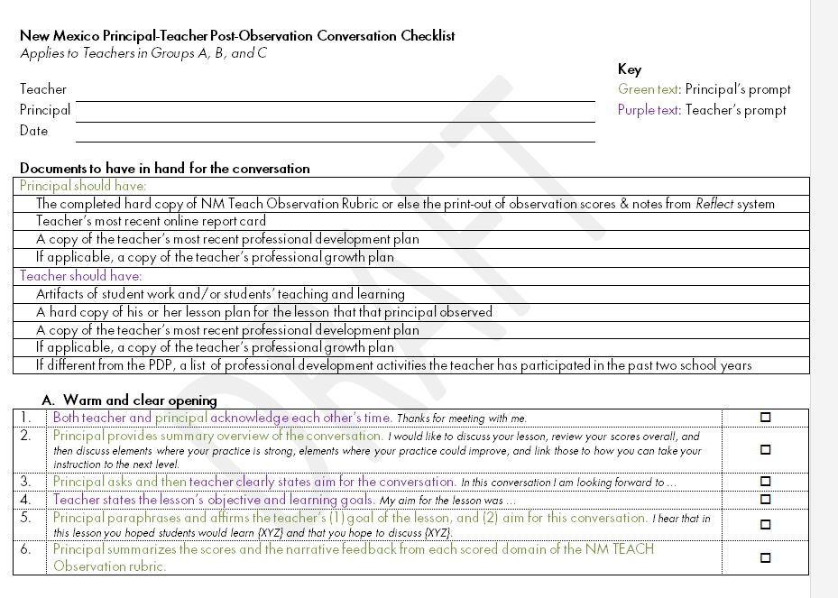
- Yes
- No

[q13b][if q8 > 0]Has your school leader ever used the “Checklist for New Mexico Principals’ Provision of Feedback to Teachers” when conducting the formal feedback conference in the 2015-2016 school year?

- Yes
- No

[q13c] [If q13b = yes)] For how many of your feedback sessions did your school leader(s) use the “Conversation Checklist”?
- 3 or more observations
- 2 observations
- 1 observation
- None of the observations
- I don’t know

[q13d [If 13a = yes)] Did you view the testimonial video that was distributed along with the Conversation Checklist?
- Yes
- No
- I don’t know

[q13e][] During the formal feedback sessions, has a school leader ever used the “Guidance for New Mexico Principals’ About Provision of Feedback to Teachers” to guide any of your formal feedback sessions during the 2015-2016 school year? The first page of the Conversation Checklist looks like this:

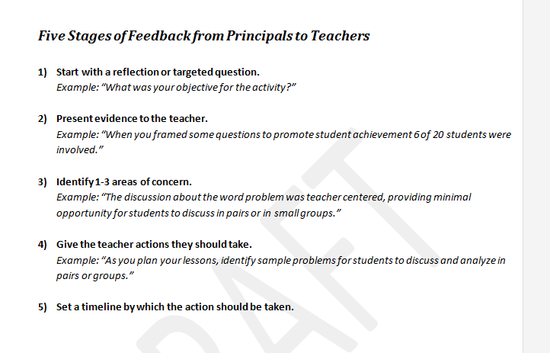
- Yes
- No

[q14x] If 13b=yes] Use the slider to indicate how much you agree or disagree with the following statements about your opinions about the Conversation Checklist this year (school year 2015-2016).

 | Disagree Strongly | Disagree Somewhat | Agree Somewhat | Agree Strongly
[q14a] The Conversation Checklist was easy to use. | [insert slider graphic here]
[q14b] The Conversation Checklist took too much time to use. | [insert slider graphic here]
[q14c] The Conversation Checklist made the feedback conversation feel formulaic. | [insert slider graphic here]
[q14d] The Conversation Checklist provided me and my school leader(s) a helpful structure for feedback. | [insert slider graphic here]
[q14e] I received more critical feedback when my school leader used the Conversation Checklist than in prior conferences when he/she didn’t use the Protocol. | [insert slider graphic here]
[q14f] The Conversation Checklist helped me commit to specific set of next steps to improve my instruction. | [insert slider graphic here]

-----------------------------------------------------[NEW SURVEY PAGE]----------------------------------

Professional Development You Received This Year (SY 2015-2016)

The questions on this page ask about all of the professional development (PD) you have participated in during the 2015-2016 school year. Don’t include any professional development you may have participated in prior to your first formal observation this school year.
- Professional development includes (but is not limited to) workshops, inservices, coaching/mentoring, collaborative planning/study, courses, institutes, professional conferences, self-directed learning, and so forth.
- Consider mandatory/required professional development as well as voluntary professional development.

[q15x] Please indicate all of the topics below that one or more school leader recommend you take. In addition, please also include which topics were covered in professional development you actually participated in this year (2015-2016). Select as many topics as apply.

 | A school leader recommended I take this PD | I took the PD online | I received the PD in person | I would have liked to take the PD but it was not available
[q15a] Classroom management
[q15b] Professionalism and communication in the classroom
[q15c] Special education and inclusion
[q15d] Standards-based lesson plans
[q15e] Common Core Standards
[q15f] Assessment (includes continuous assessment, portfolio assessment, Common Core aligned assessments)
[q15g] Data-driven instruction
[q15h] Early childhood
[q15i] Instructional strategies or content in the content area(s) you teach—e.g., Mathematics; or Literacy PD
[q15j] Response to Intervention
[q15k] Teachscape Reflect training
[q15l] Other NM TEACH training
[q15m] Sheltering Instruction for Language development
[q15n] Language Acquisition Design
[q15o] Scaffolding instruction
[q15m] Other: _______________________________
[q15n] Other: _______________________________
[q15o] Other: _______________________________

[q16x] Thinking about the professional development you have participated in this year (2015-2016, including summer 2015), use the slider to indicate how much you agree or disagree with each of the following statements.

My professional development experiences this year...

 | Disagree Strongly | Disagree Somewhat | Agree Somewhat | Agree Strongly
[q14a] Were mostly developed by school leaders or teachers at my school. | [insert slider graphic here]
[q14b] Were mostly job-embedded rather than one-time only sessions. | [insert slider graphic here]
[q16a] Were varied and numerous enough to allow the school leader to customize PD recommendations based on my performance on specific domains of the NM TEACH Observation Rubric.{link} | [insert slider graphic here]
[q16b] Have been useful for helping me improve the achievement of my students | [insert slider graphic here]
[q16c]Have been useful for improving my instruction | [insert slider graphic here]
[q16d]Have taken more time than they were worth | [insert slider graphic here]
[q16e]Have been well aligned with the Common Core State Standards and/or curriculum based on these standards | [insert slider graphic here]

[q17x]Use the slider to indicate how much you agree or disagree with each of the following statements about the support you have received related to your professional development experiences this year (SY 2015-2016, including summer 2015).

 | Disagree Strongly | Disagree Somewhat | Agree Somewhat | Agree Strongly
[q17a] I had easy access to a list of the possible professional development courses or offerings I could take. | [insert slider graphic here]
[q17b]My school leader(s) has encouraged and supported my participation in professional development. | [insert slider graphic here]
[q17c]Sufficient resources (for example, substitute coverage, funding to cover expenses, stipends) have been available to allow me to participate in the professional development I need to teach effectively. | [insert slider graphic here]
[q17d]I have had sufficient flexibility in my schedule to pursue the professional development opportunities recommended for me. | [insert slider graphic here]

-----------------------------------------------------[NEW SURVEY PAGE]----------------------------------

Your Perceptions of the Quality of Your School’s Leadership

[q18] Rate your level of agreement with the following statement: “Overall, I was satisfied with the quality of my school’s leaders (principals, assistant principals, deans, department chairs) this year (school year 2015-2016).”
- Disagree strongly
- Disagree somewhat
- Agree somewhat
- Agree strongly

[q19x] Thinking about this year (2015-2016), use the slider to indicate how much you agree or disagree with the following statements. “The school leaders who conduct formal observations of my classroom …

 | Disagree Strongly | Disagree Somewhat | Agree Somewhat | Agree Strongly
[q19a] Understand the subject matter content that I teach. | [insert slider graphic here]
[q19b] Understand what skills are needed for teachers to foster meaningful student learning. | [insert slider graphic here]
[q19c] Foster an atmosphere of trust and mutual respect in my school. | [insert slider graphic here]
[q19d] Understand the 3 rating components of the NM Teach Summative Evaluation Report (student achievement, observations, multiple measures). | [insert slider graphic here]
[q19e] Help to improve my teaching. | [insert slider graphic here]
[q19f] Are instructional leaders. | [insert slider graphic here]

-----------------------------------------------------[NEW SURVEY PAGE]----------------------------------

Your Personal Views of NM TEACH Educator Effectiveness System

[q20x]Use the slider to rate how much you agree or disagree with each of the following statements about the NM TEACH Educator Effectiveness System from school year 2015-2016.

 |  | Disagree Strongly | Disagree Somewhat | Agree Somewhat | Agree Strongly
[q20a]The NM TEACH Educator Effectiveness System does a good job distinguishing effective from ineffective teachers. |  | [insert slider graphic here]
[q20b]The NM TEACH Educator Effectiveness System is fair to all teachers, regardless of their personal characteristics or those of the students they teach. |  | [insert slider graphic here]
 | [q20c]The NM TEACH Educator Effectiveness System has helped me pinpoint specific things I can do to help improve my performance. | [insert slider graphic here]
[q20d] I understand how the overall teacher ratings work in the NM TEACH Educator Effectiveness System. |  | [insert slider graphic here]

-----------------------------------------------------[NEW SURVEY PAGE]----------------------------------

Your NM TEACH Rating Summative Evaluation

[q21]Do you know what your level of Educator Effectiveness (Ineffective, Minimally Effective, Effective, Highly Effective, Exemplary) was for the school year 2015-2016?
- Yes
- No

[q22] [if q21=yes] How did you learn your level of Educator Effectiveness for the school year 2015-2016? Select all that apply.

- I received it via email from New Mexico Public Education Department
- I logged into my teacher portal online
- A school leader told me
- I received it via my mailbox at school
- Other: ______________________
- Other: ______________________
- I don’t recall

[q23] [if q21=yes] Did a school leader ever discuss with you how to improve your Educator Effectiveness score?

- Yes, we had a conference
- Yes, in passing
- No
- I don’t recall

[q24] [if q21=yes] Did a school leader ever discuss with you how to interpret your student achievement growth score?

- Yes, we had a conference
- Yes, in passing
- No
- Not Applicable
- I don’t recall

---------------------------------------[NEW SURVEY PAGE]---------------------------------------------

Optional Comments from You

The following four questions are optional if you have any feedback you wish to share. If you do not, proceed to the next and final page.

[q25] [if 13a=yes] Do you have any suggestions to help us improve the Checklist for New Mexico Principals’ Provision of Feedback to Teachers?

[q26] Do you have any comments about professional development available to teachers in your district?

[q27] Do you have any comments about the NM TEACH Observation Rubric?

[q28] Do you have any comments about the NM TEACH teacher evaluation system?

---------------------------------------[NEW SURVEY PAGE]---------------------------------------------

Thank You!

Thank you so much for your time to complete this survey.

Within the next 2 weeks, you will receive an email message with instructions about how to claim your gift card. This email message will come from {iCard (services@icardgiftcard.com)} and will be sent to the same email address at which you received the survey invitation, unless you indicate otherwise here:

- Yes, please send my gift card information to the same email address to which you sent the survey invitation.
- Please send my gift card information to a different email address, which I am providing here: _______________
- No, I do not wish to receive a gift card email from {iCard}.

---------------------------------------[NEW SURVEY PAGE]---------------------------------------------

Thanks Again

You have completed the survey and may now close it.

