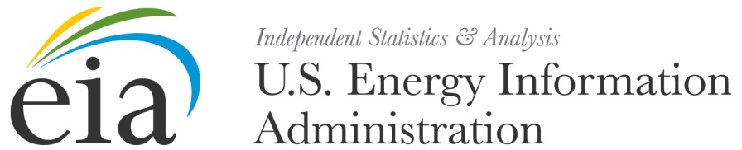

UNITED STATES DEPARTMENT OF COMMERCE
Economics and Statistics Administration

U.S. Census Bureau
Washington, DC 20233-0001

Month XX, 2014 OMB Approval No. 1905-0169

Dear Manufacturer,

One or more of your company’s establishments have been selected to participate in the 2014 Manufacturing Energy Consumption Survey (MECS), which will open electronically for your response in the early part of 2015. At this time, we are only looking to update our records with your company’s correct contact information. When the MECS is sent to you in early 2015 your company’s participation in the survey will be mandatory and is required by Federal Law. (Federal Energy Administration Act of 1974, Pub. Law No. 93-275, and under Title 3, Subtitle B, of the Omnibus Budget Reconciliation Act of 1986, Pub. Law No. 99-509, as amended by Title 1, Subtitle G, of the Energy Policy Act of 1992, Pub. Law No. 102-486)

In order for us to ensure we have the correct contact information for the person from your organization who will be completing the survey, please go to the MECS Business Help Site at http://www.census.gov/econhelp/mecs and enter the contact information for your company’s representative by Month XX, YYYY. To begin, select the link under Internet Reporting. This link will take you to a brief form that should only take a few minutes to complete. You will need your username and password which is located at the top right of this letter. If you have more than one manufacturing establishment in your company, the list of your company’s establishments sampled for the 2014 MECS is available by clicking the appropriate link. If you do not have internet access, complete the Coordinator Fax Form on the back of this letter and fax it to Mr. Leif Crider at (301) 763-8398.

The MECS Business Help Site also has information and links that describe MECS and the Federal laws that require your submission and protect the confidentiality of your data. Under Section 9 of Title 13, U.S. Code, your report to the Census Bureau may be seen only by persons sworn to uphold the confidentiality of Census Bureau information and may be used only for statistical purposes. No data are published that could reveal the identity or activities of any specific individual or firm. Further, copies retained in respondents’ files are immune from legal process. Previous data and information are also located at http://www.eia.doe.gov/emeu/mecs. If you do not have access to a fax or need to speak with a knowledgeable staff person about the MECS, please call 1-800-866-6327 and a Census staff member will gladly receive your contact information.

The MECS is the Federal Government’s only systematic survey that gauges energy impacts on various parts of the industrial sector. It measures energy consumption and related manufacturing characteristics and behaviors; provides industry, policymakers and the public with unbiased and accurate data; and evaluates manufacturing demands in the face of rising energy prices and national security concerns. Because your establishment represents other establishments of similar size and kind of business, it is essential that your company responds to ensure reliable and unbiased estimates of manufacturing energy consumption. We strongly recommend that your company selects a person that is familiar with the manufacturing processes and use of energy at the plant to complete the MECS when it arrives, such as a Plant Manager or Operations Manager.

Thank you for your time and cooperation with this important effort.

Sincerely,

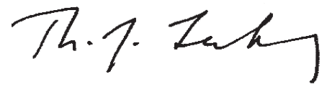

Director, Office of Energy Consumption & Efficiency Statistics
Thomas Leckey
U.S. Energy Information Administration

Nick Orsini
Chief, Economic Reimbursable Division
U.S. Census Bureau

MECS-1(L) (06/2014)

U S C E N S U S B U R E A U
Helping You Make Informed Decisions www.census.gov

U.S. Census Bureau 2014 MANUFACTURING ENERGY CONSUMPTION SURVEY

Coordinator Fax Form

2014 Manufacturing Energy Consumption Survey

Please identify your company’s survey coordinator online or by fax by Month XX, YYYY.

If you do not have access to the internet, fax this form to (301) 763-8398.

Your Company’s Username:

Password: Name of Company:

Name of coordinator

Title of coordinator

Address (line 1)

Address (line 2)

City
State
Zip

Telephone – –

(06/2014)

