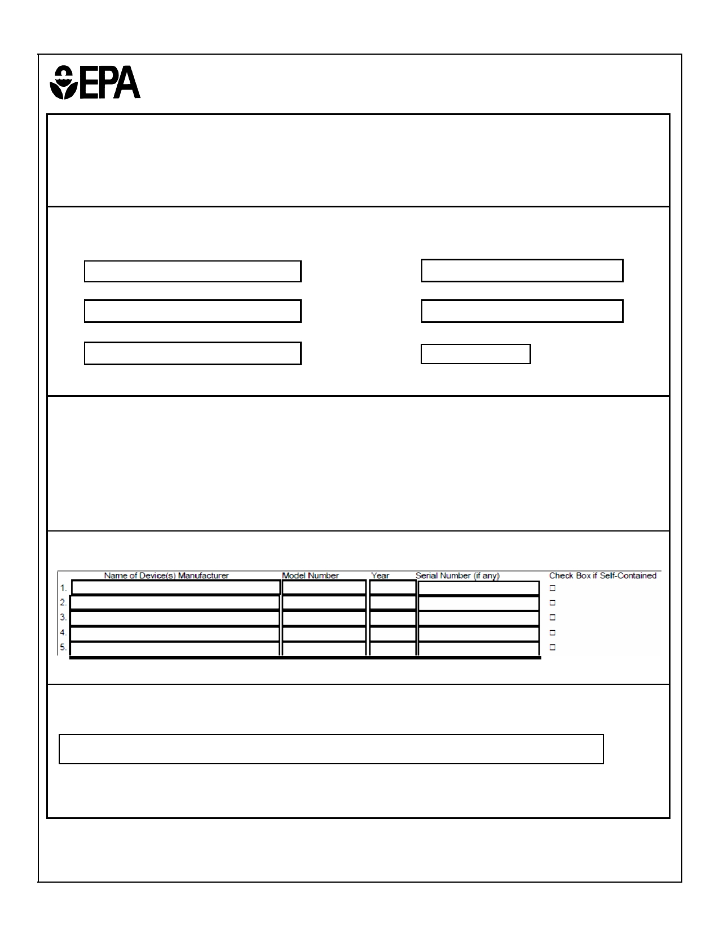Form Approved 11/04/2011

OMB No. 2060-0256 Expires: MM/DD/YYYY

**ENVIRONMENTAL PROTECTION AGENCY**

**REFRIGERANT RECOVERY OR RECYCLING DEVICE**

**ACQUISITION CERTIFICATION FORM**

EPA regulations require establishments that service or dispose of refrigeration or air-conditioning equipment to certify

that they have acquired recovery or recycling devices that meet EPA standards for such devices. To certify that you

have acquired equipment, please complete this form according to the instructions and **mail it to the appropriate**

**EPA Regional Office. BOTH THE INSTRUCTIONS AND MAILING ADDRESSES CAN BE FOUND ON THE REVERSE SIDE OF THIS FORM.**

**PART 1: ESTABLISHMENT INFORMATION**

Name of Establishment Street

(Area Code) Telephone Number City State Zip Code

Number of Service Equipment Based at Establishment Country

**PART 2: REGULATORY CLASSIFICATION**

Identify the type of work performed by the establishment**. Check all boxes that apply.**

□ Type A - Service small appliances

□ Type B - Service refrigeration or air-conditioning equipment other that small appliances

□ Type C- Dispose of small appliances

□ Type D - Dispose of refrigeration or air-conditioning equipment other than small appliances

**PART 3: DEVICE IDENTIFICATION**

**PART 4: CERTIFICATION SIGNATURE**

I certify that the establishment in Part 1 has acquired the refrigerant recovery or recycling device(s) listed in Part 2, that the establishment is complying with Section

608 regulations, and that the information gives is true and correct.

Signature of Owner/Responsible Officer Date Name (Please Print) Title

**EPA FORM 7610-31**

Form Approved 11/04/2011

OMB No. 2060-0256

Expires: MM/DD/YYYY

***INSTRUCTIONS***

**Part 1:** Please provide the name, address, and telephone number of the establishment where the

refrigerant recovery or recycling device(s) is (are) located. Please complete one form for each location. State the number of vehicles based at this location that are used to transport technicians and equipment to and from service sites.

**Part 2:** Check the appropriate boxes for the type of work performed by technicians who are

employees of the establishment. The term "small appliance" refers to any of the following products that are

fully manufactured, charged, and hermetically sealed in a factory with five pounds or less of refrigerant:

refrigerators, and freezers designed for home use, room air conditioners (including window air

conditioners and packaged terminal air conditioners), packaged terminal heat pumps, dehumidifiers,

under-the-counter ice makers, vending machines, and drinking water coolers.

**Part 3:** For each recovery or recycling device acquired, please list the name of the manufacturer of the device, and (if applicable) its model number and serial number.

If more than seven devices have been acquired, please fill out an additional form and attach it to

this one. Recovery devices that are self-contained should be listed first and should be identified by

checking the box in the last column on the right. Self-contained recovery equipment means refrigerant

recovery or recycling equipment that is capable of removing the refrigerant from an appliance without the

assistance of components contained in the appliance. On the other hand, system-dependent recovery

equipment means refrigerant recovery equipment that requires the assistance of components contained in an appliance to remove the refrigerant from the appliance.

If the establishment has been listed as Type B and/or Type D in Part 2, then the first device listed in Part # must be a self-contained device and identifies as such by checking the box in the last column on the right.

If any of the devices are homemade, they should be identified by writing "homemade" in the

column provided for listing the name of the device manufacturer. Type A or Type B establishments can

use homemade devices manufactured before November 15, 1993. Type C or Type D establishments can

use homemade manufactured anytime. If, however, a Type C or Type D establishment is using

homemade equipment manufactured after November 15, 1993, then it must not use these devices for service jobs.

**EPA FORM 7610-31**

Form Approved

OMB No. 2060-0256 Expires: MM/DD/YYYY

**EPA REGIONAL OFFICES**

Send your form to the EPA office listed under

the state or territory in which the establishment is located.

Connecticut, Maine, Massachusetts, New

Hampshire, Rhode Island, Vermont

CAA 608 Enforcement Contact: EPA Region I; Mail Code OES04-2; 5 Post

Office Square; Boston, MA 02109

New York, New Jersey, Puerto Rico, Virgin

Islands

CAA 608 Enforcement Contact: EPA Region II; Mail Code 2DECA-AC; 290

Broadway; New York, NY 10007-1866

Delaware, District of Columbia, Maryland,

Pennsylvania, Virginia, West Virginia

CAA 608 Enforcement Contact: EPA

Region III-Wheeling Office; Mail Code

3AP20; 1060 Chapline Street, Suite 303

Wheeling, W V 26003-2995

Alabama, Florida, Georgia, Kentucky,

Mississippi, North Carolina, South Carolina,

Tennessee

CAA 608 Enforcement Contact: EPA

Region IV; Mail Code APT-AE; 61 Forsyth

Street, SW; Atlanta, GA 30303-8960

Illinois, Indiana, Michigan, Minnesota, Ohio,

Wisconsin

CAA 608 Enforcement Contact: EPA

Region V; Mail Code AE-17J; 77 West Jackson Blvd.; Chicago, IL 60604-3507

Arkansas, Louisiana, New Mexico, Oklahoma,

Texas

CAA 608 Enforcement Contact: EPA

Region VI; Mail Code 6EN-HM; 1445 Ross

Ave., Suite 1200; Dallas, TX 75202

Iowa, Kansas, Missouri, Nebraska

CAA 608 Enforcement Contact: EPA

Region VII; Mail Code APCOAWMD; 901

11201 Renner Boulevard

Lenexa, Kansas 66219

Colorado, Montana, North Dakota, South

Dakota, Utah, Wyoming

CAA 608 Enforcement Contact: EPA

Region VIII; Mail Code 8ENE-AT; 1595

Wynkoop Street, Denver, CO 80202

American Samoa, Arizona, California, Guam,

Hawaii, Nevada

CAA 608 Enforcement Contact: EPA

Region IX; Mail Code AIR-5; 75

Hawthorne Street; San Francisco, CA

94105

Alaska, Idaho, Oregon, Washington

CAA 608 Enforcement Contact: EPA Region X; Mail Code OAQ-107; 1200

Sixth Ave.; Seattle, W A 98101

**EPA FORM 7610-31**

ii

Form Approved

OMB No. 2060-0256 Expires: MM/DD/YYYY

**PUBLIC BURDEN**

The purpose and need of this renewed collection request is to facilitate compliance with and

enforcement of Section 608 of the Act by reducing emissions of class I and class II ozone-depleting

refrigerants to the lowest achievable level during the service, maintenance, repair, and disposal of

appliances. EPA has used and will continue to use these records and reports to ensure that refrigerant

releases are minimized during the recovery and recycling of ozone-depleting refrigerants during the

service, maintenance, repair, and disposal of appliances. Collection of this information is mandated by EPA regulations, in accordance with 40 CFR 82.162. This information is not shared with parties outside

of the Federal government. EPA's confidentiality regulations (40 CFR 2.201 et seq.) assure computer

data security, disclosure prevention, proper handling, proper storage, and proper disposal of the submitted information.

The public reporting and recordkeeping burden for this collection of information is estimated to average one (1) hour per response per respondent annually. Burden means the total time, effort, or

financial resources expended by persons to generate, maintain, retain, or disclose or provide information to or for a Federal agency. This includes the time needed to review instructions; develop, acquire, install,

and utilize technology and systems for the purposes of collecting, validating, and verifying information,

processing and maintaining information, and disclosing and providing information; adjust the existing

ways to comply with any previously applicable instructions and requirements; train personnel to be able to

respond to a collection of information; search data sources; complete and review the collection of

information; and transmit or otherwise disclose the information. An agency may not conduct or sponsor, and a person is not required to respond to, a collection of information unless it displays a currently valid OMB control number.

To comment on the Agency's need for this information, the accuracy of the provided burden

estimates, and any suggested methods for minimizing respondent burden, including the use of automated

collection techniques, EPA has established a public docket for this ICR under Docket ID No. OAR-2003- 0018, which is available for public viewing at the Air and Radiation Docket and Information Center in the EPA Docket Center (EPA/DC), EPA West, Room B102, 1301 Constitution Ave., NW, Washington, DC.

The EPA Docket Center Public Reading Room is open from 8:30 a.m. to 4:30 p.m., Monday through

Friday, excluding legal holidays. The telephone number for the Reading Room is (202) 566-1744, and

the telephone number for the OAR Docket is (202) 566-1742. An electronic version of the public docket is available through EPA Dockets (EDOCKET) at [http://www.epa.gov/edocket.](http://www.epa.gov/edocket) Use EDOCKET to submit

or view public comments, access the index listing of the contents of the public docket, and to access

those documents in the public docket that are available electronically. Once in the system, select

"search," then key in the docket ID number identified above. Also, you can send comments to the Office

of Information and Regulatory Affairs, Office of Management and Budget, 725 17th Street, NW,

Washington, DC 20503, Attention: Desk Office for EPA. Please include the EPA Docket ID No. (OAR-

2003-0018) and OMB control number (2060-0256) in any correspondence.

**EPA FORM 7610-31**

iii