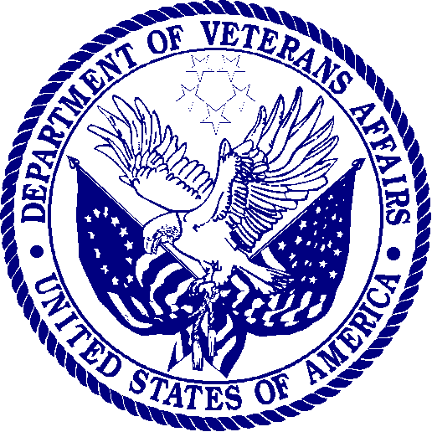 | DEPARTMENT OF VETERANS AFFAIRS  Veterans Health Administration  Washington DC 20420

Date: [INSERT CURRENT DATE]

Dear: [INSERT FIRST AND LAST NAME]:

We recently received your completed survey. Thank you for helping with this important project. Your answers will help the Department of Veterans Affairs, Veterans Health Administration improve timely communication with Veterans about where it is safe to get care in the event of a natural disaster.

Enclosed you will find $10.00 in cash as a token of our appreciation for your time. Thank you for your participation.

Sincerely,

Dr. Daniel J. Bochicchio
Director, VHA Office of Emergency Management

