NATIONAL PERSONNEL RECORDS CENTER

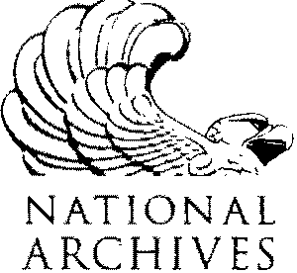

1 ARCHIVES DRIVE STLOUIS. MO 63138-1002

[www.archives.gov](http://www.archives.gov/)

**This form is ONLY for status updates for EXISTING requests. Instructions on how to initiate a**

**new request can be found at** <http://www.archives.gov/veterans>.

|  |  |  |
| --- | --- | --- |
| **Requester Information.** | | |
| **\*Name:** | | |
| **\*Zip Code:** | **\*Phone #:** | **Email Address:** |

|  |  |  |
| --- | --- | --- |
| **Veteran and Request Information.** | | |
| **\*First Name:** | **\*Middle Name:** | **\*Last Name:** |
| **\*Last 4 of SSN:** | **\*Branch of Service:** | **Request #:** |

**Additional Comments:**

\**Indicates Required Fields*

#### PRIVACY ACT OF 1974 COMPLIANCE INFORMATION

The following information is provided in accordance with 5 U.S.C. 552a(e)(3) and applies to this form. Authority for collection of the information is 44 U.S.C. 2907, 3101, and 3103, and Public Law 104-134 (April 26, 1996), as amended in title 31, section 7701. Disclosure of the information is voluntary. If the requested information is not provided, it may delay servicing your inquiry because the facility servicing the service member's record may not have all of the information needed to locate it. The purpose of the information on this form is to assist the facility servicing the records (see the address list) in locating the correct military service record(s) or information to answer your inquiry. This form is then retained as a record of disclosure. The form may also be disclosed to Department of Defense components, the Department of Veterans Affairs, the Department of Homeland Security (DHS, U.S. Coast Guard), or the National Archives and Records Administration when the original custodian of the military health and personnel records transfers all or part of those records to that agency. If the service member was a member of the National Guard, the form may also be disclosed to the Adjutant General of the appropriate state, District of Columbia, or Puerto Rico, where he or she served.

#### PAPERWORK REDUCTION ACT PUBLIC BURDEN STATEMENT

Public burden reporting for this collection of information is estimated to be two minutes per request, including time for reviewing instructions and completing and reviewing the collection of information. Send comments regarding the burden estimate or any other aspect of the collection of information, including suggestions for reducing this burden, to National Archives and Records Administration (ISSD), 8601 Adelphi Road, College Park, MD 20740-6001. DO NOT SEND COMPLETED FORMS TO THIS ADDRESS.

*National Archives and Records Administration*