Introduction
Hello! Thank you for taking the time to complete this survey. The purpose of this survey is for several federal government agencies that employ a large number of veterinarians to gain insight on your views related to career opportunities after you graduate from veterinary school. As such, it is important for us to understand your opinions and preferences to help inform how we offer financial incentives to veterinarians who may join our agency workforces. Your responses are confidential. The survey should take 10-13 minutes to complete, and we appreciate your taking the time to provide us this information.
OMB Control No. 0583-0151
Exp. Date: 05/31/2018

According to the Paperwork Reduction Act of 1995, an agency may not conduct or sponsor, and a person is not required to respond to, a collection of information unless it displays a valid OMB control number. The valid OMB control number for this information collection is 0583-0151. The time required to complete this information collection is estimated to average 13 minutes per response, including the time for reading instructions.

Vet school Demographics/ Exit Responses
Number | Question | Answer Choices
1 | What year of veterinary school are you in right now? | - First Year  - Second Year  - Third Year  - Fourth Year  - I’m not in Vet school yet.
2 | Which school are you currently attending?
3. | What age range do you fall into? | - 18-21  - 22-25  - 26-29  - 30-35  - 36-40  - 41-45  - 46+
4. | Please select the racial/national origin category with which you primarily identify. | - White  - Hispanic or Latino  - Black or African American  - Native American or American Indian  - Asian / Pacific Islander  - Other
5. | Please select the gender with which you identify. | - Male  - Female
6. | Select any of the following methods you are using this year to fund your education | - Federal Student Loans (including grad plus)  - Chapter 33 GI Bill  - Chapter 30 GI Bill  - Chapter 31 – Vocational Rehab  - Chapter 1606  - Chapter 1607  - Chapter 35  - State Aid for Veterans  - Health Professions Student Loans  - I am not funding my education with any of the listed options.
7. | Regarding your tuition, which rate are you paying this academic year? | - In state (Resident)  - Out of state (Non Resident)  - Private (All students have the same tuition costs)
8. | Have you applied for any scholarships this academic year? | - Yes, I have applied for scholarships this year.  - No, I have not applied for scholarships this year.
 | When do you start applying for scholarships each year for veterinary school? | - Between September and December  - Between January and April  - Between May and August  - At the beginning of the same school year in which they are offered
9. | Consider your scholarship search; Please select the range that best represents what you recall the “Average” veterinary scholarship offered. | - Less than $500  - $501 - $1000  - $1,001- $3,000  - $3,001 - $5,000  - $5,001 - $7,000  - $7,001 - $10,000  - More than $10,000
10. | How much have you received in total scholarship dollars for the past academic year (2016-2017)? | - Less than $2000  - $2001 - $4000  - $4001 - $6000  - $8001 - $10000  - $10,001 - $12,000  - $12,001 – $14,000  - More than $15,000
11. | Please select the top three veterinary career pathways with the highest starting salary? (Starting salary refers to the salary that you would expect to earn right out of school). | - Large Animal Practice  - Small Animal Practice  - Equine Animal Practice  - Board certified Practitioner  - Public Health Veterinarian (Federal Service)  - State Health Veterinarian (State Service  - Research (Academics)  - Other (Please Specify)
12. | To the extent that you narrowed your decision-making, which top two career pathways have you considered after graduation? | - Large Animal Practice  - Small Animal Practice  - Equine Animal Practice  - Board-certified Practitioner  - Public Health Veterinarian (Federal Service)  - State Health Veterinarian (State Service  - Research (Academics)  - Other (Please Specify)
13. | Please select the top three benefits that are most important to you in your career after veterinary school. | - Working in a specific location/geographic area  - High starting salary among my options  - Additional monetary/financial incentives beginning or throughout employment (e.g. starting bonus, student loan repayment, retention bonus)  - Generous “standard” benefits (health insurance, paid time off, sick leave)  - Generous retirement benefits (such as matching contributions)  - Flexible scheduling and/or part time opportunities/options  - Clear and strong opportunities for advancement
14. | If you were offered a position that required you to move to a location you have never lived (i.e. a new state, or city), which of the following drivers would most influence your decision to move? | - Financial (strong starting salary, student loan repayment, recruitment bonus, paid moving expenses)  - The nature of my job duties and my perceived satisfaction  - The level of job security I believe the position will offer  - The level of career growth potential I believe the position will offer  - The location being as near as possible to where I want to consider “home”  - I would not/cannot consider moving from where I have previously lived or currently live at this time  - Other (please specify)
15. | Which geographic region or regions are most appealing to you? (select one to two) | - New England (CT, ME, MA, NH, RI, VT)  - Mid Atlantic (NJ, NY, PA)  - East North Central (IL, IN, MI, OH, WI)l  - West North Central (IA, KS, MN, NE, ND, SD)  - South Atlantic (DE, FL, GA, MD, NC, SC, VA, DC, WV)  - East South Central (AL, KY, MS, TN)  - West South Central (AR, LA, OK, TX)  - Mountain (AZ, CO, ID, MT, NV, UT, WY)  - Pacific (CA, AK, HI, OR, WA)
16. | Have you ever applied for a position with the federal service? (Include any internships, permanent positions, veterinarian or non-veterinarian positions) | - I have applied for a veterinary student internship with the Federal Service.  - I have applied for an internship unrelated to veterinary medicine with the Federal service  - I have applied for a non-student, permanent, position with the Federal service  - I have not applied for any positions with the Federal service
17. | Please mark all that apply of the listed Federal agencies (including military) for which you have applied for an internship (paid or unpaid), fellowship, developmental program, or permanent position. | - Animal and Plant Health Inspection Service (USDA)  - Food Safety and Inspection Service (USDA)  - Agriculture Research Service (USDA)  - Food and Drug Administration’s Centers for Disease Control and Prevention  - Military (Army, Air Force, Navy  - Other _______  - None
18. | Please complete the sentence choosing one option: Working as a veterinarian for a federal agency after I graduate would be… | - My first job preference/career path  - My second job preference/career path  - Something I haven’t really considered, but may consider more now  - Only an option I would choose if I don’t go into private practice or research  - Really not an option for me, I am not looking for the kind of positions I have seen offered by the Federal government  - I don’t know
19. | Please provide your level of agreement with the following statement: veterinarians in the Federal government have salary packages comparable to veterinarians employed elsewhere. If you’re not sure, please select the option that most closely fits your perception. | - Strongly Agree  - Somewhat Agree  - Somewhat Disagree  - Strongly Disagree

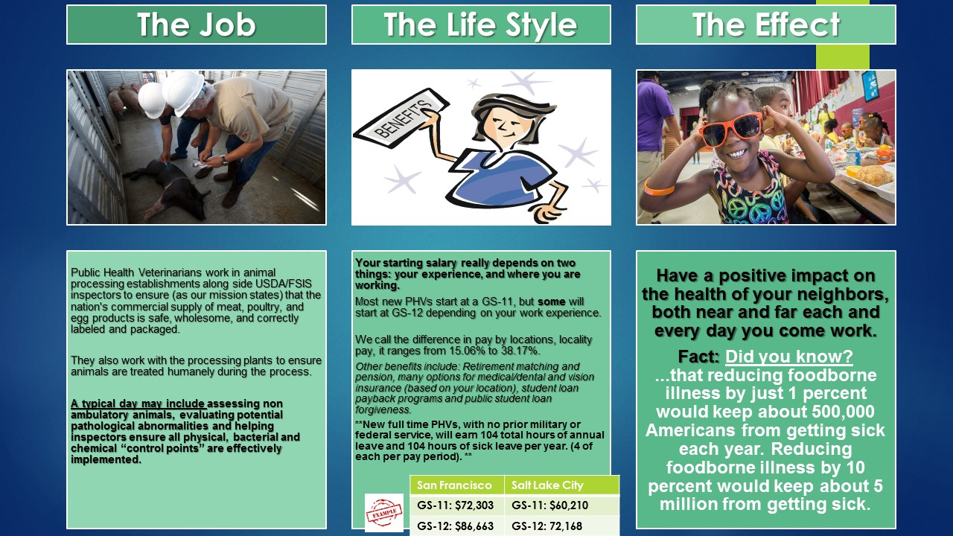
21. | Please assess the above position and indicate whether the starting salary of a federal veterinarian position is lower, higher or the same to that of non-federal veterinarian starting salary. | - Much higher  - higher  - About the same  - Lower  - Much lower
22. | How surprised were you, if at all, with the information provided on starting salaries? | - Not at all surprised  - Somewhat surprised  - Surprised  - Very surprised
25. | How appealing is having a part-time work schedule available to you as an option within the first 5 years of employment after completing veterinary school? | - Very appealing  - Appealing  - Somewhat appealing  - Neutral  - Somewhat unappealing  - Unappealing  Very Unappealing
26. | Which of the following ranges of time in Federal position of employment would be most appealing? | - 16-23hours per week  - 24-28 hours per week  - 29-32 hours per week  - 33-36 hours per week  - 37-39 hours per week
28. | Please provide any suggestions, if any, you may have to inform FSIS on what would most attract you and/or is most important to you regarding the benefits, salary, and work life balance a position offers.
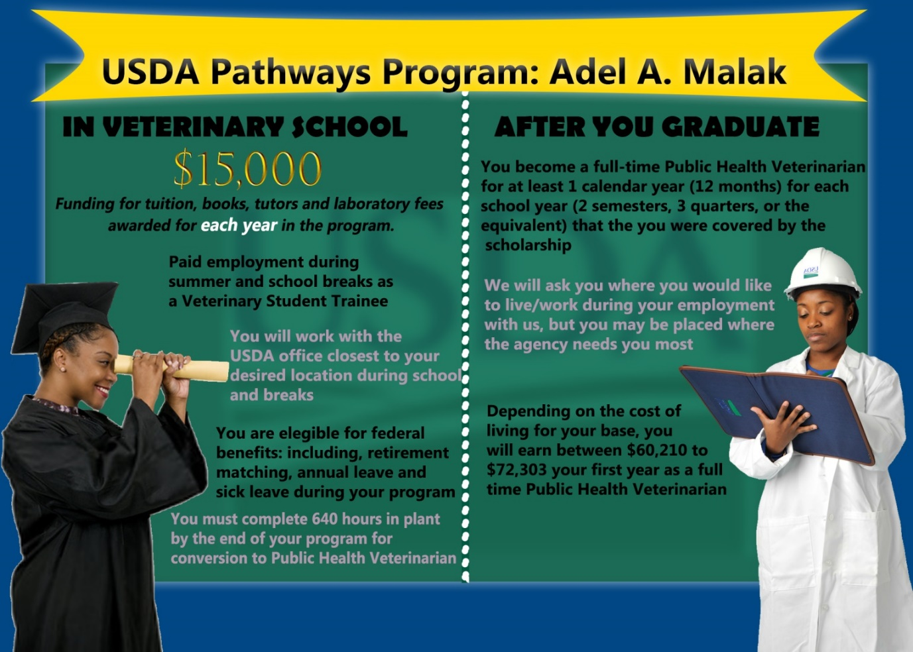

NOTE: SCHOLARSHIP AMOUNT WILL VARY BY SURVEY/ Amounts between $5k-$25k
29. | To what extent are you interested in applying for the above Adel A Malak scholarship? | - Very interested  - Interested  - Somewhat Interested  - Somewhat Uninterested  - Very Uninterested
30. | Please indicate which one or two features of this scholarship are most appealing to you. | - The scholarship amount  - Having guaranteed employment upon graduation  - The opportunity to relocate  - Strong benefits (Health insurance, saving and investment plan options, and other benefits I would utilize upon employment  - Student loan repayment options  - Mission (Food Safety/Public Health)
31. | What is least appealing about this scholarship, if anything? | - The scholarship amount  - The year for year employment commitment  - The likely requirement to relocate  - My perception of the likely work life balance  - Starting salaries  - The nature of the work  - Nothing is particularly unappealing
33. | Please check up to three factors that you believe would most likely cause you to stay with FSIS after your service commitment period, and any other financial incentive periods, would end. | - The job continues to be interesting  - I am generally satisfied with the kind of duties and responsibilities that I have  - I have a good relationship with my boss  - I have a good relationship with my co-workers  - I feel like I’m really contributing to important work at my place of employment  - The stability of my/my household’s financial situation  - Mission (Food Safety/ Public Health)  - Other (please specify)
32. | Please provide one or two reasons regarding why you are not interested in applying for this scholarship. | - The scholarship amount  - The year for year employment commitment  - The likely requirement to relocate  - My perception of the likely work life balance  - Starting salaries  - The nature of the work  - I want to keep my options open as I haven’t fully decided what I want to do after I finish veterinary school  - I am generally not interested in working for the Federal government directly after finishing veterinary school  - Other (please specify)

