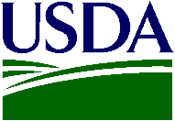

<Date>

USDA Food and Nutrition Service  
Office of Policy Support  
3101 Park Center Drive, Room 1000  
Alexandria, VA 22302

RE: Summer Food Service Program (SFSP) Interviews

Dear <School district>:

Thank you for your participation in the U.S. Department of Agriculture (USDA) *Summer Food Service Program (SFSP) Participant Characteristics Study.* Your cooperation and help distributing the recruitment packets to the parents/caregivers of NSLP students was integral in accomplishing our research objectives.

The findings from the interviews with parents/caregivers of SFSP-eligible participants and non-participants will help the USDA improve program outreach and services to make sure those who need this valuable program know about it and have access to it.

The findings from this study will help the FNS better determine which SFSP policies are successful and which need improvement. This information will ultimately help the USDA better serve our nation’s youth by providing better service to those in need of a supplemental nutrition program during the summer.

If you have any questions or concerns about your participation in this study, please contact Optimal at 877-776-8501 or SFSP@optimalsolutionsgroup.com.

For more information about the SFSP, please visit www.fns.usda.gov/sfsp/summer-food-service-program-sfsp.

Thank you again for your time and cooperation.

Sincerely,

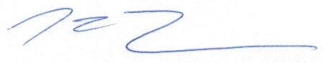

Dr. Mark Turner  
Project Director