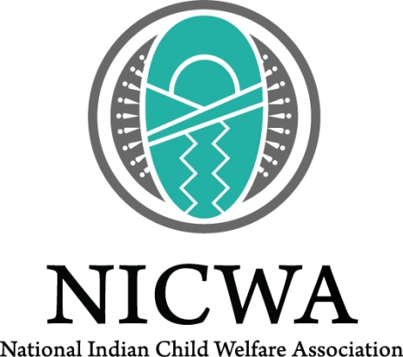

Youth Focus Group Information Sheet

We want to hear your thoughts about youth smoking!

The National Indian Child Welfare Association, Better World Advertising and the Food and Drug Administration – Center for Tobacco Products (FDA-CTP) are hosting focus groups to learn more about Native youth smoking and use of media. This information will help make a campaign.

What is this?
We need your help to learn about kids and smoking. In this research study, you will be talking in a group with other kids. It’s called a focus group. In this group two people will ask you questions. We want to learn what you think and feel about smoking. We hope you will discuss your ideas with the other youth. The focus group will last two hours. Your advice will help us learn more about kids and smoking where you live.

Who can join?
- American Indian or Alaska Native kids ages 10–16 in [community]
- Parents/caregivers of American Indian or Alaska Native youth in [community]
- Elders/community leaders/service workers of [community]

When and where will this happen?
[May 2016-April 2017 and in Alaska or the Northern Plains]

What will I be asked to do?
You will be asked to answer questions about smoking and media use in your community. You can tell us if kids use websites like Facebook, listen to the radio or watch television. You will be shown pictures and positive messages about not smoking. You can tell us what you think about them. We won’t tell your family or other people you know what you said. You won’t be asked questions like “Do you smoke?” or “Do people in your family smoke?” but you will be asked about smoking in general in your community.

You will get a gift card good for $50 for being part of the group. Anyone who gives you ride to the group will get a gift card good for $25. We will give only one gift card per driver. It does not matter how many participants ride with them.

Who can I talk with to learn more about this?
If you have any questions or would like to sign up, please call xxx-xxx-xxxx and ask for [name], or email [email address]. You may also contact Jen Rountree, research manager at NICWA, at (503) 222-4044 ext. 144 or jen@nicwa.org.

