**CREATIVE CONCEPT 1 OF 5**

**“OBEY NICOTINE”** | NICOTINE

**Key Visual**

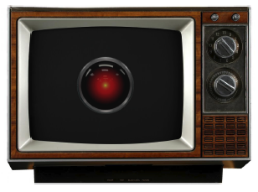

**Ad Description**

*In the background we hear a siren.*

**VISUAL (VIS):** There’s a blast of static, and then a large, red mechanical eye fills our screen.

**Voice Over (VO):** Programming on this channel will be interrupted for the next two-and-one-half minutes, while residents of Vape Sector 5 are hereby ordered by Supreme Command to report outside immediately and pay allegiance to Vape Sector 5.

**VO**: Report. Report. Report.

**VO**: Residents of Vape Sector 5, Report.

**VO**: Obey the light.

**VO**: Report.

**VO**: Pay allegiance.

**VO**: Report.

**VO**: Addiction is commitment.

**VO**: Report.

**VO**: Want is need.

**VO**: Report.

**VO**: Obey the light.

**VIS**: We pull back from the eye to reveal that it’s the light on a vape pen.

**VO**: Obey the light.

**VIS**: The vape pen dissolves into our Vape Sector 5 flag.

**AVO**: If there’s nicotine in your vape, you may soon feel the oppression of addiction.

**VIS**: The vape pen begins to produce a large cloud of smoke, which takes over the screen.

**CARD**: Nicotine can change your brain to crave more and more.

**AVO/LOGO/LOCKUP**: Know The Real Cost of Vaping.

**CREATIVE CONCEPT 2 OF 5**

**“INFECTED”** | NICOTINE

**Key Visual**



**Ad Description**

**VIS**: Open on a close-up of a parasite. It’s in what appears to be a vial filled with liquid. Over the course of the spot, the camera slowly pulls out.

**VO**: This is a message from the FDA. There’s a disease spreading that poses a public health risk.

**VIS**: The camera has now pulled out sufficiently for us to see that the “vial” is actually the fluid chamber of a vape pen in the hand of a teen. As he vapes, the parasite goes into his mouth.

**VO**: In just 10 seconds from exposure, it can spread to your brain.

**VIS**: The parasite travels under his skin, up to his brain.

**VO**: Once there, it starts making changes.

**VIS**: The teen’s face goes slack, his eyes blank as he exhales vapor.

**VO**: If you vape, you may be infected by nicotine—which can lead to a lifetime of addiction.

**SUPER**:, TRC logo, FDA logo

**CREATIVE CONCEPT 3 OF 5**

**“Nicky Tine”** | NICOTINE

**Key Visual**



**Ad Description**

**VIS**: We open on a teenager bed, working on some homework. He gets a text from “Nick O.” that we display floating in the air above his bed.

**TEXT** (Nick O.): Good seeing you yesterday. I’ll hit you up later.

**VIS**: He waves the text away, as if it’s an annoying gnat.

**VIS**: We cut to our hero at an action movie with his friends. We see them lean forward at a climactic moment, when another floating notification appears, followed by two more. He needs to peep around them to see the film.

**TEXT** (Nick O.): You around?

**TEXT** (Nick O.): You get my Snap?

**TEXT** (Nick O.): I’ll hit you later.

**VIS**: We cut to our teen playing hoops with his friends. He’s making a cut for an open three, when he’s bombarded by more notifications from this dude Nick O. He has to fight his way through them and in doing so, he takes his eye off the ball and misses the pass.

**DM** (Nick O.): Where you at, dude?

**Facebook** (Nick O.): Bro, you coming? Missin’ you over here.

**Facebook** (Nick O.): Come through, yo!

**VIS**: We cut to our hero at a party chatting with a girl, but he’s absolutely barraged by notifications and messages from Nick O. wondering where he’s at. They’re like a swarm of bees on his face, so that he can’t even concentrate on what she’s saying. This kid Nick O. is something else! Fine! You win!

**VIS**: Cut to our teen outside, vaping by himself. We see one last text from Nick.

**TEXT** (Nick O.): Good to see you again, bro.

**AVO**: Vaping can expose your brain to Nick O. Tine. Once you befriend him, he’s very needy.

**AVO**: Know The Real Cost of Vaping.

**CREATIVE CONCEPT 4 OF 5**

**“The Flavor of Addiction”** | NICOTINE

**Key Visual**



**Ad Description**

**:60 VIDEO**

**VIS**: Open at the entrance of a place resembling Willy Wonka’s chocolate factory. The owner comes out to greet a crowd of excited teens.

He swings open the gates, and the teens rush in. They go nuts, having at things like a

cinnamon volcano, a cookie ferris wheel, banana floats in a pool of butterscotch, a cola

waterfall, and bubblegum whose bubbles float off into the air. Everything gives off little

puffs of flavored vapor.

The scene darkens, and things take a turn for the worse. Everything begins rotting and

turning to ash in the teens’ hands. They start screaming in horror.

The owner locks the gate, with an evil chuckle.

**OWNER**: [Singing] Come with me and you’ll be in a world of pure incarceration.

**VIS**: The owner winks at the camera. When his eye reopens, it’s lit like a vape pen.

Everything goes to black except for the owner’s eye, which remains as the light on a

vape pen.

**AVO**: Think vaping is sweet? Think again. Its flavors may hide nicotine, which can make it as addictive as cigarettes.

**CREATIVE CONCEPT 5 of 5**

**“Brainscrew”** |” NICOTINE

**Key Visual**

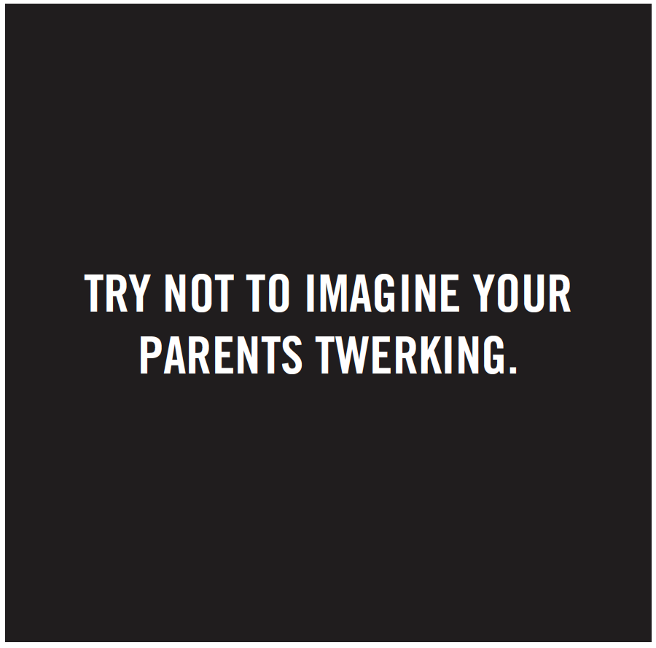

**Example Copy**

**SUPER 1**: Try not to imagine your parents twerking.

**SUPER 2**: It’s easy to put bad things in your brain.

**SUPER 3**: Vaping can put nicotine in your brain, which is addictive.

Good luck getting that out.

**END**: The Real Cost