The Real Cost Smokeless: Wave 2 Focus Group Study of Reactions to Creative Advertising Concepts Designed to Prevent Rural Youth Tobacco Use
NOTE: FMG WILL SEND THROUGH GRAPHIC DESIGN ONCE CONTENT FINAL

1. What is the message? That is, what is the most important thing they are trying to tell you?

2. What did you think about this ad? Please give it a grade from A-F.
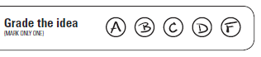

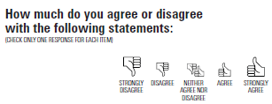
3.

- This ad grabbed my attention
- I can relate to this ad
- This ad is compelling
- This ad made me NOT want to use dip
- This ad made me want to learn more about the health risks of using dip
- This ad made me stop and think about trying or using dip

4. What about this ad is compelling?

5. What would you change about this ad to make it better?

Paperwork Reduction Act Statement: The public reporting burden for this information collection has been estimated to average 5 minutes per response to complete the Concept Ranking Worksheet (the time estimated to read and review). Send comments regarding this burden estimate or any other aspects of this information collection, including suggestions for reducing burden, to PRAStaff@fda.hhs.gov.

