Tobacco Discussion

Participant Booklet

Set 4

**Part 1.**

Pictures Alone and Pictures with Sentences

**Item 1**

Discussion of Picture Alone

|  |
| --- |
| \\fda.gov\WODC\CTP_Sandbox\OS\DPHS\SocSci\Research\GHW new\Images for Focus Groups\FDA_GHW_Image C.jpg  **1** |

**Item 2**

Discussion of Picture Alone

|  |
| --- |
| \\fda.gov\WODC\CTP_Sandbox\OS\DPHS\SocSci\Research\GHW new\Images for Focus Groups\FDA_GHW_Image D.jpeg  **2** |

**Item 3**

Discussion of Picture-Sentence Combination

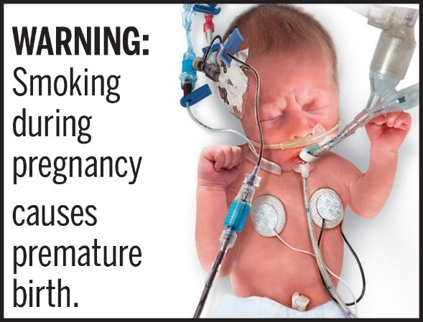

**3**

**Item 4**

Discussion of Picture-Sentence Combination

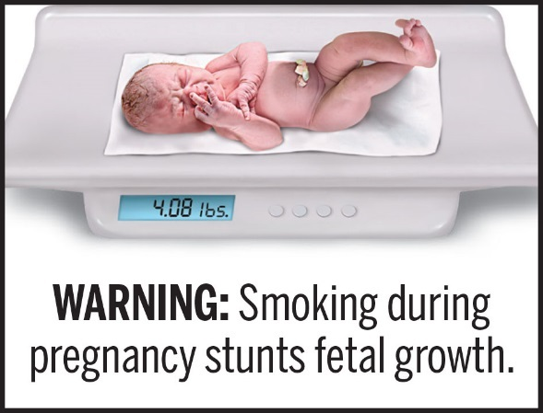

**4**

**Items 5-6**

Comparison of Picture-Sentence Combinations

PencilPlease **circle** the picture that goes best with the sentence you see on the pictures.

|  |  |
| --- | --- |
|  | |
| \\fda.gov\WODC\CTP_Sandbox\OS\DPHS\SocSci\Research\GHW new\Images for Focus Groups\FDA_GHW_Image C-4.jpg | \\fda.gov\WODC\CTP_Sandbox\OS\DPHS\SocSci\Research\GHW new\Images for Focus Groups\FDA_GHW_Image D-4.jpg |

**5 6**

**Items 7-8**

Comparison of Picture-Sentence Combinations

PencilPlease **circle** the picture that goes best with the sentence you see on the pictures.

|  |  |
| --- | --- |
|  |  |

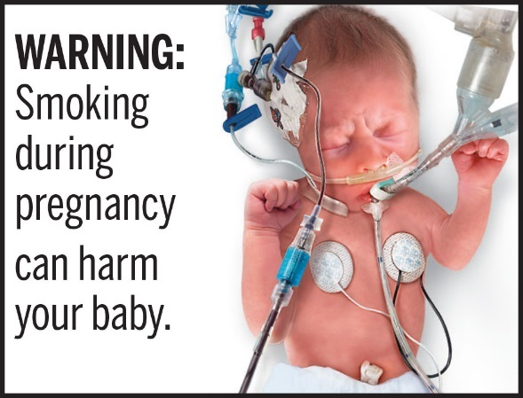 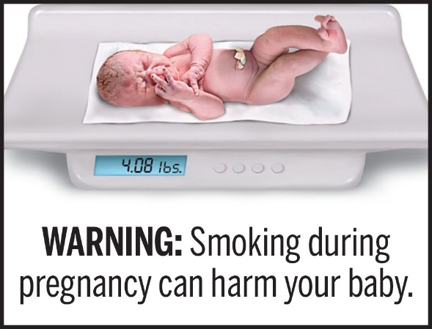

**7 8**

**Item 9**

Discussion of Picture Alone

|  |
| --- |
|  |
| \\fda.gov\WODC\CTP_Sandbox\OS\DPHS\SocSci\Research\GHW new\Images for Focus Groups\FDA_GHW_Image U.jpg  **9** |

**Item 10**

Discussion of Picture Alone

|  |
| --- |
|  |
| \\fda.gov\WODC\CTP_Sandbox\OS\DPHS\SocSci\Research\GHW new\Images for Focus Groups\FDA_GHW_Image V.jpeg  **10** |

**Items 11-12**

Comparison of Picture-Sentence Combinations

PencilPlease **circle** the picture that goes best with the sentence you see on the pictures.

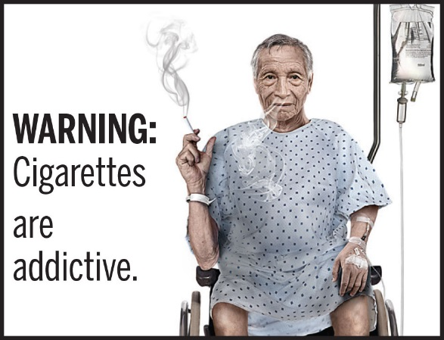 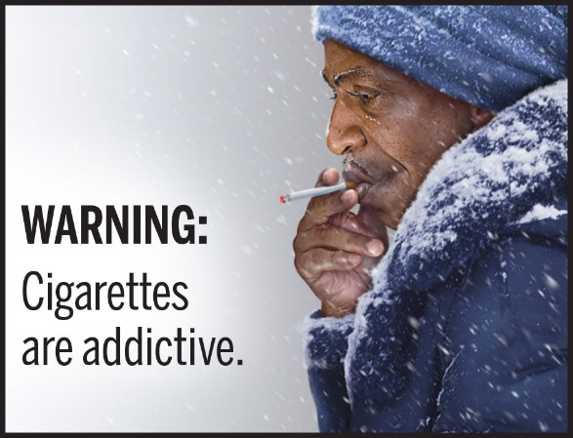

**11 12**

**Item 13**

Discussion of Picture Alone

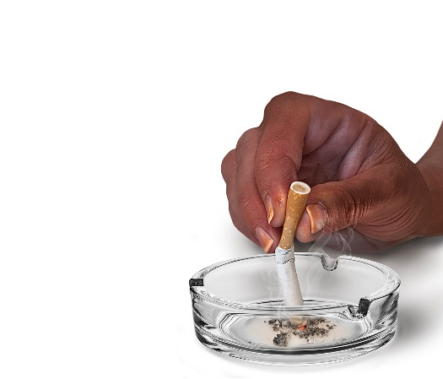

**13**

**Item 14**

Discussion of Picture Alone

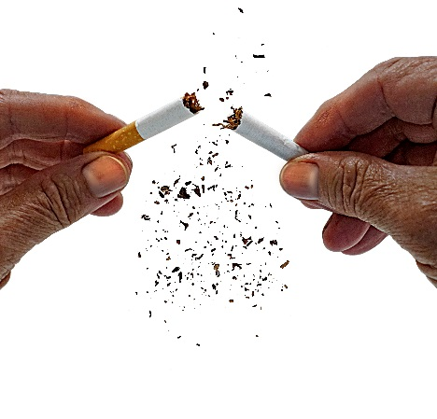

**14**

**Items 15-16**

Comparison of Picture-Sentence Combinations

PencilPlease **circle** the picture that goes best with the sentence you see on the pictures.

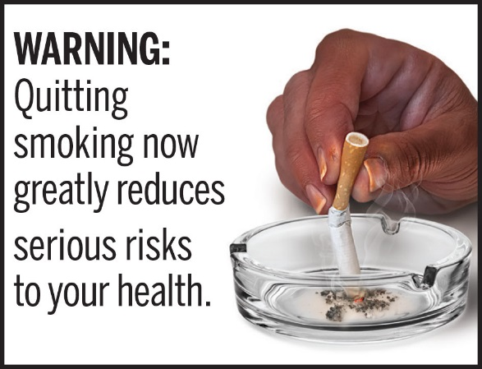 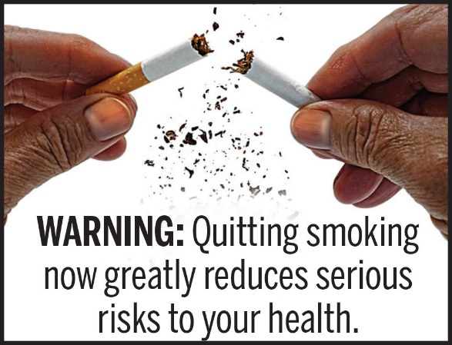

**15 16**

**Part 2.**

Individual Worksheet

PencilPlease mark an X in the box next to the **one** picture-sentence combination that you think best represents how smoking **harms children**.

|  |  |  |  |
| --- | --- | --- | --- |
|  | \\fda.gov\WODC\CTP_Sandbox\OS\DPHS\SocSci\Research\GHW new\Images for Focus Groups\FDA_GHW_Image A-1.jpg |  | \\fda.gov\WODC\CTP_Sandbox\OS\DPHS\SocSci\Research\GHW new\Images for Focus Groups\FDA_GHW_Image B-1.jpg |
|  | \\fda.gov\WODC\CTP_Sandbox\OS\DPHS\SocSci\Research\GHW new\Images for Focus Groups\FDA_GHW_Image A-2.jpg |  | \\fda.gov\WODC\CTP_Sandbox\OS\DPHS\SocSci\Research\GHW new\Images for Focus Groups\FDA_GHW_Image B-2.jpg |

PencilPlease mark an X in the box next to the **one** picture-sentence combination that you think best represents how smoking **harms babies**.

|  |  |  |  |
| --- | --- | --- | --- |
|  | \\fda.gov\WODC\CTP_Sandbox\OS\DPHS\SocSci\Research\GHW new\Images for Focus Groups\FDA_GHW_Image C-3.jpg |  | \\fda.gov\WODC\CTP_Sandbox\OS\DPHS\SocSci\Research\GHW new\Images for Focus Groups\FDA_GHW_Image D-3.jpg |
|  | \\fda.gov\WODC\CTP_Sandbox\OS\DPHS\SocSci\Research\GHW new\Images for Focus Groups\FDA_GHW_Image C-4.jpg |  | \\fda.gov\WODC\CTP_Sandbox\OS\DPHS\SocSci\Research\GHW new\Images for Focus Groups\FDA_GHW_Image D-4.jpg |
|  | \\fda.gov\WODC\CTP_Sandbox\OS\DPHS\SocSci\Research\GHW new\Images for Focus Groups\FDA_GHW_Image C-5.jpg |  | \\fda.gov\WODC\CTP_Sandbox\OS\DPHS\SocSci\Research\GHW new\Images for Focus Groups\FDA_GHW_Image D-6.jpg |

PencilPlease mark an X in the box next to the **one** picture-sentence combination that you think best represents how smoking causes **cancer**.

|  |  |  |  |
| --- | --- | --- | --- |
|  | \\fda.gov\WODC\CTP_Sandbox\OS\DPHS\SocSci\Research\GHW new\Images for Focus Groups\FDA_GHW_Image G-9.jpg |  | \\fda.gov\WODC\CTP_Sandbox\OS\DPHS\SocSci\Research\GHW new\Images for Focus Groups\FDA_GHW_Image H-9.jpg |
|  | \\fda.gov\WODC\CTP_Sandbox\OS\DPHS\SocSci\Research\GHW new\Images for Focus Groups\FDA_GHW_Image I-9.jpg |  | \\fda.gov\WODC\CTP_Sandbox\OS\DPHS\SocSci\Research\GHW new\Images for Focus Groups\FDA_GHW_Image I-11.jpg |
|  | \\fda.gov\WODC\CTP_Sandbox\OS\DPHS\SocSci\Research\GHW new\Images for Focus Groups\FDA_GHW_Image H-10.jpg |  | C:\Users\David.Portnoy\AppData\Local\Microsoft\Windows\Temporary Internet Files\Content.Outlook\3S0EDA72\FDA_GHW_Image G-10 (002).jpg |
|  | \\fda.gov\WODC\CTP_Sandbox\OS\DPHS\SocSci\Research\GHW new\Images for Focus Groups\FDA_GHW_Image J-12.jpg |  | \\fda.gov\WODC\CTP_Sandbox\OS\DPHS\SocSci\Research\GHW new\Images for Focus Groups\FDA_GHW_Image K-12.jpg |

PencilPlease mark an X in the box next to the **one** picture-sentence combination that you think best represents how smoking causes **lung disease**.

|  |  |  |  |
| --- | --- | --- | --- |
|  | \\fda.gov\WODC\CTP_Sandbox\OS\DPHS\SocSci\Research\GHW new\Images for Focus Groups\FDA_GHW_Image S-13.jpg |  | \\fda.gov\WODC\CTP_Sandbox\OS\DPHS\SocSci\Research\GHW new\Images for Focus Groups\FDA_GHW_Image T-13.jpg |
|  | \\fda.gov\WODC\CTP_Sandbox\OS\DPHS\SocSci\Research\GHW new\Images for Focus Groups\FDA_GHW_Image S-14.jpg |  | \\fda.gov\WODC\CTP_Sandbox\OS\DPHS\SocSci\Research\GHW new\Images for Focus Groups\FDA_GHW_Image T-14.jpg |
|  | \\fda.gov\WODC\CTP_Sandbox\OS\DPHS\SocSci\Research\GHW new\Images for Focus Groups\FDA_GHW_Image S-15.jpg |  | \\fda.gov\WODC\CTP_Sandbox\OS\DPHS\SocSci\Research\GHW new\Images for Focus Groups\FDA_GHW_Image T-15.jpg |
|  | C:\Users\awarrier\AppData\Local\Microsoft\Windows\INetCache\Content.Word\Tier1_image_3_label_2_wht[1].jpg |  |  |

PencilPlease mark an X in the box next to the **one** picture-sentence combination that you think best represents how smoking causes **heart disease**.

|  |  |  |  |
| --- | --- | --- | --- |
|  | \\fda.gov\WODC\CTP_Sandbox\OS\DPHS\SocSci\Research\GHW new\Images for Focus Groups\FDA_GHW_Image M-17.jpg |  | \\fda.gov\WODC\CTP_Sandbox\OS\DPHS\SocSci\Research\GHW new\Images for Focus Groups\FDA_GHW_Image N-17.jpg |
|  | \\fda.gov\WODC\CTP_Sandbox\OS\DPHS\SocSci\Research\GHW new\Images for Focus Groups\FDA_GHW_Image O-17.jpg |  | \\fda.gov\WODC\CTP_Sandbox\OS\DPHS\SocSci\Research\GHW new\Images for Focus Groups\FDA_GHW_Image M-18.jpg |
|  | \\fda.gov\WODC\CTP_Sandbox\OS\DPHS\SocSci\Research\GHW new\Images for Focus Groups\FDA_GHW_Image N-18.jpg |  | \\fda.gov\WODC\CTP_Sandbox\OS\DPHS\SocSci\Research\GHW new\Images for Focus Groups\FDA_GHW_Image O-18.jpg |

PencilPlease mark an X in the box next to the **one** picture-sentence combination that you think best represents how smoking causes **death.**

|  |  |  |
| --- | --- | --- |
|  | \\fda.gov\WODC\CTP_Sandbox\OS\DPHS\SocSci\Research\GHW new\Images for Focus Groups\FDA_GHW_Image P-19.jpg |  |
|  | \\fda.gov\WODC\CTP_Sandbox\OS\DPHS\SocSci\Research\GHW new\Images for Focus Groups\FDA_GHW_Image P-15.jpg |  |
|  | \\fda.gov\WODC\CTP_Sandbox\OS\DPHS\SocSci\Research\GHW new\Images for Focus Groups\FDA_GHW_Image P-13.jpg |  |
|  |  |  |

PencilPlease mark an X in the box next to the **one** picture-sentence combination that you think best represents how smoking causes **blindness.**

|  |  |  |  |
| --- | --- | --- | --- |
|  | \\fda.gov\WODC\CTP_Sandbox\OS\DPHS\SocSci\Research\GHW new\Images for Focus Groups\FDA_GHW_Image Q-20.jpg |  | \\fda.gov\WODC\CTP_Sandbox\OS\DPHS\SocSci\Research\GHW new\Images for Focus Groups\FDA_GHW_Image R-21.jpg |

PencilPlease mark an X in the box next to the **one** picture-sentence combination that you think best represents how smoking causes **addiction.**

|  |  |  |  |
| --- | --- | --- | --- |
|  | \\fda.gov\WODC\CTP_Sandbox\OS\DPHS\SocSci\Research\GHW new\Images for Focus Groups\FDA_GHW_Image U-23.jpg |  | \\fda.gov\WODC\CTP_Sandbox\OS\DPHS\SocSci\Research\GHW new\Images for Focus Groups\FDA_GHW_Image V-23.jpg |

PencilPlease mark an X in the box next to the **one** picture-sentence combination that you think best represents **quitting smoking.**

|  |  |  |  |
| --- | --- | --- | --- |
|  | \\fda.gov\WODC\CTP_Sandbox\OS\DPHS\SocSci\Research\GHW new\Images for Focus Groups\FDA_GHW_Image W-24.jpg |  | \\fda.gov\WODC\CTP_Sandbox\OS\DPHS\SocSci\Research\GHW new\Images for Focus Groups\FDA_GHW_Image X-24.jpg |

Paperwork Reduction Act Statement: An agency may not conduct or sponsor, and a person is not required to respond to, a collection of information unless it displays a currently valid OMB control number. The public reporting burden for this information collection has been estimated to average 90 minutes per response for the time required to participate in the focus group and complete the Participant Booklet (the time estimated to discuss, read, review, and complete). Send comments regarding this burden estimate or any other aspects of this information collection, including suggestions for reducing burden, to PRAStaff@fda.hhs.gov.