The Real Cost Smokeless Campaign: Focus Group Study of Creative Concepts Designed to Prevent Smokeless Tobacco Use Among Rural Youth.
Creative Concept Stimuli

The following five preliminary ad concepts will be tested as part of the Creative Concepts Testing in the form of video storyboard:

- Addiction is Tougher
- Declare Your InDIPendence
- Travis Cup
- The Other Tooth Fairy
- Tools of Mouth Cancer

CREATIVE CONCEPT #1: Addiction is Tougher


Key Frame
35

Concept Overview
This concept follows “Big Tim Timberfist,” a strong and tough character, through a series of outlandish vignettes that highlight his ruggedness, culminating with a vignette that demonstrates how an addiction to dip can be tougher than even Big Tim. A singing narrator will walk the viewer through the events being shown on screen.

Concept Script

NARRATOR: This commercial tells the story of Big Tim Timberfist — a massive mountain of a man, strong and tough. First we see him stride through the town with an intimidating swagger. A country singer playing guitar stands by the side of the road and sings big Tim’s theme song.
SINGER: Well, gather round you people. Let me tell you this
About the man, the myth, the legend of Big Tim Timberfist
NARRATOR: We see a close up of a sign being posted to a tree in the woods. The sign says, “WARNING: BIG TIM TIMBERFIST TERRITORY” and shows an artist’s rendering of Big Tim. We pull back and see it’s a grizzly bear hanging the sign.
SINGER: He had the meanest demeanor and the strength to match it
He was tougher than a rhino in a biker jacket
NARRATOR: Then, we see the drawing of Big Tim on the sign crossfade into Big Tim himself. We see Big Tim Timberfist using the blade of a big hunting knife as a mirror as he trims his beard with a chainsaw, one-handed.
SINGER: Well, he always did things his way. Never gave a damn
He didn’t answer to no one. He was his own man.
VISUAL: BIG TIM TAKING A SHOWER IN A FREEZING WATERFALL. HE USES A PORCUPINE AS A SPONGE.
SINGER: The ultimate tough guy – to cross him was frightening
NARRATOR: Now Big Tim is standing on top of a barn, holding a knife and fork. He tucks a napkin into his shirt collar, tilts his head to the sky and opens his mouth.
SINGER: He ate tree bark for breakfast for lunch he ate lightning
NARRATOR: Suddenly, lightning strikes Big Tim’s open mouth. He devours it hungrily.
NARRATOR: We jump to see Big Tim wrestling a pair of bears in the woods. He seems completely in control, as he has them both in a headlock
SINGER: He was covered in tattoos. All his shirts were sleeveless.
But despite all his machismo, he had one weakness
NARRATOR: We see Big Tim frantically searching for something in his truck. He appears nervous and in a panic. He finally finds what he’s looking for — his can of dip. He opens it and discovers it’s empty. He starts whimpering.
SINGER: His dark little secret. His awful affliction
He had no control over his dip addiction
NARRATOR: We see a convenience store. A giant shadow is cast over the clerk. He looks up, in awe as he sees Big Tim standing before him. But Big Tim appears forlorn.
SINGER: That dip addiction has him, it’s plain to see
It won’t let him go – it won’t let him free
NARRATOR: Big Tim points to a can of dip on the wall behind the counter. He looks defeated. The country singer enters to sing a final chorus.
SINGER: He was a dip-dip-dip-dip-dip-dip-dip-dip dippin’ that dip
Now he’s a- d-d-d-d-d-d-d-d-dicted to it
NARRATOR: The singer strums the final chord and gives Big Tim a sad, sympathetic look.
VO: Dip contains nicotine, which is highly addictive. Even if you’re tough, addiction may be tougher.
THE REAL COST LOGO APPEARS
VO: Smokeless doesn’t mean harmless.
CREATIVE CONCEPT #2: Declare Your InDIPendence

Key Frame
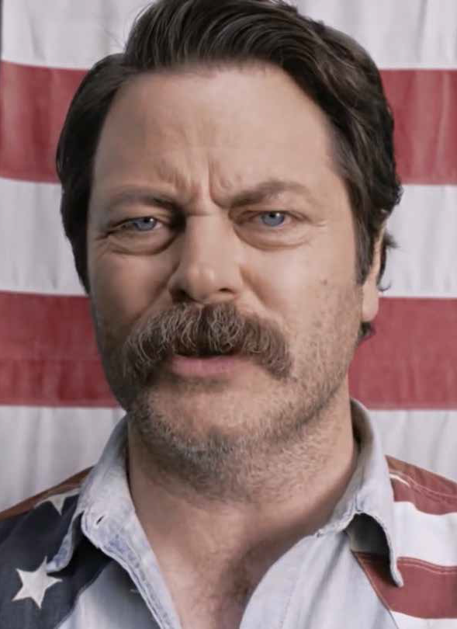

Concept Overview
This concept features a patriotic spokesperson moving through a series of vignettes depicting scenes of humorously exaggerated American freedom, ultimately demonstrating that an addiction to smokeless tobacco is counter to the virtues of true freedom.

Concept Script
NARRATOR: This commercial shows a patriotic spokesperson telling us in no uncertain terms what independence means. This is like America unleashed.
NARRATOR: Because when first we see him, the spokesperson is in a red, white and blue boxing costume, flying majestically across a beautiful blue sky on a pair of shoes consisting of bald eagles strapped to his feet.
SPOKESPERSON: Freedom.
NARRATOR: We see the spokesperson driving a star-spangled monster truck over a bunch of cars at a drive-thru carwash. He drives out in a shiny car that somehow has even more patriotic paint on it.
SPOKESPERSON: It’s a beautiful thing.
NARRATOR: He tosses food onto the grill to form the shape of the United States of America as a squadron of F18 jets perform a flyover, leaving behind a trail of red white and blue contrails.”
SPOKESPERSON: But there’s something you might not realize that could get in the way of your life, liberty and pursuit of happiness.
NARRATOR: He is walking by a lake. He holds up a can of dip.
SPOKESPERSON: An addiction to dip.
NARRATOR: He throws the can of dip and it skips across the lake many times.
SPOKESPERSON: Dip contains nicotine, which is highly addictive.
NARRATOR: We see him standing in the middle of a free-range chicken farm. He holds a cute little chick gently in his hands.
SPOKESPERSON: But we, the people, have the right to avoid dip’s oppression and tyranny. It’s simple. Choose freedom.
NARRATOR: He pets the chicken tenderly and sets it down on the ground to roam free.
NARRATOR: Now he is posing heroically on a canoe.
SPOKESPERSON: We hold these truths to be self-evident, that an addiction to dip is fundamentally in conflict with the principles of freedom. And totally lame.

NARRATOR: Cut to a huge pile of dip cans in the middle of a field. The spokesperson stands in the foreground, holding an American flag.
SPOKESPERSON: So instead of picking up that can, how about you pick up old glory? Let freedom ring, and declare your inDIPendence.
NARRATOR: The spokesperson shoots the dip-stuffed rocket launcher into the sky. It explodes, followed by an epic patriotic fireworks display.
SUPER: Declare Your InDIPendence
THE REAL COST LOGO APPEARS
SUPER: Smokeless doesn’t mean harmless.

CREATIVE CONCEPT #3: Travis Cup



Key Frame

Concept Overview
This concept shows a teen boy who is dipping, and spits into what we reveal to be a spit jug that looks like his own face. Bizarrely, he then has a conversation with his doppelganger spit jug about the harms of dip and the chemicals in it.

Concept Script

NARRATOR: This commercial shows a teenage boy, Travis, hanging out by his pickup. He has a dip in his mouth.
NARRATOR: He spits. He jumps when he hears his own voice.
VOICE: (gagging) Really, man?!
NARRATOR: Travis looks down and sees the voice is coming from the cup he’s holding – which is a cup-size version of his own face.
TRAVIS CUP: You just spit in our mouth.
TRAVIS: What the –
TRAVIS CUP: Yeah. Thanks for that. Keep it up – maybe we can get some gross gum disease, lose a tooth or even get mouth cancer.
TRAVIS: But when I spit, all the bad stuff gets out, right?
TRAVIS CUP: Doesn’t work that way. Some of it gets absorbed. So those chemicals, now they’re in us. Spit all you want, it’s still not safe.
NARRATOR: Travis looks at his face cup, unsure of what to do. The cup meets his gaze.
TRAVIS CUP: We have pretty eyes.
VO: No matter how much you spit, up to 30 cancer-causing chemicals may find their way into your body.

THE REAL COST LOGO APPEARS
VO: Smokeless doesn’t mean harmless.

CREATIVE CONCEPT #4: The Other Tooth Fairy

Key Frame
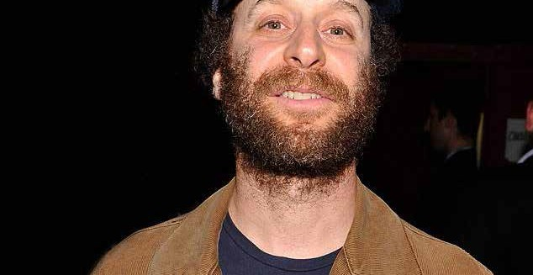

Concept Overview
This concept depicts a day in the life of the “other tooth fairy,” the disheveled fairy whose unpleasant job it is to collect teeth dip users lose to gum disease.

Concept Script

NARRATOR: This commercial starts with a middle-aged man dressed in a worn-down fairy outfit, talking to camera. He is sitting in an office cubicle being interviewed.
OTHER TOOTH FAIRY: You probably know my colleague. She comes for your baby teeth.
NARRATOR: We see him glance over to a shiny, all-white corner office. It’s the office of the real tooth fairy. We see her giggling with joy and throwing sparkly glitter around with her magic wand.
OTHER TOOTH FAIRY: She’s got a sweet gig.
OTHER TOOTH FAIRY: I’m the Other Tooth Fairy. The guy you don’t want to see. I come to collect teeth that fall out because of gum disease.
NARRATOR: He holds up a picture of rotten teeth.
OTHER TOOTH FAIRY: Nobody puts these under their pillow. I gotta yank ’em right outta their mouth.
NARRATOR: We see him getting coffee at a run-down gas station and fuels up his 1993 tan Buick LeSabre.
OTHER TOOTH FAIRY: This is what keeps me in business. (Holds up a can of dip.) Dip can cause gum disease, yet these kids keep on chewing.
NARRATOR: Now we see him out in the town, doing his job. He is walking up to a teen examining his diseased gums in the mirror. He reaches into the kid’s mouth.
OTHER TOOTH FAIRY: Hold still, son, I don’t like this any more than you do.
NARRATOR: He pulls out the tooth with his bare hands. The tooth comes out pretty easily.
NARRATOR: He offers a buck to the kid, who reaches out to take it, but he yanks it away.
OTHER TOOTH FAIRY: C’mon.
NARRATOR: He returns to his car.
OTHER TOOTH FAIRY: Another day, another tooth... they think brushing their teeth can save them from this.
NARRATOR: Now we see him back at the office of the tooth fairies. The regular tooth fairy is dusting her collection of cute pearly-white baby teeth.

NARRATOR: Meanwhile, the Other Tooth Fairy places his freshly collected tooth into an envelope and then into an old cabinet.
NARRATOR: He makes a face at the regular tooth fairy when she turns her back.
OTHER TOOTH FAIRY: Another great day at the office.
SUPER: Dip can cause painful gum disease and tooth loss.
SUPER: Know The Real Cost of Dip.

CREATIVE CONCEPT #5: Tools of Mouth Cancer

Key Frame

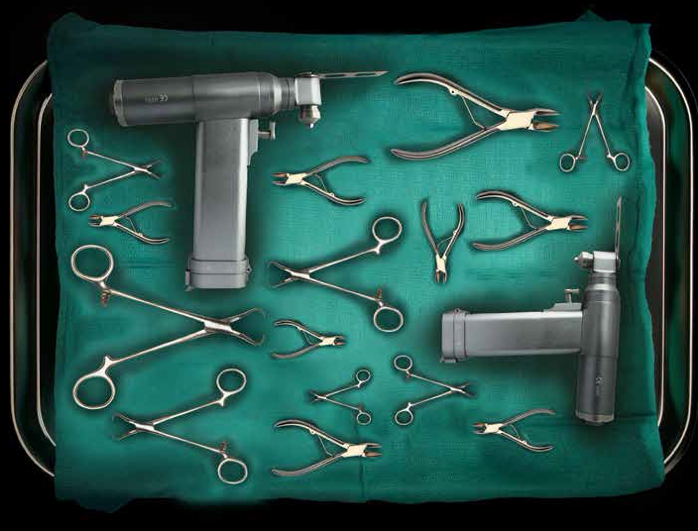

Concept Overview
This concept illustrates the unpleasant but very real details of mouth cancer surgery, specifically the type and number of tools involved in performing a mandibulectomy.

Concept Script

SUPER: SMOKELESS TOBACCO CAN CAUSE MOUTH CANCER, WHICH CAN REQUIRE THE REMOVAL OF YOUR JAW.

NARRATOR: An empty aisle in a hardware store is restocked with scary-looking medical instruments and tools. A sign that says “FOR DIPPERS ONLY” is hung above the aisle.

SUPER: A GRUELING OPERATION INVOLVING UP TO 87 TOOLS. WE PUT THEM ALL HERE...IN THE TOOL AISLE.

NARRATOR: A group of teens walk up and read the aisle sign. Curious, they walk in.

NARRATOR: They see a man wearing a surgeon’s outfit and a hardware store nametag.

The surgeon says, “Can I help you?”

One of the teens looks around at all of the scary-looking tools and says, “Um, what are these for?”

The surgeon says, “These? This is what I use on patients that get mouth cancer from dipping.”

The teen says, “Mouth cancer?”

The surgeon says, “Yep, dip contains up to 30 cancer-causing chemicals. Do you want to know more about the process?”

We see the surgeon explaining the procedure in detail to the terrified teens. He says things like “I use this screw to hold down your jaw,” “this is a new bone plate,” and “this is the feeding tube that will feed you for the first two weeks.”

NARRATOR: The teens are shocked and terrified. Some of them even walk away, not wanting to hear any more.

The surgeon says, “What, you’re not the do-it-yourself type?”

SUPER: DIP CAN CAUSE MOUTH CANCER. KNOW THE REAL COST OF DIP.

