Tobacco Discussion
Participant Booklet
Set 3

Part 1.
Pictures Alone and Pictures with Sentences

Item 1
Discussion of Picture Alone


1

Item 2
Discussion of Picture Alone
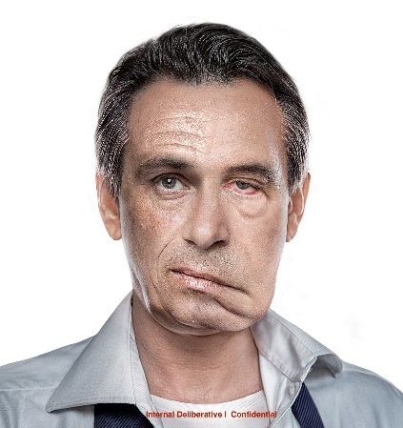
2

Item 3
Discussion of Picture Alone

3

Items 4-6
Comparison of Picture-Sentence Combinations

Please circle the picture that goes best with the sentence you see on the pictures.
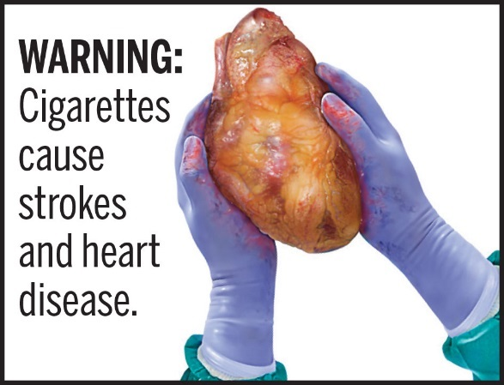 | 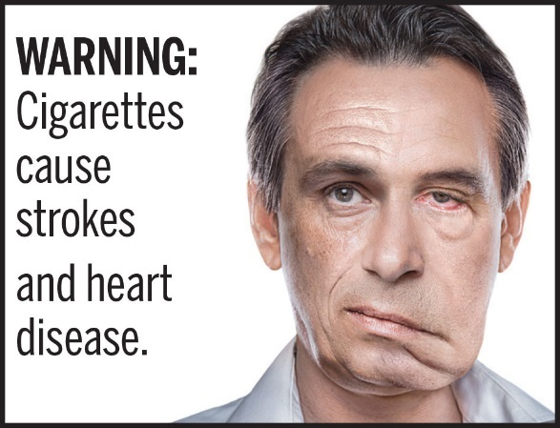

4 5

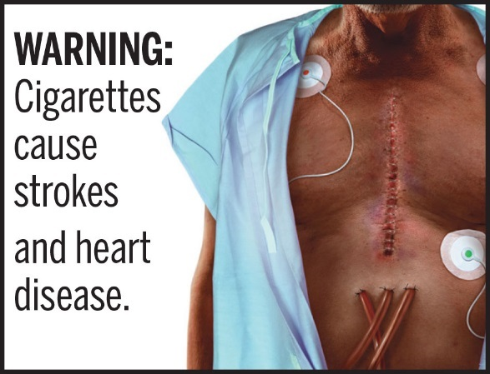
6

Items 7-9
Comparison of Picture-Sentence Combinations

Please circle the picture that goes best with the sentence you see on the pictures.
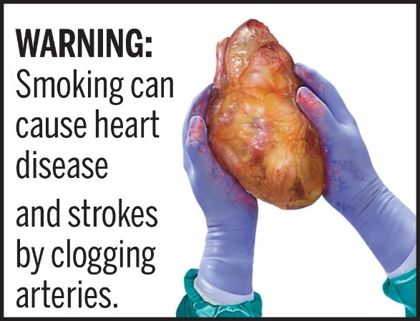 | 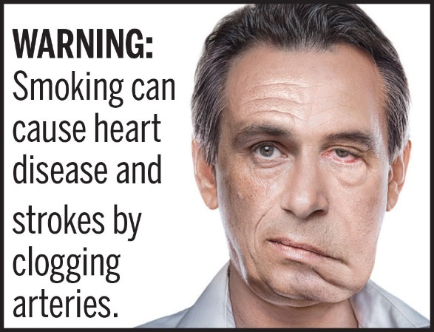

7 8

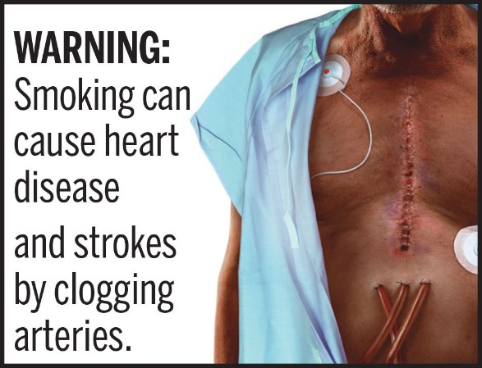
9

Item 10
Discussion of Picture Alone

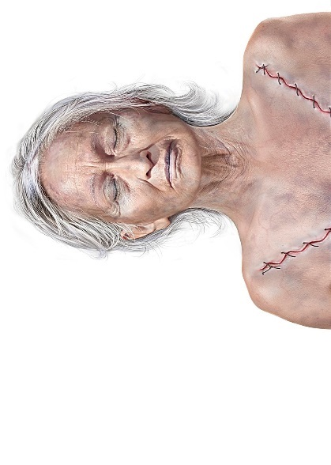
10

Item 11
Discussion of Picture-Sentence Combination

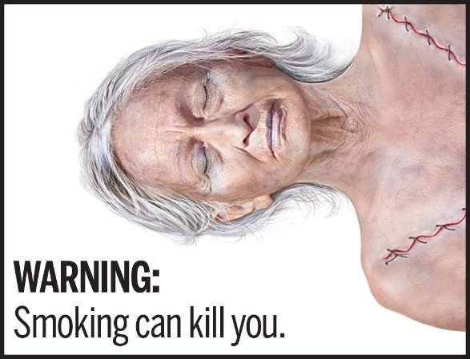
11

Item 12
Discussion of Picture-Sentence Combination

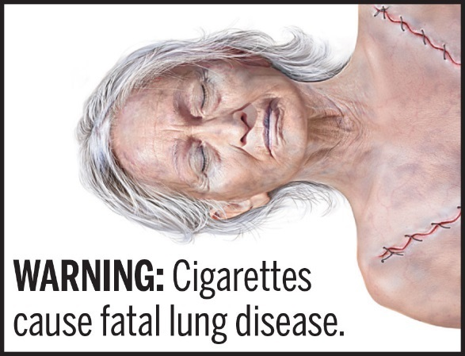
12

Item 13
Discussion of Picture-Sentence Combination

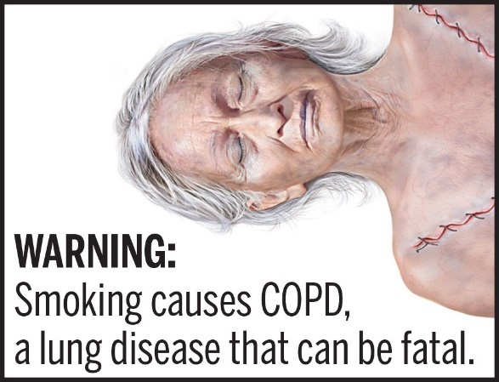
13

Item 14
Discussion of Picture Alone

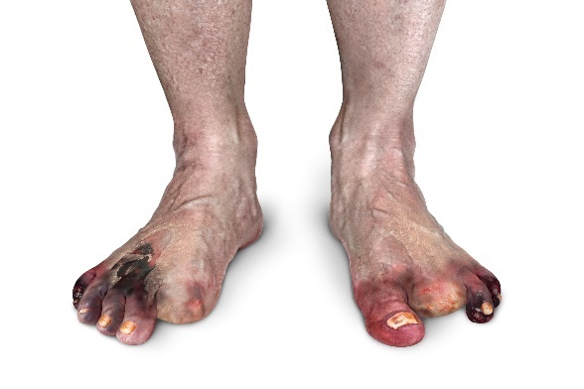
14

Item 15
Discussion of Picture-Sentence Combination

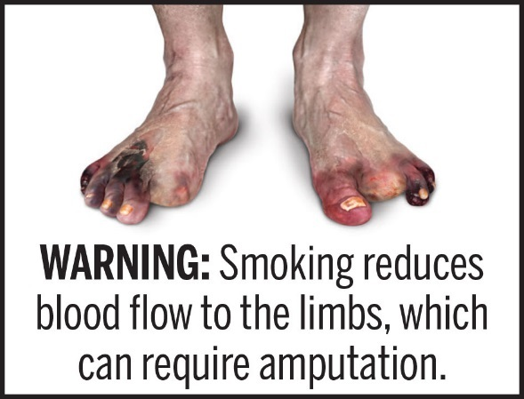
15

Item 16
Discussion of Picture Alone


16

Item 17
Discussion of Picture-Sentence Combination

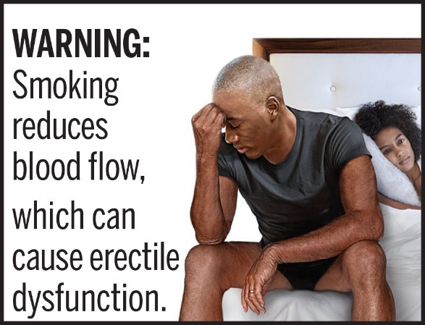
17

Part 2.
Individual Worksheet

Please mark an X in the box next to the one picture-sentence combination that you think best represents how smoking harms children.

 | 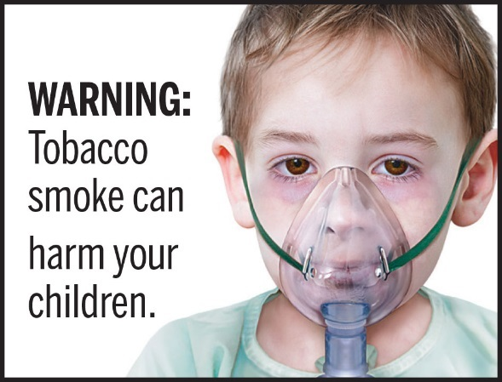 |  | 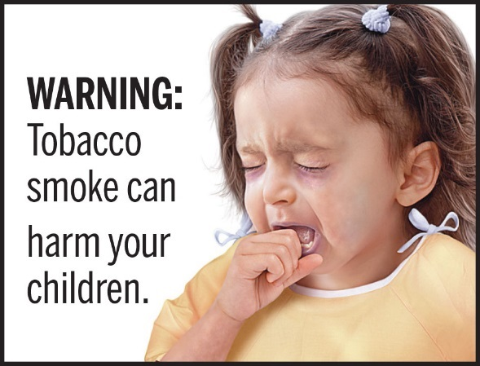
 | 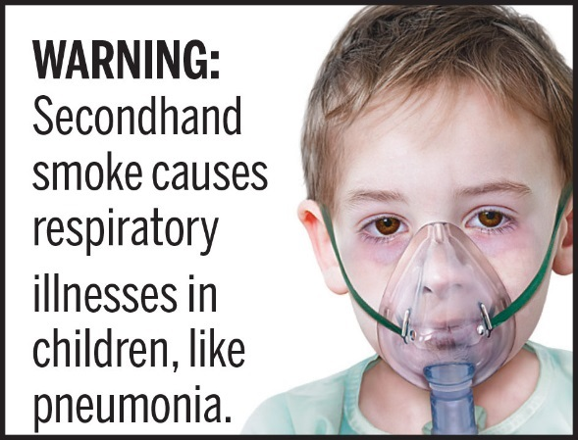 |  | 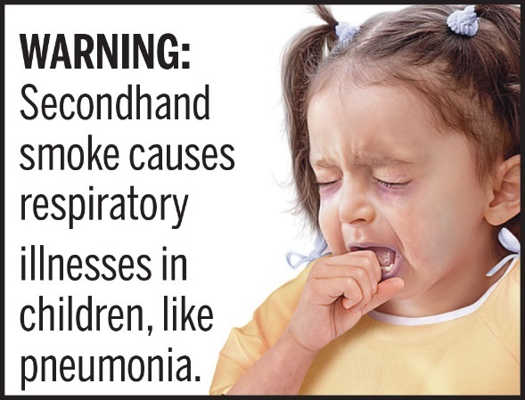

Please mark an X in the box next to the one picture-sentence combination that you think best represents how smoking harms babies.

 | 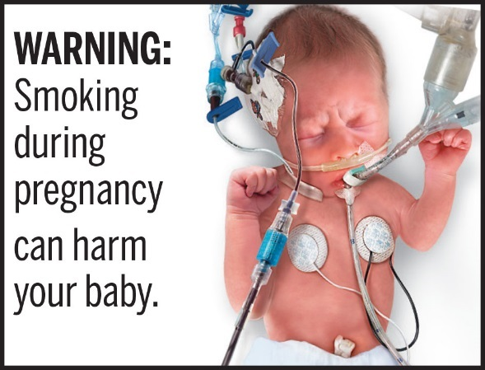 |  | 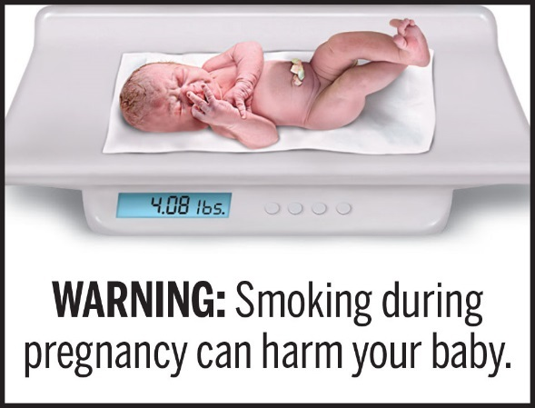
 | 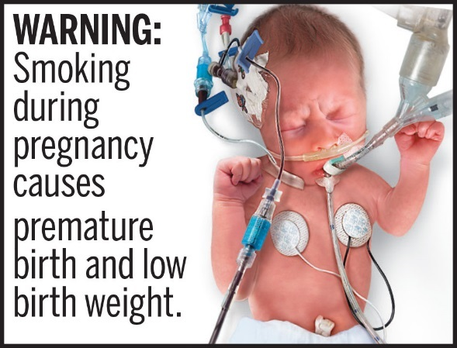 |  | 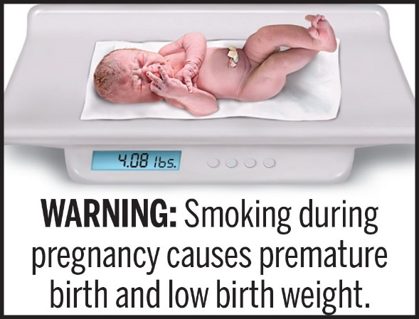
 | 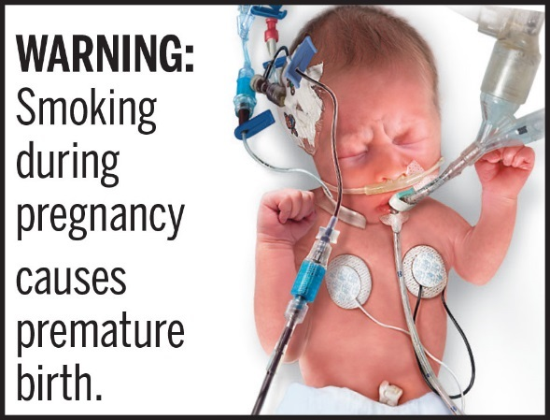 |  | 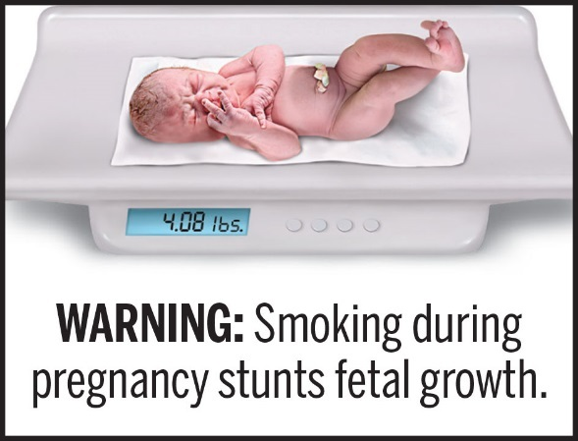

Please mark an X in the box next to the one picture-sentence combination that you think best represents how smoking causes cancer.
 | 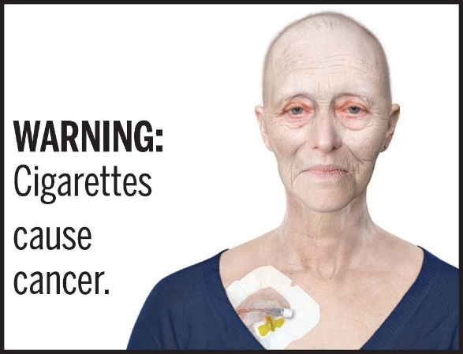 |  | 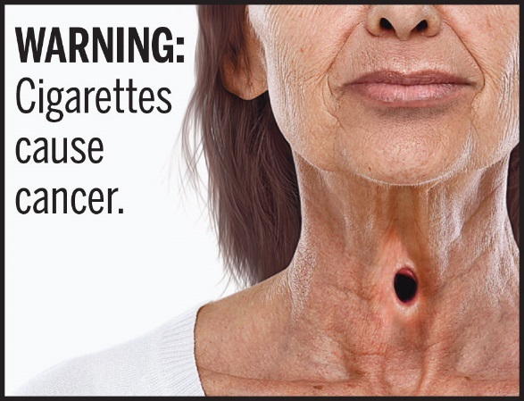
 | 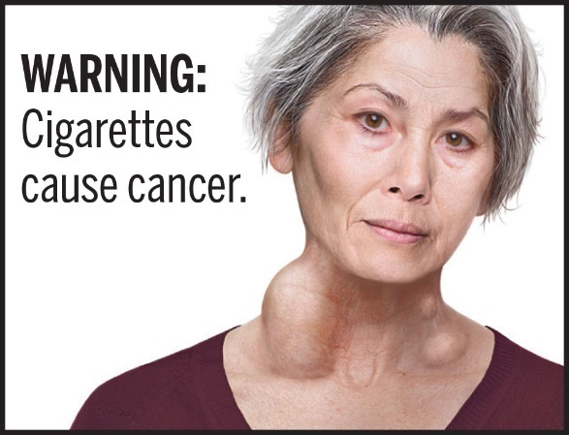 |  | 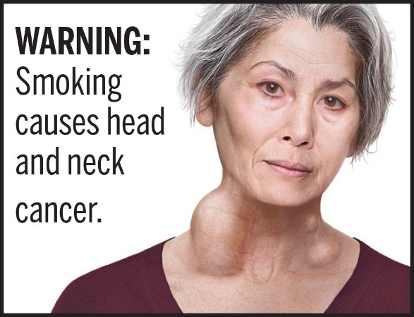
 | 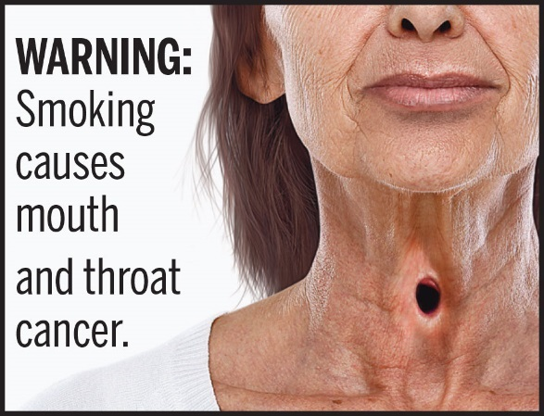 |  | 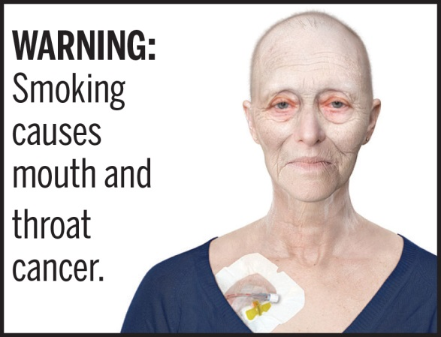
 | 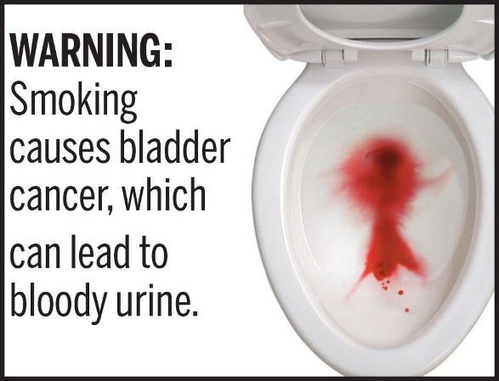 |  | 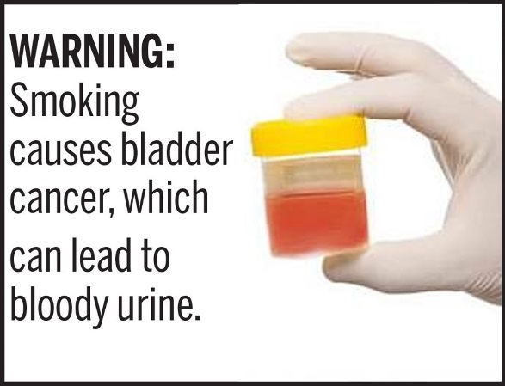
Please mark an X in the box next to the one picture-sentence combination that you think best represents how smoking causes lung disease.
 | 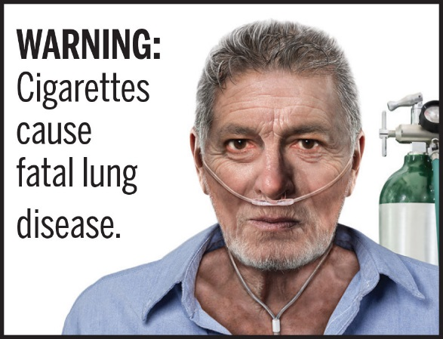 |  | 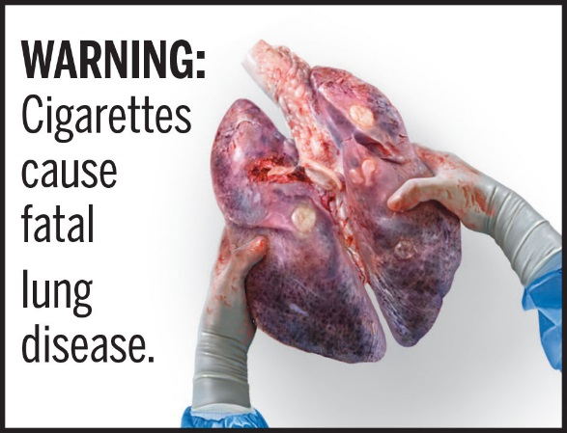
 | 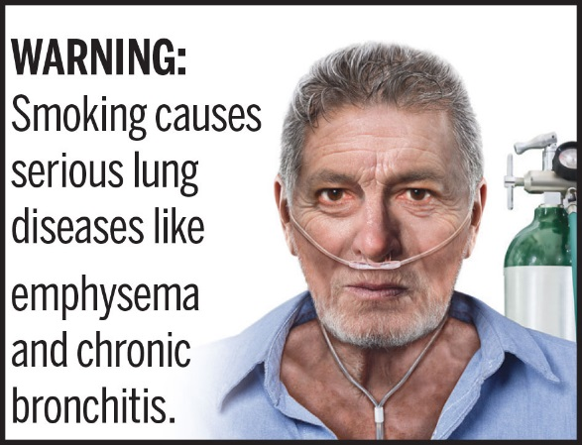 |  | 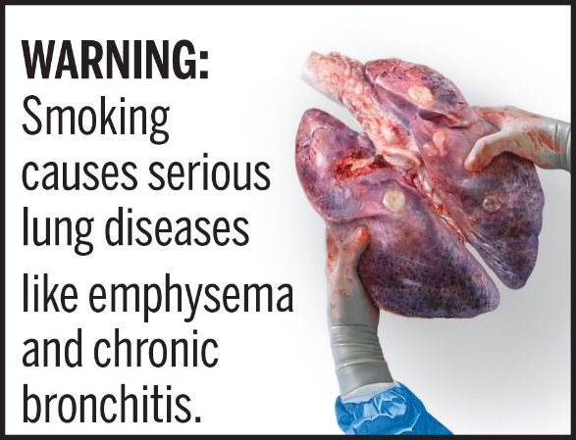
 | 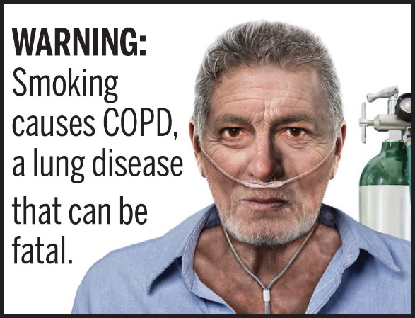 |  | 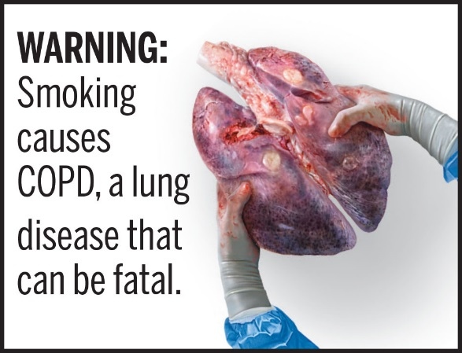
 | 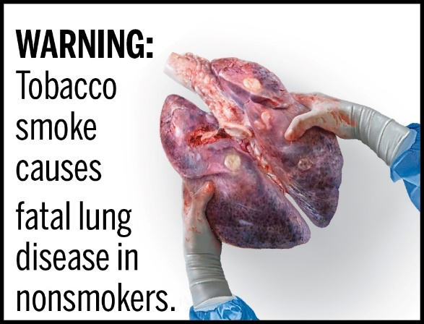

Please mark an X in the box next to the one picture-sentence combination that you think best represents how smoking causes heart disease.

Please mark an X in the box next to the one picture-sentence combination that you think best represents how smoking causes death.

Please mark an X in the box next to the one picture-sentence combination that you think best represents how smoking causes blindness.

 | 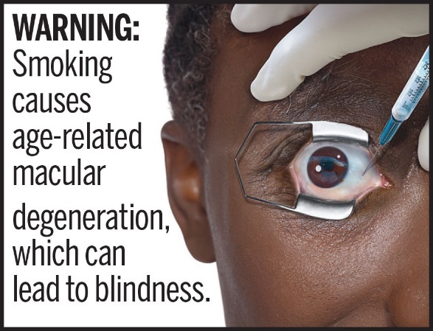 |  | 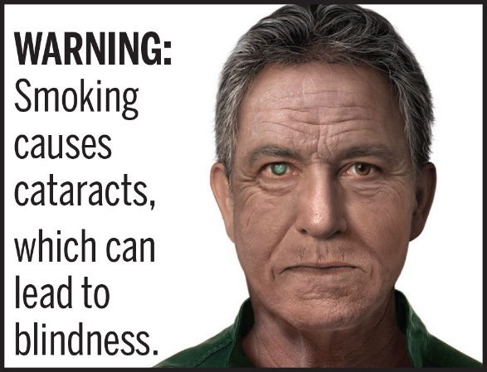

Please mark an X in the box next to the one picture-sentence combination that you think best represents how smoking causes addiction.

 | 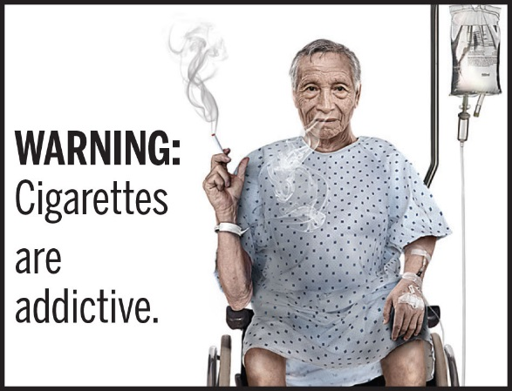 |  | 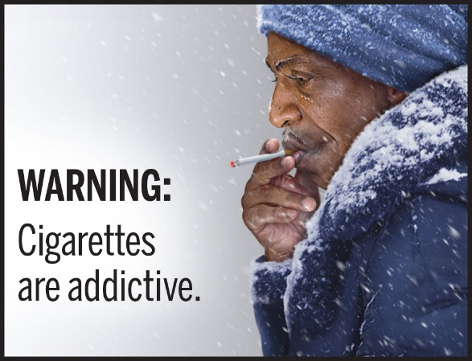

Please mark an X in the box next to the one picture-sentence combination that you think best represents quitting smoking.

 | 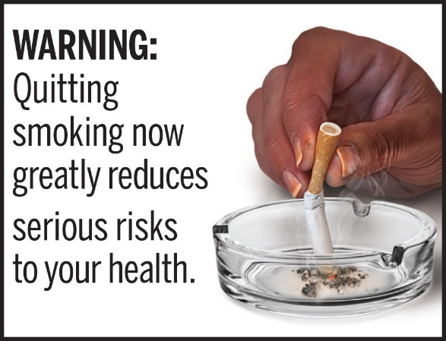 |  | 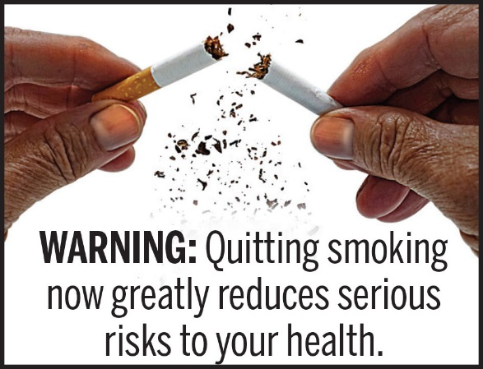

Paperwork Reduction Act Statement: An agency may not conduct or sponsor, and a person is not required to respond to, a collection of information unless it displays a currently valid OMB control number. The public reporting burden for this information collection has been estimated to average 90 minutes per response for the time required to participate in the focus group and complete the Participant Booklet (the time estimated to discuss, read, review, and complete). Send comments regarding this burden estimate or any other aspects of this information collection, including suggestions for reducing burden, to PRAStaff@fda.hhs.gov.

