Fresh Empire Campaign: Wave 2 Quantitative Study of Reactions to Rough-Cut Advertising
Designed to Prevent Youth Tobacco Use
OMB# 0910-0810
Exp. 11/30/18
In-Person Electronic Screener

WELCOME PAGE

[TEXT TO PRESENT TO PARTICIPANT]: “We are looking for students to take a survey after school. If you are selected and agree to take part in the research activities, you will receive a $25 gift card. Please answer the questions on the following pages to see if you qualify. You will find out right away at the end of the survey if you have been selected. If so, you will be asked to stay after school for about 25 minutes to take the main survey.

Only the researchers will know how you answer. We will not share the answers you give with anyone outside of the research study. There are no right or wrong answers to these questions.”

[Each item will be presented in a separate page, separated by a “NEXT” button.]

DEMOGRAPHICS AND TOBACCO USE

B1. How old are you?
- 11 years old or younger
- 12 years old
- 13 years old
- 14 years old
- 15 years old
- 16 years old
- 17 years old
- 18 years old or older

B2. During the past 7 days, did you drink a can, bottle, or glass of soda or pop, such as Coke, Pepsi, or Sprite? (Do not count diet soda or diet pop.)
- Yes [CONTINUE TO B3]
- No [SKIP TO B4]

B3. During the past 7 days, how many times did you drink a can, bottle, or glass of soda or pop, such as Coke, Pepsi, or Sprite? Your best guess is fine. (Do not count diet soda or diet pop.)
- I did not drink soda or pop during the past 7 days
- 1 to 3 times during the past 7 days
- 4 to 6 times during the past 7 days
- 1 time per day
- 2 times per day
- 3 times per day
- 4 times or more per day

B4. Have you ever tried cigarette smoking, even one or two puffs?
- Yes [CONTINUE TO B5]
- No [SKIP TO B6]

B5. About how many cigarettes have you smoked in your entire life? Your best guess is fine.
- I have never smoked cigarettes, not even one or two puffs
- 1 or more puffs but never a whole cigarette
- 1 cigarette
- 2 to 5 cigarettes
- 6 to 15 cigarettes (about 1/2 pack total)
- 16 to 25 cigarettes (about 1 pack total)
- 26 to 99 cigarettes (more than 1 pack, but less than 5 packs)
- 100 or more cigarettes (5 or more packs)

B6. Do you think that you will smoke a cigarette soon?
- Definitely yes
- Probably yes
- Probably not
- Definitely not

B7. Do you think that you will drink a can, bottle, or glass of soda or pop, such as Coke, Pepsi, or Sprite, in the next week? (Do not count diet soda or diet pop.)
- Definitely yes
- Probably yes
- Probably not
- Definitely not

B8. Do you think you will smoke a cigarette in the next year?
- Definitely yes
- Probably yes
- Probably not
- Definitely not

B9. If one of your best friends were to offer you a cigarette, would you smoke it?
- Definitely yes
- Probably yes
- Probably not
- Definitely not

B10. Have you ever been curious about smoking a cigarette?
- Definitely yes
- Probably yes
- Probably not
- Definitely not

B11. What is your sex?
- Female
- Male

B12. Are you Hispanic, Latino/a, or Spanish origin? (You can choose one answer or more than one answer)
- No, not of Hispanic, Latino/a, or Spanish origin
- Yes, Mexican, Mexican American, Chicano or Chicana
- Yes, Puerto Rican
- Yes, Cuban
- Yes, another Hispanic, Latino/a, or Spanish origin

B13. What race or races do you consider yourself to be? (Mark one or more answers)
- American Indian or Alaska Native
- Asian
- Black or African American
- Native Hawaiian or Other Pacific Islander
- White

MARKETING AND RESEARCH

C1. Do you or any member of your immediate family or a close friend work for...? (Select all that apply)
- A market research company
- A tobacco company (manufacturer or importer of tobacco products)
- An advertising agency or public relations firm
- The media (TV/radio/newspapers/magazines)
- A healthcare professional (doctor, nurse, pharmacist, dietician, etc.)
- None of these

C2. Have you ever received money or gift cards from a company for sharing your opinions in a discussion group, interview or survey?
- Yes, within the past 6 months
- Yes, more than 6 months ago
- No
- I’m not sure

PICTURE SELECTION EXERCISE

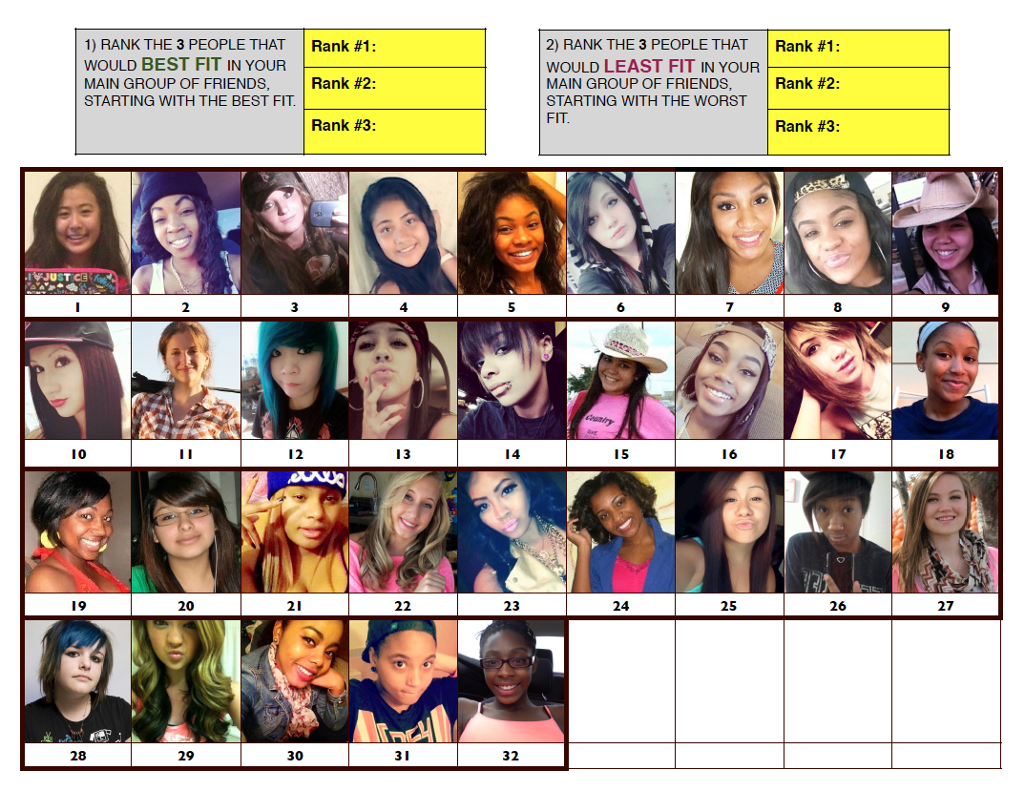

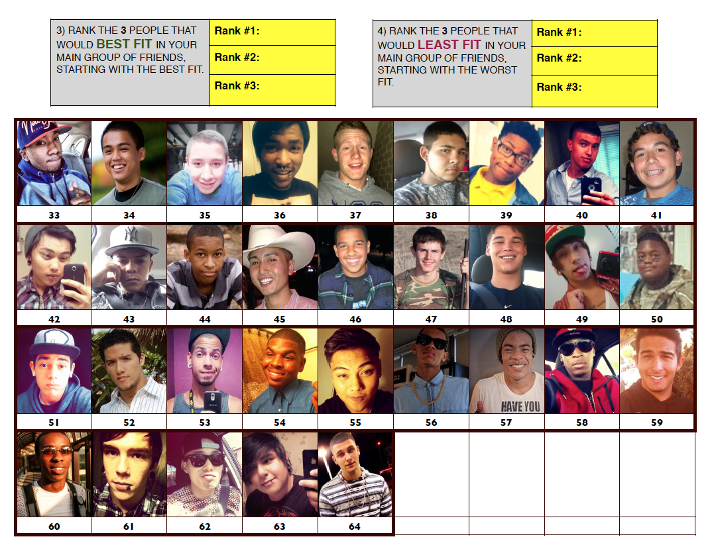

[SCREEN OUT DISQUALIFYING YOUTH BEFORE PROCEEDING TO NEXT PAGE.]

[IF B1 = A OR H, DISQUALIFY]
[IF B4 = B AND B6 = D AND B8= D AND B9 = D AND B10 = D, DISQUALIFY]
[IF B4 = A AND B5 = A AND B6 = D AND B8 = D AND B9 = D AND B10 = D, DISQUALIFY]
[IF B4 = A AND B5 = H, DISQUALIFY]

[IF C1 = B, DISQUALIFY]
[IF C2 = A, DISQUALIFY]

[IF HIP HOP I-BASE SCORE < 4, DISQUALIFY.]

[ELSE, QUALIFY]

[TEXT PRESENTED TO DISQUALIFIED PARTICIPANTS]: “Thank you for answering our questions! Unfortunately, you will not be invited to take part in the after school survey. Please return the tablet to a research assistant. Have a great day!”

[TEXT PRESENTED TO QUALIFIED PARTICIPANTS]: “Congrats! You qualify to complete the survey! Please provide the following information so that we can send you a reminder about the survey!”

CONTACT INFO PAGE
A1. First Name: ________________________

A2. Last Name: ________________________

A3. Last Classroom #/Teacher Today: ____________________________

A4. Last Classroom #/Teacher on [DATE]: ____________________________

A5. Your Phone Number: ______________________

A6. Select One: Cell or Home

A7. Your Email address: ______________________

A8. Your Email address (confirmation): ______________________

[TEXT PRESENTED TO QUALIFIED PARTICIPANTS]: “Thank you! Please return the tablet to a research assistant so that they can give you the information you need to complete the survey and receive a $25 gift card!

Paperwork Reduction Act Statement: The public reporting burden for this information collection has been estimated to average 4 minutes per response to complete this survey (the time estimated to read and complete). Send comments regarding this burden estimate or any other aspects of this information collection, including suggestions for reducing burden, to PRAStaff@fda.hhs.gov.

