Multicultural Youth Tobacco Prevention Campaign: Copy Testing Wave 2
Addendum C: Social Media Advertisements

Participants will be recruited using a social media ad campaign that includes African American, Hispanic, and Asian-Pacific Islander (API) teen ad images. Each of the 27 images will be mixed and matched with the 11 ad copy variations to allow the Social Media Team to be proactive in identifying the most effective combinations for recruitment.

IMAGES:
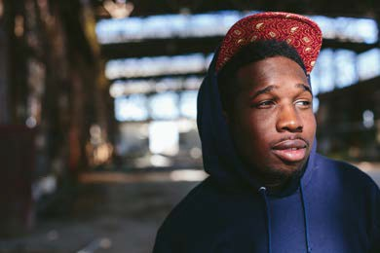

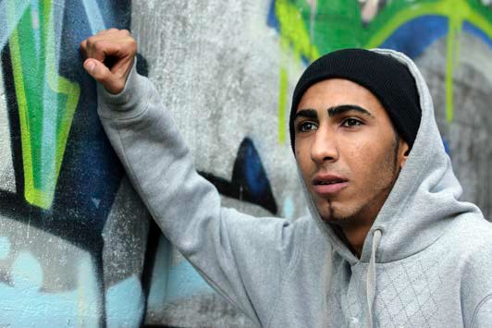
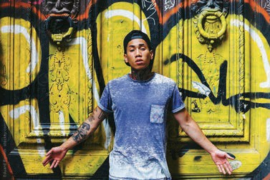
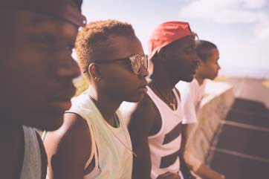

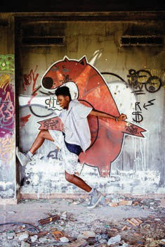

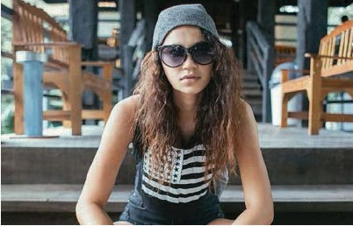
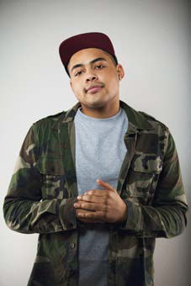
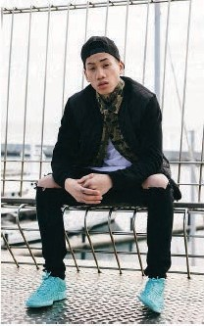

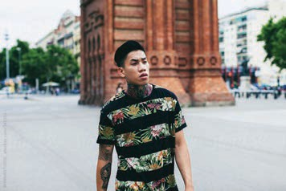

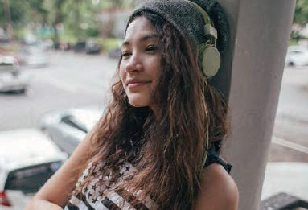

TEXT:

Name | COPY 4
Post Copy (90) | All we want is to hear what you got to say. Take this survey and we’ll thank you with $25.
Headline (25) | Share What’s on Your Mind and get $25 as a thank you.
Description (200) | Take this survey, and get a $25 thank you.
(200)
Name | COPY 7
Post Copy (90) | Got something to say? Take this survey and you could get $25 for your thoughts as a thanks.
Headline (25) | Speak Up and Get $25 as Thanks.
Description (200) | Take this survey, and you could get a $25 as thanks.

Name | COPY 11
Post Copy (90) | Got something to say? You could get $25 as thanks for just droppin knowledge – take this survey.
Headline (25) | Share What’s on Your Mind and Get for $25 as a Thank You.
Description (200) | You could get $25 as a thank you for sharing your opinions with us.

