Project Title: FDA CTP Public Education Materials Study

Appendix C. Stimuli_Materials to Test

CTP-55: Deeming Print Graphic: All Tobacco Products Are Now Regulated by FDA (English) 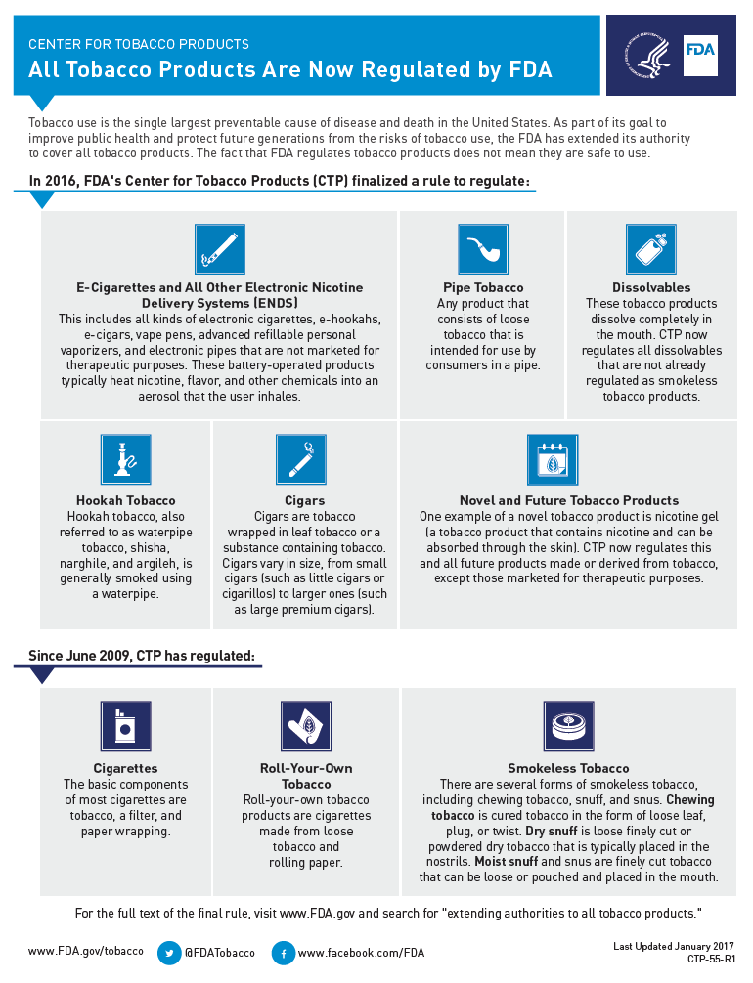

CTP-55-S: Deeming Print Graphic: All Tobacco Products Are Now Regulated by FDA (Spanish)

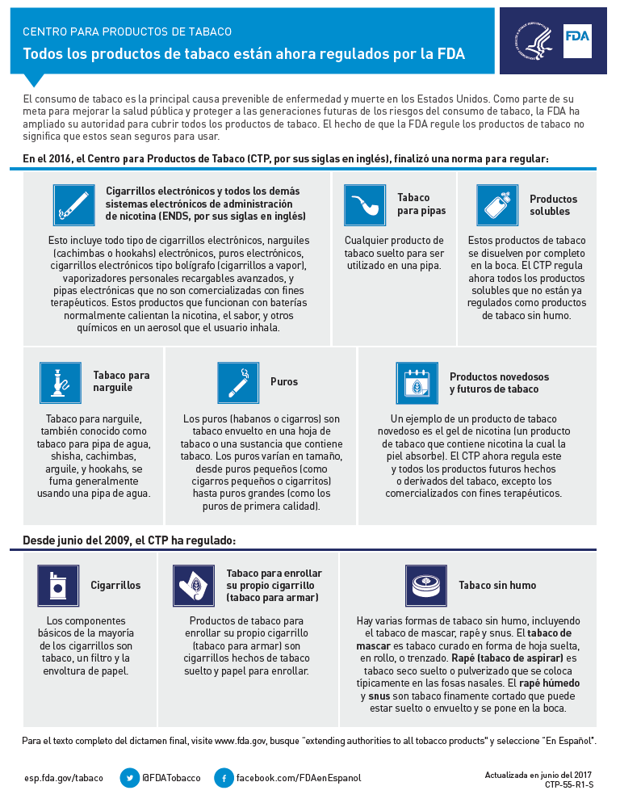

CTP-72: FDA Rules for Electronic Nicotine Delivery System (ENDS) Sales (English)
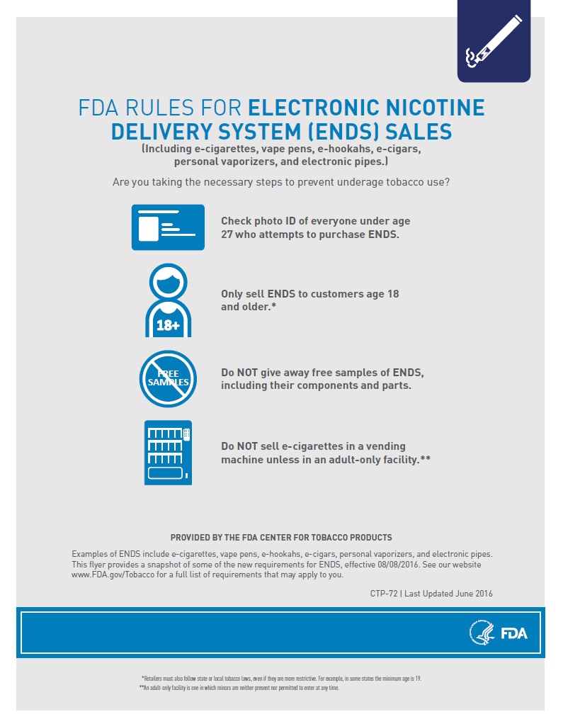
CTP-72: FDA Rules for Electronic Nicotine Delivery System (ENDS) Sales (Spanish)
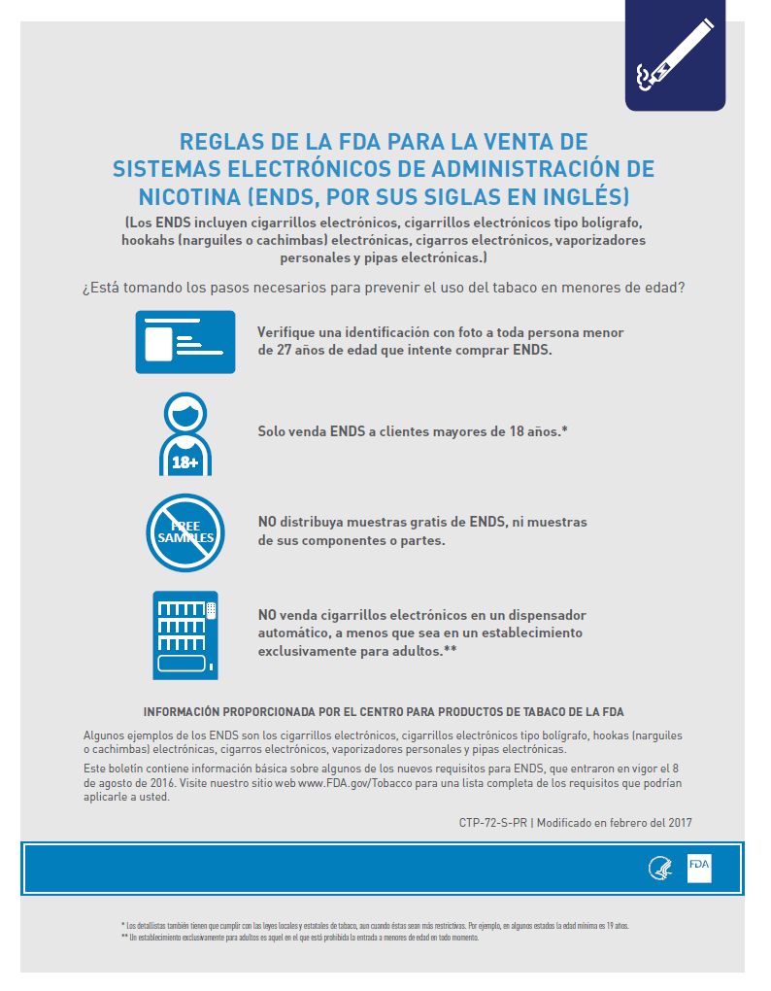

CTP-92: Infographic: 5 Tips to Help Avoid “Vape” Battery Explosions (English)
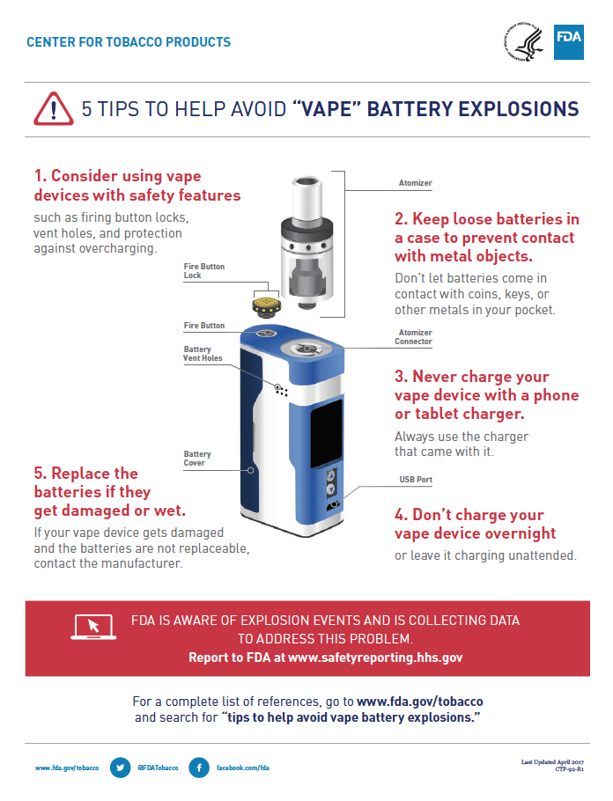
CTP-92-S: Infographic: 5 Tips to Help Avoid “Vape” Battery Explosions (Spanish)
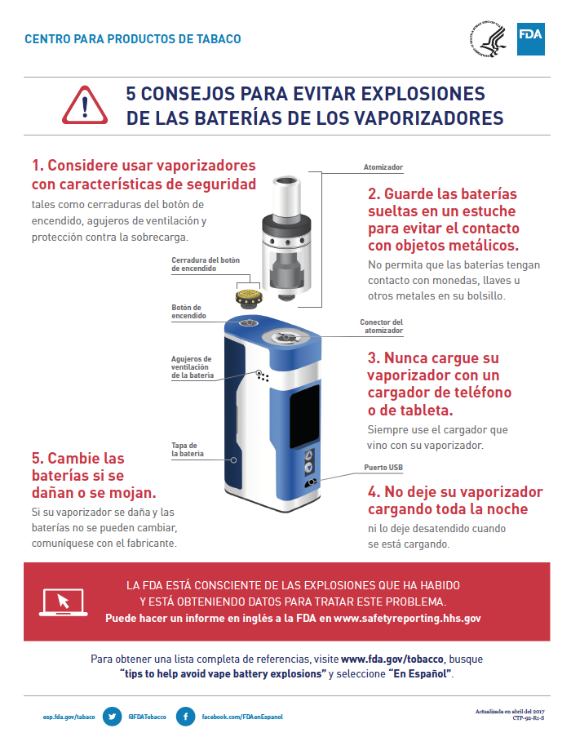
CTP-93: Chemicals in Cigarettes: From Plant to Product to Puff (English)
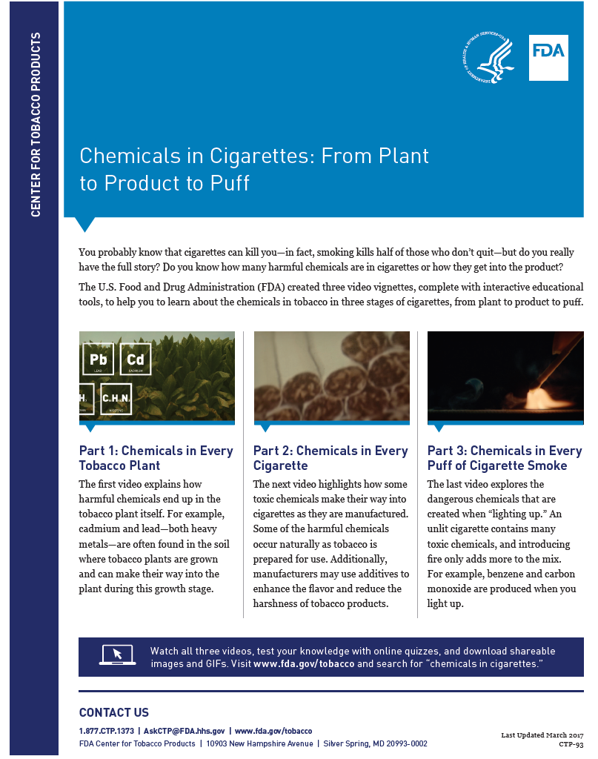

CTP-93-S: Chemicals in Cigarettes: From Plant to Product to Puff (Spanish)
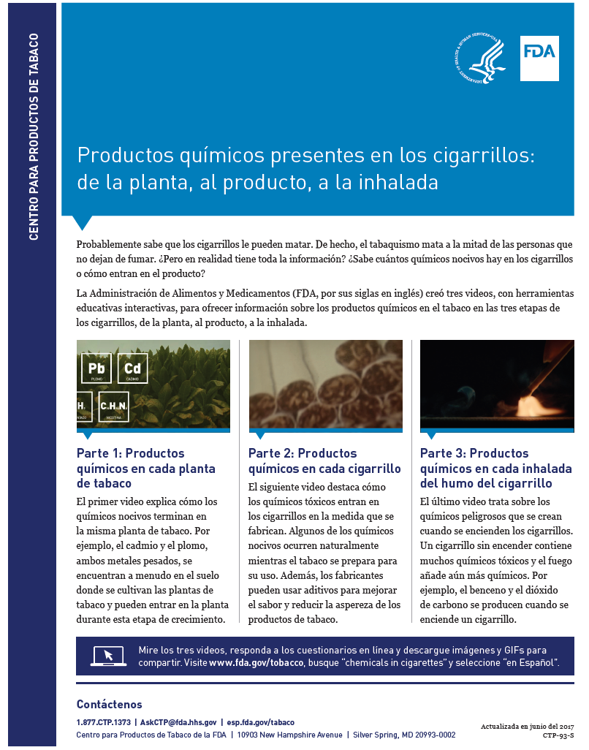
CTP-100: National Youth Tobacco Survey 2016 Infographic: Youth Tobacco Use in the U.S. (English)
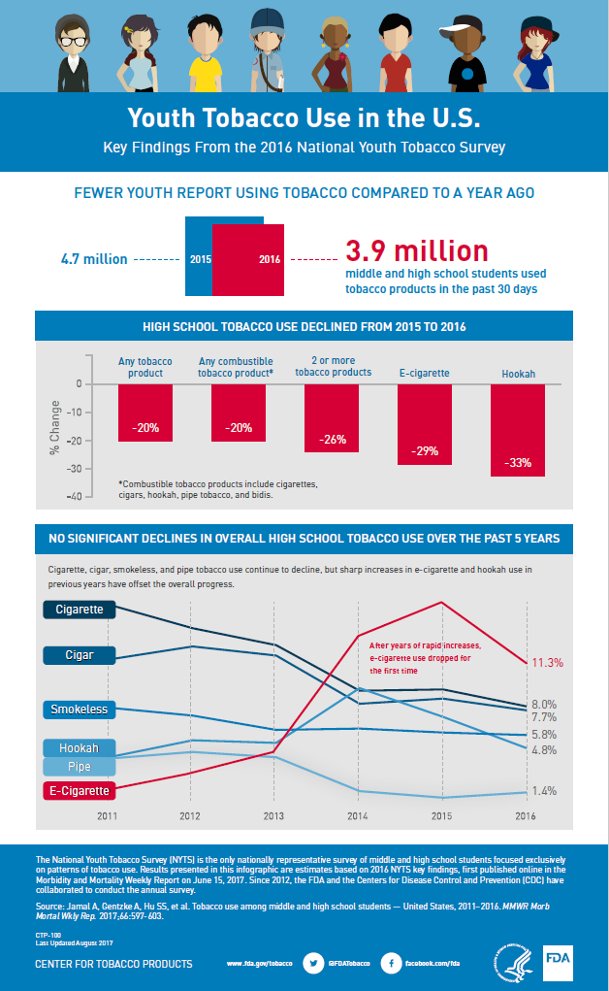

CTP-100-S: National Youth Tobacco Survey 2016 Infographic: Youth Tobacco Use in the U.S. (Spanish)
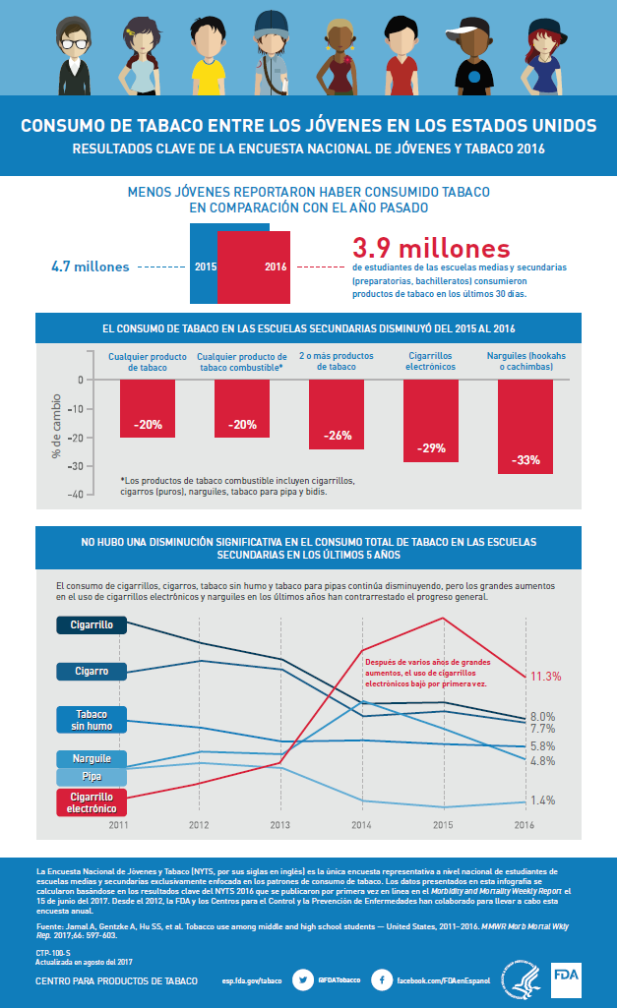
CTP-78: Poster: Smoking can cause stained teeth and gum disease, which can lead to tooth loss (English)

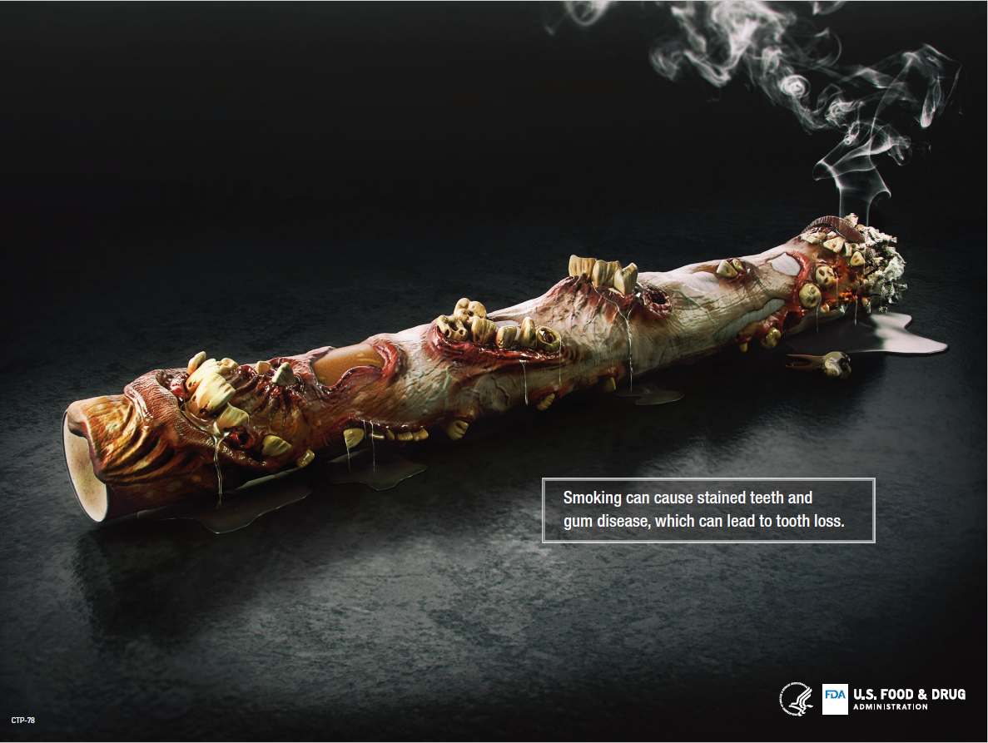

CTP-78-S: Poster: Smoking can cause stained teeth and gum disease, which can lead to tooth loss (Spanish)

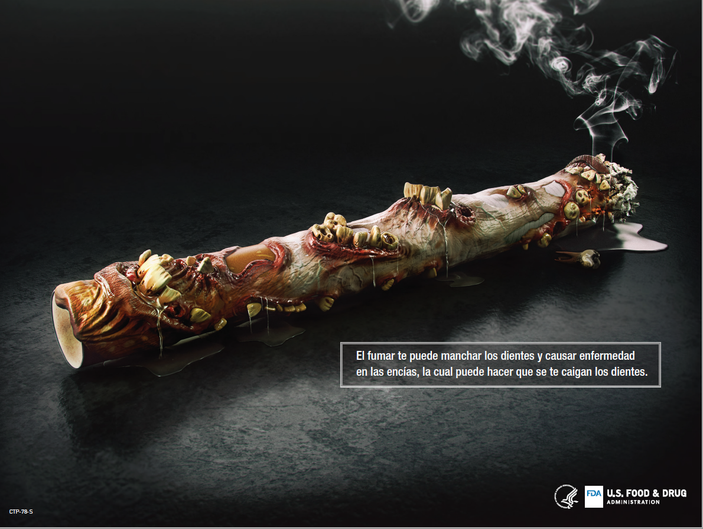

CTP-81: Poster: It hit me … Each puff is a POW! (English)

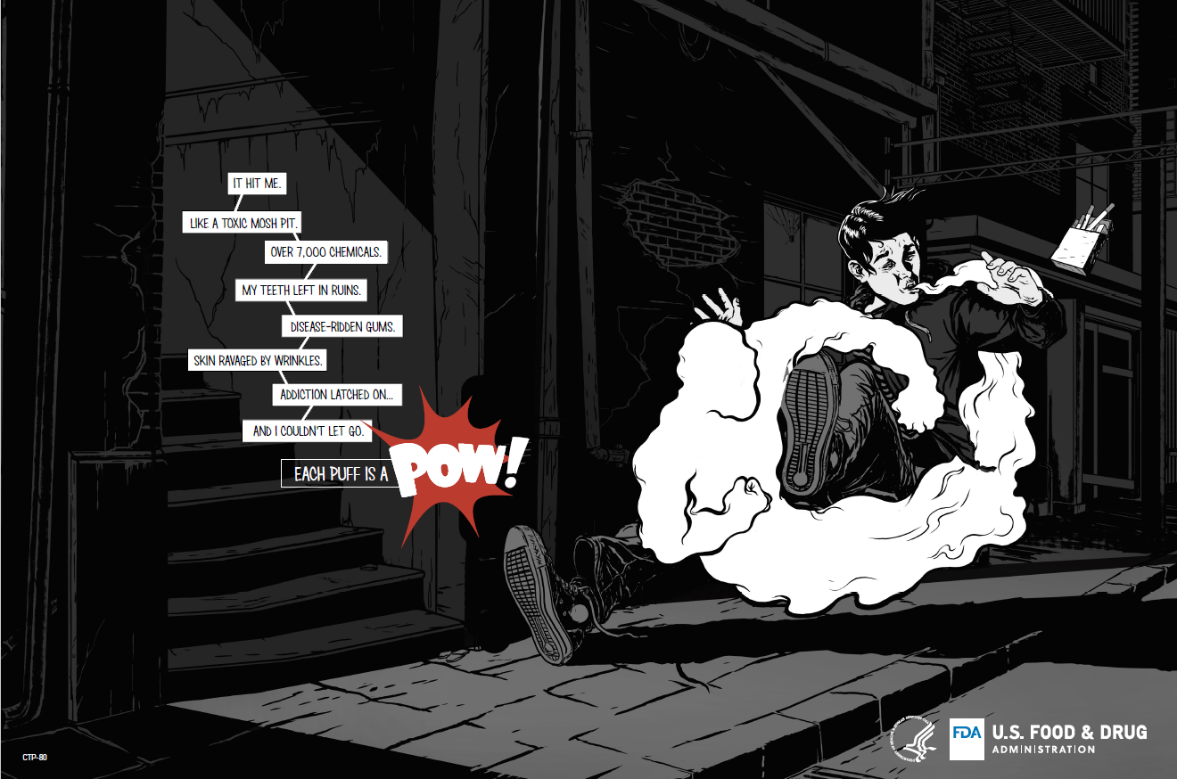
CTP-81-S: Poster: It hit me … Each puff is a POW! (Spanish)

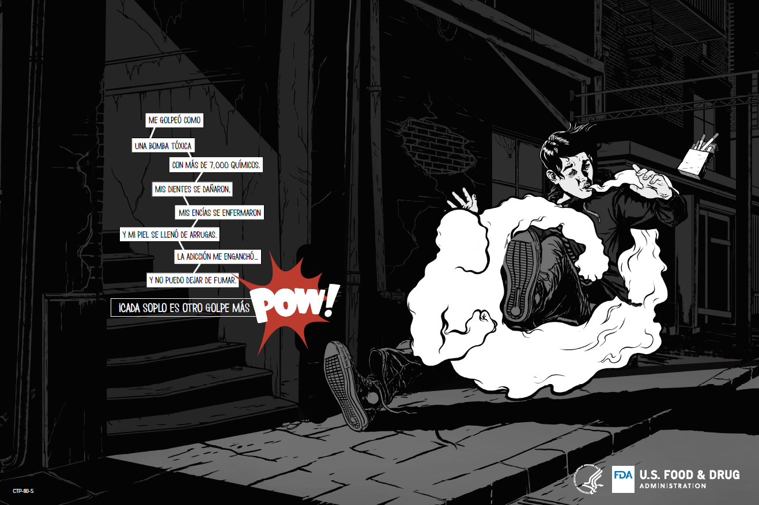

CTP-83: Poster: Be Shareable: Smoking can speed up skin aging and lead to early wrinkles (English)
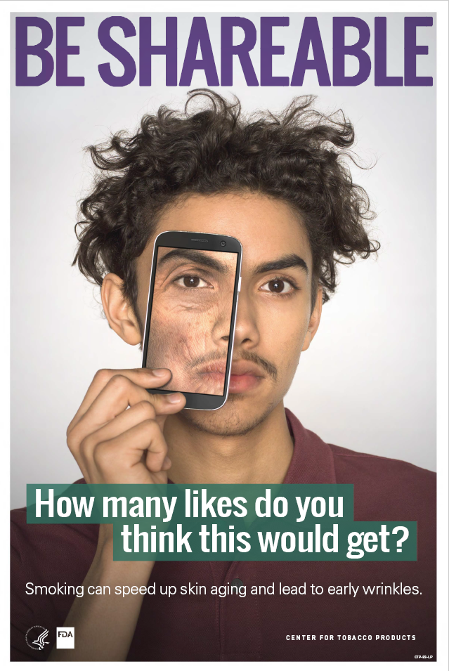

CTP-83-S: Poster: Be Shareable: Smoking can speed up skin aging and lead to early wrinkles (Spanish)
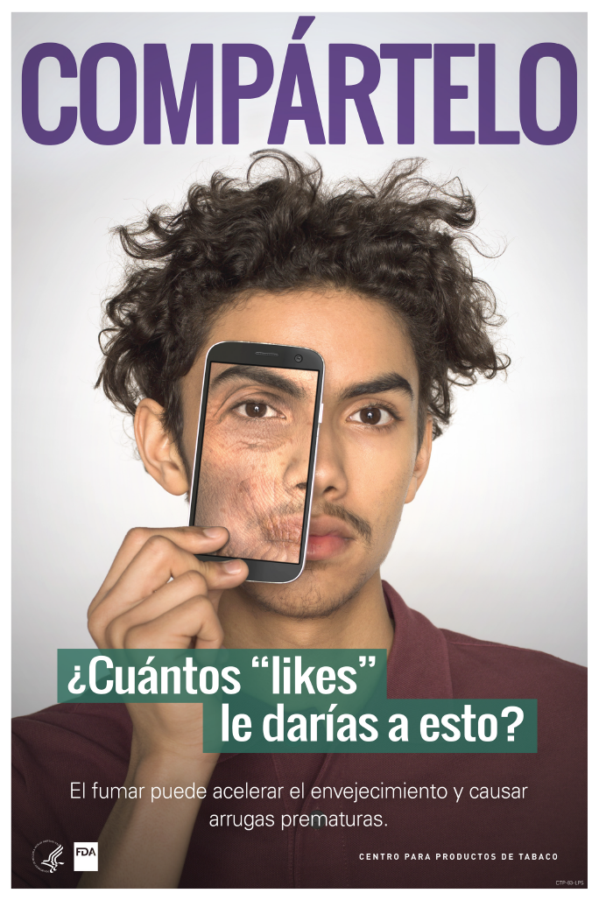
CTP-88: Poster: Want your smile to look like this? (English)
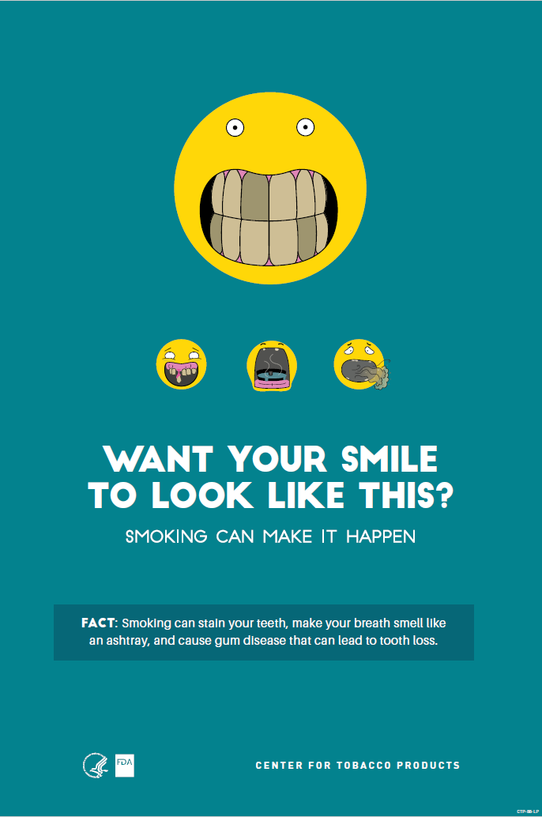
CTP-88-S: Poster: Want your smile to look like this? (Spanish)
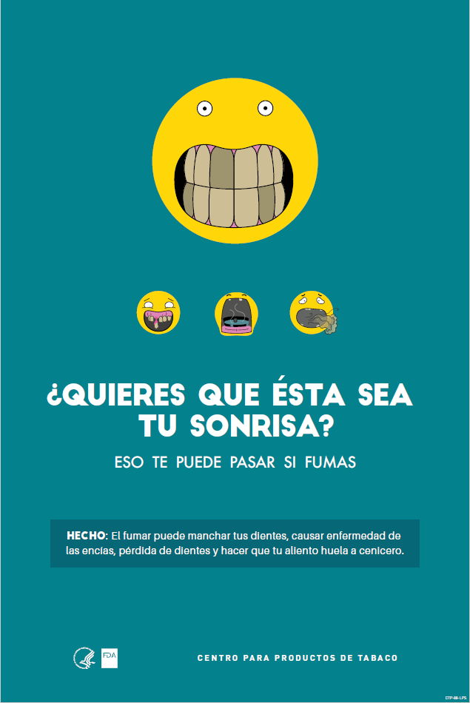
CTP-89: Poster: So what if I do? Cravings (English)
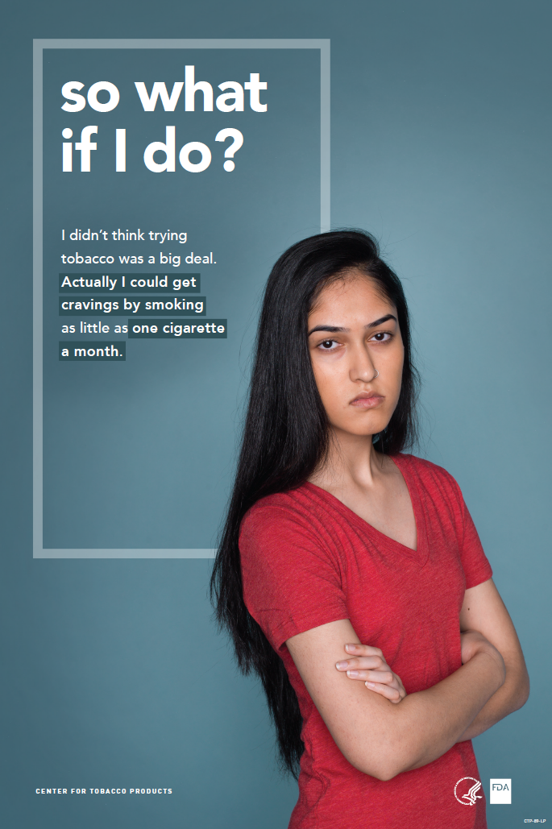

CTP-89-S: Poster: So what if I do? Cravings (Spanish)
