Attachment E

Intervention #1: Power Stow Roller System (PS)

The first intervention is the Power Stow Roller System (PSRS or PS) (see Figures below). It is an extended belt loader system used inside the cargo compartment to reduce the intensities of manual baggage handling. As shown in the Figure (a), the extended roller conveyor transfers bags to the baggage stacking area in the cargo compartment, as opposed to manual transfer from the door to the stacking area without the use of the PS. As indicated in Figure (b), the head (a small ramp) of the roller conveyor can be operated to raise up to the baggage handler’s shoulder height, at which the baggage handler can transfer a bag from the roller conveyor to the desired stacking area, rather than lift from the floor to the stacking area. Typically, the baggage handler would guide the head of the roller conveyor to en empty space in the stacking area, followed by a push/pull the bag off the conveyor to complete loading/stacking the bag. For unloading bags from the cargo compartment, the baggage handler is required to pick up bags in the stacking area to the roller conveyor, which then automatically transports bags to the belt loader all the way down to the area where other baggage handlers pick up the bags to the baggage cart.

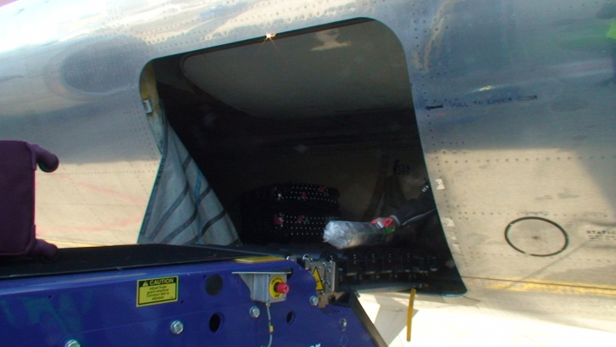
(a)

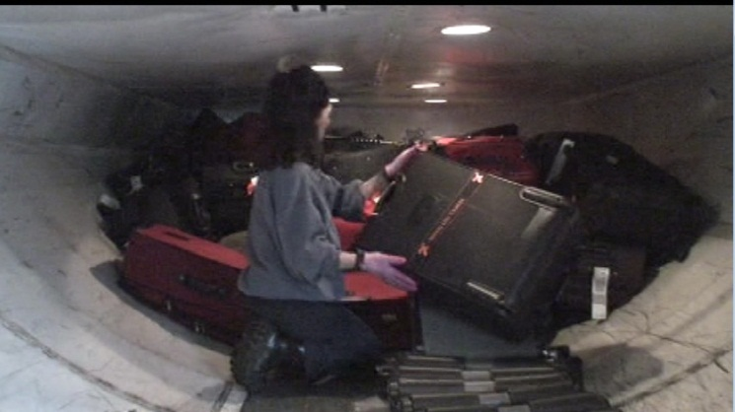
Adjustable small ramp of the PS
(b)

