**Attachment I-1**

**Annual Questionnaire**

Form Approved

OMB No. 0920-0260

Expires xx/xx/20xx



**Study Title:**

**Evaluating Interventions for Airplane Cargo Baggage Handling**

Public reporting burden of this collection of information is estimated to average 30 minutes per response, including the time for reviewing instructions, searching existing data sources, gathering and maintaining the data needed and completing and reviewing the collection of information. An agency may not conduct or sponsor, and a person is not required to respond to a collection of information unless it displays a currently valid OMB control number. Send comments regarding this burden estimate or any other aspect of this collection of information, including suggestions for reducing this burden to CDC, Project Clearance Officer, 1600 Clifton Road, MS D-74, Atlanta, GA 30333, ATTN.: PRA (0920-xxxx). Do not send the completed form to this address.

**SECTION A. GENERAL INFORMATION**

**Today's Date:**__ __ / __ __ / __ __ __ __ **Work site (3 letter airport code):** ______

month day year

1. **Last Name**: _________________________________________________________
2. **First Name**: _________________________________________________________
3. **Middle Initial**:_____
4. **Your Employee Number** *(or Clock Number)*: __________________
5. **Date of Birth**: __ __ / __ __ /__ __ __ __

month day year

1. **Gender**: 🞏 Male 🞏 Female
2. **Your home address: _______________________________________________________**
3. **Your home or cell phone number: _________________________**
4. **Your Height:** __ feet __ __ inches
5. **Your Weight:** __ __ __ pounds
6. **Are you of Hispanic or Latino origin?** 🞏 No 🞏 Yes
7. **Race (check all that apply):** 🞏 White

🞏 Black or African American

🞏 Asian

🞏 Native Hawaiian or Pacific Islander

🞏 Native American or Alaska Native

**13. What is the highest grade in school that you completed?**

🞏 8th grade or less

🞏 Some high school

🞏 High school graduate or GED

🞏 Some college

🞏 College graduate *(Bachelor's Degree or higher)*

**14. Have you ever smoked at least 100 cigarettes in your ENTIRE LIFE?**

🞏 No

🞏 Yes

🡾

🞏 Yes, but I **NO LONGER** smoke

🞏 Yes, I **CURRENTLY** smoke

**15. Which hand do you use the most at work?**

🞏 Left

🞏 Right

🞏 Both

**16. In the past year, on average, how many alcoholic beverages did you have?**

🞏 None

🞏 Less than 12 drinks

🞏 Less than 3 drinks per week

🞏 3 to 7 drinks per week

🞏 8 to14 drinks per week

🞏 More than 14 drinks per week

**17. In the past year, on average, how much total time did you spend in a vehicle each day?**

🞏 Less than 1 hour per day

🞏 1 hour to less than 2 hours per day

🞏 2 hours to less than 3 hours per day

🞏 3 hours to less than 5 hours per day

🞏 More than 5 hours per day

**SECTION B. WORK INFORMATION**

**18. How long have you worked as an airline baggage handler?**

🞏 Less than 3 months

🞏 3 months to less than 1 year

🞏 1 year to less than 3 years

🞏 3 years to less than 5 years

🞏 5 years to less than 10 years

🞏 10 years or more

**19. How long have you worked at this airport?**

🞏 Less than 3 months

🞏 3 months to less than 1 year

🞏 1 year to less than 3 years

🞏 3 years to less than 5 years

🞏 5 years to less than 10 years

🞏 10 years or more

**20. How long have you worked in the tarmac (ramp) area at this airport?**

🞏 Less than 3 months

🞏 3 months to less than 1 year

🞏 1 year to less than 3 years

🞏 3 years to less than 5 years

🞏 5 years to less than 10 years

🞏 10 years or more

**21. Are you a crew leader?**

🞏 No

🞏 Yes

**22. What is the length of your employment at this company?**

🞏 less than 1 year

🞏 1 year to less than 5 years

🞏 5 years to less than 10 years

🞏 10 years to less than 15 years

🞏 15 years to less than 20 years

🞏 20 years to less than 25 years

🞏 25 years or more

**23. How would you describe your work arrangement?**

🞏 Permanent/full time (at least 40 hours per week)

🞏 Permanent/full time (at least 20 hours per week)

🞏 Temporary worker under contract-work at least 20 hours per week

🞏 Temporary worker under contract-work at least 40 hours per week

🞏 On-call (work only when called to work)

**24. On your current job, do you usually work:**

🞏 Regular daytime shift *(anytime between 6 A.M. to 6 P.M.)*

🞏 Regular evening shift *(anytime between 2 P.M. to Midnight)*

🞏 Regular night shift *(anytime around 9 P.M. to 8 A.M.)*

🞏 Forward rotating shift - one that changes from days to evenings to nights

🞏 Backward rotating shift - one that changes from nights to evenings to days

🞏 Irregular schedule arranged by employer

🞏 Other shift

*(Specify____________________________________________)*

**25. How many HOURS PER DAY do you USUALLY work during your regular work shift at this company, not including overtime hours?**

🞏 Less than 7 ½ hours

🞏 At least 7 ½ hours but less than 8 ½ hours

🞏 At least 8 ½ hours but less than 10 hours

🞏 At least 10 hours but less than 12 hours

🞏 12 hours or more

**26. How many DAYS PER WEEK (7 days) do you USUALLY work, not including overtime hours?**

🞏 Less than 3 days per week

🞏 3 days per week

🞏 4 days per week

🞏 5 days per week

🞏 6 days per week

🞏 7 days per week

**27. Do you work overtime?**

🞏 No 🡺 *(Skip to question 28)*

🞏 Yes, **voluntary** overtime

🞏 Yes, **mandatory** overtime

🞏 Yes, **BOTH** voluntary and mandatory overtime

a. How many **overtime** HOURS PER WEEK do you USUALLY work?

🞏 Less than 5 hours per week

🞏 5 to 10 hours per week

🞏 11 to 20 hours per week

🞏 More than 20 hours per week

b. **In the past 12 months** (52 weeks), approximately how many weeks did you work ***overtime****?*

🞏 1 to 9 weeks in the past year (up to 15% of the year)

🞏 10 to 19 weeks in the past year (approximately 30% of the year)

🞏 20 to 29 weeks in the past year (approximately 50% of the year)

🞏 30 to 39 weeks in the past year (approximately 70% of the year)

🞏 40 weeks or more in the past year (77% of the year or more)

**28. What body position do you usually use to handle bags inside airplane cargo compartments?**

🞏 Kneeling

🞏 Sitting

🞏 Squatting

🞏 Standing

🞏 Combination of kneeling and sitting

**29. Do you wear knee pads for work?**

🞏 No

🞏 Yes

**30. In the past year, what is the average percentage of your work time spent in cargo compartments loading/unloading baggage during your typical workday?**

🞏 100%

🞏 About 75%

🞏 About 50%

🞏 About 25%

🞏 I do not use the Power Stow

**31. In the past year, what is the average percentage of your work time spent on lifting bags to/from baggage carts during your typical workday?**

🞏 100%

🞏 About 75%

🞏 About 50%

🞏 About 25%

🞏 I do not use the Vacuum Lift

**32. Do you work at a second job?**

*If you checked* ***no****,* ***go to*** *the top of page 7*

🞏 No 🡺

🞏 Yes

1. How long have you been working at your **second job**?

🞏 Less than 3 months

🞏 3 months to less than 1 year

🞏 1 year to less than 3 years

🞏 3 years to less than 5 years

🞏 5 years to less than 10 years

🞏 10 years or more

1. How many HOURS PER WEEK do you USUALLY work at your **second job**?

🞏 Less than 5 hours per week

🞏 5 to 10 hours per week

🞏 11 to 20 hours per week

🞏 More than 20 hours per week

1. Do you usually work your first and second job on the SAME day(s) or on DIFFERENT days?

🞏 Work SAME day(s)

🞏 Work DIFFERENT day(s)

🞏 Both

1. Does this second job involve LIFTING, PUSHING, PULLING, or CARRYING:

MODERATE weight objects? 🞏 No 🞏 Sometimes 🞏 Often

HEAVY weight objects? 🞏 No 🞏 Sometimes 🞏 Often

e. Does this second job involve bending your back?

🞏 Never or rarely

🞏 Less than half of the time

🞏 Half the time or more

f. On the scale below, rate the typical activity of your HANDS and ARMS while working at your second job.

|  |  |  |  |  |  |  |  |  |  |  |
| --- | --- | --- | --- | --- | --- | --- | --- | --- | --- | --- |
| 🞋 | ➀ | ➁ | ➂ | ➃ | ➄ | ➅ | ➆ | ➇ | ➈ | ➉ |
| no regular motion; hands and arms mostly idle |  | very slow motion; a lot of pauses |  | slow, steady motion; frequent pauses |  | steady motion, occasional pauses |  | rapid, steady motion; few pauses |  | rapid, steady motion; difficulty keeping up |

**SECTION C. PHYSICAL ACTIVITIES OUTSIDE OF WORK**

*Please think for a moment about all the different PHYSICAL activities you perform when you are not at work. Although you may not do the same activities every week, estimate below how much time “on average” you spend each week on physical activities outside of work.*

**33. How many hours on average do you spend on activities in which...**

a. you twist your back or bend forward at least as much as shown in this picture?



🞏 Less than 5 hours each week

🞏 5 to less than 10 hours each week

🞏 10 to less than 20 hours each week

🞏 20 or more hours each week4

b. you lift, push, pull or carry moderate to heavy weights?

🞏 Less than 5 hours each week

🞏 5 to less than 10 hours each week

🞏 10 to less than 20 hours each week

🞏 20 or more hours each week

**34. How many hours on average do you use vibrating tools?**

🞏 Less than 5 hours each week

🞏 5 to less than 10 hours each week

🞏 10 to less than 20 hours each week

🞏 More than 20 hours each week

**35. Are there sports or hobbies that you do every week?**

🞏 No

🞏 Yes

**SECTION D. HEALTH INFORMATION**

**36. Overall, how would you rate your health at the present time?**

🞏 Poor

🞏 Fair

🞏 Good

🞏 Very good

🞏 Excellent

**37. Have you ever told by a physician that you had any of the following?**

***a. Arthritis*** 🞏 No

🞏 Yes

***If YES to Arthritis, which areas are affected (Mark X for all that apply)***

🞏 Neck

🞏 Shoulder

🞏 Elbow/Forearm

🞏 Hands/Wrists/Fingers

🞏 Back

🞏 Other (specify: _________________________________________)

***b. Thyroid problems*** 🞏 No

🞏 Yes

***c. Raynaud’s disease*** 🞏 No

🞏 Yes

***d. Gout*** 🞏 No

🞏 Yes

***e. Kidney failure*** 🞏 No

🞏 Yes

***f. High blood pressure*** 🞏 No

🞏 Yes

***g. Diabetes*** 🞏 No

🞏 Yes

***h. Depression*** 🞏 No

🞏 Yes

***FEMALES ONLY***

**38. Are you currently pregnant?**

🞏 No

🞏 Yes

**The FOLLOWING SECTIONS ask if you have had symptoms (pain, aching, stiffness, spasm, burning, numbness, or tingling) in any of the body parts listed below**:

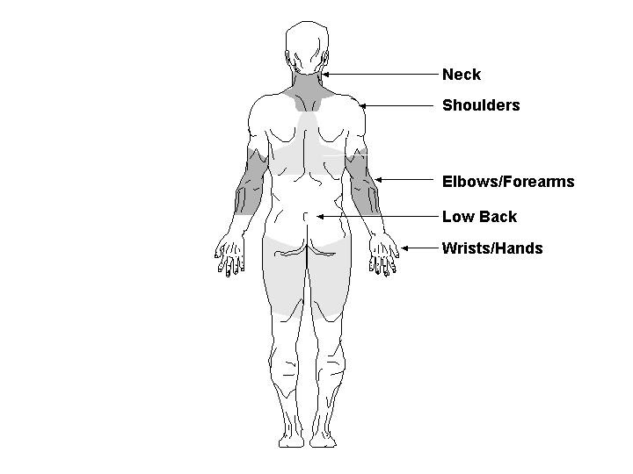

**Knees**

**39. Have you EVER had NECK symptoms (pain, aching, stiffness, spasm, burning, numbness, or tingling) lasting a week (7 days) or longer?**

🞏 No 🡺 *(Skip to question 46)*

🞏 Yes

**40. Have you EVER had surgery for your NECK symptoms?**

🞏 No

🞏 Yes

**41. In the past 12 months, have you had NECK symptoms every day for a week (7 days)?**

🞏 No

🞏 Yes

**42. In the past 12 months, how much did the NECK symptoms interfere with your normal work including both work outside the home and housework?**

🞏 Very little

🞏 A little

🞏 Moderate amounts

🞏 Much

🞏 Very much

**43. In the past 12 months, how many times have you SEEN a doctor, nurse, physical therapist or chiropractor or other health care provider for your NECK symptoms?**

🞏 None

🞏 1 time

🞏 2-4 times

🞏 5 or more than 5 times

**44. In the past 12 months, how many days have you MISSED work because of NECK symptoms?**

🞏 0 days

🞏 1 day to 1 week

🞏 More than 1 week to 2 weeks

🞏 More than 2 weeks

**45. Did the NECK symptoms in the past 12 months result from an accident or sudden injury such as a car accident or slips/falls?**

🞏 No

🞏 Yes

**46. Have you EVER had SHOULDER symptoms (pain, aching, stiffness, spasm, burning, numbness, or tingling) lasting a week (7 days) or longer?**

🞏 No 🡺 *(Skip to question 53)*

🞏 Yes

**47. Have you EVER had surgery for your SHOULDER symptoms?**

🞏 No

🞏 Yes

**48. In the past 12 months, have you had SHOULDER symptoms every day for a week (7 days)?**

🞏 No

🞏 Yes

**49. In the past 12 months, how much did the SHOULDER symptoms interfere with your normal work including both work outside the home and housework?**

🞏 Very little

🞏 A little

🞏 Moderate amounts

🞏 Much

🞏 Very much

**50. In the past 12 months, how many times have you SEEN a doctor, nurse, physical therapist or chiropractor or other health care provider for your SHOULDER symptoms?**

🞏 None

🞏 1 time

🞏 2-4 times

🞏 5 or more than 5 times

**51. In the past 12 months, how many days have you MISSED work because of SHOULDER symptoms?**

🞏 0 days

🞏 1 day to 1 week

🞏 More than 1 week to 2 weeks

🞏 More than 2 weeks

**52. Did the SHOULDER symptoms in the past 12 months result from an accident or sudden injury such as a car accident or slips/falls?**

🞏 No

🞏 Yes

**53. Have you EVER had LOW BACK symptoms (pain, aching, stiffness, spasm, burning, numbness, or tingling) lasting a week (7 days) or longer?**

🞏 No 🡺 *(Skip to question 60)*

🞏 Yes

**54. Have you EVER had surgery for your LOW BACK symptoms?**

🞏 No

🞏 Yes

**55. In the past 12 months, have you had LOW BACK symptoms every day for a week (7 days)?**

🞏 No

🞏 Yes

**56. In the past 12 months, how much did the LOW BACK symptoms interfere with your normal work including both work outside the home and housework?**

🞏 Very little

🞏 A little

🞏 Moderate amounts

🞏 Much

🞏 Very much

**57. In the past 12 months, how many times have you SEEN a doctor, nurse, physical therapist or chiropractor or other health care provider for your LOW BACK symptoms?**

🞏 None

🞏 1 time

🞏 2-4 times

🞏 5 or more than 5 times

**58. In the past 12 months, how many days have you MISSED work because of LOW BACK symptoms?**

🞏 0 days

🞏 1 day to 1 week

🞏 More than 1 week to 2 weeks

🞏 More than 2 weeks

**59. Did the LOW BACK symptoms in the past 12 months result from an accident or sudden injury such as a car accident or slips/falls?**

🞏 No

🞏 Yes

**60. Have you EVER had KNEE symptoms (pain, aching, stiffness, spasm, burning, numbness, or tingling) lasting a week (7 days) or longer?**

🞏 No

🞏 Yes

**61. Have you EVER had surgery for your KNEE symptoms?**

🞏 No

🞏 Yes

**62. In the past 12 months, have you had KNEE symptoms every day for a week (7 days)?**

🞏 No

🞏 Yes

**63. In the past 12 months, how much did the KNEE symptoms interfere with your normal work including both work outside the home and housework?**

🞏 Very little

🞏 A little

🞏 Moderate amounts

🞏 Much

🞏 Very much

**64. In the past 12 months, how many times have you SEEN a doctor, nurse, physical therapist or chiropractor or other health care provider for your KNEE symptoms?**

🞏 None

🞏 1 time

🞏 2-4 times

🞏 5 or more than 5 times

**65. In the past 12 months, how many days have you MISSED work because of KNEE symptoms?**

🞏 0 days

🞏 1 day to 1 week

🞏 More than 1 week to 2 weeks

🞏 More than 2 weeks

**66. Did the KNEE symptoms in the past 12 months result from an accident or sudden injury such as a car accident or slips/falls?**

🞏 No

🞏 Yes

**SECTION E. WORK ENVIRONMENT**

**67. For each of the following questions about the work environment at this airport, please indicate how much you agree or disagree by marking an X in the circle for one of the options.**

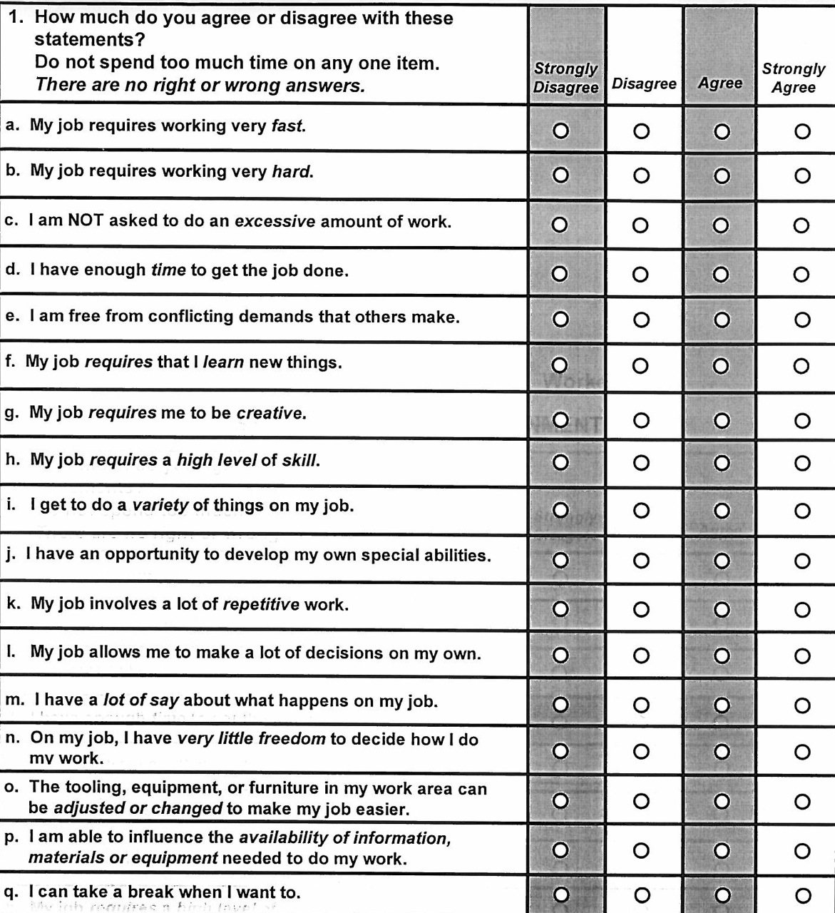

**68. For each of the following questions about the work environment at this airport, please indicate how little or how much you have over aspects of your work by marking an X in the circle for one of the options.**

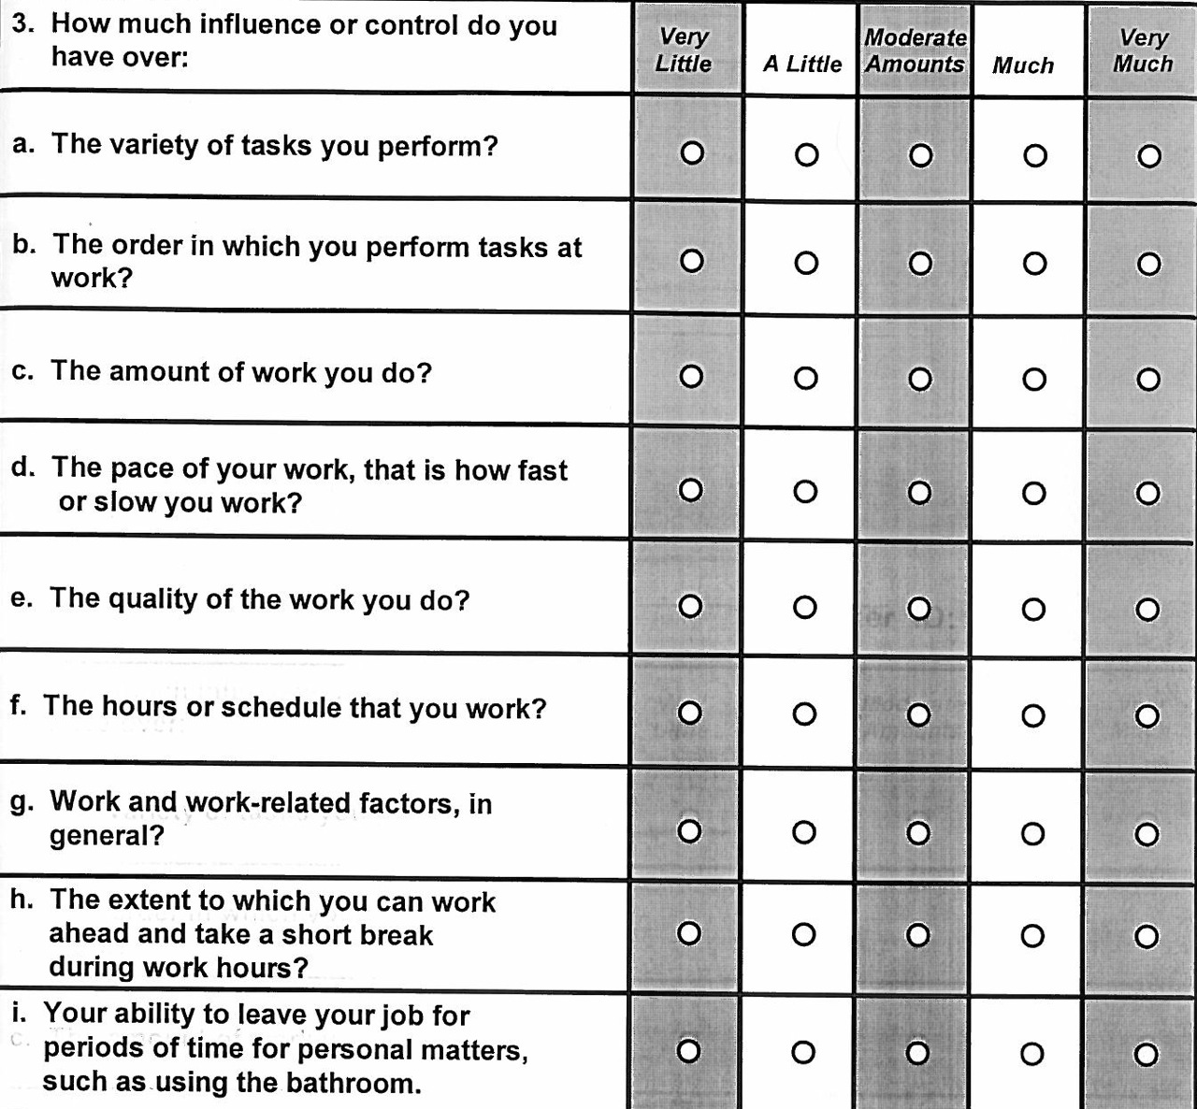

**69. For each of the following questions about the work environment at this airport, please indicate how little or how much support you receive on the job by marking an X in the circle for one of the options.**

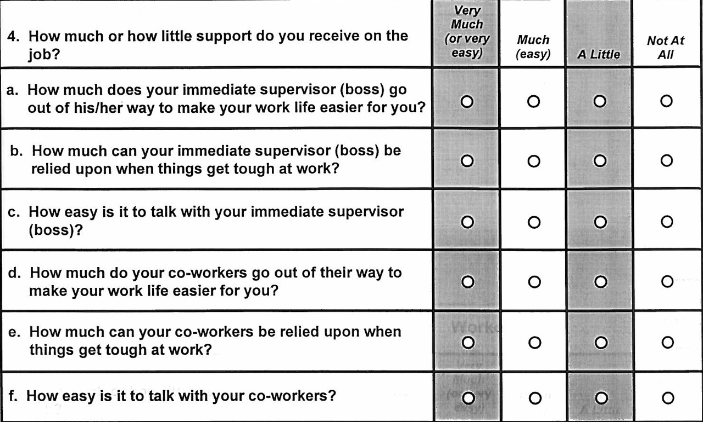

**70. All in all, how satisfied are you with your job?**

🞏 Not at all satisfied

🞏 Not too satisfied

🞏 Somewhat satisfied

🞏 Very satisfied

**71. During the past year, how often were you in a situation where you thought you might be laid off?**

🞏 Never

🞏 Faced the possibility once

🞏 Faced the possibility more than once

🞏 Constantly

🞏 Was actually laid off

**72. On the scale below, rate the typical activity of your HANDS/ARMS while working at this airport. Please mark one of the circles below.**

|  |  |  |  |  |  |  |  |  |  |  |
| --- | --- | --- | --- | --- | --- | --- | --- | --- | --- | --- |
| 🞋 | ➀ | ➁ | ➂ | ➃ | ➄ | ➅ | ➆ | ➇ | ➈ | ➉ |
| no regular motion; hands and arms mostly idle |  | very slow motion; a lot of pauses |  | slow, steady motion; frequent pauses |  | steady motion, occasional pauses |  | rapid, steady motion; few pauses |  | rapid, steady motion; difficulty keeping up |

**73. Please rate your OVERALL PHYSICAL EFFORT level demanded by your job today. Please mark the circle next to the number with an X:**

