SMOKER FOLLOW-UP SURVEY (WAVES 2-5)

[DISPLAY]
Form Approved
OMB No. 0920-0923
Exp. Date XX/XX/XXXX

Evaluation of the National Tobacco Prevention and Control Public Education Campaign Smoker Questionnaire

Public reporting burden of this collection of information is estimated to average 30 minutes per response, including the time for reviewing instructions, searching existing data sources, gathering and maintaining the data needed, and completing and reviewing the collection of information. An agency may not conduct or sponsor, and a person is not required to respond to a collection of information unless it displays a currently valid OMB control number. Send comments regarding this burden estimate or any other aspect of this collection of information, including suggestions for reducing this burden to CDC/ATSDR Reports Clearance Officer, 1600 Clifton Road NE, MS D-74, Atlanta, Georgia 30333; ATTN: PRA (0920-0923).

SUBJECTS FOR QUESTIONNAIRE

SECTION A: INTRODUCTORY QUESTIONS
SECTION B: TOBACCO USE QUESTIONS
SECTION C: SMOKING CESSATION
SECTION D: ATTITUDES AND BELIEFS RELATED TO CESSATION
SECTION E: SECONDHAND SMOKE
SECTION F: MEDIA USE AND AWARENESS
SECTION G: CLOSING QUESTIONS

SECTION A: INTRODUCTORY QUESTIONS

A5. During the past 30 days, that is since [DATE FILL], on how many days did you smoke cigarettes?

__________Number of Days

SECTION B: TOBACCO USE QUESTIONS

The next few questions are about tobacco use and smoking cessation.

B1. On the average, about how many cigarettes a day do you now smoke?

__________number of cigarettes

B2. On the days that you smoke, how soon after you wake up do you usually have your first cigarette? Would you say…

- Within 5 minutes
- 6-30 minutes
- From more than 30 minutes to 1 hour
- After more than 1 hour

The next few questions ask about your attempts to quit smoking regular cigarettes at different times over the past year. In answering, please think specifically about the timeframe for each question.

C2. During the past 3 months, how many times have you stopped smoking for one day or longer because you were trying to quit smoking cigarettes for good?

_____ Number of times

[ASK C1 of ALL RESPONDENTS]

C1. During the past 12 months, that is, since [DATE FILL], how many times have you stopped smoking for one day or longer because you were trying to quit smoking cigarettes for good?
_____ Number of times

C1a. During the past 4 months, on which days did you try to quit smoking? Using your cursor, click on each day that you did not smoke cigarettes because you were trying to quit smoking. Your best guess is fine.

Please click on each date you did not smoke due to quitting. If you did not try to quit smoking on any day in the past four months, select the 'Did not' response below.

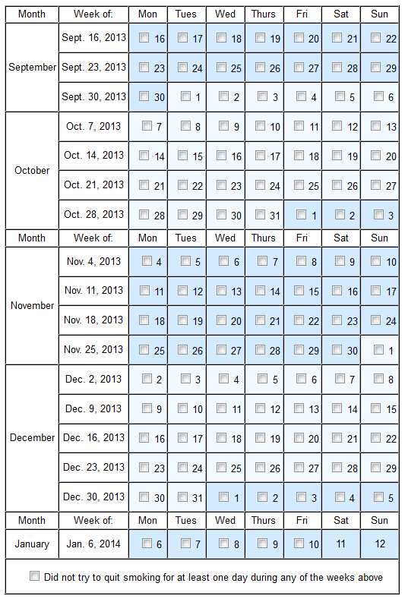

C1b. In the past 4 months, during any of the weeks listed below did you quit smoking entirely for at least one day because you were trying to quit smoking?

Please click on each week that you did not smoke due to quitting for at least one day. If you did not try to quit smoking for at least one day during the following weeks in the past four months, select the 'Did not' response below.

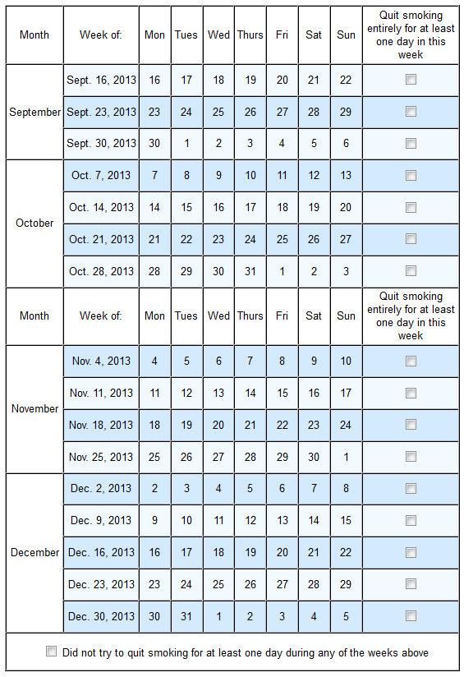

C1c. On which days did you try to quit smoking during these weeks over the past 4 months? Using your cursor, click on each day that you did not smoke cigarettes because you were trying to quit smoking. Your best guess is fine.

If you did not try to quit smoking on any day during the following weeks in the past four months, select the 'Did not' response below.

C1d_1. Did you use electronic cigarettes/e-cigarettes on at least one day during any of the following weeks in the past 4 months?

If you did not use e-cigarettes during any of the following weeks, select the 'Did not' response below.

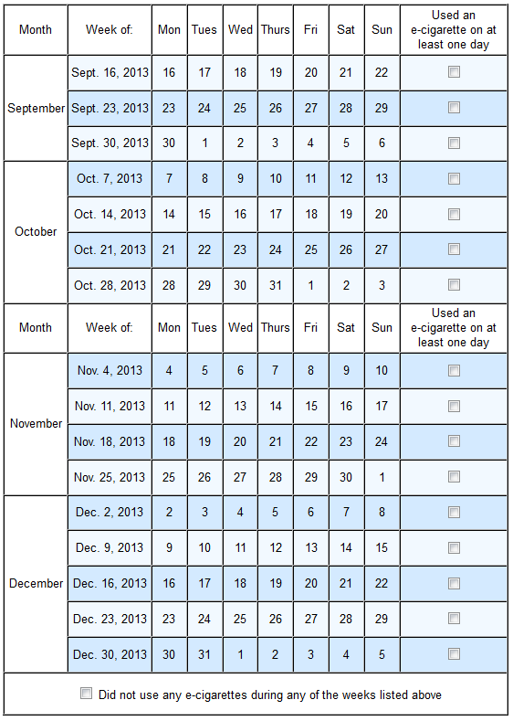

C1d_2. Did you use any tobacco product other than cigarettes or electronic cigarettes/e-cigarettes on at least one day during any of the following weeks in the past 4 months?

If you did not use any tobacco product other than cigarettes or electronic cigarettes/e-cigarettes during any of the following weeks, select the 'Did not' response below.

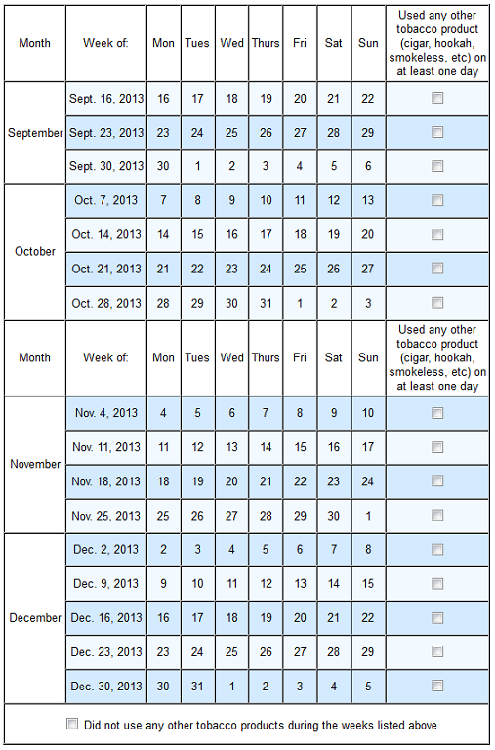

C1e. For each week listed below, we have 3 questions:
1) did you quit smoking during the week for at least one day because you were trying to quit smoking?
2) did you use an electronic cigarette/e-cigarette on at least one day during the week?
3) did you use any tobacco product other than cigarettes or electronic cigarettes/e-cigarettes (such as cigar, hookahs or smokeless tobacco products) on at least one day during the week?
Select all weeks that apply within each column. If you did NOT do a particular behavior for all the weeks, select the appropriate 'Did not' response at the bottom.

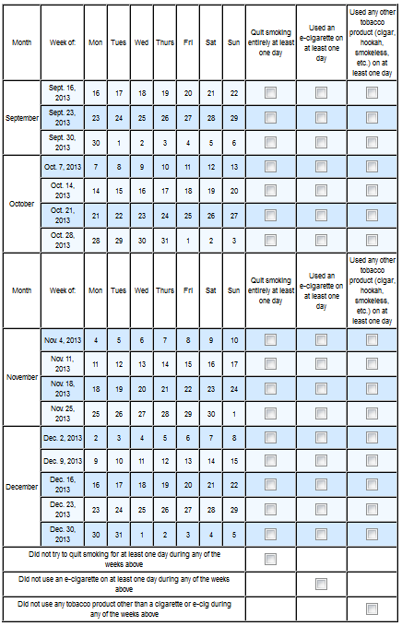
[ASK C3 OF ALL RESPONDENTS]

C3. How long has it been since you last smoked a cigarette?

C3a. _____________[ENTER NUMBER]

C3b. [DROP BOX FOR UNITS]

- Hours (0 – 24)
- Days (0 -10)
- Weeks (0 – 26)
- Months (0 – 6)

[IF C1>0 or C1a=1, ASK C3]

C4. When you last tried to quit smoking, did you do any of the following?

[PRESENT IN RANDOM ORDER]

[ANSWER ALL] Select

- Yes
- No

C4_1. Give up cigarettes all at once
C4_2. Gradually cut back on cigarettes
C4_3. Switch completely to electronic cigarettes or e-cigarettes such as Blu or NJOY
C4_4. Substitute some of your regular cigarettes with electronic cigarettes or e-cigarettes
C4_5. Switch to mild or some other brand of cigarettes
C4_6. Use nicotine replacements like the nicotine patch or nicotine gum
C4_7. Use medications like Zyban or Chantix
C4_8. Get help from a telephone quit line
C4_9. Get help from a website such as Smokefree.gov
C4_10. Get help from a doctor or other health professional

[IF C1>0 or C1a=1, ASK C5]

C5. When you last tried to quit smoking, did any of the following motivate you to try to quit?

[PRESENT AS GRID IN RANDOM ORDER, ASK ALL]

- Yes
- No

C5_1. A family member or friend encouraged me to try to quit
C5_2. Television commercials, radio ads, or other types of advertisements that
focus on the health consequences of smoking
C5_3. My doctor or other health professional advised me to quit smoking
C4_4. Workplace restrictions on smoking
C5_4. Other, specify___________

C6. Since [FILL START DATE] between [START DATE] and [END DATE], did you see or talk to any type of dental care provider (dentist, dental hygienist, orthodontist, oral surgeon, any other dental specialist) for dental care or a dental check-up?

- Yes
- No

[IF C6=1, ASK C6_1 AND C7]

C6_1. During the past [FILL # MONTHS PLANNED CAMPAIGN DURATION] months, that is since [FILL DATE], have you talked with your dental care provider (dentist, dental hygienist, orthodontist, oral surgeon, any other dental specialist) about your smoking or about quitting smoking?

- Yes
- No

C7. During the past [FILL # MONTHS PLANNED CAMPAIGN DURATION] months, that is since [ FILL DATE], has a dental care provider (dentist, dental hygienist, orthodontist, oral surgeon, any other dental specialist) advised you to quit smoking?

- Yes
- No

C6a. Do you want to quit smoking cigarettes for good?

- Yes
- No [FILL C7b=1, GO TO C9]

[ASK C7b IF C6a=1]

C7b. How much do you want to quit smoking? Would you say you want to quit…

- Not at all
- A little
- Somewhat
- A lot

C9. Do you plan to quit smoking for good….

- In the next 7 days,
- In the next 30 days,
- In the next 6 months,
- In the next 1 year, or
- More than 1 year from now?
- Not sure/Uncertain

C10. If you decided to give up smoking altogether in the next 12 months, how likely do you think you would be to succeed? Would you say…

- Extremely Likely
- Very Likely
- Somewhat Likely
- Very Unlikely
- Extremely Unlikely

C11. How much do you think your health would improve if you were to quit smoking?

- Not at all
- A little
- Somewhat
- A lot

C12. How worried are you that smoking will damage your health in the future?

- Not at all worried
- A little worried
- Somewhat worried
- Very worried

C14. Among close friends, do

- All of them smoke?
- Most of them smoke?
- Most of them not smoke?
- None of them smoke?

C15. Among close relatives, do

- All of them smoke?
- Most of them smoke?
- Most of them not smoke?
- None of them smoke?

E-Cigarette Questions

The next questions are about electronic cigarettes, often called e-cigarettes. An e-cigarette looks like a regular cigarette, but it runs on a battery and produces vapor instead of smoke. There are many types of e-cigarettes.

B8. Have you ever used electronic cigarettes or e-cigarettes, such as Smoking Everywhere, NJOY, Blu or Vapor King, even one time?

- Yes
- No

[IF B8=1 ASK B9]

B9. Do you now use electronic cigarettes or e-cigarettes….

- Every day
- Some days
- Not at all

[IF B9=1 ASK b9a and b9b]

B9a. Do you usually use disposable electronic cigarettes/e-cigarettes an electronic cigarette/e-cigarette that uses cartridges, or an electronic cigarette/e-cigarette that uses tanks?

Please indicate the type of e-cigarette that you use the most.

- Disposable electronic cigarettes/e-cigarettes
- Electronic cigarette/e-cigarette that uses cartridges
- Electronic cigarette/e-cigarette that uses tanks

B9b. On average, about how many [FILL “disposable e-cigarettes” IF B9a=1]; [FILL “e-cigarette cartridges” if B9a=2]; [FILL “e-cigarette tanks” if B9a=3] do you now use each week?

________________ [ENTER NUMBER]

[IF B8=1 ASK B10 & B11]

B10. Are any of the following a reason why you [IF B9=3, FILL: first tried; IF B9=1 or 2, FILL: currently use] electronic cigarettes/e-cigarettes?

[SELECT ALL THAT APPLY, PRESENT RANDOMLY]

Yes No

B10_1. They cost less than other forms of tobacco [PATH]
B10_2. They can be used in places where smoking cigarettes isn’t allowed
B10_3. They might be less harmful to me than regular cigarettes
B10_4. They might be less harmful to people around me than regular cigarettes
B10_5. Electronic cigarettes/e-cigarettes come in flavors I like
B10_6. Electronic cigarettes/e-cigarettes can help me quit smoking regular cigarettes
B10_7. Electronic cigarettes/e-cigarettes can help me reduce the number of regular cigarettes I smoke.
B10_8. Electronic cigarettes/e-cigarettes don’t smell
B10_9. Using an electronic cigarette/e-cigarette feels like smoking a regular cigarette
B10_10. Electronic cigarettes/e-cigarettes don’t bother people who don’t use tobacco
B10_11. The advertising for electronic cigarettes/e-cigarettes appeals to me.
B10_12. They help me deal with cravings to smoke.
B10_13. I have a friend or family member who suggested I use electronic cigarettes/e-cigarettes as a way to quit smoking.
B10_14. I was curious about electronic cigarettes/e-cigarettes
B10_15. Other, specify________________________

B11. Which of those is the main reason you [IF B9=3, FILL: first tried; IF B9=1 or 2, FILL: currently use] electronic cigarettes/e-cigarettes?

[IF MORE THAN ONE ITEM SELECTED IN B10, DISPLAY LIST OF ALL REASONS SELECTED IN B10. IF ONLY ONE ITEM SELECTED IN B10, FILL FOR B11]

[IF B9 = 3, ASK B11a]

B11a. You indicated previously that you have tried electronic cigarettes/e-cigarettes before but do not currently use them. Using the text box below, tell us in a few words why you do not use electronic cigarettes/e-cigarettes now.

OPEN-ENDED________________________

[IF B9=1 OR B9=2, ASK B11b]

B11b. You indicated previously that you currently smoke cigarettes and also currently use electronic cigarettes/e-cigarettes. Using the text box below, tell us in a few words why your reasons for not switching completely from regular cigarettes to electronic cigarettes/e-cigarettes.

OPEN-ENDED________________________

[ASK B12 IF B9=1 or 2]

B12. Do you use electronic cigarettes/e-cigarettes in places where smoking regular cigarettes is not allowed?

- Yes
- No

B12a. Do you use electronic/e-cigarettes in any of the following places?

- Yes
- No

[ANSWER ALL, RANDOMIZE ORDER]

B12a_1. Restaurants or bars
B12a_2. Stores or shopping malls
B12a_3. Airplanes
B12a_4. Beaches, parks, or other outdoor places
B12a_5. In your car or other type of vehicle
B12a_6. In your home
B12a_7. Somewhere else, specify _______________

[IF B9=1 or 2 (DUAL USERS), ASK B13]

B13. As far as you know or believe is the use of electronic cigarettes/e-cigarettes in combination with regular cigarettes less harmful than smoking only regular cigarettes, more harmful than smoking only regular cigarettes, or equally as harmful as smoking only regular cigarettes?

Please indicate your answer on a scale of 1 to 5, where one is much less harmful, 3 is the same as regular cigarettes, and 5 is much more harmful.

1 (much less harmful than smoking only regular cigarettes)
2
3 (equally as harmful as smoking only regular cigarettes)
4
5 (much more harmful than smoking only regular cigarettes)

[ASK C6 & C7 OF ALL SMOKERS]

QUITLINE USE AND AWARENESS

C18. A telephone quitline is a free telephone-based service that connects people who smoke cigarettes with someone who can help them quit. Are you aware of any telephone quitline services that are available to help you quit smoking?

1. Yes
2. No

C20. Have you heard of 1-800-QUIT-NOW?

1. Yes
2. No

[IF C20=1, ASK C20a]

C20a. Have you called 1-800-QUIT-NOW or any other telephone quit line in the past 3 months since [FILL DATE]?

- Yes
- No

SECTION D: ATTITUDES AND BELIEFS RELATED TO CESSATION

The next few questions will ask about your opinions related to smoking, tobacco use, and cessation.

Please tell us if you strongly disagree, disagree, agree, or strongly agree with the following statements.

1 2 3 4
Strongly Strongly
Disagree Disagree Agree Agree

[RANDOMIZE ORDER]

D1. Smoking cigarettes is pleasurable.
D2. Smoking cigarettes relieves tension.
D3. Smoking helps me concentrate and do better work.
D4. I would be more energetic right now if I didn’t smoke.
D5. I’m embarrassed that I have to smoke.
D6. Smoking is hazardous to my health.

Thoughts About Quitting

Please tell us if you strongly disagree, disagree, agree, or strongly agree with the following statements.

1 2 3 4
Strongly Strongly
Disagree Disagree Agree Agree

[RANDOMIZE ORDER]

D8. I am eager for a life without smoking.

Worries About Health

Please tell us if you strongly disagree, disagree, agree, or strongly agree with the following statements.

1 2 3 4
Strongly Strongly
Disagree Disagree Agree Agree

[RANDOMIZE ORDER]

D10. I get upset when I think about my smoking.
D11. I am disappointed in myself because I smoke.
D12. I get upset when I hear or read about illnesses caused by smoking.
D13. Warnings about the health risks of smoking upset me.
D14. Smoking will severely lower my quality of life in the future.
D16. Smokers should take warnings about cigarette smoking and lung cancer seriously.

D17. On a scale from 1 to 5 with 1 being the “lowest” and 5 being the “highest,” how would you rate quitting smoking as a priority in your life?

- Lowest

- Highest

Risk Perception

Please tell us if you strongly disagree, disagree, agree, or strongly agree with the following statement.

D18. Smoking can cause immediate damage to your body.

- Strongly Agree
- Agree
- Disagree
- Strongly Disagree

D20. How likely do you think you are to develop a smoking-related disease as a result of smoking?

- Extremely Likely
- Very Likely
- Somewhat Likely
- Very Unlikely
- Extremely Unlikely

D21. Do you believe cigarette smoking is related to

[RANDOMIZE ORDER] 1 2
Yes No

D21_1. Lung Cancer
D21_2. Cancer of the mouth or throat
D21_3. Heart Disease
D21_4. Diabetes
D21_5. Emphysema
D21_6. Stroke
D21_7. Hole in throat (stoma or tracheotomy)
D21_8. Buerger’s Disease
D21_9. Amputations (removal of limbs);
D21_10. Asthma
D21_11. Gallstones
D21_12. COPD or Chronic bronchitis
D21_13. Periodontal or Gum Disease
D21_14. Premature birth
D21_15. Colorectal Cancer

E8b. How likely do you think it is that smoking by diabetics will make their medical complications from diabetes such as blindness, renal failure, or amputations worse?

- Extremely Likely
- Very Likely
- Somewhat Likely
- Very Unlikely
- Extremely Unlikely

SECTION E: SECONDHAND SMOKE

E1. Other than yourself, does anyone who lives in your home smoke cigarettes now?

- Yes
- No

E7. Do you think that breathing smoke from other people’s cigarettes or from other tobacco products
is...

- Not at all harmful to one’s health
- Somewhat harmful to one’s health
- Very harmful to one’s health

E8a. How likely do you think it is that regularly breathing secondhand smoke from cigarettes would cause non-smokers to have asthma, infections, or lung damage?

- Extremely likely
- Very likely
- Somewhat Likely
- Very unlikely
- Extremely unlikely

E8b. Not counting decks, porches, or garages, inside your home, is smoking….

- Always allowed
- Allowed only at some times or in some places
- Never allowed

E9. Are you seriously considering increasing restrictions on smoking in your household?

- Definitely Yes
- Probably Yes
- Probably Not
- Definitely Not

SECTION F: MEDIA USE AND AWARENESS

F1. On an average day, how much television do you watch?

- None
- Less than one hour
- About 1 hour
- About 2 hours
- About 3 hours
- About 4 hours
- 5 hours or more

F2. On an average day, how many hours do you listen to the radio?

- None
- Less than one hour
- About 1 hour
- About 2 hours
- About 3 hours
- About 4 hours
- 5 hours or more

F3. On an average day, how many hours do you use the Internet for personal reasons?

- None
- Less than one hour
- About 1 hour
- About 2 hours
- About 3 hours
- About 4 hours
- 5 hours or more

F4. What type of Internet connection do you have for your home computer or other primary computer?

- Cable/DSL/Broadband/High-Speed
- Dial-Up
- Not sure

F13. Have you heard of the Website www.cdc.gov/Tips?

1. Yes
2. No

[IF F13=1 ASK F13a]

F13a. Have you visited www.cdc.gov/Tips in the past 3 months, since [FILL DATE]?

1. Yes
2. No

F17. In the past [FILL # MONTHS PLANNED CAMPAIGN DURATION], that is since [FILL DATE], have you seen or heard of any ads on television or radio with the following themes or slogans?

[RANDOMIZE ORDER] 1 2
Yes No

F17_1. TIPS FROM A FORMER SMOKER
F17_2. TRUTH
F17_3. BECOME AN EX
F17_4. EVERY CIGARETTE IS DOING YOU DAMAGE
F17_5. TOBACCO FREE LIVING

[IF F17_1=1, ASK F18]

F18. Where have you seen or heard about the TIPS Campaign?

1 2
Yes No

[RANDOMIZE]

F18_1. On TV
F18_2. On the radio
F18_3. In newspapers or magazines
F18_4. On the Internet
F18_5. Billboards or other outdoor ads

F20. The TIPS campaign is on social networking sites including Facebook, MySpace, and Twitter. Have you
ever seen the TIPS campaign on these sites?

- Yes
- No

EXPOSURE AND REACTION TO TV ADS

Now, we would like you to view a series of advertisements that have been shown on television and online in the U.S. Please make sure your computer’s volume is set to an appropriate level. You may be prompted by your computer to download a program enabling video playback. If the videos do not work, you’ll still be able to see images and descriptions of the advertisements. When you are ready, please click on the link below to view the first advertisement. There is a total of [FILL # TOTAL ADS] ads to view. After you view each ad, there will be a few questions that ask about your opinions of the ad.

[SHOW AD_x]

F21_x. Were you able to view this video?

- Yes
- No

[IF F21_x=2, GO TO F23_x]

[ASK F23_x IF F21_x=2]

F23_x. Now we would like to show you some screen shots from a television advertisement that has been shown in the U.S. Once you have viewed the images displayed below, please click on the forward arrow below to continue with the survey.

[DISPLAY STORYBOARD IMAGES FOR AD_x]

F24_x. Have you seen this ad on television or online in the past [FILL # MONTHS SINCE CAMPAIGN LAUNCH] months, since [CAMPAIGN LAUNCH DATE]?

- Yes
- No

[IF F24_x = 1, ASK F24a_x_TV]

F24a_x_TV. In the past [FILL # MONTHS SINCE CAMPAIGN LAUNCH] months, how frequently have you seen this ad on television?

- Never
- Rarely
- Sometimes
- Often
- Very Often

[IF F24_x = 1, ASK F24a_x_COMPUTER]

F24a_x_COMPUTER. In the past [FILL # MONTHS SINCE CAMPAIGN LAUNCH] months, how frequently have you seen this ad on a laptop or desktop computer?

- Never
- Rarely
- Sometimes
- Often
- Very Often

[IF F24_x = 1, ASK F24a_x_MOBILE]

F24a_x_MOBILE. In the past [FILL # MONTHS SINCE CAMPAIGN LAUNCH] months, how frequently have you seen this ad on a tablet or smartphone?

- Never
- Rarely
- Sometimes
- Often
- Very Often

[IF F24a_x_COMPUTER = 1, ASK F24d_x]

F24d_x. You previously indicated that you have seen this ad on either a laptop or desktop computer. When you saw this ad on your computer, did you…..

- Yes
- No

F24d_x_1. Notice the ad on a Website that you were visiting?
F24d_x_2. Search for the ad on YouTube, Google, or other Internet search engine?

[SHOW F25_x – F28_x FOR FIRST 3 ADS ONLY]

F25_x. Please tell us if you strongly agree, agree, neither agree nor disagree, disagree, or strongly disagree with the following statements.

- Strongly Disagree
- Disagree
- Neither agree nor disagree
- Agree
- Strongly Agree

[RANDOMIZE ORDER]

F25a_x. This ad is worth remembering.
F25b_x. This ad grabbed my attention.
F25c_x. This ad is powerful.
F25d_x. This ad is informative.
F25e_x. This ad is meaningful to me.
F25f_x. This ad is convincing.
F25g_x. This ad is ridiculous.
F25h_x. This ad is terrible.
F25i_x. This ad was difficult to watch.

F26_x. On scale of 1 to 5, where 1 means “not at all” and 5 means “very”, please indicate how much this ad made you feel…
1 2 3 4 5
[RANDOMIZE ORDER] Not at all Very

F26a_x. Sad
F26b_x. Afraid
F26c_x. Irritated
F26d_x. Ashamed
F26e_x. Discouraged
F26f_x. Hopeful
F26g_x. Motivated
F26h_x. Understood
E26i_x. Angry

F28_x. Would this ad make you want to quit smoking?

- Yes
- No

[DISPLAY: Now, we would like you to view another ad]

[REPEAT ABOVE SEQUENCE OF QUESTIONS FOR EACH OF THE NEXT 2 ADS SHOWN]

[ASK F28a IF ANY F24_x=1]

For the next few questions, think about all of the advertisements you just viewed and recalled seeing in the past [FILL # MONTHS SINCE CAMPAIGN LAUNCH] months.

F28a. In the past [FILL # MONTHS SINCE CAMPAIGN LAUNCH] months, since [CAMPAIGN LAUNCH DATE], have these ads stopped you from having a cigarette when you were about to smoke one? Would you say….

  - Never
  - Once
  - A few times
  - Many times

[ASK F30 IF ANY F24_x=1]

F30. Did you talk to anyone about any of these ads?

- Yes
- No

[IF F30=1, ASK F31]

F31. When you talked about the ads, did the person talking to you about the ads encourage you to stop smoking?

    - Yes
    - No

EXPOSURE TO RADIO ADS

Now, we would like you to listen to a radio advertisement that has aired in the U.S. Please make sure your computer’s volume is set to an appropriate level. You may be prompted by your computer to download a program enabling audio playback. If you cannot hear the audio, you’ll still be able to read a description of the advertisement. There is a total of [FILL # TOTAL RADIO ADS] radio ads to listen to. When you are ready, please click on the link below to listen to the ad. After you listen to the ad, there will be a few questions that ask about your recent recall of the ad.

[PLAY RADIO AD CHOSEN]

F32_x. Were you able to listen to this ad?

- Yes
- No

[IF F32_x=2, GO TO F34]

[ASK F34_x IF F32_x=2]

F34_x. Now we would like to show you a script from a radio advertisement that has been shown in the U.S. Once you have read the script displayed below, please click on the forward arrow below to continue with the survey.

[DISPLAY SCRIPT FOR RADIO AD]

F35_x. Have you heard this ad on the radio in the past [FILL # MONTHS SINCE CAMPAIGN LAUNCH] months, since [CAMPAIGN LAUNCH DATE]?

- Yes
- No

[IF F35_x=1, ASK F35a_x]

F35a_x. In the past [FILL # MONTHS SINCE CAMPAIGN LAUNCH] months, how frequently have you heard this ad on the radio?

- Rarely
- Sometimes
- Often
- Very Often

EXPOSURE TO DISPLAY, PRINT, AND OUT-OF-HOME

Next, you will see some advertisements that have recently appeared in magazines, on websites, and on signs in areas such as bus shelters, bus interiors, billboards and other public places. There are 3 sets of images to view, followed by a few questions about whether you have seen these ads before. When you are ready to view them, please click “Next.”

[SHOW IMAGE “Online Compilation.jpg”]

Please click “Next” to view the next set of images.

[SHOW IMAGE “Print Compilation.jpg”]

Please click “Next” to view the next set of images.

[SHOW IMAGE “Out of Home Compilation.jpg”]

Please click “Next” to proceed to the next questions.

F36. In the past [FILL # MONTHS SINCE CAMPAIGN LAUNCH], since [CAMPAIGN LAUNCH DATE], have you seen any of these ads in magazines, on Websites, or in public places outside your home?

- Yes
- No

[IF F36=1, ASK F37]

F37. Where did you see these advertisements?

1. Yes 2. No

[RANDOMIZE]

F37_1. Magazines or print publications
F37_2. Websites online
F37_3. Public places such as bus shelters, bus interiors, outdoor bulletins, etc.

AWARENESS OF E-CIGARETTE ADS

F38_x. Now we would like to show you a series of screen shots from [FILL # ADS] television advertisements that have been shown in the U.S. Once you have viewed the images displayed below, please click on the forward arrow below to continue with the survey.

[DISPLAY STORYBOARD IMAGES FOR E-CIG AD_x]

F38_x. Have you seen this ad on television or online in the past 3 months, since [FILL DATE]?

  - Yes
  - No

[IF F38_x = 1, ASK F38a_x_TV]

F38a_x_TV. In the past 3 months, how frequently have you seen this ad on television?

- Never
- Rarely
- Sometimes
- Often
- Very Often

[IF F38_x = 1, ASK F38a_x_COMPUTER]

F38a_x_COMPUTER. In the past 3 months, how frequently have you seen this ad on a laptop or desktop computer?

- Never
- Rarely
- Sometimes
- Often
- Very Often

[IF F38_x = 1, ASK F38a_x_MOBILE]

F38a_x_MOBILE. In the past 3 months, how frequently have you seen this ad on a tablet or smartphone?

- Never
- Rarely
- Sometimes
- Often
- Very Often

F41_x. Please tell us if you strongly agree, agree, neither agree nor disagree, disagree, or strongly disagree with the following statements.

- Strongly Disagree
- Disagree
- Neither agree nor disagree
- Agree
- Strongly Agree

[RANDOMIZE ORDER]

F41a_x. This ad is worth remembering.
F41b_x. This ad grabbed my attention.
F41c_x. This ad is powerful.
F41d_x. This ad is informative.
F41e_x. This ad is meaningful to me.
F41f_x. This ad is convincing.

F42_x. Please tell us if you strongly agree, agree, neither agree nor disagree, disagree, or strongly disagree with the following statements.

- Strongly Disagree
- Disagree
- Neither agree nor disagree
- Agree
- Strongly Agree

[RANDOMIZE ORDER]

F42a_x. [IF B8=2, EVER_ECIG=NO)] This ad makes me want to try an e-cigarette.
F42b_x. This ad makes me want to switch to e-cigarettes completely and quit smoking regular cigarettes.
F42c_x. This ad makes me want to use e-cigarettes as a way to cut back on smoking regular cigarettes.
F42d_x. This ad makes me want to use e-cigarettes in places where you normally cannot smoke regular cigarettes.

SECTION G: CLOSING QUESTIONS

[IF SAMPLE = KP, GENDER, RACE, EDUCATION, INCOME, MARITAL STATUS, AND EMPLOYMENT VARIABLES WILL BE IMPORTED FROM KP PROFILE INFORMATION]

[ASK G1 OF ALL RESPONDENTS]

G1. How many children aged 17 or younger live in your household 6 months or more of the year?

__ Number of Children

[IF SAMPLE = ABS, ASK G5]

G5. What is the highest level of school you have completed?

- No formal education
- 1st, 2nd, 3rd, or 4th grade
- 5th or 6th grade
- 7th grade or 8th grade
- 9th grade
- 10th grade
- 11th grade
- 12th grade, no diploma
- High school graduate – high school Diploma or the equivalent (GED)
- Some college, no degree
- Associate degree
- Bachelor’s degree
- Master’s degree
- Professional or Doctorate degree

[IF SAMPLE = ABS, ASK G6]

The next question is about the total income of YOUR HOUSEHOLD for the PAST 12 MONTHS. Please include your income PLUS the income of all members living in your household (including cohabiting partners and armed forces members living at home). Please count income BEFORE TAXES and from all sources (such as wages, salaries, tips, net income from a business, interest, dividends, child support, alimony, and Social Security, public assistance, pensions, or retirement benefits).

G6. Was your total HOUSEHOLD income in the past 12 months…

- Below $35,000
- $35,000 or more
- Don’t Know

[IF G6=1, ASK G6a]

G6a. We would like to get a better estimate of your total HOUSEHOLD income in the past 12 months before taxes. Was it…

  - Less than $5,000
  - $5,000 to $7,499
  - $7,500 to $9,999
  - $10,000 to $12,499
  - $12,500 to $14,999
  - $15,000 to $19,999
  - $20,000 to $24,999
  - $25,000 to $29,999
  - $30,000 to $34,999

[IF G6=2, ASK G6b]

G6b. We would like to get a better estimate of your total HOUSEHOLD income in the past 12 months before taxes. Was it…

  - $35,000 to $39,999
  - $40,000 to $49,999
  - $50,000 to $59,999
  - $60,000 to $74,999
  - $75,000 to $84,999
  - $85,000 to $99,999
  - $100,000 to $124,999
  - $125,000 to $149,999
  - $150,000 to $174,999
  - $175,000 or more

[IF SAMPLE = ABS OR SSI, ASK G7]

G7. Are you now married, widowed, divorced, separated, never married, or living with a partner?

- Married
- Widowed
- Divorced
- Separated
- Never married
- Living with a partner

[IF SAMPLE = ABS OR SSI, ASK G8]

G8. Which statement best describes your current employment status?

- Working - as a paid employee
- Working - self-employed
- Not working - on temporary layoff from a job
- Not working - looking for work
- Not working - retired
- Not working - disabled
- Not working - other

[ASK G9 OF ALL RESPONDENTS]

G9. How many smoking or tobacco related web surveys like this have you completed during the past year?

- None
- 1 survey
- 2 surveys
- 3 surveys
- 4 surveys
- 5 or more surveys

[ASK G15 OF ALL RESPONDENTS]

G15. Have you been diagnosed by a physician or other qualified medical professional with any of the following medical conditions?

1 2
Yes No

[RANDOMIZE, WITH “SOMETHING ELSE” ALWAYS LAST]

G15_1. Acid reflux disease
G15_2. ADHD or ADD
G15_3. Anxiety disorder
G15_4. Asthma, chronic bronchitis, or COPD
G15_5. Cancer (any type except skin cancer)
G15_6. Chronic pain (such as low back pain, neck pain, or Fibromyalgia)
G15_7. Depression
G15_8. Diabetes
G15_9. Heart attack
G15_10. Heart disease
G15_11. High blood pressure
G15_12. High cholesterol
G15_13. HIV/AIDS
G15_14. Kidney disease
G15_15. Mental health condition
G15_16. Multiple sclerosis
G15_17. Osteoarthritis, joint pain or inflammation
G15_18. Osteoporosis or osteopenia
G15_19. Rheumatoid arthritis
G15_20. Seasonal allergies
G15_21. Skin cancer
G15_22. Sleep disorders such as sleep apnea or insomnia
G15_23. Stroke
G15_24. Something else

G20. Do you or anyone in this household connect to the Internet from home?

- Yes
- No

G21. Do you live in a metro or non-metro area?

- Non-Metro (Rural)
- Suburban
- Urban

[ASK G22 OF ALL RESPONDENTS]

G22. Using the scale below, please tell us how much you agree or disagree with the following statements.
1 2 3 4 5
Strongly Somewhat Neither Somewhat Strongly
Agree Agree Agree nor Disagree Disagree
Disagree

G20a. I usually try new products before other people do.
G20b. I often try new brands because I like variety and get bored with the same old thing.
G20c. When I shop I look for what is new.
G20d. I like to be the first among my friends and family to try something new.
G20e. I like to tell others about new brands or technology.

[IF KP ACTIVE, DISPLAY]:

Thank you for completing today’s survey. Your input will greatly help researchers assess the impact of television ads about quitting smoking.

[IF KP ACTIVE, DISPLAY]:

You will be awarded [AMOUNT] bonus points credited to your KnowledgePanel account for completing the survey. A follow-up survey will be sent to you in about [FILL # MONTHS PLANNED CAMPAIGN DURATION] and you will be awarded [AMOUNT] bonus points for completing that survey.

[IF ABS, DISPLAY]:

ADD1. Those are all of our questions. Thanks so much for your participation in our survey. As a token of our appreciation, we would like to send you [IF SAMPLE = KP WITHDRAWN, “$15”; IF SAMPLE=ABS, “$20”]. Would you please provide your name and mailing address so that we can put the check in the mail. This information will not be connected with your survey responses in any way.

After you have entered your information, please make sure to click “Next”.

Name (First/Last): [TEXTBOX]
Street Address (If applicable, include unit number): [TEXTBOX]
City: [TEXTBOX]
State: [TEXTBOX]
Zip Code : [TEXTBOX]

