Attachment 6. Map showing Syracuse census tracts by poverty rate
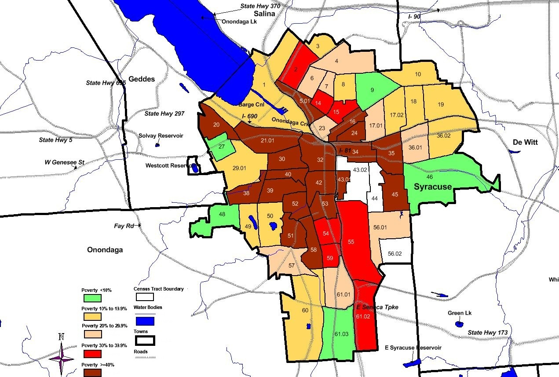
Attachment 6 Table: Syracuse census tract demographics for low-income neighborhood tracts with a poverty rate of approximately 40% or higher
Demographics of tracts with a poverty rate near or higher than 40% in the Southwest neighborhood of Syracuse based on 2010 census and American Community Survey 2006-2010 data (for poverty rates).
Tract | Total Population | % White | % African American | % Asian | % Hispanic | % Minority | % 20-64 years | % >64 years | % Female | % Male | % Below Poverty
58 | 2,510 | 9.9 | 83.3 | 0.3 | 4.8 | 91.2 | 51.2 | 7.6 | 54.9 | 45.1 | 40.2
53 | 1975 | 13.4 | 78.9 | 0.3 | 5.4 | 87.3 | 44.3 | 13.1 | 51.3 | 48.7 | 53.0
52 | 2127 | 10.5 | 76.3 | 0.1 | 11.4 | 91.9 | 51.4 | 8.2 | 53 | 47 | 41.4
51 | 2434 | 25.4 | 61.6 | 0.2 | 12.3 | 79.7 | 55.1 | 6.3 | 54.4 | 45.6 | 43.6
42 | 2065 | 10.7 | 78.7 | 0.2 | 11.5 | 92.3 | 52.2 | 6.1 | 58.9 | 41.1 | 73.9
40 | 1580 | 33.7 | 39.6 | 0.3 | 30.6 | 74.6 | 52.7 | 6.3 | 52.7 | 47.3 | 41.1
39 | 3602 | 32.9 | 44.1 | 0.3 | 30.4 | 77.3 | 55.3 | 6.3 | 51.7 | 48.3 | 51.1
38 | 2520 | 46.7 | 31.2 | 0.4 | 23.8 | 60.8 | 52.7 | 9 | 54.8 | 45.2 | 45.8
32 | 2146 | 51.1 | 30.9 | 13.9 | 5.3 | 51.5 | 86.9 | 5.1 | 30.9 | 69.1 | 46.4
30 | 2111 | 32.6 | 47.7 | 0.2 | 34.2 | 77.1 | 58.5 | 6.9 | 46.7 | 53.3 | 58.3
21.01 | 2791 | 61.8 | 22.8 | 0.5 | 14.1 | 43.9 | 59 | 7.4 | 51.6 | 48.4 | 43.1
20 | 2264 | 79.8 | 9.6 | 0.2 | 6.7 | 23.1 | 62.6 | 7.5 | 50.2 | 49.8 | 46.6
54 | 2761 | 8.7 | 83.3 | 0.4 | 8.9 | 94.1 | 49.5 | 9.1 | 54 | 46 | 39.5
59 | 1834 | 14.6 | 75.4 | 0.3 | 11.1 | 88.5 | 51.9 | 8.8 | 53.7 | 46.3 | 37.5

