## Attachment 6.1 Protocol

## Title: HIV study in blood donors from five Chinese regions

Investigators:

Institute of Blood Transfusion, Chinese Academy of Medical Sciences

Prof. Jingxing Wang

Peibin Zeng, PhD

Miao He, PhD

Johns Hopkins University

Hua Shan, MD, PhD

Paul Ness, MD

Jing Liu, PhD

Wei Cai, MT, SBB

University Of Massachusetts

Ling Shi, MD, PhD

FEi Systems

Guang Song, M.S.

RTI

Marian Sullivan

Darryl Creel

Don Brambilla

Michelle Yuan

Date: Jan 09, 2014

## 2. Concept Synopsis and Study Schema

The UNAIDS estimates there were about 33.3 million people living with HIV/AIDS and 2.6 million who became newly infected with HIV in 2009[1]. In China, there were 780,000 people infected by HIV and about 28,000 died in 2011[2]. An estimated over 300,000 HIV infected people in China are not aware of their infectious status [2]. The huge migrating population and the complexity of HIV transmission routes in China make it difficult to implement a comprehensive and effective national HIV control strategy[2]. This HIV epidemiology survey in the blood donor population provides a perspective on the HIV epidemic in the general population. Most blood donors are from low risk populations and HIV infected blood donors typically have been recently infected. Risk factor studies in donors provide information both for improving blood safety and for HIV prevention and treatment for recently infected individuals. Together with the data from high risk groups, the profile of HIV genotype and drug resistance from infected blood donors are important in HIV screening assay development and guiding effective initial highly active antiretroviral therapy (HAART) for HIV treatment naïve patients in China.

As the number of HIV cases continues to grow in China and the infection increasingly spreads into the general population, the risk of transfusion transmitted HIV poses a significant threat to blood safety in China. Although there have been studies to monitor the HIV epidemiology in the general Chinese population and high risk populations, information from the blood donor population is significantly lacking. We propose a comprehensive HIV study in Chinese blood donors. The ultimate goal of this study is to reduce the risk of transfusion-transmitted HIV infection in China. We propose to achieve this goal by conducting studies to understand the epidemiological features of HIV infection among Chinese blood donors including incidence and prevalence rates, risk factors, residual risk estimation, sub-typing and drug resistance studies. The proposed studies will build upon and expand our preliminary investigation on HIV infection in Chinese blood donors under the REDS-II China Program. Information obtained in this study will be valuable to develop more effective strategies in recruiting low risk donors and improving donor testing, therefore helping to reduce the risk of HIV transmission and improve blood safety.

**3. Table of Contents**

1. Title: HIV Study in Blood Donors from FiveChinese Regions 1

2. Concept Synopsis and Study Schema 2

3. Table of Contents 3

4. Protocol 5

4.1 Background & Significance 5

4.1.1Background 5

4.1.2 Significance 9

4.2 Objectives 10

4.2.1 Primary 10

4.2.2 Secondary 11

4.3 Study Population or Specimens for Analysis 11

4.3.1. Participating blood centers 11

4.3.2. Inclusion Criteria 13

4.3.3. Exclusion Criteria 13

4.4 Study Enrollment or Specimen Procurement 14

4.4.1 Study population and sample collection 14

4.4.2. Stratification or Randomization (if applicable) 15

4.5 Measurement 15

4.5.1. Prevalence rate determination 15

4.5.2. Incidence rate determination **.**15

4.5.3. Estimating residual risk of transfusion-transmitted HIV infection 17

4.6 HIV Laboratory testing 17

4.6.1. RNA extraction, amplification and sequencing 17

4.6.2. Subtype analysis 18

4.6.3. Alternate sequencing method for the pol gene 19

4.6.4. Drug resistance interpretation 19

4.6.5. Detailed env diversity analysis and full genome sequencing 19

4.6.6. Data analysis (Aim A1-3 and Aim B1-4) 20

4.6.7. Inclusion of peripheral non-REDS blood centers……………………………………………………..…...22

4.6.8. Sample size…………………………………………………….……………………………………………………..…...22

4.7 HIV Risk factor survey **.**23

4.7.1. Questionnaire Design 24

4.7.2. Donor enrollment and questionaire administration 24

4.7.3. Case/Control Selection 28

4.7.4. Survey Method 28

4.7.5. Data Compilation 30

4.7.6. Variables to be collected and data analysis (Aim A4) 31

4.7.7. Sample size 32

4.7.8. Survey considerations 34

4.7.9. Personnel training 35

4.8 Specimen and Data Management 35

4.8.1. Specimen Tracking System 35

4.8.2. Repository of confirmed HIV reactive donor samples 36

4.8.3. Data management and data transfer 36

4.8.4 .Data quality assurance and quality control 37

4.9 Statistical Considerations 40

4.10 Human Subjects 40

4.10.1. Procedures & risks 41

4.10.2. Recruitment, consent and protection against risks 41

4.11 Time line 42

5. Reference 43

6. Appendix 47

6.1. Appendix A: Guangxi CDC support letter 47

6.2. Appendix B: Data collection form for peripheral blood centers 48

6.3. Appendix C:Informed consent form for all blood donors **Error! Bookmark not defined.**49

6.4. Appendix D: HIV Risk Factor Survey questionnaire 50

6.5. Appendix E:Informed consent form for 2nd sample collection 62

6.6. Appendix F:Protocol for additonal testing of ELISA-/NAT+ and ELISA+/NAT- samples 63

6.7. Appendix G: Screen shots of online HIV Risk factor survey 68

6.8. Appendix H: HIV Risk Factor questionnaire data entry form 69

6.9. Appendix I: Study Tracking Form for Blood Center and Guangxi CDC 69

4. Protocol

## 4.1 Background and Significance:

4.1.1 Background

HIV epidemic in China

AIDS was first reported in Beijing, China, in 1985[3]. In 2011 there were an estimated 780 000 people living with HIV/AIDS in China. Although the overall national HIV/AIDS prevalence rate is low (0.058%), there are regions of high HIV prevalence involving high risk populations such as injecting drug users (IDUs), former plasma donors (FPDs), sex workers and their clients, and men who have sex with men (MSM)[4].

The HIV epidemic in China can be divided into four phases. The first phase was from 1985 to 1988, which was characterized by a small number of AIDS cases identified in several coastal cities. The cases were mainly foreigners or Chinese who had traveled overseas. Four hemophiliac HIV infected patients who acquired their infection through imported factor VIII were reported in Zhejiang Province[5]. The second phase (1989–1993) began with the HIV infection in 146 drug users in Yunnan province, southwestern China, which was the first outbreak of an isolated and regional HIV epidemic[5]. The third phase (1994–2000) was characterized by a considerable number of cases of HIV infection among drug users and commercial plasma donors from additional regions. By the end of mid-1990s, all modes of transmission were reported in China. In August 1996, 4500 cases of HIV infection and 130 cases of AIDS were reported officially. By 1998, HIV infection had been reported in all 31 provinces, regions, and municipalities[6]. The fourth phase was from 2001 until now, with reported HIV infection cases increasing dramatically since 2001. In 2003, there were 45,092 newly reported AIDS cases in China with 1800 deaths. There were an estimated 840,000 people living with HIV/AIDS at the end of 2003 nationwide, with the estimated population prevalence of 0.07%[7]. The surveillance data from more regions as well as HIV screening in former plasma donors (FPDs) were added into statistical consideration. By the end of 2011, there were estimated 780,000 people living with HIV/AIDS, with 48,000 newly infections and 28,000 deaths, and HIV infections were reported from all provinces in China[2]. Although the HIV/AIDS epidemic spreads nationwide, more than 75% HIV infected patients were from six provinces: Yunnan, Sichuan, Guangxi, Xinjiang, Henan and Guangdong. The newly infected people in 2007, 2009 and 2011 are 50,000, 48,000 and 48,000, which indicates the HIV epidemic in China is becoming stable. However, the percentage of HIV infections through sexual transmission is increasing continually[2]. Some indications suggested that the epidemic had been spreading from high risk groups into the general population[8].

HIV subtype distribution in China

There are four major subtypes/circulating recombinant form (CRF) genotypes of HIV-1 in China, which are CRF_07BC, CRF_08BC, CRF_01AE and subtype B, while HIV-2 is seldom reported[10]. CRF_07BC strains are mainly transmitted via IDUs, which is a nationally distributed subtype [11]. In Xinjiang province, more than 90% HIV-1 cases were CRF_07BC[12]; CRF_01AE are common in people infected via unsafe sexual behaviors, which also spread throughout the country, but concentrated in some development regions and coastal areas[13]; Subtype B is mainly in the central China, such as Henan province, where almost 95% HIV strains are B and most of HIV infections with B subtype were infected by former paid illegal plasma collection[14]; CRF_08BC subtypes are mainly distributed in Yunnan province with the transmission route of injection drug use[15].

HIV control in Chinese blood donation policy

Unsafe blood, especially risk of HIV infection, is a major threat in transfusion. The Chinese government has made great effort on HIV screening and management of blood center to ensure the safety of blood products. In 1990s, an outbreak of HIV epidemic caused by FPDs made the Chinese government promulgate a series of policies to prohibit former commercial plasma collection and regulate blood/plasma donations[16]. In 1998, the “Law on Blood Donation” became effective nationwide. It requires HIV screening for all blood donations and more than 85% of blood to be provided by non-profit blood centers for clinical use[17]. All the efforts greatly enhance the blood safety in China. In 2008, almost all donations were from voluntary donors[18], compared with 22% in 1998[17]. Because of the lessons learned from the experience of having many HIV infections caused by a contaminated blood supplies and illegal commercial blood collection, the government is striving to further reduce the risk of HIV transmission through blood transfusion.

REDS-II HIV study in China

Epidemiological information is critical for the effective prevention of an infection. There has been very little data on HIV epidemiology in Chinese blood donors. The first large study to measure HIV prevalence in Chinese donors was the REDS-II China Program. In 2009, five REDS-II China blood centers had a total of about 800 screening anti-HIV1/2 reactive samples (0.3% of all donations). The confirmatory rate in 2009 was about 23% using a Chinese government licensed test (anti-HIV 1/2 Immunoblot, AUSIA).Our REDS-II findings from five blood centers located in HIV high prevalence regions suggested that in the study period of 2008-2010, the HIV prevalence among first time donors was 66/100,000 (95% CI: 59-74/100,000 donors); Incidence among repeat donors was 9/100,000 person-years(95% CI: 7-12/100,000 person-years).The estimated transfusion-transmitted infection (TTI) residual risk for HIV was on average 5.4 (1.2-12.5) infections per million whole blood donations in 2008-2010[25]. Although it is much lower than 34.1 (95% CI 7.8-70.7) per million donations in sub-Saharan Africa and 11.3 (95% CI: 8.4-14.2) per million donations in Brazil[26,27], the residual risk is substantially higher than in the United States (1 in 2 million donations) and other developed countries [28,29]. In addition, the genetic diversity of some HIV-1 strains among the HIV positive donors indicated the possibility of additional undetected HIV infections [23].

Little data are available on the molecular epidemiological features of HIV infection in Chinese donors. The national molecular epidemiology survey from 2001–2003 showed that the prevalence of the HIV-1 CRF_BC among HIV infected individuals has reached over 50%, compared with 30% in the first survey (1996–1998); whereas the prevalence of HIV-1 B' subtype showed a decrease from 48% in the first survey to 32% in the second survey [19].Data on the molecular epidemiology of HIV among blood donors is limited. There are distinctive regional differences in subtype distribution among HIV infected blood donors. Former paid blood donors from Henan and other central China provinces were mostly of subtype B’[20,21]. In Southwest China, from 2005-2006, Kunming blood center found that in 49 specimens from infected blood donors the distribution of subtypes was CRF08＿BC(51.0%), CRF07＿BC(24.5%), CRF01＿AE (20.4%) and B(4.1%), while province-wide HIV-1 molecular epidemiological study in Yunnan between 1989 and 2004 identified three major circulating subtypes: C/CRF07_BC/CRF08_BC (53%), CRF01_AE (40.5%), and B (6.5%). [22]

In the REDS-II China program, samples from 113 HIV infected donors from five blood centers was successfully amplified and analyzed for partial HIV-1 pol region: Kunming (n = 82/111), Urumqi(n = 14/35), Liuzhou (n = 10/14), Mianyang (n = 5/6), and Luoyang (n = 2/6). There were more males than females and 20.4% of these donors were from non-Han ethnic background while the overall percentage of non-Han donors from these five blood centers for the study period was 13.3% (unpublished REDS-II China data). Most donors (89.4%) were first-time donors. A total of 84.9% of donors in this study were between 20 and 40 years of age and the majority of them had high school or lower education. For the whole group, the HIV-1 subtype distribution by phylogenetic analysis was as follows: G = 1 (0.9%), B = 3 (2.7%), CRF01_AE = 37 (32.7%), CRF07_BC = 25 (22.1%), and CRF08_BC = 47 (41.6%). CRF_BC and AE were dominant subtypes in this study. The subtype distribution of samples from Kunming was B = 1 (1.2%), CRF01_AE = 21 (25.6%), CRF07_BC = 13 (15.9%), and CRF08_BC = 47 (57.3%). All CRF08_BC strain samples in this study were from Kunming. All 10 samples from Liuzhou were CRF01_AE. Two samples from Luoyang were both of B subtype. The only subtype G was from Urumqi. Female donors represent 45.1% of all cases and 63.9% cases with DRMs. The prevalence of samples with potential low or higher resistance among Chinese blood donors is 4.4% [23].

Understanding the changing risk factors for HIV infection in donors is critical for improving blood safety, identifying new transmission routes, and for HIV prevention and treatment for recently infected individuals. In the 2011 Estimates of HIV/AIDS Infections in China, China’s HIV epidemic is described as ‘diverse and evolving’. Among the 780,000 PLHIV, 46.5% contracted HIV through heterosexual contact, 28.4% were infected through injecting drug use, and 17.4% through homosexual contact[2]. On the other hand, among the 48,000 (95% CI: 41,000 – 54,000) new HIV infections, the same three modes of transmissions accounted for 52.2%, 18.0%, and 29.4% respectively, with a rapid rise of new infections among MSM. Findings in 2009 suggested that approximately 25% of the heterosexual transmissions occurred during spousal sexual contact. This indicates the spread of HIV infections from high-risk groups to the general population that portends an increasing threat to the safety of blood supply. The demographic profile of newly infected people is changing. Since 2005, the portion of 50- to 64-year-old infected people increased from 1.6% to 13.6%, representing a 8.5-fold increase since 2000. From January 2006 to September 2011, the portion of reported cases in individuals self-identified as students, especially those within the age range of 20-24 years also increased from 0.96% in 2006 to 1.64% in 2011. Among reported cases in individuals self-identified as students, there was also an increase of individuals between 20-24 years of age, from 20.3% in 2006 to 49.0% in 2011. Homosexual and heterosexual behaviors were reported as the major routes of transmission in these young and old infected individuals. Although the upper age limit for Chinese donors is 55 and those above 50 years of age only contribute a small proportion of blood supply, some blood centers have lifted and some are planning to lift the bar. For example, in Guangzhou Blood Center, effective in July 2012, a repeat donor’s age is extended to 60 years old[23]. The potential threat of these elderly people to the safety of blood supply warrants further study. On the contrary, people younger than 26 years old contribute a dominant proportion of Chinese blood supply. Their infectious status will be detrimental to the already worrisome blood supply.

Additionally, young migrant workers from the countryside are an important part of the donor population. There are currently more than 150 million migrant workers in China. Most of them work temporarily in some fast developing regions and change their location frequently. Most migrants are young and sexually active, and some engage in commercial sex. Many of them do not have access to health care and HIV prevention education, making this group of people particularly susceptible to HIV infection[9]. These migrant workers may become a carrier of HIV transmission between rural and urban areas as well as between HIV major epidemic regions and low prevalence regions. It is important to understand the risk factors associated with these emerging high-risk groups to prevent window-period donations from getting into the blood supply. Meanwhile, for fear of the social stigma against MSM and people infected with HIV/AIDS in the Chinese society, people with limited access to health care may be more inclined to seek alternative channels, e.g., blood donation for testing of HIV and other sexually transmitted diseases.

In REDS-II, we conducted a HIV risk factor study that enrolled 77 HIV positive and 65 HIV negative donors who completed a survey regarding their medical, behavioral risks for HIV infections, and test-seeking tendency. With limited data from HIV positive donors, we found that test-seeking tendency (getting test result for HIV or hepatitis status as an important reason for donation), having two or more sexual partners, paying or receiving money for sex, being MSM, and having a tattoo were significantly associated with HIV infections. In addition, living with a person involved in illegal drug injection was a marginal risk factor for HIV infection, with only a small number of donors responded YES to this question (4.1% vs. 0.5% among HIV positive and negative donors). Due to the small number of HIV positive donors, many questions, especially those related to drug use such as “Ever shared needles to inject street drugs?” and “Had household contact with someone who had Hepatitis or HIV/AIDS?” were not analyzed due to low response rate. Although reported HIV infections associated with injecting drug use have decreased in recent years, the use of new non-injection drugs is increasing. Its association with increased homosexual and heterosexual sexual risk behavior has been documented. Non-injection drugs and sexual risk behavior have been reported to be the important modes of HIV transmissions. Geographic location was a major factor in the initial spread of HIV infections. Two of the REDS-III blood centers, Liuzhou and Urumqi that will also participate in the Risk Factor study are located in regions bordering foreign countries and on the commercial sex and drug trafficking routes. Understanding the regional differences in HIV risk factors will shed light on the current and changing transmission routes in these regions and help develop HIV control strategies.

The REDS-II HIV risk factor study had a short data collection period. Continuing to study HIV risk factors under REDS-III will increase sample size and provide more up-to-date information. To better understand the diversifying and changing HIV epidemic, and the current risk factors, especially those associated with recent HIV infections, as well as regional variations, we propose to conduct a HIV risk factor study in REDS-III study period. In addition, with the new HIV testing technology, we can distinguish HIV recent infections from long-term infections. These donors also most likely represent the current transmission routes and behaviors of the high risk individuals. By linking the recent and long-term infection status with donor characteristics and donor behavior risks in REDS-III, and comparing them with our preliminary data from the REDS-II study, we will be able to establish profiles of recently HIV infected donors and thus develop new strategies to prevent window period donations from high risk donors.

Finally, effective in July 1, 2012, the Chinese Ministry of Health issued a new Health History Inquiry standard to be used in donor selection process. In the new form (equivalent to the US Donor History Questionnaire), questions about the donor’s behavior regarding injection drug use, MSM, and having multiple sex partners are split into separate questions whereas they were combined in one question in the old form. Similarly, questions about syphilis and HIV diagnosis were also expanded. If the new form is effective in screening out high risk donor before donation, we expect to see fewer HIV infected donors acknowledging having these itemized risk behaviors. Results of the REDS-III HIV risk factor study may provide a timely evaluation of the effectiveness of the new health screening form in addition to serving as a sentinel of the changing HIV epidemiology.

4.1.2 Significance

In the past, the rate of repeat donation has been very low and there was no longitudinal follow-up of donations from the same donors. Recent years have seen an increase of repeat donations in most Chinese regions. In the REDS-II study period, about 40% of all donations were made by repeat donors Based on the current blood collection volume and the rate of increase in recent years, we estimate that the total number of blood donations in 2012 from the five REDS-III China blood centers will be about 350,000. HIV prevalence and incidence data from Chinese blood donors will be combined with data from the general Chinese population and high risk populations to build a comprehensive HIV surveillance system in China. This information will also contribute to the global HIV surveillance and prevention. Accurate and up-to-date epidemiological information including the prevalence rates, incidence rates, and residual risk of HIV transmission by transfusions in Chinese blood donors is badly needed and will be valuable in guiding the development of new blood safety initiatives in China. Information on donor demographic correlates of risk will support policy discussions over strategies to recruit the low risk donors in China. Our result will help in estimating the safety impact and cost effectiveness of new testing methods such as NAT. Since many infected donors are likely to have been recently infected, analyzing their viral genotype profile will allow for characterization of circulating strains of viruses thus enabling early detection of rare variants and longitudinal tracking of changes in genotype frequency of actively transmitted strains. This information will also be helpful in guiding future anti-viral and vaccine research. Meanwhile, findings from the HIV risk factor study will not only identify new and major risk factors among blood donors to reduce the spread of secondary transmissions, but also help develop more effective donor behavioral screening policies to prevent window period and undetectable infections from threatening the safety of blood supply.

## 

## 4.2 Objectives

### 4.2.1 Primary

Aim A: To study the epidemiological characteristics of HIV infections among Chinese blood donors

A1, Monitor the HIV prevalence and incidence rates; estimate residual risk of transfusion-transmitted HIV infections in China

A2, Analyze prevalence and incidence infections in the context of donor and donation characteristics

A3, Identify recently HIV infected blood donors

A4, Study risk factors associated with HIV infection among blood donors

Aim B: To study the molecular epidemiological features of HIV infection among Chinese blood donors including sub-typing and the detection of drug resistance mutations (DRMs)

B1, Measure the frequency of distinct viral lineages and DRMs in blood donor infections

B2, Compare the profile of genotypes and DRMs from newly and long-term HIV infected donors.

B3, Analyze the env gene characteristics and full genome of the virus in incident HIV infections among blood donors

### 4.2.2 Secondary

--Evaluate whether the prevalence and incidence rates vary by demographics (age, gender, occupation, education level, ethnicity, etc.) and by geographical location;

--Evaluate whether the rates among blood donors change with time;

--Compare rates documented in infected donors to those of the general Chinese population and in high-risk groups reported in the literature; and

--Using residual volume from the characterized specimens, create a linked repository for future HIV studies.

## 4.3 Study Population or Specimens for Analyses

4.3.1. Participating blood centers

A. Primary REDS-III centers:

Chongqing Blood Center. Chongqing is a new addition to the REDS program. Located in Chongqing City, Chongqing is a newly established autonomous city where economic dynamics have brought about cultural as well as public health changes. By November 2011, 11,704 cumulative cases of PLHIV were reported in Chongqing, with 65.8% transmissions through sexual contact. From 2004-2009, about 1,000 HIV/AIDS cases were reported each year, with increasing HIV prevalence rates among MSM. Estimated annual donation in 2012 is 122,000. In previous years, 50-70 HIV positive donors were identified each year.

Guangxi Liuzhou Blood Center. Guangxi Province has been among the top three high prevalence regions with more than 60,000 PLHIV. Liuzhou BC is the provincial level blood center located in Liuzhou city, Guangxi. According to a report from local CDC, in the first six months in 2012, there were 819 new HIV/AIDS cases, a drop from 976 in 2011. About 61.2% of the new HIV infections were 25-55 years old, and 31.8% were above 55 years of age. Heterosexual transmission accounted for more than 90% of these infections. Total number of annual donations in 2008-2010 was 50,800.

Luoyang Blood Center. With 61,200 annual donations, Luoyang BC is located in Henan Province, one of the high prevalence regions with 49,335 cumulatively reported HIV/AIDS cases by the end of 2010. Unsafe plasma collection stations were an important source for early infections. However, in recent years, sexual transmission is playing an increasingly important role in new HIV infections. During REDS-II study, 3 HIV positive donors were identified at the blood center in 3 years. Nevertheless, the nationwide changing HIV epidemiology indicates that sentinel surveillance for HIV among blood donors should continue.

Mianyang Blood Center. Mianyang BC is located in Mianyang city of Sichuan Province. According to the 2011 HIV/AIDS estimates, HIV prevalence in Sichuan is increasing with a substantial portion of IDU associated HIV infections. However, there is limited data on the HIV infections in Mianyang city and surrounding areas. In 2008, it was reported that there were 77,730-191,079 high-risk individuals in Mianyang, with 1,533 HIV/AIDS cases reported among 15-49 years old. With 33,500 annual donations, it was estimated that there were 21 HIV positive donors during REDS-II study period.

Urumqi Blood Center. Urumqi BC is located in the capital of Xinjiang Autonomous Region, one of the top 6 high-prevalence regions. IDU is historically a leading risk factor for HIV and other infections, and sexual behavior is also becoming a major mode of transmission. Annual number of donations is 46,600. In 2008-2010, it was estimated there were 15 confirmed HIV positive donors per year.

As regional blood centers for their respective Chinese regions, each of the REDS-III primary blood centers serves the functions of overseeing lower-tier blood centers’ operation and providing training and quality assurance for the lower-tier blood centers.  Some of the HIV positive donors will be from the lower-tier blood centers and will be enrolled into the HIV study following the same procedures.

B. Additional HIV positive samples and blood donors from peripheral blood centers in Guangxi Autonomous Region

Since our previous experience indicates that it is difficult to reach and enroll HIV positive donors, we expect a high rate of donor loss in follow up and have developed a plan to procure samples and recruit HIV positive donors from additional blood centers in Guangxi Autonomous Region with the help of Guangxi Provincial CDC. Guangxi CDC is authorized to perform HIV confirmatory testing for screening reactive samples from all blood centers in Guangxi autonomous region with the exception of Liuzhou Blood Center (a REDS-III blood center). All HIV screening positive samples in Guangxi Autonomous Region are to be sent to Guangxi CDC who is authorized to notify and contact confirmed HIV positive individuals (including blood donors) for follow up testing, counseling, and medical care referral. Therefore, through collaboration with Guangxi CDC, we’ll have the opportunity to obtain additional HIV positive samples and enroll donors from other blood centers into this REDS-III study. Inclusion of these HIV samples/donors as cases and controls from these additional blood centers will not only allow us to maintain the sample size and power we proposed for the HIV study but may provide additional information on risk factors and donor characteristics associated with new infections.

From January 1 to September 10, 2013, a total of 478 HIV screen reactive donation samples were received by Guangxi CDC; 165 were confirmed positive (Data generated through email communication with Guangxi CDC Division of HIV and TB Control and Prevention). Positive confirmatory rate is 34.5%.Guangxi Provincial CDC is located in Nanning city, one of the high prevalence cities in Guangxi. During 1999-2005, 55 Confirmed HIV positive donors among 439,202 donations were identified at Nanning Blood Center. In 2005-2009, there were 94 HIV positive donors among 460,906 donations. An increasing trend was predicted as a consequence of the increasing importance of heterosexual transmission in the general population. Even if we assume the HIV positive rate among blood donors is stable or decreasing slightly, we expect to procure about 10-18 HIV positive samples per year in Nanning Blood Center alone.

With the official approval of the Autonomous Regional MOH for REDS-III study and the commitment of Guangxi CDC to this study, we have obtained the support letter from their Division of HIV and TB Control and Prevention (Appendix A). Meanwhile, Liuzhou Blood Center, one of our REDS-III primary blood centers, is the provincial level blood center that provides education, training, and guidance to all peripheral blood centers in Guangxi. Therefore, we expect successful collaboration with participating peripheral Guangxi blood centers.

### 4.3.2. Inclusion Criteria

All blood donors (whole blood and apheresis platelets) from the five REDS-III China participating blood centers who passed the routine pre-donating screening process during blood donation will be eligible for the study. The pre-donation process includes: a Health History Questionnaire screening, a pre-donation rapid testing for HBsAg (and ALT at selected centers), and a brief physical examination. Pre-donation rapid testing procedures vary across blood centers, but all contain hepatitis B virus surface antigen (HBsAg), ABO blood type, and hemoglobin.

Peripheral blood centers recruited through Guangxi CDC will also participate in the Phase 2 study by contributing HIV screening reactive donors’ samples, and interviews with HIV confirmed positive and negative donors for the HIV risk factor survey.

The donor selection and donation screening process at ALL participating Chinese blood centers follow the same standard protocol issued by Chinese MOH starting in July 2012.

### 4.3.3. Exclusion Criteria

N/A

## 

## 4.4 Study Enrollment or Specimen Procurement

### 4.4.1 Study population and sample collection

From the five REDS-III blood centers, there is a REDS-III donor and donation database to record general demographic information, routine donor testing results as well confirmatory test results from all donors and donation at the five participating blood centers. This database has been established since Phase 1 of REDS-III China program and will continue during Phase 2.

We do not plan to extract donor and donation information from participating non-REDS peripheral blood centers. Basic donor and donation information will be collected through the same Specimen Tracking System used for REDS-III and as part of the HIV Risk Factor Survey. If necessary, these blood centers will extract additional required information about donors and donations from their donation database and enter such information in a pre-defined data collection form (See Appendix B for Data collection form for peripheral blood centers).

The same protocols for sample collection, labeling, packing and shipping, and donor recruitment will be followed at the peripheral blood centers. We will conduct centralized protocol training of research staff and on-site supervision and QC of the sample collection, labeling, packing, and shipping procedure, as well as donor recruitment and data management for the risk factor study. We will also send designated staff to participating sites to monitor and QC protocol adherence to ensure that all sample collection and shipping follow the standard procedure. IRB and Human Subjects Protection training can be completed either at in-person training or online.

For HIV laboratory testing, four samples from donations with reactive HIV antibody screening results will be labeled with REDS-III study ID and stored by participating centers and Guangxi CDC at -200C, preferably at -70 0C. The plasma (or serum) specimens’ minimal acceptable volume will be 1.0 ml. Screening reactive samples are shipped in batch to IBT by blood centers on dry ice every month. Western blot confirmed HIV positive samples will be shipped to IBT by Guangxi CDC on a monthly basis. When NAT is implemented in REDS-III blood centers, screening negative but NAT positive samples that are likely window period” infections (pre-seroconversion), although maybe just a few, will be shipped to IBT for further testing.

For the HIV risk factor survey, all donors whose sero-reactive samples that are confirmed reactive by Western blot (HIV blot 2.2 by MP, as approved by Chinese FDA) at the local CDC will be recruited for participation in the study as cases. All sero-reactive samples that are WB confirmed negative will be further tested by NAT. If NAT result is negative, the donor will be classified as a control. If NAT result is positive, further testing will be performed at IBT to determine the infectious status. Donors with window period infection (Pre-seroconversion) that is screening negative but NAT positive will also be enrolled as “cases”.  Western blot indeterminate donors, about 3.75% in REDS-II study period and 1% based on currently available REDS-III confirmatory testing results (provided by IBT HIV lab), will be excluded from final analysis. We will work with blood centers and local CDC to follow up these WB indeterminate donors, the scope of which may be beyond this study. Exclusion of these WB indeterminate donors will not have much impact on the power and sample size calculation given the slightly higher than 1:2 case:control ratio of the subject enrollment projection. Details about subject enrollment, case-control definition, and data collection for this study are presented in Section 4.7.

### 4.4.2. Stratification or Randomization (if applicable)

N/A

4.5 Measurement

4.5.1. Prevalence rate determination

### As a part of our core REDS-III China Program, all donations will first undergo a routine screening for anti-HIV with two different ELISA assays. A reactive result from either one or both assays will result in the unit being discarded and the donor disqualified for future donation. Screening reactive samples will be shipped to the local CDC and IBT for confirmatory testing using a Western Blot assay (HIV blot 2.2, MP). The HIV prevalence rate will be determined using the rate of confirmatory result among all first time donors based on results from local CDC. The WB confirmatory test results from IBT will be also be entered into the analytic database and used as a reference in analysis.

### 4.5.2. Incidence rate determination:

Measuring incidence by identifying seroconversions: The REDS-III longitudinal database will allow us to identify seroconversions for anti-HIV among repeat donors; in four of the five REDS-III centers that participated in REDS-II, longitudinal data from additional years will be available to enhance this capability. With our built-in confirmatory testing for anti-HIV and the ability to follow repeat donation information with the longitudinal database, we will be able to identify HIV seroconversions from the five REDS-III blood centers and use this information to calculate the HIV incidence rate in this population. The incidence rate will be calculated as the number of seroconverters divided by the total number of person-years at risk and expressed as cases per 100,000 person-years. This method will be used to calculate incidence rates for donors who will have made at least two donations in a given 3-year period. The numerator (incident cases) will be the number of donors with seronegative donations followed by a confirmed HIV reactive donation during each 3-year period. The denominator, expressed in person-years, will be calculated as the sum of the intervals between the first and last donation for all donors during each 3-year period. This method can only be applied to repeat donors, because it requires the follow-up of viral markers to identify donors who tested negative at a previous donation and who have subsequently undergone seroconversion. Thus, to estimate incidence in all donors, assumptions must be made about first-time donor incidence, based on the incidence in repeat donors.

Four of the five regular REDS-III blood centers were also members of the REDS-II program. We propose to link the REDS-II China database, and possibly expanding it by adding data from GAP period (between REDS-II and REDS-III), to enhance the detection of sero-converters.

Measuring incidence using STARHS: A supplemental approach to estimate the incidence rate is by using the Serologic Testing Algorithm for Recent HIV Seroconversion (STARHS). STARHS can provide HIV incidence calculations by testing a single blood specimen at relatively low cost. However, the interpretation of the STARHS results may be more problematic in geographic locations such as China with non clade-B infections,[30-32]although the bias may not be as pronounced in the blood donor population as in other populations[33,34]. Thus, [19]the reliability for using established STARHS methods in the Chinese population is uncertain.

The new interest in HIV incidence estimation is the measurement of antibody avidity. During HIV sero-conversion period, the antibody avidity will continually increase. The US CDC recently published a novel assay, single-well limiting antigen avidity EIA (LAg-Avidity EIA), to measure avidity of HIV antibodies [35]. The theoretical principles of this method are: (1) to use a multi-subtype recombinant protein (rIDR-M) encoded by the immune-dominant region (IDR) of gp41 for HIV-1, group M, so that only high-avidity antibodies can be attached to the limiting amount of antigen, and (2)to use an acidic buffer to separate the low and high avidity antibodies. The US CDC described the assay as having good performance among different HIV subtypes and populations [36].

This assay was introduced to the National AIDS Reference Laboratory in the China Center for Disease Control and Prevention in 2012. Although no published data have been reported about the application of LAg-Avidity EIA in China, the Chinese CDC believes the performance of the new assay may be better than the one based on BED-CEIA previously used to detect recent and long-term infection. The new EIA has been popularized to several local CDC and HIV sentinel surveillance sites.

We will apply this approach as a parallel way to identify recent infections among Chinese blood donors. All Western blot confirmed HIV samples will undergo Lag-Avidity EIA to distinguish recent from long-term infection. Special attention will be given to the differences in window-periods of the different subtypes. Incidence rate estimates derived from seroconverting repeat donors and the STARHS approach will be compared and analyzed in the context of sub-typing information of the infected donors (sub-typing information will be available from Aim B).

Measuring incidence rate from NAT: In 2011 for selected Chinese blood centers, the Chinese government started implementing mini-pool NAT (MP-NAT, for HIV, HBV and HCV). More centers will start using NAT in donor screening in the coming years. Because the REDS-III Chinese blood centers are located in HIV high prevalence areas, most REDS-III blood centers have started to implement NAT. The HIV RNA yield rate from NAT will provide another mechanism to identify recently HIV infected donors and provide an estimate for incidence rate [34].MP-NAT yield cases will be defined as HIV-1 MP-NAT positive, antibody negative donations. When estimating the incidence rate, the number of MP-NAT yield cases will be divided by person-years. Person-years can be estimated as the sum of all periods during which donations are at risk of being yield cases (by multiplying the total number of screened donations by the time during which RNA is detectable by MP-NAT but antibodies are not detectable, expressed in years). Using the yield cases from MP-NAT, the incidence rates for both the first time donors (FT) and repeat donors (RPT) can be estimated separately. The incidence rate (IR) for the entire donor population can then be calculated as:

IR = (FT% x FT incidence) + (RPT% x RPT incidence)

### 4.5.3. Estimating the residual risk of transfusion-transmitted HIV infection in China:

We will estimate the residual risk level using the incidence–window-period model [34,37,38]. In this model, the residual risk is estimated by multiplying the incidence with the reported window periods before seroconversion (expressed in fractions of a year), to derive a probability that a seroconverting donor gives an infectious donation during the window period when the virus cannot be detected by the currently used donor screening antibody test. If NAT will be implemented during the REDS-III study period, the observed NAT yield case rate will be analyzed in comparison with the estimated residual risk of HIV by using the incidence–window-period model.

### 4.6 Laboratory Testing

### 4.6.1. RNA extraction, amplification, and sequencing:

The REDS-III China central laboratory at IBT will extract RNA and perform RT-nested PCR using appropriate PCR primers for fragments of HIV. PCR products will be purified and directly sequenced. The nucleotide sequences of pol genes will be amplified and sequenced. Phylogenetic tree and drug resistance analyses will be performed. Sequence data will be proof-read for quality and their sequences assembled and entered into a final database. Viral sequences will then be analyzed using different web sites in order to determine phylogenetic clade/subtype and drug resistance genotype for HIV. Residual plasma of the samples analyzed will be retained in the REDS-III China sample repository.

Blood collected in acid-citrate-dextrose will be separated into plasma within 6 hours after collection. Plasma will be stored at -70°C in the blood centers until shipped to IBT and stored at -70°C in IBT laboratory until use. Viral RNA will be extracted by use of a viral RNA mini kit (QIAamp, Qiagen, Inc., Hilden, Germany), with processing performed according to the manufacturer’s instructions and resuspended in 60 mL of RNA diluents. The extracts will be amplified by a nested PCR performed in house at IBT laboratory. RNA will be used as a template, and one-step RNA PCR kit (TaKaRa Biotechnology, Dalian, China) and the outer primers (MAW26, 5′-TGGAAATgTGGAAAGGAAGGAC-3′, HXB2 2029-2050; and RT21, 5′ CTGTATTTCTGCTATTAAGTCTTTTGATGGG -3′, HXB2 3509-3539) will be used in the first round of PCR. The amplification will run at 50°C for 30 minutes for reverse transcript and then 94°C for 2minutes, followed by 30 cycles at 94°C for 30 seconds, 55°C for 30 seconds, 72°C for 2 minutes, and finally an extension of 10 minutes at 72°C. The first-round PCR product (5 mL), TaKaRa Ex Taq, and the inner primers (PRO-1, 5′-CAGAGCCAACAGCCCCACCA-3′, HXB2 2147-2166; and RT27, 5′-CTTCTGTATATCATTGACAGTCCAGCT-3′, HXB2 3299-3327) will be used in the second round of PCR. The amplification will run at 94°C for 5minutes, followed by 30 cycles at 94°C for 30 seconds, 63°C for 30 seconds, and 72°C for 2 minutes and finally an extension of 10 minutes at 72°C. The nested-PCR product will be purified using a gel extraction kit (QIAquick, Qiagen, Inc.) and sequenced with a DNA sequencer (ABI3100, Applied Biosystems, Inc., Foster City, CA). The primers that will be used for DNA sequencing are PRO-1, reverse transcriptase (RT)-27, RT-A (5′-GTTGACTCAGATTGGTTGCAC-3′, HXB2 2519-2539), RT-B (5′-CCTAGTATAAACAATGAGACAC-3′, HXB2 2946-2967), and Proc1-down (5′-CCCTGCTGGGTGTGGTATTCC-3′, HXB2 2826-2846). For each PCR procedure, we will use distilled water as blank control, RNA extracted from an HIV-1–free sample as negative control, and an RNA sample containing a well-known HIV-1 sequence as positive control to monitor cross-contamination. The RNA extraction and PCR amplification will be performed in two separate rooms to avoid aerosol contamination of the PCR amplicon. In addition, phylogenetic analysis of all patient sequences will be performed to check for contamination or sample mix-up. The serum from all samples included in this study will be collected for viral load detection. The viral load will be tested using QIAGEN TaqMan assay.

### 4.6.2. Subtype analysis:

The determination of subtypes will be accomplished by submitting the obtained pol sequences, including the entire protease and the first 242 codons of RT gene (1023 bp) to the Los Alamos HIV-1 subtyping tool (http://hivweb.lanl.gov). Pol region has been identified before as a reliable region for HIV-1 subtyping [39,40]. Phylogenetic analyses will be performed using all sequences obtained in this study. The sequences will be aligned with a set of reference sequences of group M subtypes available at the Los Alamos Database using ClustalW. The SIVCPZ will be used as the outgroup for phylogenetic comparisons. The alignment will be edited using Bioedit. The gaps will be removed manually and the sequences will be trimmed to obtain fragments of equivalent length. The subsequent detailed phylogenetic analysis will be done using molecular evolutionary genetics analysis software. The phylogenetic tree will be generated with the neighbor-joining method based on the Kimura two-parameter distance model with a transition/ transversion bias of 2.0. The reliability of the tree topology will be estimated from 1000 bootstrap replicates.

### 4.6.3. Use of alternative sequencing method (The Abbott ViroSeq assay) for the pol gene on samples unable to be amplified using a single set of consensus pol primers.

The experience with the REDS-II molecular surveillance programs in China noticed that 30% of HIV-positive donor samples were unable to amplify pol gene due to low viral loads or variant viruses using single sets of consensuspol primers. The REDS-II Brazil group reported Abbott’s optimized commercial genotyping and ViroSeq resistance assays may probably enhance the amplification rate of HIV- positive samples[41]. We will use this assay as an alternative method on samples that failed to be amplified using single sets of pol primers (estimate 225 samples in phase II), which will allow us to evaluate the performance of this assay among Chinese HIV infected population as well as acquire more sequences for analysis.

### 4.6.4. Drug resistance interpretation:

Assessment of the possible impact of Drug Resistant Mutations (DRMs) on the response to HAART will be performed by the use of the Stanford HIVdb drug resistance algorithm (available at http://hivdb.stanford.edu). The Stanford database algorithm assigns a drug-specific score to each DRM detected. The final score obtained from the combination of all DRMs observed in a single viral strain will be translated into one of five levels of susceptibility: susceptibility, potential low-level resistance, low-level resistance, intermediate resistance, and high-level resistance.

### 4.6.5. Perform detailed env diversity analysis and full genome (FG) sequencing in blood donations with incident HIV infections

The HIV envelope glycoprotein (env) plays a critical role in viral replication, transmission, infectivity, neutralization, and, hence, many vaccine candidates. ENV is the most rapidly evolving component of the HIV-1 proteome. The profile of env geneHIV-1 strains in incident HIV infections will help us on vaccine development. Together with the information from the full genome virus, we can directly monitor the trends of HIV evolution and spread.

Based on a previous publication, it appears that about 40% of HIV infected blood donors in China are incident infections [42]. We will analyze the env gene from all incident HIV infections using 454 or other next-generation sequencing platforms in phase II (about 300 samples) and do full genome sequencing using bulk half-genome PCR on 92 HIV infected donors, including:

6 samples per year ×4years =24 samples each from Liuzhou, Chongqing, and Nanning;

3 samples per year ×4 years =12 from Urumqi;

2 sample per year x 4 years =8 samples each from Mianyang, and Luoyang

4.6.6. Data Analysis

We will analyze HIV prevalence and incidence in the context of the donation characteristics (first time or repeat donation, whole blood, apheresis platelet, whole blood donation volume, etc.) and donor demographic features (age, marital status, education level, occupation, etc.).Combined with information obtained from Aim A.3., this will help the Chinese blood centers to design donor recruitment approaches for attracting the safest donors.

For Aim A: To study the epidemiological characteristics of HIV infections among Chinese blood donors, we will generally follow a data analysis approach that proceeds through four stages: (1) exploratory data analysis, (2) adjustment for missing data, (3) descriptive data analysis, and (4) modeling. Before actually beginning the analysis for Aim A, we will conduct the exploratory data analysis, the adjustment for missing data, and descriptive analysis stages.

The exploratory data analysis stage will investigate the information provided in the data sets to determine, type of variable, valid values, level of missingness, and, if applicable, coding schemes. In addition, if there is any information available about relationships among variables, these relationships will be checked for logical consistency. Any data anomalies or logical inconsistencies identified during this stage of the analysis will be resolved. This will provide a relatively clean data set for the next stages of the data analysis.

The adjustment for missing data stage will minimize the potential bias from missing data. Virtually all data collection efforts experience the challenge of missing data. Typically, the missing data are not missing completely at random. Consequently, failure to account for the missing data, e.g., available or complete case analysis, can potentially lead to bias in the estimates produced. To investigate the potential for bias from the nonresponse, we will conduct a nonresponse bias analysis. Given the results of this analysis, which usually indicates that there is the potential for bias, we will use multiple imputation to account for the missing values, and, therefore, minimize the potential bias.

In general, the descriptive stage will provide summary information about all relevant variables. For categorical variables,[1] e.g., gender, marital status, and education, frequency distributions with standard errors will be produced. For continuous variables, e.g., age and whole blood donation volume, the minimum, 25th percentile, median, mean, 75th percentile, maximum, and associated standard errors will be produced.

The specific descriptive and modeling stages will be described in the context of the objectives identified under Aim A.

A1, Monitor the HIV prevalence and incidence rates; estimate residual risk of transfusion-transmitted HIV infections in China

The calculation of prevalence and incidence are described in section 4.5.1 and 4.5.2, respectively. For the analysis of prevalence or incidence, we will construct an indicator variable, i.e., a variable with a value of one for presence of the characteristic and a value of zero for absence of the characteristic, for prevalence and for incidence. Prevalence and incidence will be estimated overall.

The residual risk of transfusion-transmitted HIV infections in China will be calculated using the incidence/window period model as described below:

Residual Risk = (Incidence rate among repeat donors X Infectious Window Period in days)/365.25 days

Estimates will be produced overall and by blood center.

A2, Analyze prevalence and incidence infections in the context of donor and donation characteristics

The analysis of A2 follows directly from the analysis conducted for A1and will include residual risk estimates, if possible. That is, the prevalence, incidence rates, and residual risk will be estimated by donor characteristics, e.g., age category, marital status, education level, and occupation, and donation characteristics, e.g., whole blood, apheresis platelet, and whole blood donation volume. This can be considered bivariate modeling. Any relevant continuous variable, e.g., age, may be categorized or treated as continuous depending on the specific analysis.

A3, The characteristics of recently infected blood donors will be investigated using descriptive statistics.

This will include providing summary information about all relevant variables for recently infected blood donors. For categorical variables,[2] e.g., gender, marital status, and education, frequency distributions with standard errors will be produced. For continuous variables, e.g., age and whole blood donation volume, the minimum, 25th percentile, median, mean, 75th percentile, maximum, and associated standard errors will be produced.

Analysis for Aim A4 will be described in Section 4.7.6.

For Aim B1-B4, the number of HIV positive donors, number of past and recent infections, number of DRMs, and number of genotypes will be tabulated by blood center for regional analysis, and by blood donor demographics. Chi-square or Fisher’s Exact statistics will be utilized for statistical comparisons of these variables of interest by blood center and donor demographic categories. An alpha of < 0.05 is considered to be statistically significant.

4.6.7. Inclusion of peripheral non-REDS blood centers

Through collaboration with Guangxi Provincial CDC, non-REDS-III peripheral blood centers will contribute HIV samples for testing to determine cases and controls for the HIV Risk Factor survey. No specific donor or donation data other than basic information about donors’ age, gender, race, education, and previous number of donations will be collected through the Specimen Tracking System and the risk factor survey (although such information will be available if needed, through a link between REDS-III data and donation database kept at the blood centers only). Since these additional blood centers come from areas surrounding one of the participating REDS-III blood centers, we do not expect much difference in the characteristics of the donor population. However, before conducting any statistical analysis, we will examine center differences in donor characteristics and adjust for these differences, if any, through statistical modeling. Controls for the cases in these blood centers will be recruited in the same way as in the five REDS-III blood centers. If the number of enrolled donors at a particular blood center is too small (< 5), we will consider combining blood centers with similar donor characteristics into new groups in the final analysis.

4.6.8. Sample Size

Aims A1-3

The primary goals of this study are to study the epidemiological characteristics of HIV infections, estimate HIV prevalence, and estimate HIV incidence among Chinese blood donors. All donor and donation data collected during the study period will be included in the analysis. The estimated number of annual donations from the five REDS-III blood centers is 350,000. In four years of the Phase 2 period, we expect to have 1,400,000 donations from the five REDS-III blood centers in the donation database. If we include data from the REDS-II program and data from the interval between the end of REDS-II and the beginning of REDS-III (i.e. the REDS-III gap period from January 2011- March 2012 for, which approval has been obtained from JHU IRB), we will have an accumulation of about 2 million donation records.

We plan to collect all HIV confirmed reactive donor samples during the study period from the five REDS-III blood centers and participating peripheral blood centers. Collection of HIV screening reactive samples for REDS-III was started in April 2012. Sample collection for Phase 2 HIV testing will end by March 31, 2016 and HIV testing will end by March 2017. Based on HIV test results from the past several years, we estimated the sample size for the 48 months from April 2012 to March 2016, to be:

Chongqing: 50 samples per year ×4 years = 200 samples

Liuzhou: 30 samples per year×4 years = 120 samples

Luoyang: 2 samples per year ×4 years = 8 samples

Mianyang: 5 samples per year ×4 years = 20 samples

Urumqi: 15 samples per year ×4 years = 60 samples

The total number of samples expected from the five centers each year is 102. The total number of samples expected in 4 years is 408.

If we start additional HIV sample collection from peripheral blood centers through Guangxi CDC in January 2015 and end by June 2017 (2.5 years), we expect about 140 HIV positive samples from blood donors per year. For the additional 2.5 years,

140 samples per year× 2.5 years = 350 samples.

Combining the estimated samples, we get 408 (primary) + 350(peripheral) = 758 samples in total.

Aim A4:

Sample size estimate for the HIV risk factor study is presented in Section 4.7.7.

Aims B1, B2:

To measure the frequency of distinct viral lineages and DRMs in blood donor infections and compare the profile of genotypes and DRMs from newly and long term HIV infected donors, we plan to test 750 samples in total (allowing a small number of sample handling and testing errors for the estimated total of 758 collected). Among them, we estimate that about 525 samples (about 70% of the 750 samples) will yield successful genotyping results. Therefore, >250 samples from all sites per year will be tested for Aims B1 and 2 in this study.

### 

### 4.7. HIV Risk Factor Survey.

### To study risk factors associated with HIV infection among blood donors,weplan to conduct a case-control study. Each of the five REDS-III blood centers, located in the cities of Urumqi, Luoyang, Mianyang, Liuzhou, and Chongqing, and the peripheral blood centers recruited through Guangxi CDC will participate in this study. Chongqing is a new addition to the REDS-III China program.

### Since four of the REDS-III blood centers also participated in REDS-II HIV risk factor and HBV/HCV risk factor studies, they have demonstrated the ability to perform this REDS-III risk factor study. Guangxi CDC has a long history of collaboration with Johns Hopkins University on several NIH-funded HIV studies and has demonstrated the ability to perform similar tasks.

4.7.1. Questionnaire Design

We have developed a Risk Factor Questionnaire (RFQ) that will be used for assessing the risk factors for HIV infection. The questionnaire will collect general demographic and risk factor information pertinent to HIV infection.  The questionnaire has been developed based on a thorough review of the current international and Chinese literature.  Efforts have been made to ensure that our questionnaire is comprehensive and culturally appropriate.  The questionnaire has been translated into Chinese and Uyghur languages. The Uyghur translation will be used for Uyghur donors in Urumqi, Xinjiang. A similar version of the questionnaire was used in a REDS-II survey, for which we conducted focus group discussions and cognitive testing to improve the potential reliability of responses.  Appendix C and D presents the Donor Consent Form for all REDS-III blood donors and the HIV Risk Factor Survey Questionnaire with an introduction letter in English.

4.7.2. Donor Enrollment and Questionnaire Administration

This study will follow all policies and rules established by the Chinese government for protecting the confidentiality and other rights of HIV infected individuals.

At the REDS-III blood centers, blood donors who gave consent to be included in the REDS-III China Donation Database and whose donations have complete post-donation screening test results will be eligible for this study. At the time of donation, these donors will have already given consent for their samples and information to be used for blood safety research. Each donor will have also been assigned a REDS-III Study ID under which donor and donation information can be identified in the REDS-III China Core Donation Database. This database does not include any personally identifying information.

Routinely, screening tests for HIV infection are done at the blood centers. Confirmatory testing is the responsibility of local Chinese CDC (C-CDC) laboratories. Local C-CDCs are also responsible for notifying, counseling, and follow-up care to donors with confirmed anti-HIV results. Guangxi CDC receives all the screen reactive samples and donor information from its peripheral blood centers. Consequently, we will follow exactly the same recruitment and enrollment procedures. As soon as CDC receives the screen reactive donor information through email or telephone, designated staff at CDC will request trained peripheral blood center staff to contact screen reactive donors and invite them to participate the study. The same REDS-III Informed Consent Form will be completed by these donors. Upon completion of these consent forms, peripheral blood center staff will extract donor information from their database and complete the Data Collection Form for Peripheral Blood Centers (Appendix B) and email them to Guangxi CDC. Screen reactive samples may be received a couple of days later for Western blot confirmation. The required donor and sample information will be entered into the Specimen Tracking System developed for REDS-III and sent to FEI and IBT on a monthly basis. FEI and IBT will merge the data by site and send to RTI after data QC.

### Specifically, at both the REDS-III primary and peripheral blood centers, we will follow the same recruitment and enrollment procedure presented below:

1. At both the REDS-III blood centers (primary sites) and Guangxi CDC (peripheral sites), we will try to contact all blood donors as soon as 1) their samples test positive in HIV screening EIA (REDS-III blood centers) and 2) when the Guangxi CDC receives screening reactive samples for confirmatory testing for HIV from peripheral sites.

2. We plan to get in contact and conduct the survey with these donors before the HIV confirmatory results on their samples will be available. They will be informed during this contact that their sample may or may not be positive for HIV, and, if their sample is subsequently found to be positive, they will receive notification and follow up by the local CDC.

3. Both the REDS-III blood centers and Guangxi CDCwill follow the same recruitment protocol and mail the study package to the donors. The donors have the option to return the completed survey by mail or complete the survey online.

4. If the donors come into the Guangxi CDC for the result notification before they have completed the survey by mail or online, we will ask them to complete the survey before providing confirmatory testing results and consultation. Donors will be asked to complete the survey alone (paper or online) in a private room, seal it in an envelope if in paper format, and place the completed survey in a sealed mailbox for the protection of anonymity.

5. The key is to obtain the survey answers as soon as possible after the positive screening result is available and before the confirmed positive donors receive the result notification and consultation. This is because of the significant concern from our study team (based on experience from REDS–II), that a very low response rate is found when 1) a donor has already been notified by CDC and 2) there has been a long lapse in time between donation and the contact by the blood center.

If we choose to wait for all donors to have already been notified by CDC with confirmatory test results, we will need to wait for a much longer period before we can contact the donors, because the turn-around time for CDC confirmatory testing and notification varies between regions. It usually takes about a week or two (7-14 days) for the blood centers to receive confirmatory test results from the local CDC.

Table 1 summarizes a few key points of the recruitment procedure.

Table 1. Uniform Recruitment Protocol at Primary and Peripheral Sites– The Prospective Study

|  |  |  |
| --- | --- | --- |
|  | Primary Sites (REDS-III Blood Centers) | Peripheral Sites (through Guangxi CDC) |
| Initiation of Donor Recruitment | Could be as soon as donor sample tests positive in HIV screening EIA testing and will definitely be within 2 weeks of donation | As soon as screen reactive samples and donor contact information are received by local CDC within two weeks of donation. (Donor information can be sent to CDC through password protected Email or telephone to speed up the process.) |
| Mode of Recruitment | Phone call confirmation of address, oral consent for survey participation | Same as for primary sites |
| Survey Method | Mail survey in paper or online format | Same as for primary sites |
| Follow up sample collection | None | When confirmed donors present to CDC for further testing and counseling, we will request for a follow up sample (A separate consent form has been prepared, Appendix E) |
| Case/control definition | Cases: Screen reactive donors who later confirmed by Western blot for HIV infection and have completed the survey;  Control : Screen reactive donors who are Western blot NEGATIVE and have completed the survey | Cases: Same as for primary sites  Control: Same as for primary sites |

One additional task that will be performed by Guangxi CDC is to obtain a second blood sample of WB confirmed donors when they visit Guangxi CDC for follow up testing and counseling. Consent form for the 2nd sample collection is presented in Appendix E. This second blood sample will be shipped to IBT following the same protocol for HIV laboratory testing as described in Section 4.6. Donor information associated with the 2nd sample will be entered into the Specimen Tracking System and sent to IBT.

Figure 1 represents the donor enrollment procedure for primary and peripheral sites. The differences between primary and peripheral REDS-III sites are highlighted in orange color rectangle.

1 Sample sent to Local CDC

Send Enrollment Package in Mail

2 Samples sent to IBT

Case

YES

NO/

Non-response

YES

NO/

Refusal

Indeterminate4

YES/

true positive

Call to confirm Receipt/Remind

Completed survey in mail or online in 10 days?

Send Incentive & Thank you letter

NO

Withdraw

<= 5 calls or messages on Day 4-7

YES

NO

4 Samples in 10 ml EDTA tubes

1 Sample in Storage

ENROLL

NO/

Refusal

STOP

STOP

STOP

Control2

YES

<= 5 reminder calls/messages

Screen reactive donation

NO/

Negative

YES

2 Sample sent to IBT

No Show

YES

1 WB = Western blot;

2 Controls are HIV false positive donors confirmed negative by Western blot and NAT.

3 Chinese CDC is authorized to contact WB confirmed HIV positive individuals for follow up testing, counseling, and medical care.

4About 1% of all screen reactive samples had WB indeterminate results, based on currently available REDS-III confirmatory testing results.

EXCLUDE

**STOP after 5 reminders**

Figure 1. An illustration of the case and control enrollment procedure.

4.7.3. Case/Control Selection.

For this study, all screening anti-HIV reactive samples from REDS-III China blood centers and peripheral blood centers will be shipped to the HIV confirmatory testing laboratory at the Institute of Blood Transfusion (IBT, a Chinese Ministry of Health licensed HIV Confirmatory Laboratory and REDS-III China Program’s in-country coordinating center) as well as to local CDC laboratories. At local CDC laboratories, all screening reactive samples will undergo HIV Western Blot testing using an FDA licensed kit. Cases are defined as donors with Western blot confirmed anti-HIV antibody reactivity who have either completed the risk factor survey or agreed to complete the survey before receiving CDC donor notification of their confirmatory status. Controls will be HIV false positive donors who screened reactive by ELISA but confirmed negative by Western blot and have completed or agreed to complete the survey.

Since NAT is being gradually implemented at REDS-III blood centers, we may have a small number of NAT yield cases (negative by ELISA screening) that are likely window period infections. We will perform confirmatory NAT testing and repeat serological testing on these samples. If confirmed as window period infections, we will try to enroll these donors as cases in the risk factor study. The protocol for laboratory testing of these rare cases is presented in Appendix F.

All local CDC labs and IBT use the same Western blot kit for HIV confirmatory testing on seroreactive donations. Once confirmed as positive, the local CDC will inform the blood centers of the confirmatory test result and contact the confirmed positive donors for further testing, counseling, and follow up care.

4.7.4. Survey method.

For all five regular REDS-III blood centers, blood centers will mail a study enrollment packet to all donors selected as potential Cases and Controls. Telephone calls will be made before sending out packets to confirm the correspondence address. Cases and Controls will receive the same packets which will include:

* Consent Form: Embedded in the HIV Risk Factor Survey questionnaire. Receipt of a completed paper or online survey indicates a donor’s agreement for participation of the study. Donor’s signature is not required on the paper form as a protection of confidentiality.
* Study Information Sheet: This document will discuss the purpose and design of this study, the confidential and anonymous nature of this study, the voluntary nature of a donor’s participation, and the amount of incentive for the participants. A donor is clearly informed that he/she may or may not be infected with HIV. The Study Information Sheet will mention that if a donor has been notified by the blood center or CDC with a preliminary infectious disease testing result, the donor should follow the instruction of the blood center or CDC for additional testing, consultation and follow-up care, if he or she has not already done so. A donor’s infectious testing result will not be provided in the mailing packet because HIV result notification is the responsibility of CDC and blood centers are not authorized(unless they are endorsed by local CDC in special cases) to give HIV test results to donors.
* Risk Factor Questionnaire (RFQ): The paper questionnaire will be sent to all participants along with instructions for completing the questionnaire online as an alternative way of participating. The RFQ will be labeled only with a REDS-III Study ID, i.e., no personal identifiers will be used.

The REDS-III Risk Factor Study online survey data collection tool will be developed and maintained by FEI. A similar data collection tool was used for REDS-II study during which 16 questionnaires were completed online and all data were extracted appropriately. Appendix G presents a few example screen shots for the online survey and illustrates the major features.

* A pre-stamped envelope for returning the completed questionnaire to the blood center.
* A 100 Yuan (equivalent to 15 US dollars) monetary reward for completing the survey. Online survey completion will prompt local blood centers/Guangxi CDC to issue the incentive either in the form of cash to be picked up by individuals at CDC or local blood centers, coupons for phone charge through email, or a check or paper coupons in mail of the same value.

Active follow up reminder.

* Follow up calls or text messages (no more than 5 times) will be made 4 days after sending out the questionnaire to inquire whether or not the donor has received the questionnaire. If the questionnaire has been received, the donor will be reminded to complete the questionnaire (online completion is optional). If the questionnaire is not received by the donor, the staff will mail the questionnaire again and remind the participant to complete the questionnaire (online completion is optional).
* If the questionnaire is not mailed back to blood center within 10 days (or if online completion of the questionnaire is not observed in 10 days), reminder telephone calls or text messages will be made. In order to increase the successful contact rate, the blood center will call in different time slots (morning, afternoon and evening on weekdays). Weekend calls will be made if necessary. A maximum of five calls or text messages will be made for non-responded donors. Additional calls will not be made if a donor refuses to participate. The interval between the first and last call/text message will be at least one week. Each telephone call and text message will be documented. After 5 reminder calls or text messages, the follow up process will end. Surveys not returned to the blood centers or Guangxi CDC after the 5th reminder will be defined as no responses.

4.7.5. Data Compilation.

HIV confirmatory results and results from the risk factor survey will be entered into the pre-defined REDS-III HIV risk factor survey data collection form in Excel (see Appendix H. Validation checks and pre-defined value ranges will be added to the final data collection form)on a monthly basis using double key entry. Any discrepancy between double entries will be resolved by the onsite study manager by going through the original paper forms or computerized database. Data will then be transferred to FEI and double checked for logical errors and consistency at China data coordinating center (FEI) and REDS-III Coordinating Center (RTI).

When a completed questionnaire is received in the mail at a blood center or Guangxi CDC, a designated staff member will review the responses for completeness. They will check for any missing responses, whether a missing value is valid or not, and whether or not there is clear discrepancy between the donor’s responses (e.g., answered ‘No’ to a screening question but gave an answer to the following question that should be triggered by a positive answer to the screening question). After reviewing the returned questionnaire, the staff member will make a copy of the questionnaire. The original copy will be stored with the donor’s consent form in a locked cabinet in a locked storage room. The copy will be used for data entry before being put on a different file folder in the same storage place. Once a month, these copies will be shipped to IBT for documentation. One designated blood center staff member will enter questionnaire data into an Excel data collection form on a computer. A second center staff member will also enter the data for quality control. Double data entry will be performed once a month, on 15% of the returned questionnaires. Monthly data will be transferred to FEI through a secured FTP site. A notification email will be sent to FEI from the blood centers once a dataset is loaded on to the FTP site so that FEI will download the dataset in a timely manner and remove it from the FTP site immediately after downloading.

If a donor completes an online questionnaire, FEI will receive a notification. They will then download the electronic data (in the same Excel format). When FEI merges the data from paper questionnaires and online questionnaires from the different blood centers, the electronic data from online questionnaires will be given an indicator to distinguish it from data coming from the paper questionnaires. Double data entry is not applicable to these online questionnaires. However, the same quality control procedure for paper questionnaires will be applied to review the online data by FEI staff and a notification will be sent to the blood center. Incomplete or discrepant data issues will be resolved through contact with the blood center.

After data compilation and the data quality check, FEI will transfer the merged dataset in Excel format to RTI on a monthly basis through a secure FTP site. RTI will then perform consistency checks on the data. Frequencies of all responses will be generated and reviewed by an RTI analyst and the study coordinator. A data summary report will be generated every month to be reviewed by the JHU, IBT, RTI, and FEI team during the monthly conference call. If there are any concerns from the study team, inquiries will be issued by RTI to FEI, who will then work with IBT to communicate with blood centers to either resolve the issues or find an explanation.

Regardless of the completeness and quality of the questionnaire data, inclusion or exclusion of a donor’s responses is a decision to be made at the final statistical analysis stage.

An Excel format study tracking form (Appendix I) will be developed and maintained at the blood centers. When an HIV positive or negative donor is identified and recruited for the study, blood center staff will assign a study ID to the enrolled donor and enter the ID into the study tracking form. The tracking form will include the following information: Initial phone contact outcome, number of attempted contacts, confirmation of mailing address, oral agreement for study participation, study packet mailing status, follow up reminder call or text message, questionnaire completion, etc. The tracking form will be updated weekly and sent to IBT on a monthly basis. Issues regarding donor recruitment, follow up, and questionnaire completion will be discussed during the weekly and monthly conference calls.

A data tracking form will be developed in Excel format and maintained by RTI to facilitate the data transfer from FEI to RTI. Each month, when FEI transfers the compiled questionnaire data to RTI, they will fill in the form to provide information on the number of questionnaires included in the transferred dataset, number of complete and incomplete records, number of questionnaires from each blood center, and data collection period. Upon receipt of the data tracking form and the dataset from FTP site, RTI will perform data QC and send an email to FEI to confirm the number of questionnaires received and the quality of data. RTI will merge the monthly datasets from FEI to build the final HIV risk factor dataset for analysis. All data issues generated from RTI will be sent to FEI, who will work with IBT in follow up queries with blood centers. Outcomes of the data queries will be sent back to RTI and reviewed during conference calls.

4.7.6. Variables to be Collected and Data Analysis

Case/Control status will be the main outcome variable (e.g., HIV-positive vs. control), whereas the various risk factors will be the independent variables of main interest.  Other variables such as blood center, age, gender, ethnicity, education, occupation, and first-time/repeat status could be potential confounders or effect modifiers and will be evaluated.

For analysis of Aim A4, we will first produce frequency tables and associated Chi-square tests (or Exact tests for small sample size) to review potential associations.  We will calculate odds ratios (OR) with 95% CI using logistic regression analysis to compare the odds of HIV positive donors having a risk factor compared to HIV negative donors.

We also plan to explore risk factors associated with recent HIV infections vs. those associated with long term infection. Regional differences as represented by blood center variations in the association between certain risk factors and HIV infection status will be explored. Multiple logistic regression models will be constructed both unadjusted and adjusted for factors that may affect the association between the risk factor and the infection of interest. We will also determine what final set of independent risk factors appear to be associated with the infection of interest by building a multiple logistic regression model that includes as independent variables such as all risk factors that are independently associated with each infection.

We will use several automated variable selection methods, e.g., forward selection, backwards elimination and stepwise, to build the multiple logistic regression models and will examine interactions between independent variables, as appropriate.  We hope to identify the risk factors that have the greatest impact on HIV infections among donors. JHU and RTI epidemiologists and statisticians are experienced at building such models.

4.7.7. Sample size

Aim A4 of this study is focused on identifying risk factors associated with HIV infection among blood donors, especially risk factors that are associated with new infections. We propose to recruit all screen reactive donors before their Western blot confirmatory test results are available in an attempt to minimize donor loss since it is well known that HIV positive donors are difficult to track. With the knowledge that about 30% of ELISA screen reactive samples will be confirmed positive, we expect the other 70% to be false positive donors who will serve as controls provided they complete the survey at the time of initial study notification. Details about donor recruitment procedure are presented in Section 4.7.3 Case and Control Selection.

The reasons for recruiting all ELISA screen reactive donors are: 1) In general, there is little chance for the donor to change their contact information within such a short period of time; 2) A donor who is unaware of his/her infectious status may be more likely to respond, based on previous experience; 3) Once a donor has received the notification letter from the local CDC after confirmation of his/her HIV positive status, the CDC takes the sole responsibility for donor follow up testing and counseling, and the donor will be less available to respond to the blood center’s contact. The screen reactive donors who are later confirmed positive by the local CDC will be classified as CASES whereas the false positives will be categorized as CONTROLS. WB indeterminate donors, if their surveys are completed, will be flagged in the database and excluded from final analysis. At peripheral blood centers with the help of Guangxi CDC, the same recruitment procedure will be followed. Detailed recruitment procedure is presented in Section 4.7.2. Here in Table 2, we present two sample size estimates based on 50% and 33% response rates, within the study period of January 2015 to June 2017 (30 months).

Table 2. Sample size estimates for HIV risk factor study

|  |  |  |
| --- | --- | --- |
| Response Rate | Primary Sites | Peripheral Sites |
| 50% | Assuming 50 screen reactive samples per month, 14 confirmed positive (28% CT rate):  Cases: N = (14*30 months)*50% = 210  Control : N = (36*30 months)*50% = 540  Total = 210+540 = 750 | Assuming 40 screen reactive samples per month, and 12 confirmed positive (30% CT rate):  Cases: N = (12*30 months)*50% = 180  Control: N = (28*30 months)*50% = 420  Total =180+420 =600 |
| 33% | Cases: N = (14*30 months)*33% = 138  Control 1: N = (36*30 months)*33% = 356  Total = 138+356=494 | Cases: N = (12*30 months)*33% = 118  Control: N = (28*30 months)*33% = 277  Total = 118+277= 395 |

Thus, assuming 50% response rate and 30% HIV Western blot confirmatory rate, we expect to have 210 HIV positive donors from primary REDS-III blood centers and 180 from peripheral blood centers. Meanwhile, 540 and 420 false positive donors will be recruited as controls from primary and peripheral sites respectively. We therefore will have a total of (210+180) = 390 HIV positive donors and (540+420) = 960 controls at 50% response rate. At a slightly higher than 1:2 case:control ratio, such sample sizes will allow us to detect an odds ratio of 3:1 with greater than 80% power, when the prevalence of a risk behavior is about 4% in the case group and 2% in the control group. The test statistic used is the two-sided Z test with pooled variance. The significance level of the test was targeted at 0.0500.

Currently available REDS-III confirmatory testing results suggest 1% Western blot indeterminate rate among screen reactive samples (3.75% in REDS-II study period). Exclusion of these WB indeterminate donors may result in the loss of a small number of donors in the control group. Given the slightly higher than 1:2 case to control ratio for this study, the power and sample size would remain intact by the exclusion of indeterminate donors.

On the other hand, assuming 33% response rate and 30% HIV WB confirmatory rate, we will enroll 138 HIV positive donors from primary sites and 118 from peripheral blood centers, and 346 and 336 false positive controls respectively. We therefore will have a total of 256 HIV positive donors and 633 controls at 33% response rate. Again, at a slightly higher than 1:2 case:control ratio, such sample sizes will allow us to detect an odds ratio of 3:1 with greater than 80% power, when the prevalence of a risk behavior is about 6% in the case group and 3% in the control group, or an odds ratio of 4:1 with greater than 80% power, when the prevalence of a risk behavior is about between 1-2% in the control group. The test statistic used is the two-sided Z test with pooled variance. The significance level of the test was targeted at 0.0500. Figure 1 presents the power and sample size estimates for various odds ratios that can be detected at varying prevalence of risk factors in the control group for different sample sizes. Section 4.9 Statistical Considerations also presents discussion of unexpected occurrences and proposed solutions.

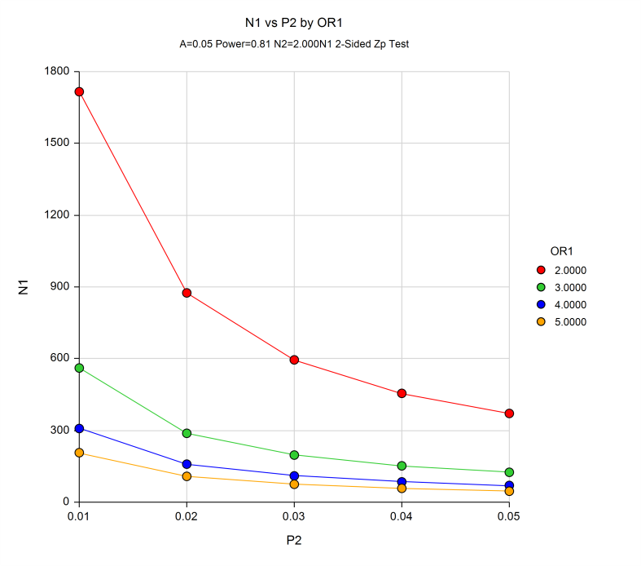

Figure 1. Two Independent Proportions (Null Case) Power Analysis (The sample size and power calculations were calculated using PASS 11 software (Hintze, J. 2011). PASS 11. NCSS, LLC. Kaysville, Utah, USA. [www.ncss.com](http://www.ncss.com). N1 = Sample size for HIV cases; P2 = prevalence of risk factor in Controls; OR1 = Odds ratio for case and control groups)

4.7.8. Survey Considerations

  The primary limitations of this study are those which are inherent with questionnaire surveys to ascertain specific risk factors.  The data may be influenced by socially desirable responses, recall bias, and non-response bias.  We will attempt to maximize the reliability of the results by assuring the participants of the confidential nature of the study. A detailed explanation will be given to each participant in the study package on the research objectives and his or her individual rights as a research subject. The study results will be entered into the REDS-III China database using a REDS-III China study ID. Although a link between the REDS-III Study ID and a donor’s personal identifying information (name, citizen ID, contact information etc.) will be maintained at the blood center, this link is not available to and cannot be accessed by the REDS-III China data center.

4.7.8. Personnel training

Study personnel from REDS-III blood centers and peripheral blood centers will be trained at a central location (e.g., a study site or IBT). The training will include the following:

1. The protocol of the study and the Manual of Operating Procedures will be presented to educate the study personnel about the goal, significance, and methods of the study.
2. A telephone conversation with candidate donors during initial recruitment and follow up reminder calls or text messages.
3. The standard description of the study and professional responses to donors’ inquiries.
4. The survey packet, returned mail handling, and incentive distribution.
5. The QA on received questionnaires and potential follow up clarification of questionable responses.
6. The secured questionnaire storage, data entry, data entry QC, i.e., double entry, and electronic data warehouse management.

At the end of the training, a quiz will be given to the trainees and a certificate will only be issued for those who pass the quiz.

## 4.8 Specimen Tracking and Data Management

4.8.1 Specimen Tracking System

Following blood collection, the reactive samples, as well as the control samples, will be sent from the blood centers to IBT for confirmatory testing. For the REDS-III China program including this study, IBT has developed a barcode system to label the samples. The barcode will not have any linkage to the donor’s direct Personal Identification Information (PII) such as name, birthday, citizen ID number, address, phone number, or other personal information. The donor’s PII is maintained only at the blood center level. Blood centers will perform the follow-up investigation with donors with confirmed reactive test results (either serological or PCR testing).

The Specimen Tracking System is an application with a relational database within REDS-III China website application. It is designed to trace a sample from the time when the sample is received and checked into the freezers in storage facility at IBT until the sample is submitted for lab analysis, disposed of after a study is completed, or shipped to the third party for further confirmative tests. All the information reported on the check-in, check-out Chain of Custody (COC) which describes in detail all pertinent information specific to each sample, including dates and persons who handle the sample and sample disposal information is entered in the Specimen Tracking database. Queries, data entries, and reports are designed for a study to record and access fields to manage information about the specimens.

A specimen tracking system can be used for both sample tracking and management purpose. Upon receipt of the sample, IBT will download a data matrix sheet of the sample using a function built into the application which automatically assigns a storage unit for each of the sample units. Accordingly, field crew will immediately store the sample unit in the specific storage unit in a freezer at the IBT storage facility. The system will be used by the blood centers and IBT to trace samples throughout the process from the point when the sample is prepared for shipment, shipped from blood center, received and checked into the storage facility at IBT, submitted for testing, tested with results recorded, and to the point when the sample is stored in the long-term repository.

4.8.2. Repository of confirmed HIV reactive donor samples

An HIV positive sample repository and a control sample repository have been built under the REDS-II China Program. These samples will be available for studies under REDS-III. We propose to continue collecting confirmed HIV reactive donor samples into a repository. These samples will be used in the proposed HIV study. All HIV screening reactive samples will be shipped to IBT from all REDS-III blood centers and from the Guangxi CDC. After confirmatory testing, IBT will place confirmed specimens into this repository for the HIV study. Any unused specimens will be stored in IBT -800C freezers for up to 10 years.

4.8.3. Data management and data transfer

All HIV testing results will be entered into an electronic form by IBT and transferred to REDS-III Central Coordinating Center (i.e. FEi) via a secure transmission channel. The CCC will conduct quality checks on the data and submit it to REDS-III Data Coordinating Center (DCC) via secure FTP site. To ensure donor confidentiality, a 32-digit Donation Identification number (Donation ID) will be used in the data transmitted to DCC. The Donation ID will be created by CCC’s ID generator computer program. It will be a random combination of numbers and letters and contains no identifiable information about a donation. This Donation ID will also be used as a linkage to the donor’s non-PII demographic information, donation information, and pre-screening test results in the REDS-III China database.

The data transfer starts from the participating blood centers. All data will be encrypted with the unique identification number and no donor personal identification data will be included. Only the blood center and/or Guangxi CDC will maintain the link between the unique donor identification number and donor identity. This information shall be stored in a secure location, which is accessible only by authorized research staff at the Blood Center. No other participating centers (CCC, REDS-III DCC, etc.) will have access to this information.

The participating Blood centers then transfer the HIV risk factor data or donation data associated with HIV positive donors to the REDS-III CCC through the CCC's web site, web services, or other secure channels. The CCC data import program processes the uploaded data.

The REDS-III CCC is responsible for incorporating all blood center data records into a central database and will compile and transform the data according to established protocols. If there is an error in the uploaded data, the data will be rejected and sent back to the participating blood center. A QA meeting will be scheduled to resolve the data that caused the error. The data will be corrected and re-submitted to the REDS-III CCC. The consolidated and verified data will then be converted into data files in CSV format and be uploaded to the data transfer utility in the CCC’s web application for download by REDS-III DCC.

If the REDS-III DCC's QA system discovers data quality issues, the data quality investigation request is sent back to CCC. The CCC will work with the data supplier (one of the blood centers) to correct the error data and re-submit the data.

The CCC provides electronic transmission of donor/donation records to REDSIII -DCC on a pre-determined, periodic basis (.e.g., monthly). The data are transmitted with accompanying versions of English code books for the purposes of interpretation, interoperability, and standardization.

The data to be transmitted is encrypted and sent via a secure transmission channel to prevent unauthorized access or tampering.

4.8.4. Data Quality Assurance and Quality Control

The REDS-III China Site data quality assurance and quality control will be implemented in three areas – technical design, process control, and data assessment. China CCC implements or assists in the first two of these areas. RTI assumes responsibility for the third area.

Technical Design

From the technical side, data quality assurance and control is implemented during the database design. The data integrity rules implanted in database schema/table design are the first mechanisms to ensure data quality. Data integrity enforcement includes the following,

* Entity Integrity – it enforces that every donor or donation as an entity in each data source that will be uniquely identified by, for example, a Study ID, Donor ID, Donation ID, or other unique identifier (Specimen barcode).
* Referential Integrity - the referential integrity check ensures that any Study ID, Donor ID, Donation ID or other identifier value in secondary data table shall refer to Study ID, Donor ID or Donation ID in the primary source. In other words, secondary tables are related or tied to the primary table through Study ID, Donor ID, Donation ID or other unique identifier. For example, Study ID - A433BE6DCADD36B9664C7EE8619C2D97 in the Donor List table is related to the same Study ID record in the Donor table.
* Domain Integrity – it defines the possible values of a field in a database table. Domain Integrity governs these values in data type, length, date format, range, constraint, etc. For example, a Study ID is a data type of character with up to 50 characters in length and shall not be null; the donation date format is spread in three fields with four digit as the year, two digit as the month, and two digit as the day; the upper range of a donor’s age is < 1940 (born before 1940); and as a constraint, for example, for a first-time donor, his or her last donation date must be null.

Many of the business rules for data quality controls are actually embedded in the database design and implementation.

Process Control

The China CCC/FEI performs ongoing data quality control checks on incoming data from the blood centers. It employs two types of quality control checking: automated system checks and manual review.

Automated system checks reduce the burden of complicated operation and time-intensive troubleshooting and allow an inexperienced user to run a full QC check of the data.

Automated quality checks are performed at three levels of detail.

* Field level checks are performed on all data, ensuring conformance for presence of field data, field type accuracy, and value range.
* Cross-field validations are performed to ensure field values do not conflict.
* Cross-record checks are executed to ensure that incoming data records do not conflict with already validated and stored data.

Manual data review occurs as the result of queries on the data that reveal data of interest and/or data anomalies. It is another layer of data checking to ensure accuracy, completeness, or other reasons.

When the quality checks reveal that the data received is outside the acceptable range, China CCC/FEI will contact the blood center to verify if that data is correct and valid. Based on the outcome of the verification, the data will either get re-coded or kept as is. CCC will document this process including blood center’s explanation and communicate it to DCC when the data is transferred.

After QA/QC design is implemented technically into the system, the application of the QA/QC process is subject to human and organizational factors which can impact QA/QC’s effectiveness. The REDS-III China CCC makes data quality process control efforts to make sure that the blood centers and their personnel understand the importance of data quality so that they are motivated to collect high-quality data and report problems as they occur. The process control includes performing data quality monitoring which addresses the entire process by which the data are gathered, transmitted, stored, and analyzed. Data quality is monitored continually, with error or summary reports prepared and distributed to the appropriate parties. Appropriate training and communication also enhances data quality, and site visits allow data collection and storage processes to be observed directly. The process control is flexible enough so that new means of quality assurance or monitoring can be added when necessary. During the course of the program whenever a consistent approach can be adopted to eliminate a data quality issue, it can be integrated seamlessly into the QA/QC system. To achieve the QA/QC goal, the Program also encourages the blood centers and their personnel to provide prompt feedback and suggestions for corrective action, whenever a data quality problem is discovered. All parties understand that delays in initiating any stage of data management and quality monitoring may result in uncorrectable data problems. Knowledgeable and efficient blood center personnel are essential to achieving good data quality.

Data Assessment

Data assessment is used to assess the type, quantity, and quality of data in order to verify that the data quality objectives are satisfied and that the data are suitable for its intended purpose. Data assessment is a multiple-step procedure for determining whether or not a data set is suitable for its intended purpose. This assessment is an evaluation of data to determine if it is of the type, quantity, and quality needed and may be performed to check the process of data collection or to check if objectives are met.

Data assessment is performed by RTI in REDS-III in the following key area:

a. Accuracy. Data accuracy is about the extent to which an estimated data value approaches its true value.

b. Consistency. Data validity is the correctness and reasonableness of data. For example, the following data values are not considered as valid:

* a donor’s age is 16 years
* A donor’s weight is less than 45 kg

c. Reliability. Data reliability refers to the accuracy and completeness of system processed data, given the uses they are intended for.

d. Relevance. Data should be relevant for the purposes for which it is used.

e. Completeness. Data completeness refers to an indication of whether or not all the data necessary to meet the current and future information demand are available in the data resource.

g. Compliance. Data must comply with regulations on data collection, data protection and data security.

DCC will generate monitoring reports to support JHU and China CCC to manage and ensure the data quality for this study.

4.9 Statistical Considerations

RTI will conduct the statistical analysis. For the HIV molecular surveillance study, a descriptive study in percentage terms of all recorded variables will be performed using computer software (SAS/STAT software, Version 9.3, of the SAS systems for Windows). We will calculate the proportion (frequency) and associated 95% CI of each viral lineage based on the laboratory results. To evaluate if the proportions of different lineages by year, geographic area, and demographics, we will produce frequency multidimensional tables incorporating these characteristics. Further, exploratory logistic regression models may be used with viral lineage as an outcome and year, geographic area, and demographics as predictor variables. These models would allow us to estimate whether the odds of having a particular genotypic variant differs by years, geographic area, or demographics while adjusting for other variables.

In the case-control HIV Risk Factor study, we want to understand risk factors for HIV infection in Chinese blood donors. In addition to investigating the association between exposure to some well-established risk factors, such as injection drug use, history of previous whole blood or plasma donation, and blood transfusion history, and HIV infection, we also want to investigate some potential risk factors such as having multiple sex partners, involvement in commercial sex, male to male sex, therapeutic acupuncture, and test-seeking behavior as routes of transmission for HIV among blood donors. According to the REDS-II China study (“An Analysis of Risk Factors for HIV Infection among Chinese Blood Donors”, by Jingxing Wang et al43), the odds ratios of HIV infection and risk factors among Chinese blood donors ranged between 2-5 (OR=2.7 for test-seeking tendency, OR=1.8 for medical-related risks, and OR=5.1for high-risk sexual behaviors). The prevalence of the risk factors among controls (i.e. general population) ranged between 0.2% and 23% (11% test-seeking tendency, 3% having had blood transfusion, 23% injection in the past 12 months,7% endoscopy, 4% having a tattoo, 15% having two or more sexual partners, 4% paying or receiving money for sex, and 0.2% being MSM).

As mentioned in Section 4.7.7(Sample Size for the HIV risk factor study), if our response rate is 33% instead of 50% for both groups, we will end up with a sample size of 306 cases plus 682 controls. Thus, if the actual enrollment rate is lower than expected, the potential to detect secondary risk factors with lower prevalence in the control groups is limited. While acknowledging such limitations, our preliminary data from the REDS-II risk factor study seems to suggest that we should be able to detect the effects of most major risk factors given that such risk factors play an important role in HIV transmission. Meanwhile, to maximize the sample size and increase the power of detecting the effects of secondary risk factors, we will constantly monitor the enrollment process and work with the participating sites to develop effective techniques and strategies to increase the tracking and response rates to help improve the HIV positive donor enrollment. Meanwhile, as a backup plan, in the event that our enrollment number is below our expectation, we may recruit those who donated in April 2012-December 2014, retrospectively, to increase the sample size and power.

## 4.10 Human Subjects

### 4.10.1. Procedures & risks:

The primary limitations of this study are those which are inherent with questionnaires to ascertain specific risk factors.  The data may be influenced by socially desirable responses, recall bias, and non-response bias.  We will attempt to maximize the reliability of the results by assuring the participants of the confidential nature of the study.

### 4.10.2. Recruitment, consent and protection against risks:

All donors at the REDS-III China participating blood centers will be invited to participate in the REDS-III study. The general consent for the REDS-III study asks for permission for the inclusion of routine donor and donation information in the REDS-III database, for the use of donor samples in studies relevant to investigating blood safety, and, if necessary, for storing of samples in the REDS-III sample repository. The consent will be accompanied by a one-page description of the purpose and nature of the REDS-III China research program. Trained blood center staff will be available to answer questions from the donors about REDS-III China program.

The REDS-III consent forms that will be given to all donors will explain that all study information entered into the REDS-III China database, submitted to REDS-III China Data Coordinating Center (FEI, Xian, China), and then submitted to REDS-III Data Coordinating Center (RTI, NC, USA) will be identified only with a study ID, i.e., without any of the donor’s personal information. The study ID is generated for the REDS-III China program using an irreversible process. A link between the Study ID and the donor personal information is only maintained by the blood center without any access of the other study personnel outside of the blood center. The consent form will include information on the potential of a follow-up investigation and a look-back study.

Detailed final study protocols will be submitted for approval by the IRB at JHU and by the Ethical Committees at IBT, the Chinese Institute of Blood Transfusion in China. All measures will be implemented to protect the privacy and confidentiality of all the study participants by maintaining a secure database. All study personnel will be trained and certified using the materials provided by JHU’s Office of Research Administration on human subject protection in research. Only research staff at the blood centers will have access to donor personal identification information needed for the follow-up contact. All data and samples will be identifiable by the Study ID only before submitted to the REDS-III China Data Coordinating Center and IBT.

The following will be the REDS-III China donor and donation identification procedure: Standardized donor and donation data forms will be used at all blood collection sites to document donor and donation information. The standard data form used by the blood centers will show a donor’s name and contact information (including address and phone number), a unique REDS-III China Study Identification number (Study ID), and donor and donation information required for REDS-III. All donor and donation information that will be transferred first to REDS-III China CCC, then to REDS-III DCC, will only be identified by the REDS-III China Study ID, with no personal identification information including donor names, contact information, and other unique private identification information (such as citizen identification number). The link between a donor’s identity and Study ID will be maintained only at the blood center and will not be available to any other REDS-III study personnel.

## 4.11 Time line

9/2012-11/2013: Protocol development

12/2013 to 2/2014 NHLBI review and subcontracting

3/2014-12/2014 JHU, IBT, RTI IRB, OMB application & approval;

Study personnel training

3/2014 -3/2017: Data collection for HIV samples

1/2015-6/2017 HIV risk factor study data collection

7/2017-3/2018 Data analysis and manuscript preparation

5. Reference

1. Global report: UNAIDS report on the global AIDS epidemic 2010.<http://www.unaids.org/globalreport/global_report.htm>.

2. Chinese HIV/AIDS epidemic report, 2011. <http://www.moh.gov.cn/publicfiles/business/htmlfiles/mohjbyfkzj/s3586/201201/53957.htm>.

3. Zhang Kl KL, Ma SJ (2002) Epidemiology of HIV in China. BMJ 324: 803-804.

4. Zhu TF, Wang CH, Lin P, He N (2005) High risk populations and HIV-1 infection in China. Cell Res 15: 852-857.

5. Lu F LT (2003) HIV/AIDS epidemiology. “AIDS clinical therapy and care” CDC China. Beijing: Beijing University Medical Publishing Company. 1: 11.

6. Chu TX LJ (2005) Injection drug use and HIV/AIDS transmission in China. Cell Res 15: 865-869.

7. KL Z (2005) Influential factors and prediction of trend in HIV/AIDS epidemics in China. Basic Clin Med 25: 481-486.

8. KL Z (2002) Prevalent rule and trend of HIV/AIDS in China and Asia. BMJ 324: 38-39.

9. J T (1998) HIV/AIDS in China: migrant population, drug injection responsible for increased transmission. AIDSlink 49: 12-14.

10. Wang S, Nie J, Wang Y (2011) Comparisons of the genetic and neutralization properties of HIV-1 subtype C and CRF07/08_BC env molecular clones isolated from infections in China. Virus Res 155: 137-146.

11. Han X, Zhang M, Dai D, Wang Y, Zhang Z, et al. (2007) Genotypic resistance mutations to antiretroviral drugs in treatment-naive HIV/AIDS patients living in Liaoning Province, China: baseline prevalence and subtype-specific difference. AIDS Res Hum Retroviruses 23: 357-364.

12. Liu S, Xing H, He X, Xin R, Zhang Y, et al. (2008) Analysis of putative N-linked glycosylation sites and variable region of envelope HIV-1 CRF07_BC recombinant in intravenous drug users in Xinjiang Autonomous Region, China. AIDS Res Hum Retroviruses 24: 521-527.

13. Zhang Y, Lu L, Ba L, Liu L, Yang L, et al. (2006) Dominance of HIV-1 subtype CRF01_AE in sexually acquired cases leads to a new epidemic in Yunnan province of China. PLoS Med 3: e443.

14. Ma L, Huang J, Xing H, Yuan L, Yu X, et al. (2010) Genotypic and phenotypic cross-drug resistance of harboring drug-resistant HIV type 1 subtype B' strains from former blood donors in central Chinese provinces. AIDS Res Hum Retroviruses 26: 1007-1013.

15. Tee KK, Pybus OG, Li XJ, Han X, Shang H, et al. (2008) Temporal and spatial dynamics of human immunodeficiency virus type 1 circulating recombinant forms 08_BC and 07_BC in Asia. J Virol 82: 9206-9215.

16. Wu Z RK, Cui H (2004) The HIV/AIDS epidemic in China: history, current strategies and future challenges. AIDS Educ Prev 16: 7-17.

17. Wu Z SX, Sullivan SG, Detels R (2006) Public health. HIV testing in China. Science 25: 173-175.

18. World Health Organization, Blood Safety. Fact Sheet No. 279, June 2011.<http://www.who.int/worldblooddonorday/media/who_blood_safety_factsheet_2011.pdf>. Accessed on May 10, 2012.

19. Shao Y (2004) Basic Science Update by Chinese Ministry of Science and Technology. Basic Science Update by Chinese Ministry of Science and Technology 5: 16-18.

20. Ma L, Guo Y, Yuan L, Huang Y, Sun J, et al. (2009) Phenotypic and genotypic characterization of Human Immunodeficiency Virus type 1 CRF07_BC strains circulating in the Xinjiang Province of China. Retrovirology 6: 45.

21. Zhao F (2009) Human immunodeficiency virus type 1 subtypes prevalence in central China. Yonsei Med J 50: 644-649.

22. Tu Y, Wang M, Yao J, Zhu X, Pan P, et al. (2009) Human immunodeficiency virus-1 genotypic drug resistance among volunteer blood donors in Yunnan, China. Transfusion 49: 1865-1873.

23. Zeng P, Wang J, Huang Y, Guo X, Li J, et al. (2012) The human immunodeficiency virus-1 genotype diversity and drug resistance mutations profile of volunteer blood donors from Chinese blood centers. Transfusion 52: 1041-1049.

24. <http://gz.bendibao.com/news/2012621/content100209.shtml>. Accessed on September 10, 2012.

25. Jingxing Wang JL, Fuzhu Yao, Guoxin Wen, Julin Li, Yi Huang, Yunlai Lv, Xiuqiong Wen, David Wright, Qilu Yu, Nan Guo, Paul Ness, Hua Shan Prevalence, Incidence, and Residual Risks for Transfusion Transmitted HIV-1/2 Infection among Chinese Blood Donors. Accepted by Transfusion.

26. Lefrere JJ, Dahourouh H, Dokekias AE, Kouao MD, Diarra A, et al. (2011) Estimate of the residual risk of transfusion-transmitted human immunodeficiency virus infection in sub-Saharan Africa: a multinational collaborative study. Transfusion 51: 486-492.

27. Sabino EC, Goncalez TT, Carneiro-Proietti AB, Sarr M, Ferreira JE, et al. (2012) Human immunodeficiency virus prevalence, incidence, and residual risk of transmission by transfusions at Retrovirus Epidemiology Donor Study-II blood centers in Brazil. Transfusion 52: 870-879.

28. Dodd RY, Notari EPt, Stramer SL (2002) Current prevalence and incidence of infectious disease markers and estimated window-period risk in the American Red Cross blood donor population. Transfusion 42: 975-979.

29. O'Brien SF, Yi QL, Fan W, Scalia V, Fearon MA, et al. (2012) Current incidence and residual risk of HIV, HBV and HCV at Canadian Blood Services. Vox Sang 103: 83-86.

30. Young C, Hu D, Byers R, Vanichseni S, Young N, et al. (2003) Evaluation of a sensitive/less sensitive testing algorithm using the bioMerieux Vironostika-LS assay for detecting recent HIV-1 subtype B' or E infection in Thailand. AIDS Res Hum Retroviruses 19: 481-486.

31. Withum D. Serological Testing Algorithm for Recent HIV Seroconversion (STARHS): CDC's Investigational New Drug (IND) Program and Uses of a Testing Strategy to Detect Early HIV-1 Infection International AIDS Conference: STARHS Satalitte meeting; 2000; Bangkok; 2000.

32. Remis RS, Palmer RWH (2009) Testing bias in calculating HIV incidence from the Serologic Testing Algorithm for Recent HIV Seroconversion. AIDS 23: 493-503.

33. Glynn S, Kleinman S, Schreiber G, Busch M, Wright D, et al. (2000) Trends in incidence and prevalence of major transfusion-transmissible viral infections in US blood donors,1991 to 1996. REDS Study. JAMA 284: 229-235.

34. Busch M, Glynn S, Stramer S, Strong D, Caglioti S, et al. (2005) A new strategy for estimating risks of transfusion transmitted viral infections based on rates of detection of recently infected donors. Transfusion 45: 254-264.

35. Wei X, Liu X, Dobbs T, Kuehl D, Nkengasong JN, et al. (2010) Development of two avidity-based assays to detect recent HIV type 1 seroconversion using a multisubtype gp41 recombinant protein. AIDS Res Hum Retroviruses 26: 61-71.

36. Duong YT, Qiu M, De AK, Jackson K, Dobbs T, et al. (2012) Detection of recent HIV-1 infection using a new limiting-antigen avidity assay: potential for HIV-1 incidence estimates and avidity maturation studies. PLoS One 7: e33328.

37. Schreiber G, Busch M, Kleinman S, Korelitz J (1996) The risk of transfusion-transmitted viral infections. The Retrovirus Epidemiology Donor Study. N Engl J Med 334.

38. Glynn S, Kleinman S, Wright D, Busch M (2002) International application of the incidence rate/window period model. Transfusion 42: 966-967.

39. Hue S, Clewley J, Cane P, Pillay D (2004) HIV-1 pol gene variation is sufficient for reconstruction of transmissions in the era of antiretroviral therapy. AIDS 18: 719-728.

40. Njouom R, Pasquier C, Sandres-Saune K, Harter A, Souyris C, et al. (2003) Assessment of HIV-1 subtyping for Cameroon strains using phylogenetic analysis of pol gene sequences. J Virol Methods 110: 1-8.

41. Brennan CA, Yamaguchi J, Devare SG, Foster GA, Stramer SL (2010) Expanded evaluation of blood donors in the United States for human immunodeficiency virus type 1 non-B subtypes and antiretroviral drug-resistant strains: 2005 through 2007. Transfusion 50: 2707-2712.

42. Tu YQ, Wang MJ, Yao J, Zhu XM, Pan PL, et al. (2009) Human immunodeficiency virus-1 genotypic drug resistance among volunteer blood donors in Yunnan, China. Transfusion 49: 1865-1873.

43. Wang, JX, Liu, J, et al. (2013). An analysis of risk factors for HIV infection among Chinese blood donors.[Transfusion.](http://www.ncbi.nlm.nih.gov/pubmed/23113801) 2013 Oct;53 Suppl 3:2431-40. doi: 10.1111/trf.12062.

## 6. Appendix:

## 6.1 Appendix A. Support Letter from Guangxi CDC Division of HIV and TB Control and Prevention



6.2. Appendix B. Data collection form for peripheral blood centers

|  |  |  |  |  |  |  |  |  |  |  |  |  |
| --- | --- | --- | --- | --- | --- | --- | --- | --- | --- | --- | --- | --- |
| CenterID | StudyID | Birth  Year | Sex | Birthplace - Province | Birthplace - City | Birthplace-County | Ethnicity | Current occupation | Highest education level | Marital status | Number of previous donations | Last Donation Date |
|  |  |  |  |  |  |  |  |  |  |  |  |  |
|  |  |  |  |  |  |  |  |  |  |  |  |  |
|  |  |  |  |  |  |  |  |  |  |  |  |  |
|  |  |  |  |  |  |  |  |  |  |  |  |  |
|  |  |  |  |  |  |  |  |  |  |  |  |  |
|  |  |  |  |  |  |  |  |  |  |  |  |  |
|  |  |  |  |  |  |  |  |  |  |  |  |  |
|  |  |  |  |  |  |  |  |  |  |  |  |  |
|  |  |  |  |  |  |  |  |  |  |  |  |  |
|  |  |  |  |  |  |  |  |  |  |  |  |  |

6.3. Appendix C. Informed Consent Form for all REDS-III blood donors

I am voluntarily donating my blood to ________ Blood Center for use as decided by the blood center. My answers to the Donor Health Inquiry Questionnaire are true. I agree for the blood center to collect my blood samples and conduct required routine blood donor testing. I agree that my blood samples may be stored and used for additional laboratory testing for blood safety research purpose. The blood center may or may not notify me with the results from the additional laboratory testing. The blood center may invite me to take part in future study. I have the right to decide whether to participate in any additional study. I agree that my Donor Form data, Health Inquiry information, and testing results may be used for research purpose in a confidential manner. I understand that the information and testing are only used for purpose of improving blood safety and adequacy, and not for any other purposes, such as health insurance or disease diagnosis.

I understand that should I answer any of the screening questions or make the above statement untruthfully that I will be responsible for any consequences incurred as a result.

Donor’s signature:

Identification number:

Date:

6.4. Appendix D. HIV Risk Factor Survey (See attachment for both Chinese and English version. Current version will be modified for final printing).

RETROVIRUS EPIDEMIOLOGY DONOR STUDY-III (REDS-III)

HIV RISK FACTOR QUESTIONNAIRE

You are being asked to take part in a research survey which is jointly conducted by __________ Blood Center, Institute of Blood Transfusion (of Chinese Academy of Medical Sciences), the Johns Hopkins School of Medicine and the United States National Institute of Health. The objective of this survey is to learn about the risk factors for HIV infection among blood donors. Results from this survey will be used to design more effective mechanisms to further improve blood safety.

Information provided by our volunteer blood donors is very valuable in further improving blood safety. We appreciate your participation in the questionnaire study. We would like to ask you some questions about your health and lifestyle. It will take about 20 minutes to complete these questions. In order to protect your confidentiality, your name and other personal identifiable information will not be asked. You are assigned a study number. Your answers will be identified by your study number, not by any of your personal information. Protecting donors’ privacy and confidentiality is a very important goal of our work. This study protocol has been reviewed and approved by research ethic committees at Chinese Academy of Medical Science and Johns Hopkins School of Medicine. OMB CONTROL NUMBER:____________；Expiration Date:___________。

Your participation is voluntary. You have the right to not answer any question or withdraw at any time. But we would like you to be as complete and truthful as possible for those questions you do answer. After you finish the questionnaire, please mail it directly to us using the enclosed pre-addressed, postage-paid return envelope. To protect your privacy, please do not write down your name on the questionnaire or the envelope. Instead of filling this form, you may also complete this survey online at our website: __________[(to](http://www.???.com.cn) be provided).

Please be aware that the questionnaire is only used for the purpose of identifying risk factors for HIV, and not for any other purposes, such as disease diagnosis. This survey includes donors who may or may not have abnormal results from donor testing. The CDC office is responsible for notifying you if you have an abnormal test result. In this case, please follow CDC office’s advice for further follow-up.

Thank you for taking the time to help us with this important study. Please accept the RMB 100 as a token of our gratitude for your effort after completion of the survey. If you have any question about the study, please call your blood center at _______________. Thanks for your contribution to blood safety.

Date: __ __/__ __/__ __ __ __ (D D/ M M / Y Y Y Y)

Study identification number: __ - __ __ __ __ __ __ __ - __

RETROVIRUS EPIDEMIOLOGY DONOR STUDY-III (REDS-III)

HIV RISK FACTOR QUESTIONNAIRE

Date: __ __/__ __/__ __ __ __ (D D/ M M / Y Y Y Y)

Study identification number: __ - __ __ __ __ __ __ __ - __

Instructions: Please answer each of the following questions about your health, lifestyle, and blood donation history. For each question, provide a response unless directed to skip to another question further down in the questionnaire. It will take approximately 20 minutes to complete these questions.

1. Your Background

|  |  |
| --- | --- |
| 1. When were you born? | __ __ __ __ (year) |
| 1. What is your gender? | Female  Male |
| 1. What is your place of birth? | Province:____________________________  City:________________________________  County:______________________________ |
| 1. What is your ethnicity? | Han  Hui  Uygur  Man  Dai  Zhuang  Other, specify ______________ |
| 1. What is your current occupation?   5a. Have you ever provided special services at entertainment business (including night clubs, private clubs, night bar, Karaoke clubs)? | Worker  Farmer who works at hometown  Farmer or worker working out of town  Service or business  Education/research/government  Military/Police  Medicine/Health care  Student  Company employee  Self-employed  Other, specify _____________  Yes (please describe)__________________________  No  Unknown |
| 1. What is the highest level of education you have received? | Primary school or less  Junior high school  High School or vocational school  Associate degree  Bachelor’s degree  Graduate level degree  Other, specify _____________ |
| 1. What is your marital status? | Never married  Married or co-habiting  Divorced  Separated  Widowed  Other, specify _____________ |

1. History of Blood Donation & Infection Risks
2. How many times have you donated blood?

__ __ time (s)🡪ANSWER QUESTION 8a-8c

Please list the most recent three blood donations indicating the year and type of blood donation for each.(If you have donated blood more than 3 times, please list the most recent three):

|  |  |  |
| --- | --- | --- |
| Donation | Year | Type of Donation |
| 8a. Most recent donation | __ __ __ __ | Whole blood donation  Apheresis donation |
| 8b. Next most recent donation | __ __ __ __ | Whole blood donation  Apheresis donation |
| 8c. Next most recent donation | __ __ __ __ | Whole blood donation  Apheresis donation |

1. How much do you agree or disagree with each of the statements (9a-9c) below:

|  |  |  |  |  |
| --- | --- | --- | --- | --- |
| Statement | Do not  agree  at all | Disagree  a little | Agree a  little | Agree  very  much |
| 9a. It’s important that I received blood test results from blood donation. |  |  |  |  |
| 9b. I think blood donation is a good, fast, anonymous way to get my blood test result. |  |  |  |  |
| 9c. One of my reasons for donating blood is to find out if I have HIV and/or hepatitis infection. |  |  |  |  |

|  |  |
| --- | --- |
| 1. Have you ever been told that you are at risk for spreading diseases through your blood?   10a. What kind of diseases? (Mark all that apply)  10b. When was the last time you were told so? | Yes🡪ANSWER QUESTION 10a  No 🡪Skip to Q11  Unknown🡪Skip to Q11  Hepatitis A  Hepatitis B  Hepatitis C  Syphilis/Gonorrhea  HIV/AIDS  Other, specify __________  Unknown  Within 3 days up to 1 month  Within 1-3 months  Within 3-6 months  From 6 months to less than 1 year  1 year ago  Unknown |
| 1. Did you ever receive notification from blood center about your infection status?   11a. Before your most recent donation, had you ever received notification from blood center about your infection status (excluding any such notification after your most recent blood donation)?  11b. Had you sought further testing or health care according to the instruction of the notification (excluding any such notification after your most recent blood donation)?  11c. Are you planning to seek further testing or health care according to the instruction of the notification? | Yes🡪ANSWER QUESTION 11a-11c  No 🡪Skip to Q12  Unknown🡪Skip to Q12  Yes  No  Unknown  Yes  No  Unknown  Yes  No  Unknown |
| 1. Before your most recent donation, had you ever been permanently deferred as a blood donor?   12a. For what reason were you permanently deferred?(Mark all that apply) | Yes🡪ANSWER QUESTION 12a  No🡪SKIP TO 13  Unknown🡪SKIP TO 13  Hepatitis B  Hepatitis C  Syphilis  HIV  Didn’t pass Physical Exam, specify ________  Didn’t pass blood Test, specify __________  Other, specify ______________________ |
| 1. Before your most recent donation, had you ever been temporarily deferred as a blood donor?   13a. For what ineligibility were you temporarily deferred?(Mark all that apply) | Yes🡪ANSWER QUESTION 13a  No🡪SKIP to Q 14  Unknown🡪SKIP to Q14  HBV rapid test  ALT  Hemoglobin (Hb) level  Blood pressure  Heart rate  Body Weight  Fasting  Other, specify ______________________ |

1. Health Condition History

|  |  |
| --- | --- |
| 1. Have you ever received acupuncture treatment?   14a. In the past6 months, did you have acupuncture? | Yes 🡪ANSWER QUESTION 14a  No🡪SKIP TO 15  Unknown🡪SKIP TO 15  Yes  No  Unknown |
| 1. In the past 6 months, did you have any injection (including intravenous [IV] and intramuscular [IM] injections)?   15a. How many times did you have injection(s)? | Yes 🡪ANSWER QUESTION 15a  No🡪SKIP TO 16  Unknown🡪SKIP TO 16  __ __ times |
| 1. Have you had any finger sticks (excluding the one prior to making a donation)?   16a. In the past 6 months, did you have finger sticks (other than the one prior to making a donation)? | Yes🡪ANSWER QUESTION 16a  No🡪SKIP TO 17  Unknown🡪SKIP TO 17  Yes  No  Unknown |

1. When you had acupuncture, finger sticks, or injections, were needles and syringes used disposable?

|  |  |  |  |  |  |
| --- | --- | --- | --- | --- | --- |
| Were needles and syringes used disposable? | Seldom | Sometimes | Often | Always | Unknown |
| a. Acupuncture |  |  |  |  |  |
| b. Finger sticks |  |  |  |  |  |
| c. Injections |  |  |  |  |  |

|  |  |
| --- | --- |
| 1. In the past 6 months, have you ever visited the following medical facilities?(Mark all that apply)   18a. What kind of treatment did you receive from the above medical facilities?(Mark all that apply) | Yes, county hospital🡪ANSWER QUESTION 18a  Yes, town hospital🡪ANSWER QUESTION 18a  Yes, community hospital🡪ANSWER QUESTION 18a  Yes, village clinic🡪ANSWER QUESTION 18a  Yes, private outpatient clinic🡪ANSWER QUESTION 18a  Yes, other, please specify🡪ANSWER QUESTION 18a  No 🡪SKIP TO 19  Unknown🡪SKIP TO 19  Intravenous (IV) or intramuscular (IM)injection  Therapeutic transfusion  Outpatient surgeries (including anesthesia, removal of sebaceous cyst, wound suture etc.)  Dental care  Pediatrician visit or accompany for someone else  Other, please specify__________ |
| 1. Have you ever had in-patient medical surgery?   19a. In the past 6 months, did you have in-patient medical surgery? | Yes🡪ANSWER QUESTION 19a  No🡪SKIP TO 20  Unknown🡪SKIP TO 20  Yes  No  Unknown |
| 1. Have you ever had out-patient medical surgery?   20a. In the past 6 months, did you have out-patient medical surgery? | Yes 🡪ANSWER QUESTION 20a  No🡪SKIP TO 21  Unknown🡪SKIP TO 21  Yes  No  Unknown |
| 1. Have you ever had cosmetic surgery (e.g. laser, eye/lip surgery, collagen injection, dermal abrasion)?   21a. In the past 6 months, did you have cosmetic surgery? | Yes 🡪ANSWER QUESTION 21a  No🡪SKIP TO 22  Unknown🡪SKIP TO 22  Yes  No  Unknown |
| 1. Have you ever received a blood transfusion?   22a. How many times did you have blood transfusions?  22b. Year of your first time of blood transfusion?  22c. Year of your last time of blood transfusion? | Yes🡪ANSWER22a-22c  No🡪SKIP TO 23  Unknown🡪SKIP TO 23  __ __ times  __ __ __ __ (year)  __ __ __ __ (year) |
| 1. Have you ever had any dental cleaning?   23a. In the past 6 months, did you have dental cleaning? | Yes🡪ANSWER QUESTION 23a  No🡪SKIP TO 24  Unknown🡪SKIP TO 24  Yes  No  Unknown |
| 1. Have you ever had any dental surgery, such as root canal treatment or tooth extraction?   24a. In the past 6 months, did you have dental surgeries? | Yes🡪ANSWER QUESTION 24a  No🡪SKIP TO 25  Unknown🡪SKIP TO 25  Yes  No  Unknown |
| 1. Have you ever had any endoscopy (such as gastroscopy and colonoscopy)?   25a. In the past 6 months, did you have endoscopies? | Yes🡪ANSWER QUESTION 25a  No🡪SKIP TO 26  Unknown🡪SKIP TO 26  Yes  No  Unknown |
| 1. Have you ever been previously diagnosed with hepatitis?   26a. What type(s) of hepatitis did you have (please choose all that apply)? | Yes🡪ANSWER QUESTION 26a  No🡪SKIP TO 27  Unknown🡪SKIP TO 27  Hepatitis A  Hepatitis B  Hepatitis C  Other, specify _____________  Unknown |
| 1. Have you ever been previously diagnosed with syphilis, gonorrhea, or any other sexually transmitted disease? | Yes  No  Unknown |
| 1. Have any of your family members had hepatitis? | Yes  No  Unknown? |
| 1. Have any of your family members had HIV/AIDS? | Yes  No  Unknown |
| 1. Have you ever had household contact with someone with HIV/AIDS?   30a. In the past 6 months, did you have household contact with someone with HIV/AIDS? | Yes🡪ANSWER QUESTION 30a  No🡪SKIP TO 31  Unknown🡪SKIP TO 31  Yes  No  Unknown |

1. Drug Use History

|  |  |
| --- | --- |
| 1. Have you ever used needles to shoot (or take) street drugs?   31a. How long have you shot (or taken) street drugs?  31b. How many times per month did you shoot (or take) street drugs?  31c. Have you ever shared needles or syringes with others to inject street drugs?  31d. In the past 6 months, did you ever use needles to shoot (or take) street drugs? | Yes🡪ANSWER QUESTIONS 31a-31d  No🡪SKIP TO 32  Unknown🡪SKIP TO 32  __ __ years  __ __ times/month  Yes  No  Unknown  Yes  No  Unknown |
| 1. Have you ever used illegal oral or intranasal drugs without doctor’s prescription?   32a. In the past 6 months, did you use illegal oral or intranasal drugs without doctor’s prescription | Yes🡪ANSWER QUESTION 32a  No🡪SKIP TO 33  Unknown🡪SKIP TO 33  Yes  No  Unknown |
| 1. Have you ever lived with a person who was an IDU?   3a. In the past 6 months, did you live with a person who was an intravenous drug user? | Yes🡪ANSWER QUESTION 33a  No🡪SKIP TO 34  Unknown🡪SKIP TO 34  Yes  No  Unknown |
| 1. Are any of your close friends or family member’s intravenous drug users? | Yes  No  Unknown |

1. Sexual History

The next section of questions will ask you about your sexual experiences. In these questions, include only those people you have had oral, vaginal, or anal sex with. Do not include people that you have just kissed. Please note that for the next few questions the term "sex" refers to any of the following activities, whether or not a condom or other protection was used: Vaginal sex (contact between penis and vagina), Oral sex (mouth or tongue on someone’s vagina, penis, or anus), Anal sex (contact between penis and anus).

|  |  |
| --- | --- |
| 1. Have you had more than 2 concurrent sexual partners of the opposite sex?   35a1. In your lifetime, how many heterosexual partners did you have?  35a2. In the past 6 months, how many heterosexual partners did you have?  35b1. How often do you or your sex partner use a condom when you have sex with your heterosexual partner?  35b2. In the past 6 months, how often do you or your sex partner use a condom when you have sex with your heterosexual partner? | Yes🡪ANSWER QUESTIONS35a1-35b2  No🡪SKIP TO 36  Unknown🡪SKIP TO 36  1-2  3-4  5-7  8-10  >10  1-2  3-4  5-7  8-10  >10  Never  Sometimes  Half of time  Most of time  Always  Never  Sometimes  Half of time  Most of time  Always |
| 1. (FOR MALE RESPONDENTS ONLY) In your lifetime, have you ever had sex with another male?   36a1. In your lifetime, how many times did you have sex with males?  36a2. In your lifetime, how many male partners have you had sex with?  36a3. In your lifetime, how often do you or your sex partner use a condom when you have sex with male partner?  36b1. In the past 6 months, how many times did you have sex with males?  36b2. In the past 6 months, how many male partners have you had sex with?  36b3. In the past 6 months, how often do you or your sex partner use a condom when you have sex with male partner? | Yes🡪ANSWERQUESTIONS 36a1-36b3  No🡪SKIP TO 37  Unknown🡪SKIP TO 37  1-2  3-5  6-10  >10  1-2  3-5  6-10  >10  Never  Sometimes  Half of time  Most of time  Always  1-2  3-5  6-10  >10  1-2  3-5  6-10  >10  Never  Sometimes  Half of time  Most of time  Always |
| 1. Have you ever paid or received money or other forms of remuneration for having sex?   37a. In the past 6 months, have you paid or received money or other forms of remuneration for having sex? | Yes🡪ANSWER QUESTIONS37a  No🡪SKIP TO 38  Unknown🡪SKIP TO 38  Yes  No  Unknown |
| 1. Have you ever had a sex partner that was an intravenous drug user?   38a. In the past 6 months, did you have a sex partner that was an intravenous drug user? | Yes🡪ANSWER QUESTION 38a  No🡪SKIP TO 39  Unknown🡪SKIP TO 39  Yes  No  Unknown |
| 1. In your lifetime, have you ever had a sex partner who had a positive test for syphilis, gonorrhea, or any other sexually transmitted disease?   39a. In the past 6 months, did you have a sex partner who had a positive test for syphilis, gonorrhea, or any other sexually transmitted disease? | Yes🡪ANSWER QUESTION 39a  No🡪SKIP TO 40  Unknown🡪SKIP TO 40  Yes  No  Unknown |
| 1. In your lifetime, have you ever had a sex partner who had been diagnosed with HIV/AIDS?   40a. In the past 6 months, did you have a sex partner who had been diagnosed with HIV/AIDS? | Yes🡪ANSWER QUESTION 40a  No🡪SKIP TO 41  Unknown🡪SKIP TO 41  Yes  No  Unknown |
| 1. In your lifetime, have you had sexual contact with anyone who received blood transfusion?   41a. In the past 6 months, did you have sexual contact with anyone who received blood transfusion? | Yes🡪ANSWER QUESTION 41a  No🡪SKIP TO 42  Unknown🡪SKIP TO 42  Yes  No  Unknown |

1. Other Risk Factors

|  |  |
| --- | --- |
| 1. Have you ever contacted with human blood and other human body fluids in your workplace?   42a. In the past 6 months did you ever contact with human blood and other human body fluids in your workplace? | Yes🡪ANSWER QUESTION 42a  No🡪SKIP TO 43  Unknown🡪SKIP TO 43  Yes  No  Unknown |
| 1. Have you ever had a tattoo?   43a. In the past 6 months, did you have a tattoo? | Yes🡪ANSWER QUESTION 43a  No🡪SKIP TO 44  Unknown🡪SKIP TO 44  Yes  No  Unknown |
| 1. Have you ever had your ears or other body parts pierced?   44a. In the past 6 months, did you have your ears or other body parts pierced? | Yes🡪ANSWER QUESTION 44a  No🡪END  Unknown🡪END  Yes  No  Unknown |

Thank you very much for your participation!

Thank you for your contribution to our blood safety research!

6.5 Appendix E. Informed consent form for 2nd sample collection

REDS-III China Program

Informed Consent Form for HIV Voluntary Testing

Guangxi Provincial Center for Disease Control and Prevention, Division of HIV/AIDS Prevention, ________________ Branch, I am voluntarily donating my blood samples for laboratory testing of HIV antibodies and relevant confirmatory testing as well as medical counseling. I’m fully informed of the procedure and consequence of REDS-III HIV antibody and other related laboratory testing. I also understand that my blood samples may be stored in a blood bank and used for additional laboratory testing for blood safety research purpose. I agree that my demographic data and aforementioned testing results may be used for research purpose in a confidential manner. I understand that such information and testing results are only used for the purpose of improving blood supply safety, and not for any other purposes, such as health insurance or disease diagnosis. CDC or the blood center may notify me of such laboratory testing results in the future and may invite me to participate in future studies on blood safety. I will have the right to decide whether to participate in any additional study or not.

I understand that I may have the risks of developing bruise at needle injection, experiencing pain, dizziness, and occasional syncope that are associated with the procedure of phlebotomy.

Subject’s signature:

Identification number:

Date:

6.6. Appendix F. Protocol for additional testing of ELISA-/NAT+ and ELISA+/NAT- samples

Two of the five blood centers in RED-III (Chongqing and Liuzhou) have started using the Novartis system to detect nucleic acid of HIV、HBV and HCV in addition to routine serological donor sample screening. Other blood centers are planning to implement NAT donor screening in the near future. As a part of the REDS-III program, we propose the following protocol to further analyze the NAT+ELISA- and ELISA+NAT- samples detected from routine donor screening from participating blood centers.

Background

1, Chinese blood centers used to be required to screen for anti-HIV, anti-HCV and HBsAg by ELISA in two rounds of testing using two different reagents. This requirement was recently modified to allow one round of NAT plus one round of serological testing before releasing donated blood products for clinical use.

2, At Chongqing and Liuzhou blood centers, all donor samples undergo single sample NAT screening for HIV, HBV and HCV (Novartis system is used at both centers) and two rounds of ELISA testing for anti-HIV, HBsAg and anti-HCV using different kits (both Chongqing and Liuzhou blood centers decided to continue performing two rounds of ELISA screening in addition to NAT screening on all their donations for maximum sensitivity).

3, At the blood center, all NAT reactive samples will undergo NAT discriminatory testing for HIV, HBV or HCV. All ELISA screening reactive samples (reactive in either one or both rounds of ELISA screening testing) will be shipped to IBT for serological confirmatory testing (Western blot for anti-HIV, RIBA for anti-HCV and neutralization for HBsAg).

Significance

NAT in donor screening is only recently being implemented in some Chinese blood centers. Chinese blood centers are still accumulating experience using the new NAT screening approach. Continued data collection and further study to validate the new donor screening approach is critical for ensuring blood safety under the new policy.

Definition of NAT+ELISA- samples

Samples reactive at the blood center in NAT discriminatory testing for HIV, HBV or HCV while negative in ELISA screening testing or reactive in ELISA screening testing but non-reactive in serological confirmatory testing.

Definition of ELISA+NAT- samples

Samples tested reactive by IBT for serological confirmation testing for HIV, HBV or HCV while non-reactive at the blood center in NAT screening testing.

Objectives

1: To confirm ELISA-/NAT+ and ELISA+/NAT- status at IBT on both index (a different sample source from the index donation) and follow up samples

2, To repeat testing on follow-up samples for the purpose of detecting seroconversion or persistent NAT reactivity.

3, To further characterize ELISA-/NAT+samples.

4, To determine whether the confirmed ELISA+/NAT- samples would have been missed by just one round of ELISA if only one round of ELISA was done in donor screening. Documenting results for ELISA reagent used.

5．To analyze the reason for different results of ELISA and NAT for the same donation.

Protocol for the study of ELISA-/NAT+samples

* As soon as NAT screening is done, blood center will make a list of NAT+/ELISA- donations and notify IBT.
* The sample tube for NAT and plasma bag should be shipped to IBT and the blood center will make every effort in contacting the donors and obtaining a single follow-up sample for HIV ELISA-/NAT+ , and HCV ELISA-/NAT+ donors at an interval between two weeks and two months post donation.For those HBV NAT yield donors who test anti-HBc negative at IBT, a follow-up contact and sample collection will be scheduled as soon as the IBT anti-HBc results are obtained. .
* The following testing and analysis will be conducted at IBT.

For NAT reactive samples, IBT will first confirm NAT reactive status by repeat test using both the appropriate Novartis discriminatory NAT and the corresponding discriminatory NAT from a different approved manufacture on a different sample from the index donation (e.g from the plasma bag). If initial repeat testing is nonreactive, repeat up to 10 times for maximum detection sensitivity. The 10-replicate testing will be very important for the samples with very low viral load because of the [Poisson distribution](http://www.iciba.com/Poisson_distribution). We’ll make sure to collect enough sample quantity for the 10 - replicate testing. There are not too many ELISA-/NAT+samples, thus 10-replicate testing will not cost too much.

If confirmed for HIV NAT reactive status:

1. Decide the viral load on COBAS S201 (COBAS® TaqMan® HIV-1 Test).
2. HIV antigen and antibody should be tested again at IBT using a different sample (e.g from the plasma bag) by two ELISA kits. The Western blot confirmatory test should be conducted if the ELISA result is reactive for anti-HIV.
3. We will then extract HIV RNA, conduct RT-PCR and analyze the sequence.
4. All follow-up samples should be tested according to the above plan.

Table 1, EIA kits currently used by the five blood centers

|  |  |  |  |  |  |  |  |
| --- | --- | --- | --- | --- | --- | --- | --- |
| Blood center | Testing type | HBV | | HCV | | HIV | |
| Chongqing | Screen | HBsAg ELISA, Beijing Wantai Biological Pharmacy Enterprise CO., LTD. (Beijing) | Diagnostic Kit for Hepatitis B Virus Surface Antigen(ELISA), Biomerieux (Shanghai) | EIA kit for the detection of Anti-HCV, Shanghai Kehua Bio-engineering Co., Ltd. (Shanghai) | HCV 3.0 ELISA Test System with Enhanced SAVe, Ortho-Clinical Diagnostics Inc.(A Johnson & Johnson Company), (US) | EIA kit for the detection of Anti-HIV (1+2), Shanghai Kehua Bio-engineering Co., Ltd. (Shanghai) | Diagnostic Kit for Antibodies to Human Immunodeficiency Virus (ELISA), KINGHAWK PHARMACEUTICAL (Beijing) |
| Luoyang | Screen | Diagnostic Kit for Hepatitis B Surface Antigen (ELISA), Shanghai Rongsheng Biotech Co., Ltd. (Shanghai) | Diagnostic Kit for Hepatitis B Surface Antigen(ELISA), InTec Products, INC. (Xiamen) | EIA kit for the detection of Anti-HCV, Shanghai Kehua Bio-engineering Co., Ltd. (Shanghai) | Diagnostic Kit for Antibody to Hepatitis C Virus(ELISA), InTec Products, INC. (Xiamen) | Antibody to HIV 1+2 ELISA, Beijing Wantai Biological Pharmacy Enterprise CO., LTD. (Beijing) | Diagnostic Kit for Antibodies to Human Immunodeficiency Virus (ELISA), Biomerieux (Shanghai) |
| Mianyang | Screen | Diagnostic Kit for Hepatitis B Surface Antigen (ELISA), Abbott GmbH & Co.KG | HBsAg ELISA, Beijing Wantai Biological Pharmacy Enterprise CO., LTD. (Beijing) | Diagnostic Kit for Antibody to Hepatitis C Virus(ELISA), Abbott Laboratories Ltd. (US) | Antibody to hepatitis C virus (HCV) ELISA, Beijing Wantai Biological Pharmacy Enterprise CO., LTD. (Beijing) | Diagnostic Kit for Antibodies to Human Immunodeficiency Virus (ELISA), ZHUHAI LIVZON DIAGNOSTIC INC. (Zhuhai) | GENSCREEN ULTRA HIV Ag-Ab, BIO-RAD (France) |
| Urumqi | Screen | Diagnostic Kit for Hepatitis B Surface Antigen (ELISA), Shanghai Kehua Bio-engineering Co., Ltd. (Shanghai) | Diagnostic Kit for HBsAg(ELISA), KINGHAWK PHARMACEUTICAL (Beijing) | Antibody to hepatitis C virus (HCV) ELISA, Beijing Wantai Biological Pharmacy Enterprise CO., LTD. (Beijing) | Diagnostic Kit for Antibody to Hepatitis C Virus(ELISA), KINGHAWK PHARMACEUTICAL (Beijing) | Antibody to HIV 1+2 ELISA, Beijing Wantai Biological Pharmacy Enterprise CO., LTD. (Beijing) | Diagnostic Kit for Antibodies to Human Immunodeficiency Virus (ELISA), Biomerieux (Shanghai) |
| IBT | Confirmatory test | Confirmatory test Kit for Hepatitis B Surface Antigen (Neutralization test). ZHUHAI LIVZON DIAGNOSTIC INC. (Zhuhai) | | HCV antibody recombinant immunoblot assay (RIBA), Beijing Wantai Biological Pharmacy Enterprise CO., LTD. (Beijing) | | HIV Blot 2.2, The MP Diagnostics, Singapore | |

Table 2. EIA kits that will be used by IBT

|  |  |  |
| --- | --- | --- |
|  | Reagent 1 | Reagent 2 |
| HIV p24 antigen | Ortho |  |
| HIV Ab/Ag | Biorad | Biomerieux |
| HBsAg | Biorad Monalisa | Murex |
| anti-HBc | Murex |  |
| HCV core antigen | Ortho |  |
| HCV Ab/Ag | Murex | Biorad Monalisa |
| HCV Ab | Ortho | Lizhu |

If confirmed for HCV NAT reactive status:

(1) Decide the viral load on COBAS S201 (COBAS® TaqMan® HCV Test).

(2) HCV antibody and core antigen should be tested at IBT again using a different sample (e.g. from the plasma bag) by two ELISA kits which are different from the kits used in blood centers. The confirmatory test should be conducted if the ELISA result is reactive for anti-HCV.

(3) We will then extract HCV RNA, conduct RT-PCR and analyze the sequence.

If confirmed for HBV NAT reactive status:

(1) Decide the viral load on COBAS S201 (COBAS® TaqMan® HBV Test).

(2) The samples should be tested for HBsAg again by two ELISA kits which are different from the kits used in blood centers using a different sample (e.g from the plasma bag). The confirmatory test by neutralization should be conducted if the ELISA result is reactive.

(3) The samples should be tested for anti-HBc (Murex).

(4) We will then extract HBV DNA, conduct PCR and analyze the sequence.

If we can’t conduct the extraction and amplification of HIV RNA/HCV RNA/HBV DNA successfully, we will concentrate the virus by [ultracentrifugation](http://www.iciba.com/ultracentrifugation) and then do the extraction, amplification and sequence analysis.

Protocol for the study of ELISA+/NAT- samples

1, As a part of the ELISA confirmation testing protocol of the REDS-III study, all ELISA screening reactive samples from all blood centers will be shipped to IBT. After serological confirmatory testing at IBT, IBT will compare the list of ELISA confirmed donations with the NAT screening result from a blood center to identify ELISA+/NAT- donations.

2, IBT will contact the blood center requesting saving the plasma bag of the ELISA+/NAT- donations below -20℃ and shipping the bags to IBT.

3, Serological confirmatory testing for HIV, HBV and HCV will be repeated on a different sample (e.g. the plasma bag).

4, The NAT will be conducted for the confirmed serological positive samples on the four systems (Novartis, Roche, Haoyuan, Kehua) at the same time using sample from the plasma bag.

(Estimated rates of confirmed ELISA+/NAT- donations: 1-2% HIV would be NAT-non reactive; around 20% for HCV; and 0% for HBV).

5, If NAT is positive by at least one NAT screening test and discriminatory NAT the samples in the plasma bag will be extracted and tested by the four kits again. If NAT is negative, we will concentrate the virus by [ultracentrifugation](http://www.iciba.com/ultracentrifugation) and conduct NAT on the four systems again to see if the low viral load resulted in the negative NAT result t of blood center.

6, The supplemental serological test (anti-HBc) will be conducted for HBsAg confirmed positive samples.

7, We will try to conduct the nucleic acid extraction, amplification and sequencing of the concentrated samples. (Because we design different primers, we may successfully do this on some of the ELISA+/NAT- samples.)

8, We’ll analyze ELISA+/NAT- results of samples reactive in only one of the two rounds of ELISA for to evaluate the risk for omitting one round of ELISA in donor screening when adding NAT screening.

6.7. Appendix G. Screen shots for online HIV Risk Factor Survey

Login Page with Study ID:

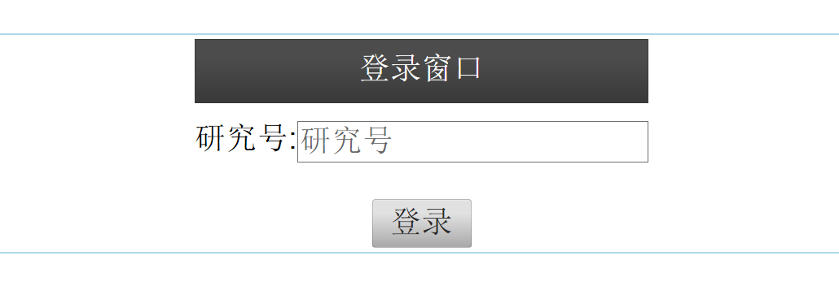

Home Page with an introduction to the study with click-to-begin button.

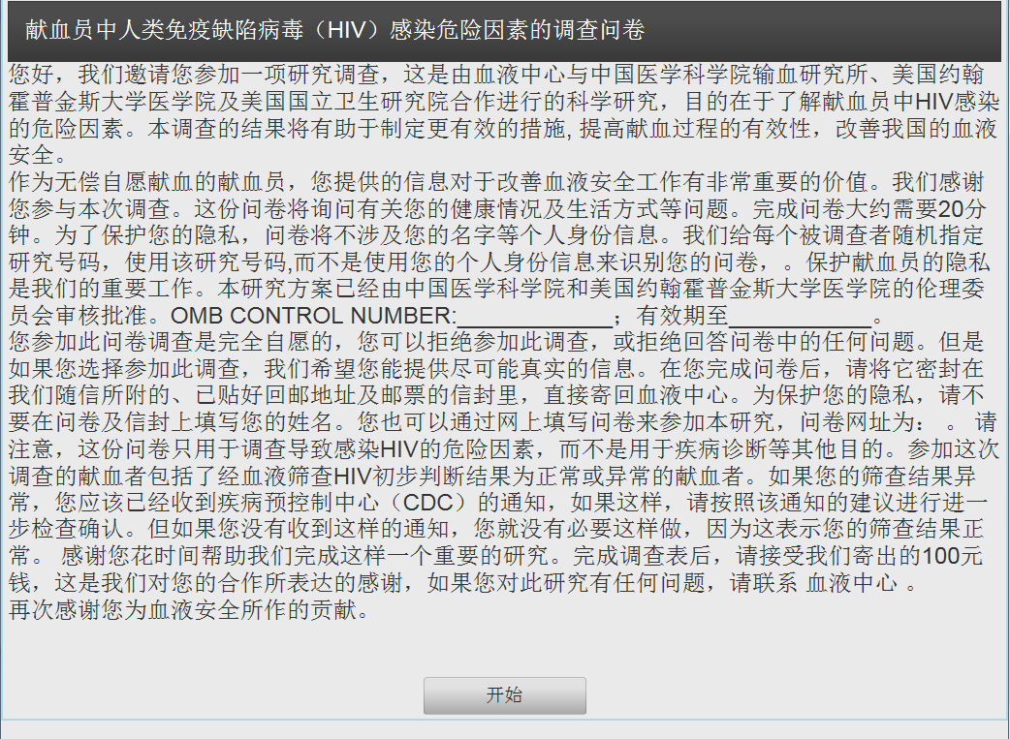

Beginning page of the survey with brief instructions.

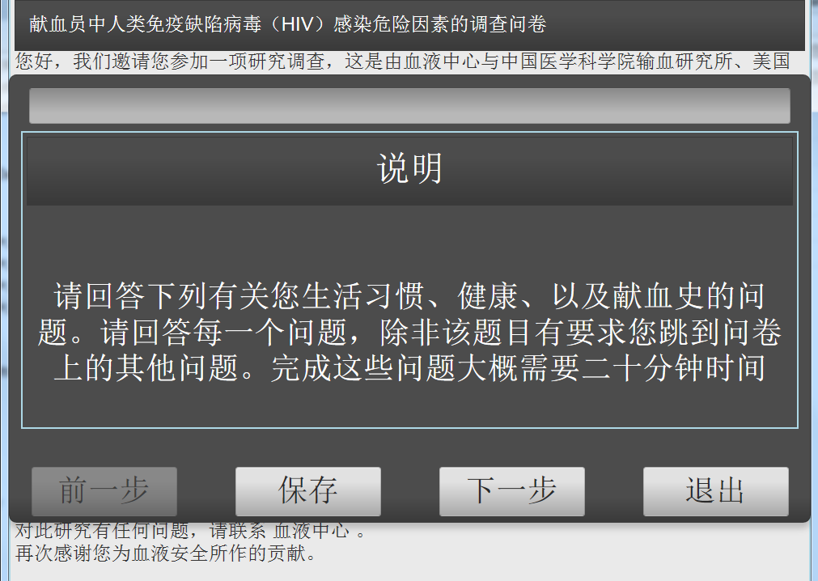

Questions will be shown on the popup window one by one. Support jump to feature.

Page of Survey Question Section A, Questions 1-3

The blue color in the top bar indicates how much the participant has completed in the survey process.

1. Background

Q1. What is your birth year? _________________

exit

next

save

back

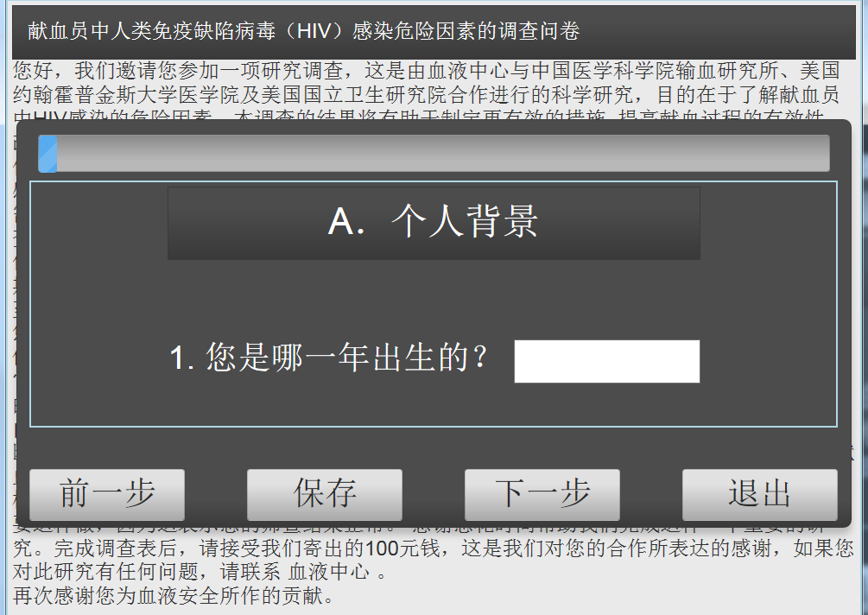

1. Background

Q2.What is your gender?

Male female

exit

next

save

back

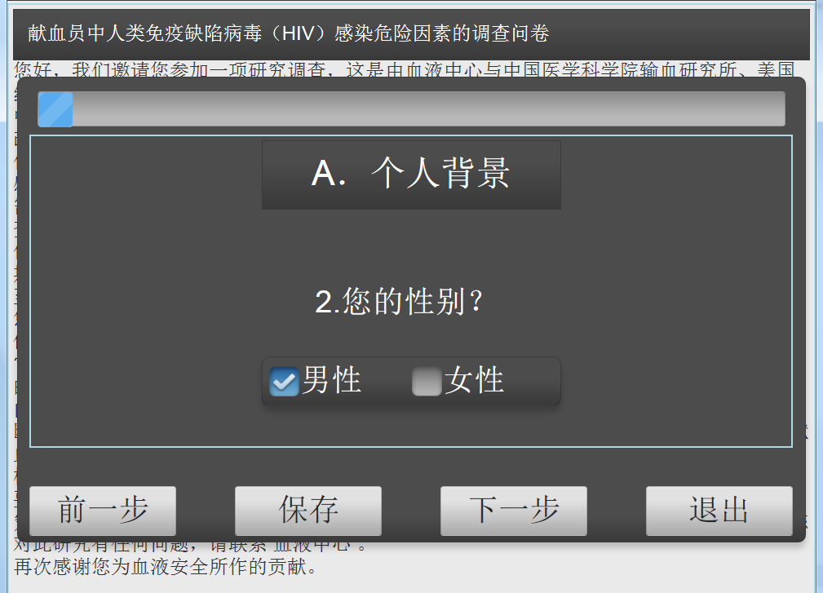

1. Background

Q3.What is your birth place?

___________________ Province

___________________City

__________________County

exit

next

save

back

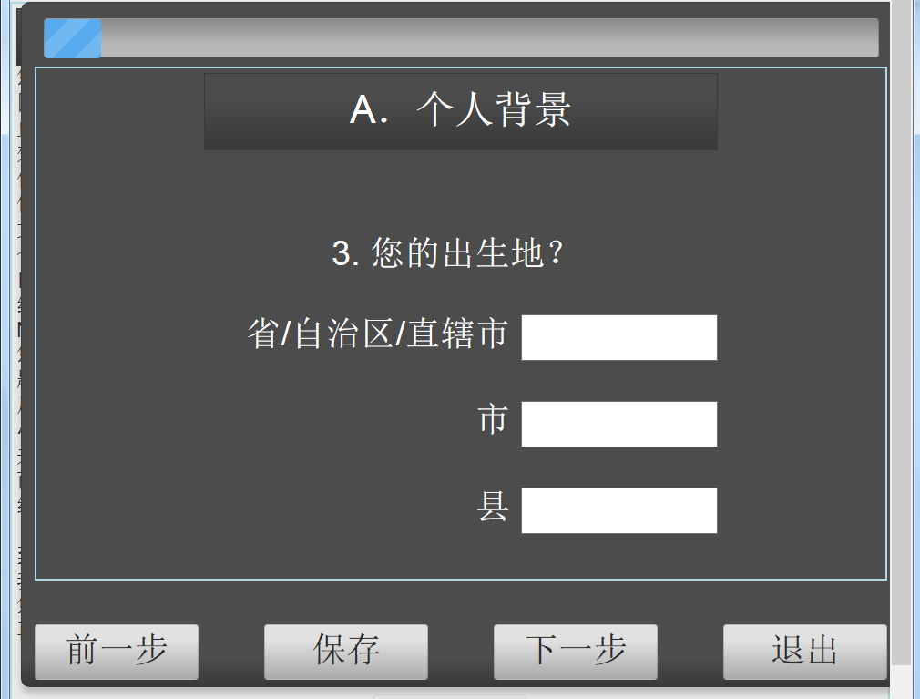

Preview, confirm, and submit page. Only questions that current user must answer will be shown on the popup and submit page.

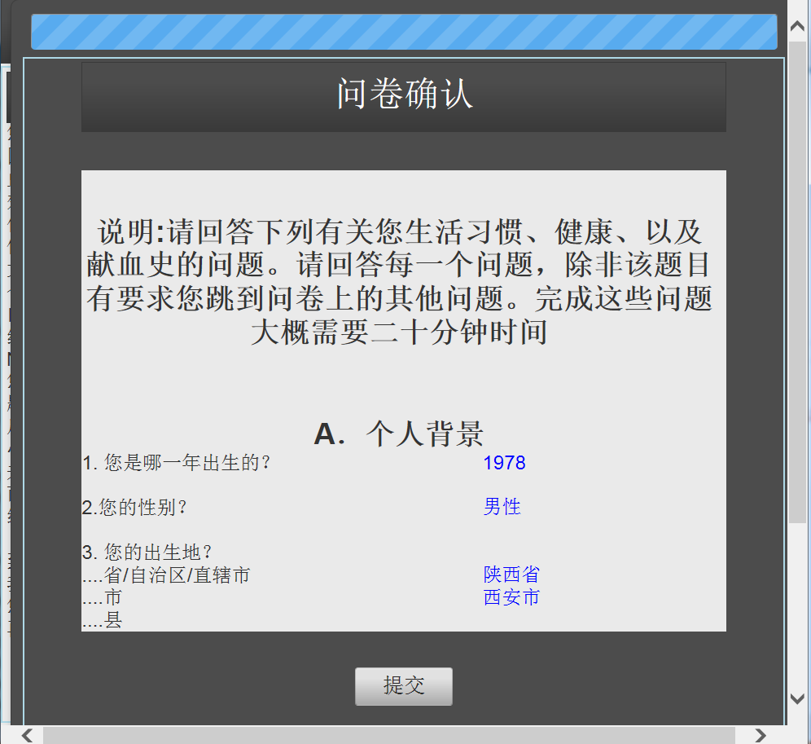

6.8. Appendix H. HIV Risk Factor Survey Data Entry Form (See attached Excel format)

-Validation checks will be added to this form upon approval of protocol and final version of survey questionnaire.

6.9. Appendix I. Study Tracking Form for blood centers and Guangxi CDC (See attached Excel form)

1. In this case, categorical variables include binary, nominal, ordinal, and, possibly, count variables with a small number of counts.
2. In this case, categorical variables include binary, nominal, ordinal, and, possibly, count variables with a small number of counts.