NIH Office of the Director (OD)
Attachment 6
Privacy Act Memo

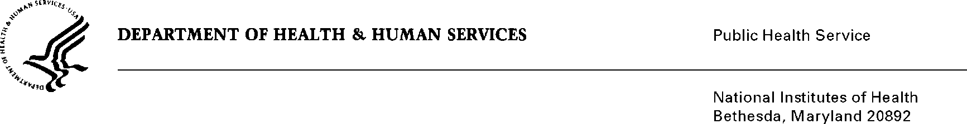

DATE: September 26, 2014

TO: Michelle M. Timmerman, Ph.D.
Office of Extramural Research
Office of the Director
National Institutes of Health

FROM: NIH Privacy Act Officer

SUBJECT: Applicability of the Privacy Act: “Evaluation of the NIH Academic Research Enhancement Award (AREA)”

I have reviewed the NIH submission to OMB referenced above. The AREA program aims to enhance the overall research environment of the grant institutions receiving approximately 78 million dollars annually. The evaluation will indicate whether the content of the current R15 application materials need to be revised to provide more concrete guidelines for applicants.

To collect information about the extent to which the receipt of a grant promotes the scientific workforce and enhances the research environment at the institution where the grant is held, the OD proposes to collect data from awardees, unsuccessful applicants and students.

The evaluation study will utilize a structured web-based survey and a semi-structured telephone interview which will collect quantitative outcome data and qualitative data on implementation as to how the AREA grant was implemented at the host institutions. Potential participants will receive email notifications, invitations and reminders announcing the evaluation, explaining its purpose, detailing the topics the survey or interview will cover, and describing the voluntary nature of participation.

Respondents will provide data using a computerized system managed under contract (e.g., commercial web survey platform) which will allow the collection of responses and creation of reports. The telephone interviews will be conducted by trained interviewers and each interview will be recorded on a digital file labeled with the respondent’s ID number. The audio files will have a standardized unique file name (i.e., AREA-99) and be sent to a transcription service via a secure File Transfer Protocol. All data will be maintained in a locked, secure facility and will be subject to controlled access only by authorized personnel. Electronic data will be password protected and stored by the data management contractor. Data will be destroyed after two years.

Page 2 - Applicability of the Privacy Act: AREA Evaluation

Personally identifiable information will be maintained separately from completed data collection forms and computerized data files used for analysis. The Institute/Center Committee of AREA Program Administrators will receive access to data tables for all comparison groups for which data is available, along with the final report and slide presentation. NIH leadership, former awardees and applicants will have access to the final report with aggregate finds and recommendations. NIH leadership will share selected data with Congress in reports about the AREA program. Findings and lessons for the evaluation will eventually be made public and/or disseminated to agencies and organizations who oversee similar projects. Dissemination may take the form of a study report, conference presentation, and publication of study methods and journal findings. However, individual-level data, or detailed data tables will not be provided.

Since participants will receive email notifications, invitations and reminders announcing the evaluation, I have determined that the Privacy Act will apply to this data collection. The data collection is covered by NIH Privacy Act Systems of Record 09-25-0156, “Records of Participants in Programs and Respondents in Surveys Used to Evaluate Programs of the Public Health Service, HHS/PHS/NIH/OD.”

If you have questions, please contact me at (301) 402-6201.

Karen M. Plá

Enclosure

cc: Mikia Currie, OD PRA Liaison (w/o enclosure)

