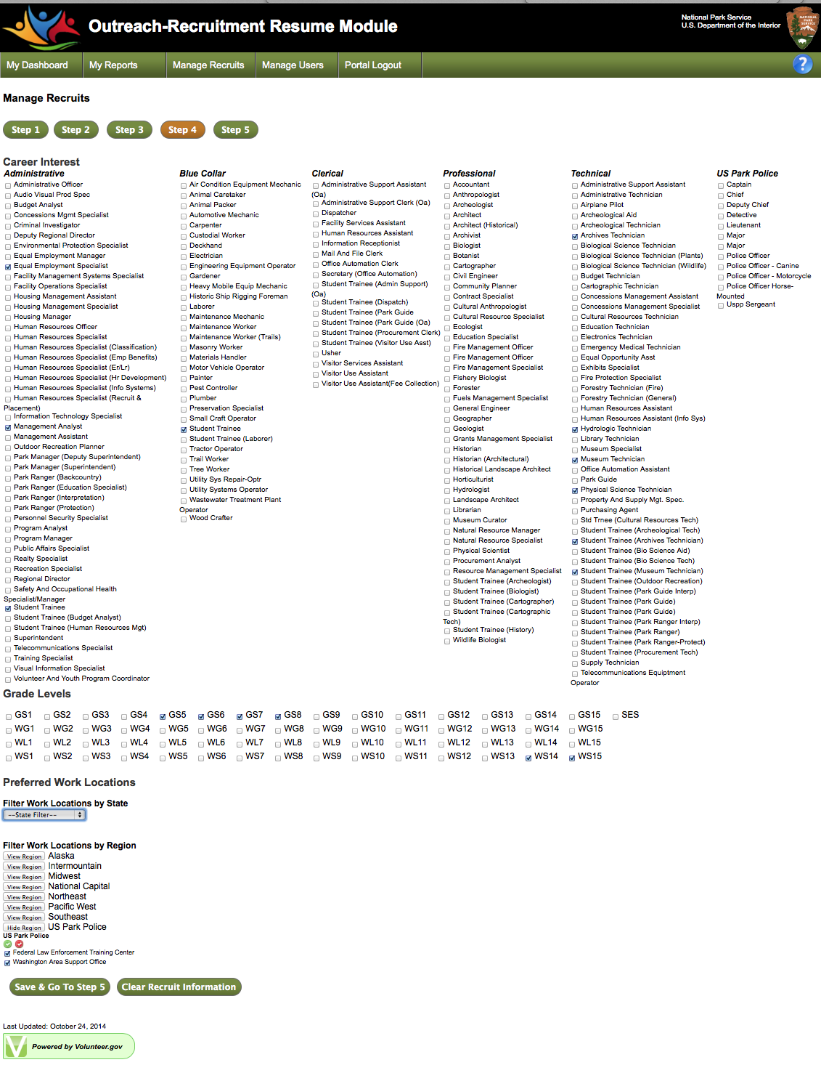

NOTE: This information will be gathered at recruiting events along with a resume`. Government resources will then enter this information into the Outreach recruitment On-line Form on behalf of the candidate.