Rep E-File Screen Flows & Currently Developed ELIS2 Screens (US6502):
Below is the overall sequence of the screens that are depicted in detail below:
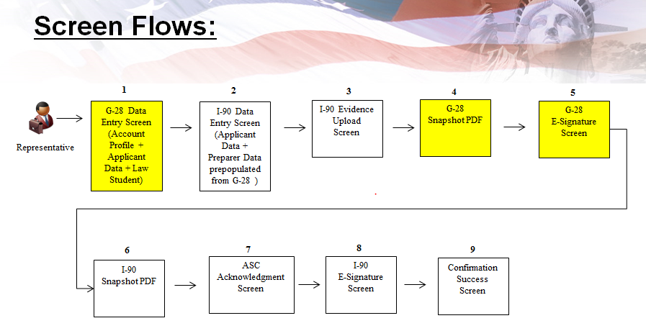

Screen 1: Rep Homepage with no current cases initiated:
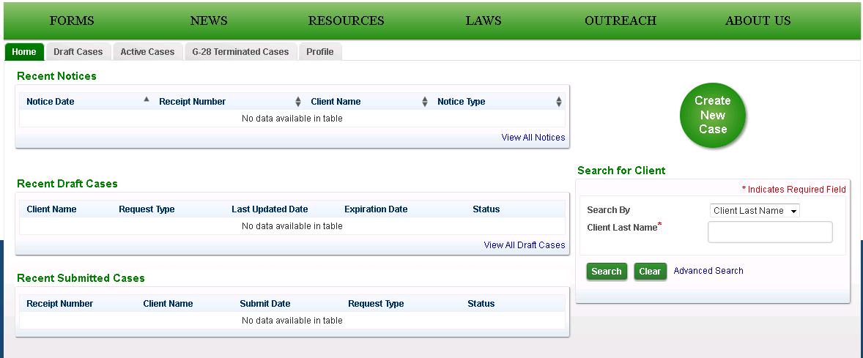

Screen 2: Rep selects to create a new case – then picks the I-90 from the listed options:
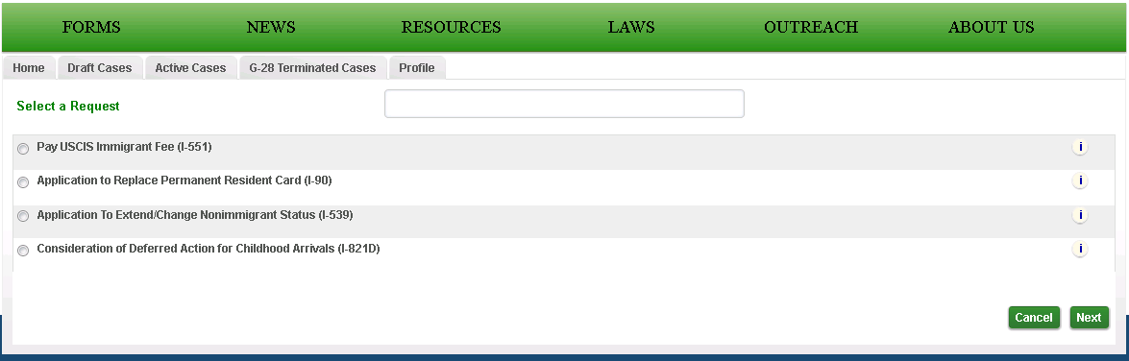

Screen 3: This is the Form G-28 displayed to the Rep. The Name; Contact; Address; and most of the Eligibility sections are prefilled with the data from the Rep’s Profile.
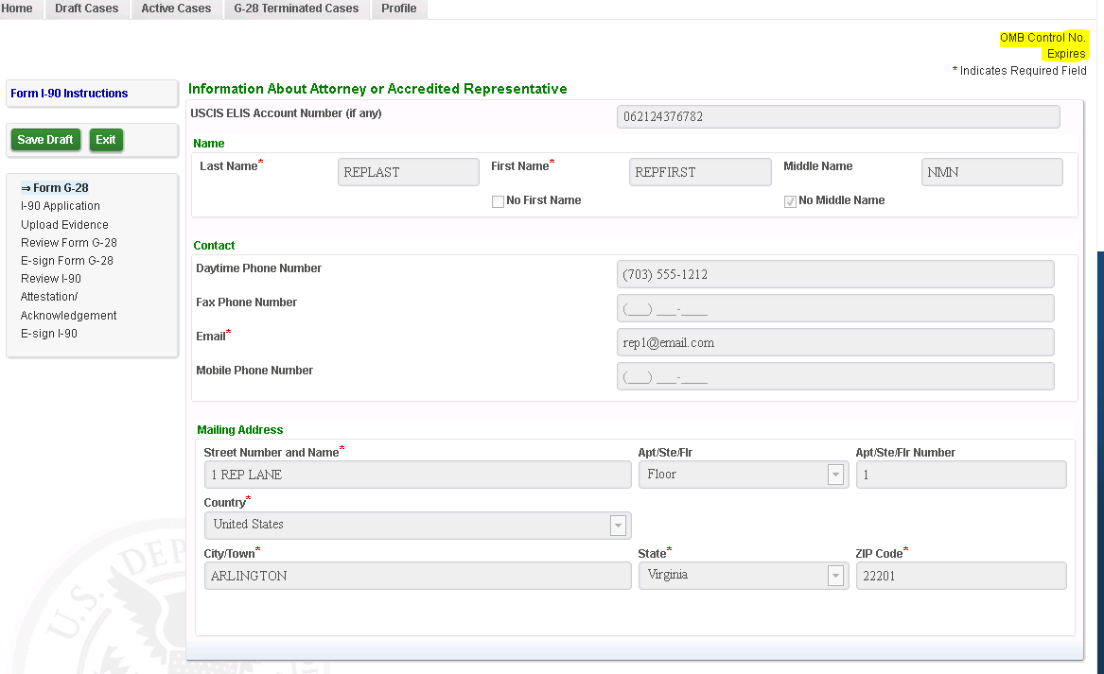

Screen 4: Information About Applicant; Applicants Address; Role selection; and Law Student sections are open for the Rep to enter the data elements:
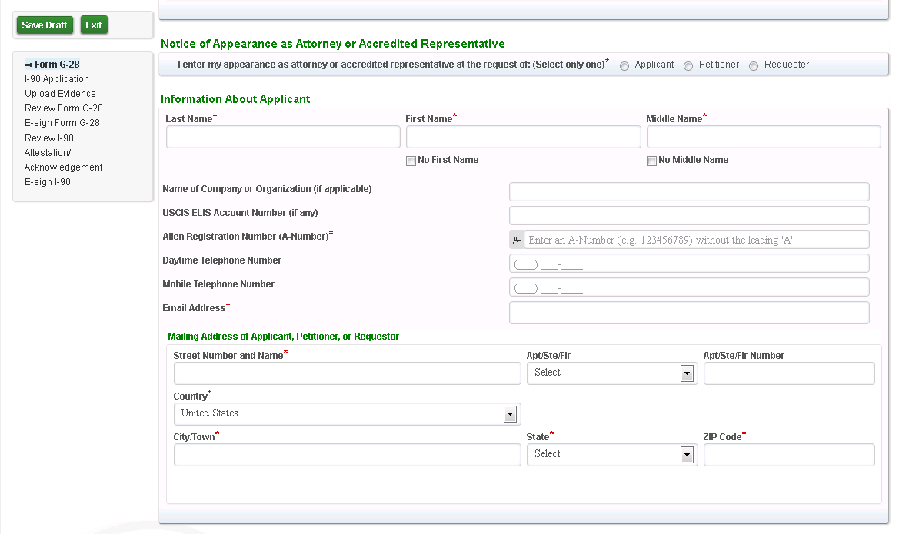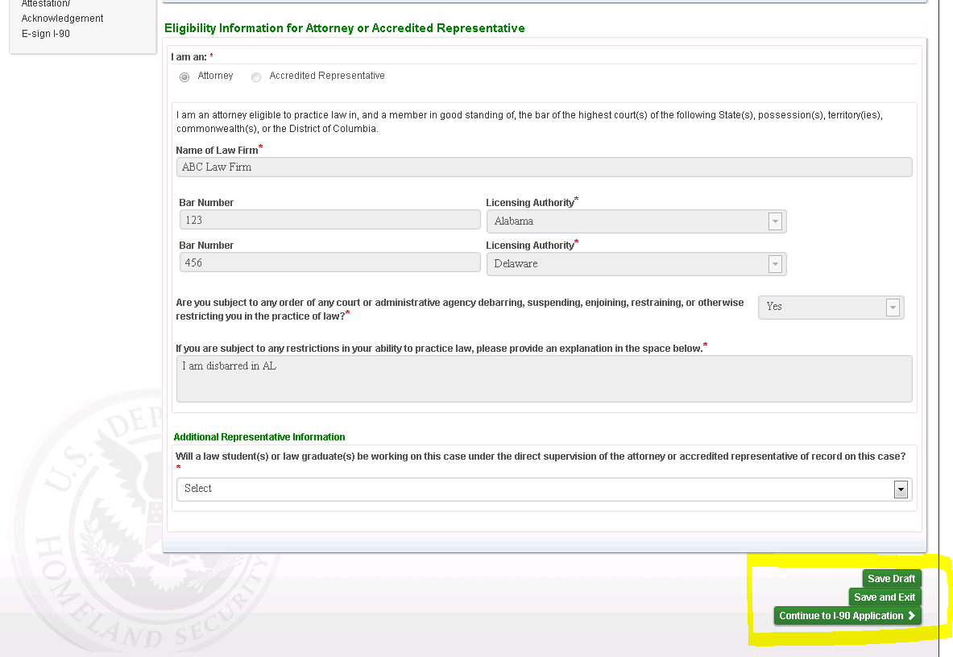
Screen 5: This screen shows data after its been filled in by the Rep for the following sections: Information About Applicant; Applicants Address; Role selection; and Law Student sections.
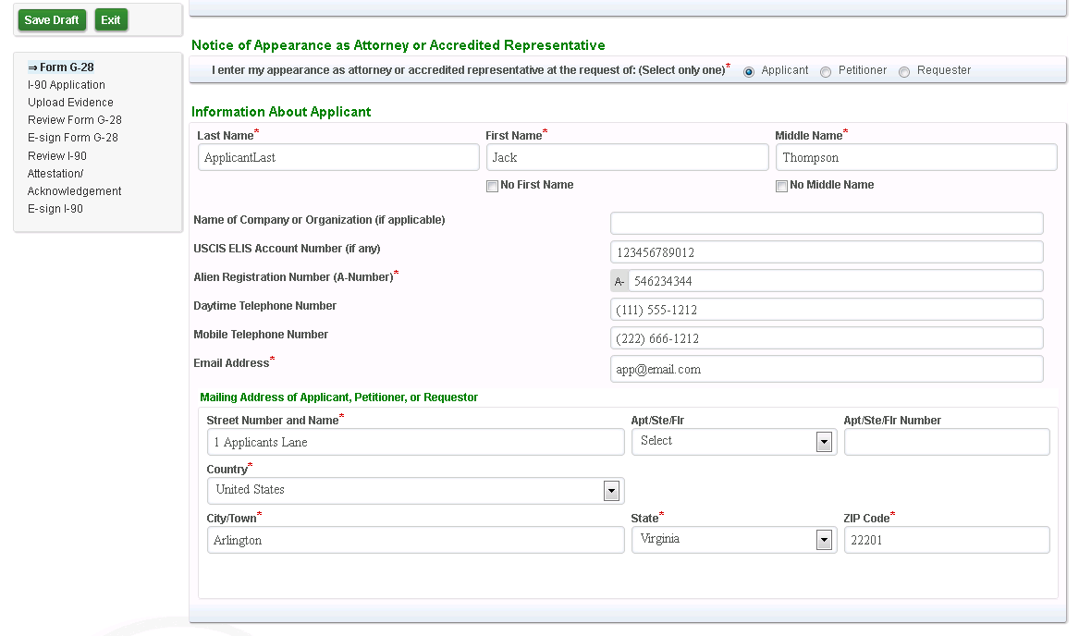
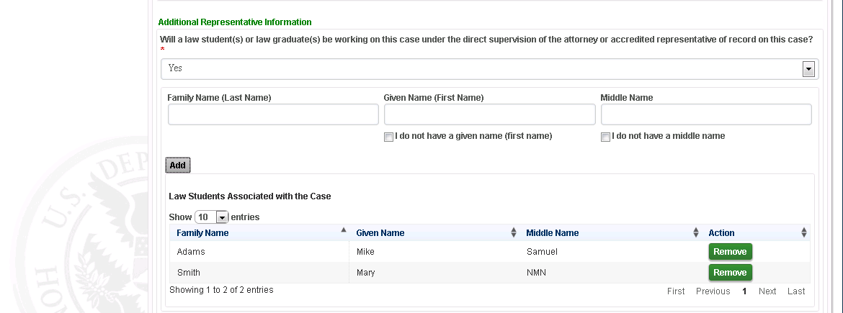

Screen 6: If the Rep saves the G-28, then back on their homepage screen they will now have an ‘In Process’ case under the ‘Recent Draft Cases’ section
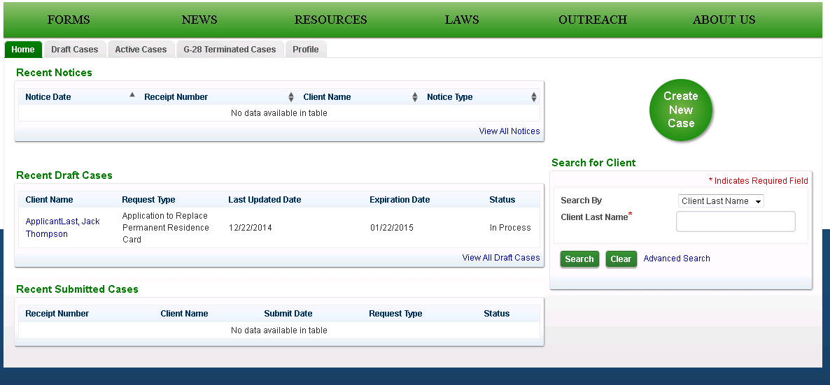

Screen 7: After the Form G-28 is completed, the Rep is then taken to the I-90 Screen. The Applicant’s Account Info; Name section; Mailing Address; Preparer sections prefilled with the data from collected on the previous G-28 data entry screen:
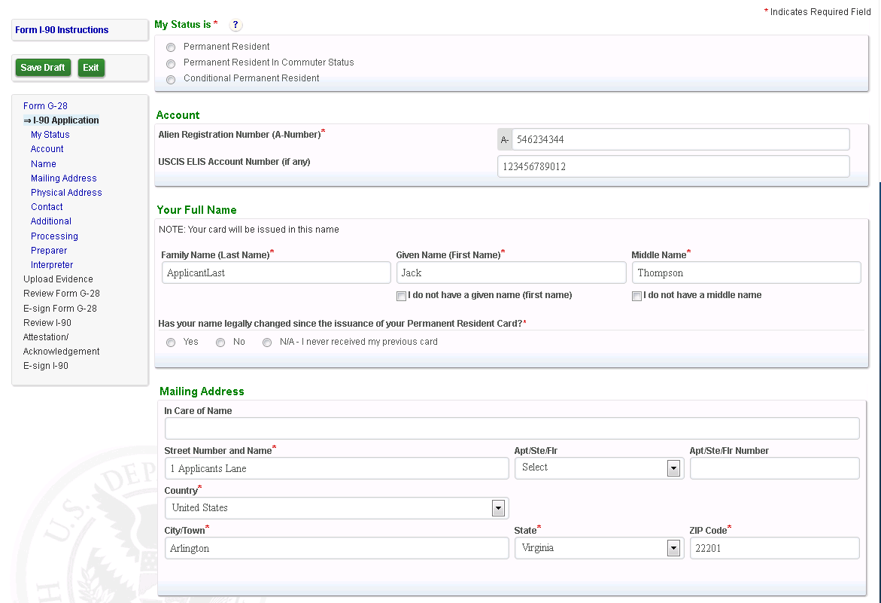
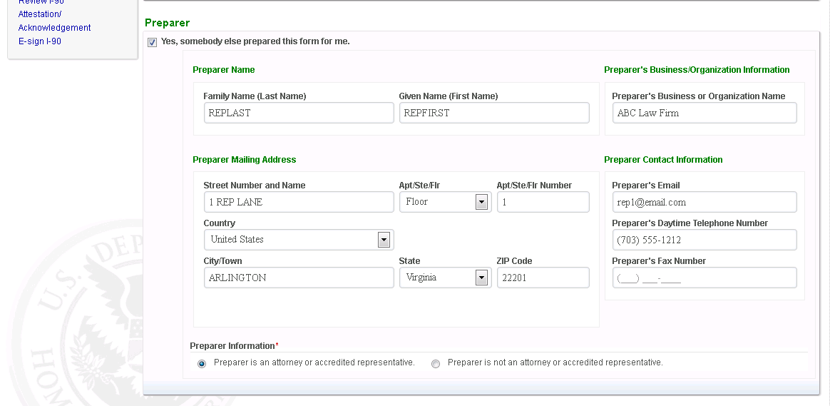

Screen 8: Evidence Upload screen displayed after the I-90 data entry:
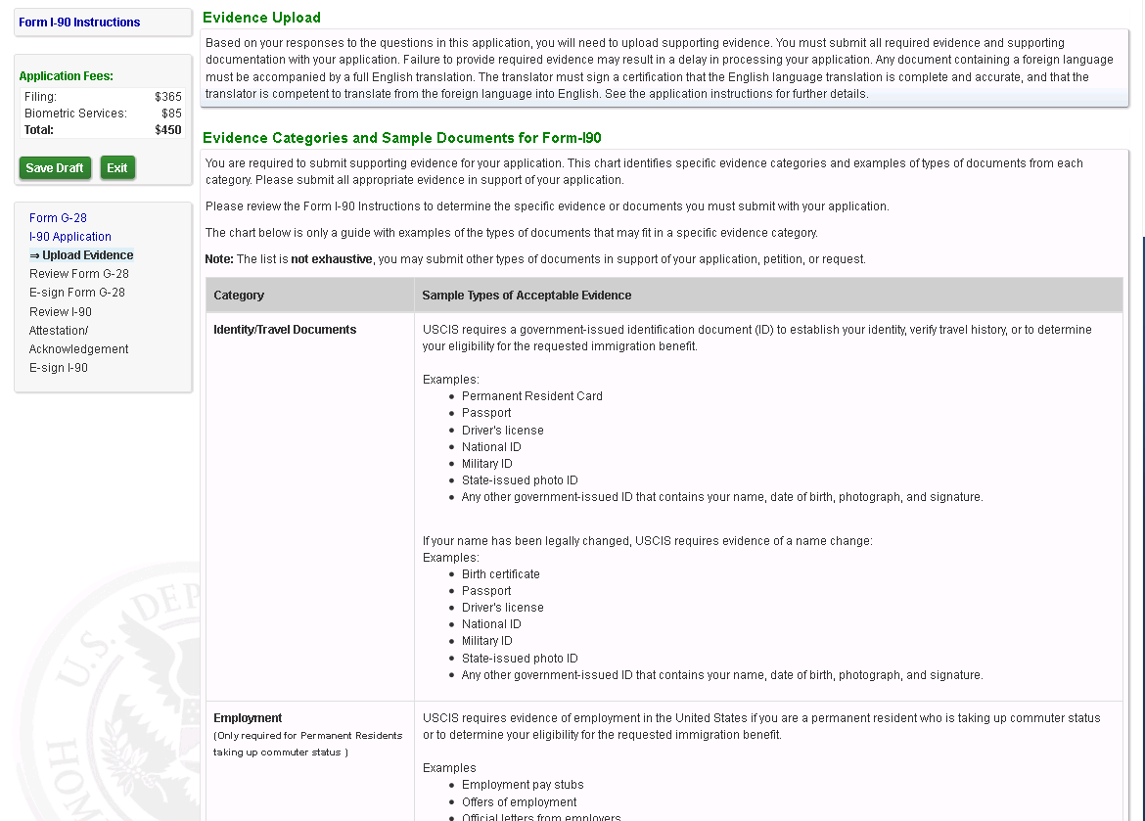
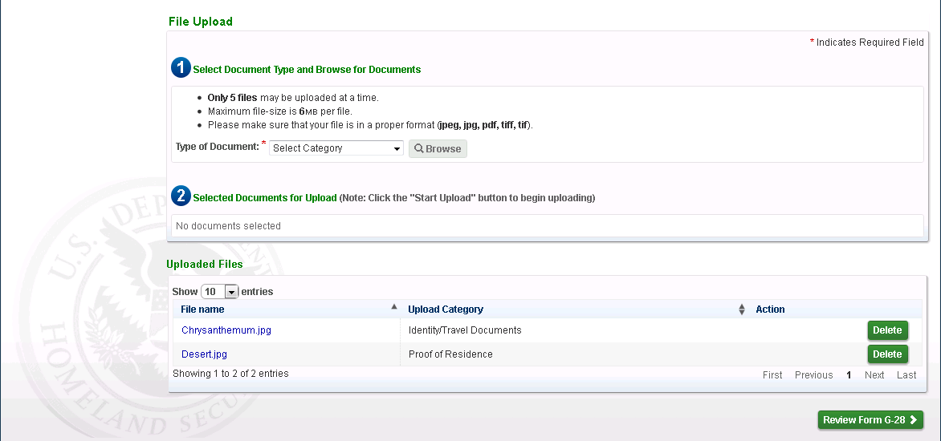

Screen 9: Form G-28 Snapshot displayed as an Inline PDF for the Rep to review prior to e-signing it:
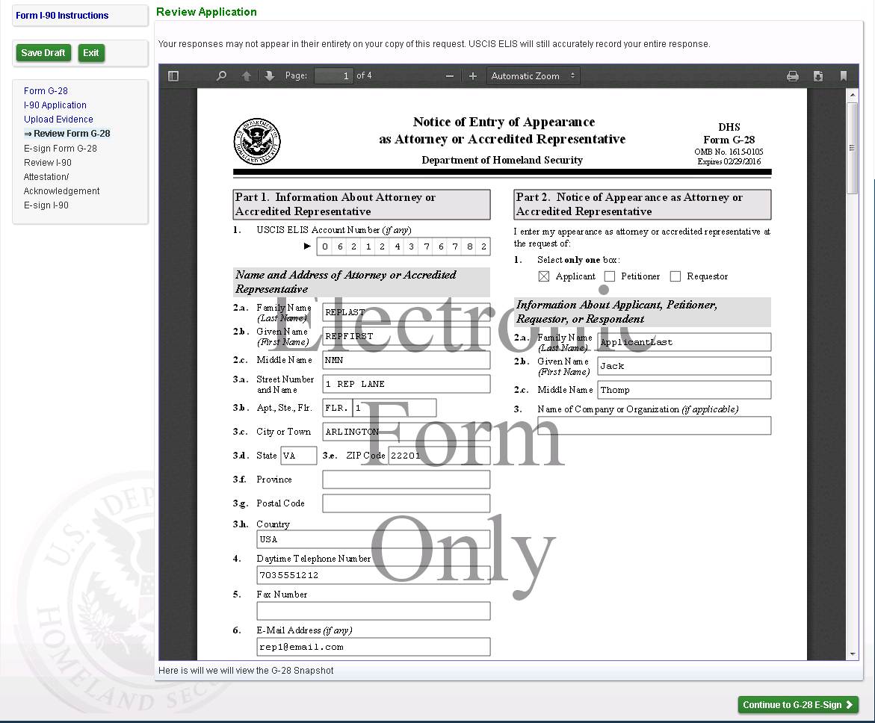
Screen 10: Rep E-Signs the Form G-28
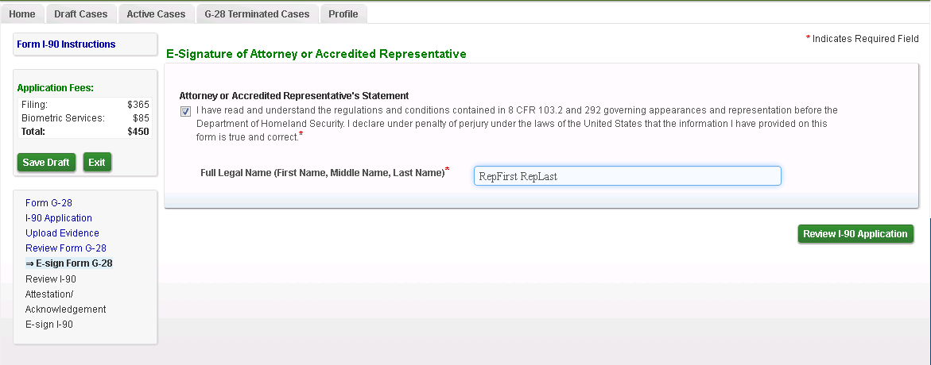
Screen 11: Rep now reviews the Form I-90 PDF as an inline PDF:
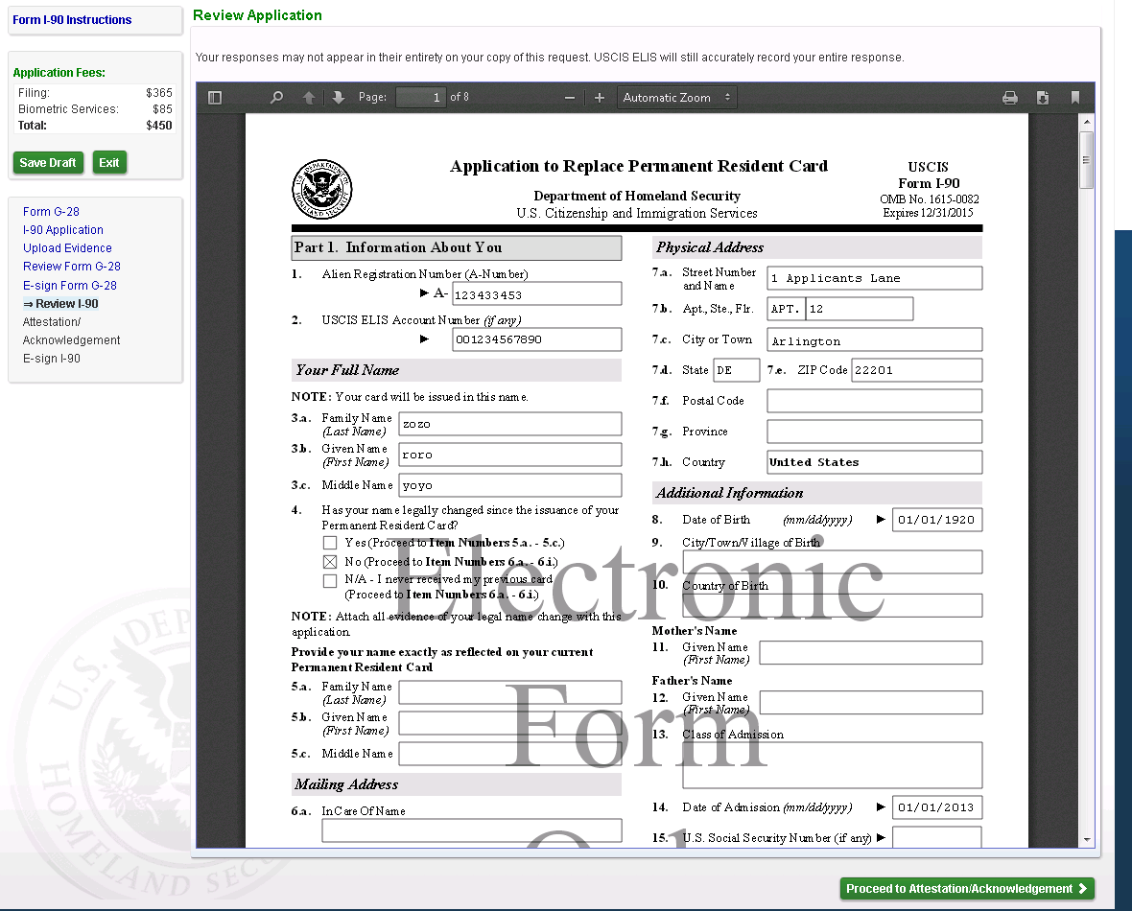

Screen 12: Rep now reviews the ASC Acknowledgement language:
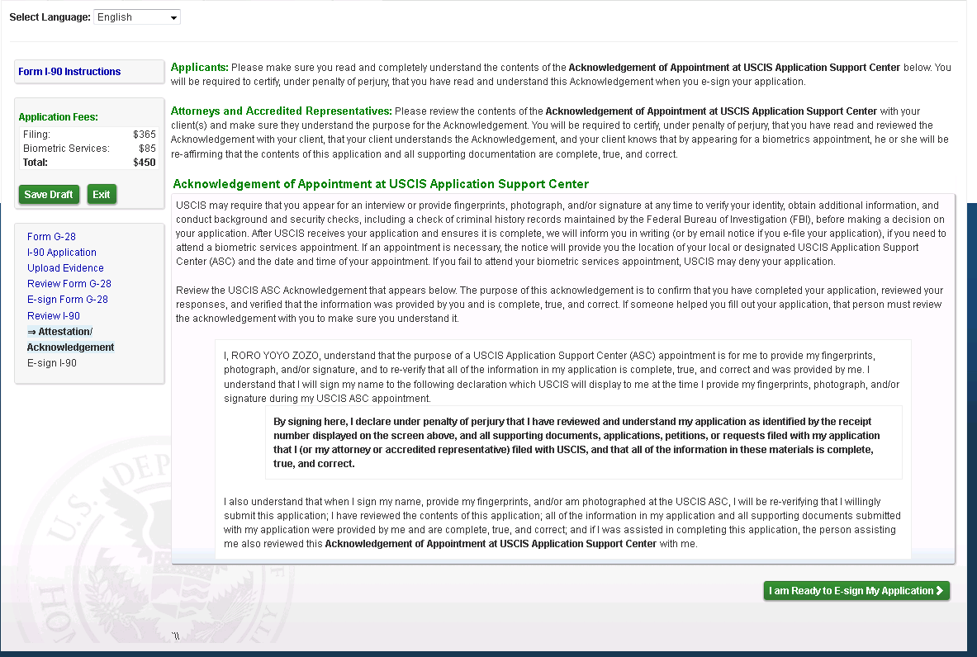

Screen 13: Rep now E-Signs the Form I-90:
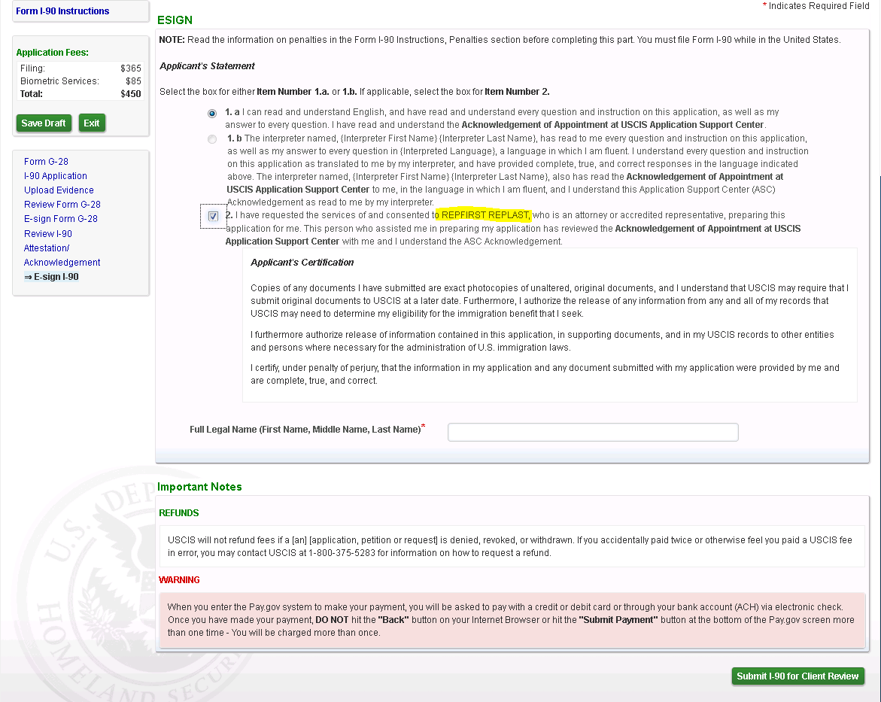

Screen 14: Success confirmation screen displayed to the Rep when he has e-Signed the I-90. Rep is displayed with the Case Passcode which they will provide to their client so that the draft G-28 and I-90 can be reviewed by the client.

