Usability Testing and User Feedback:   
E-Verify Mobile Application

*Protocol*

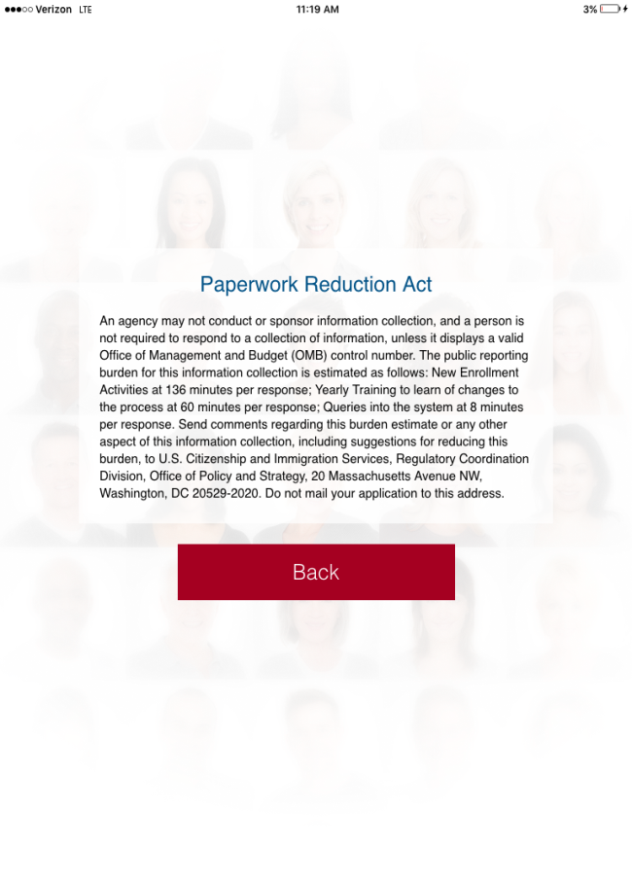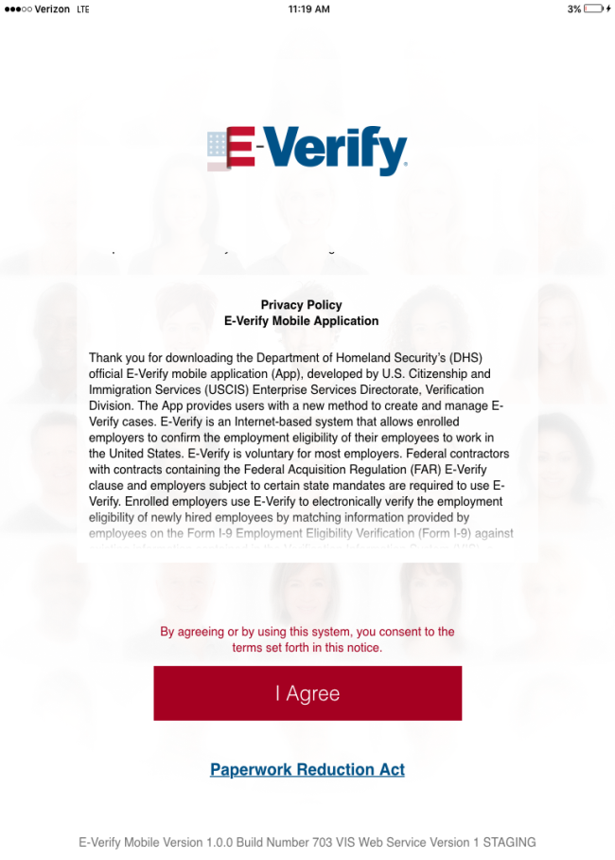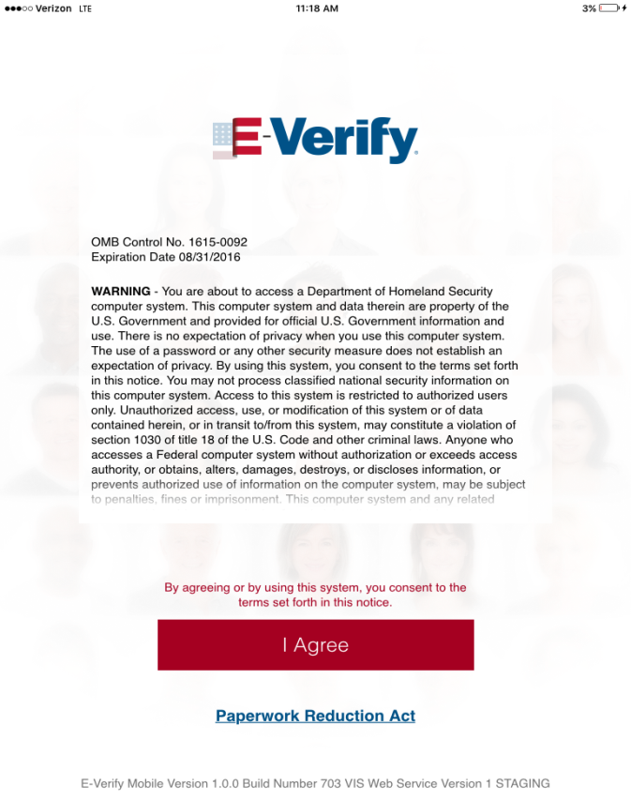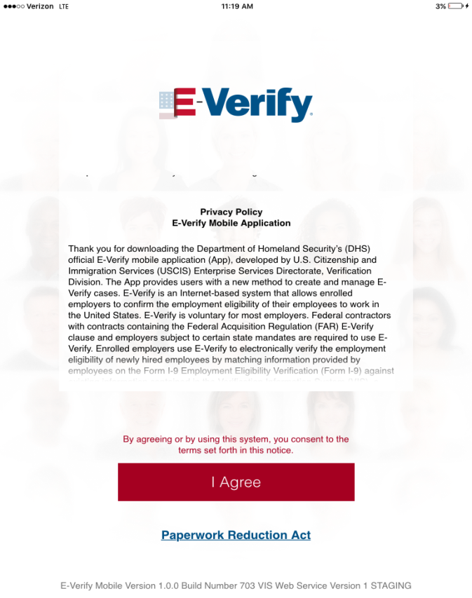

**OMB Control No. 1615-0121  
Expiration Date 3/31/2018**

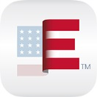

Contents

1.0 Usability Testing Announcement (Alert) 3

2.0 E-Mail Response to All Users Expressing Interest 4

3.0 TestFlight Invitation 5

4.0 Apple TestFlight Feedback Tool 6

# 1.0 Usability Testing Announcement (Alert)

**To: Current E-Verify Users**

**From: E-Verify**

**Subject: E-Verify Mobile Application Usability Testing  
Medium: Alert appears when E-Verify user logs into E-Verify**

Interested in learning about E-Verify’s new mobile product? E-Verify invites currently enrolled users to participate in a 90 day usability testing for the E-Verify mobile app. To participate, you will need access to an Apple iPad (2nd or 3rd generation) and to allow E-Verify to use your email address to send you information about the product testing.

**Note regarding time burden:**

USCIS estimates that participants will require a total of 45 minutes to download the app and participate in testing. Participants will require a one-time 25 minute period to volunteer for testing and download the app, including:

* Reading this usability testing announcement and instructions for volunteering to participate in usability testing (10 min)
* Emailing USCIS to volunteer for usability testing (5 min)
* Reading instructions and downloading the TestFlight App (5 min)
* Reading instructions and downloading the E-Verify App (5 min)

Once the App is downloaded, average case processing and providing comments should take approximately 20 minutes, including:

* Create E-Verify Case(s) (8 min/case)[1]
* Providing feedback via TestFlight (12 min) *optional*

Feedback regarding you experience is submitted using the “Send Feedback” option in Apple TestFlight. Your feedback will help E-Verify evaluate and improve the App.

To learn more, send an email to [MobileE-Verify@uscis.dhs.gov](mailto:MobileE-Verify@uscis.dhs.gov) by [month, xx, 2016]. Participants will be selected on a first come basis.

# 2.0 E-Mail Response to All Users Expressing Interest

**To: E-Verify users responding to alert**

**From: E-Verify (**[**mobile-verify@uscis.dhs.gov**](mailto:mobile-verify@uscis.dhs.gov)**)**

**Subject: Mobile E-Verify  
Medium: E-Mail response automatically sent to all users who sent an e-mail in response to alert**

Hello!

Thank you for expressing interest in E-Verify efforts to better support mobile accessibility.

E-Verify invites currently enrolled users to test the E-Verify mobile app, a free native application that provides users a new method to access and create E-Verify cases from a mobile device.

E-Verify will select testers from those who have expressed interest in using and providing feedback on the mobile app. If selected, within 10 days, you will receive an email from Apple TestFlight with a link to download the beta E-Verify mobile app.

To participate in testing, you will need to:

* Have access to an iPad (2nd or 3rd generation).
* Install the TestFlight app* from the Apple App Store.

*\*This allows us to send you beta versions of the E-Verify mobile app.*

* Use the link provided in the email from Apple TestFlight to download the E-Verify mobile app.
* Log into the E-Verify mobile app using your existing E-Verify credentials to create and/or manage cases.

The app will be available to testers for 90 days. During this period, you may opt out of testing at any time. At the end of t, E-Verify will use tester feedback to inform future mobile support efforts.

Thank you,

The E-Verify Mobile Team

# 3.0 TestFlight Invitation

**To: Testers**

**From: Apple TestFlight Program**

**Subject: You’re invited to test E-Verify  
Medium: Email sent to selected participants through Apple TestFlight**

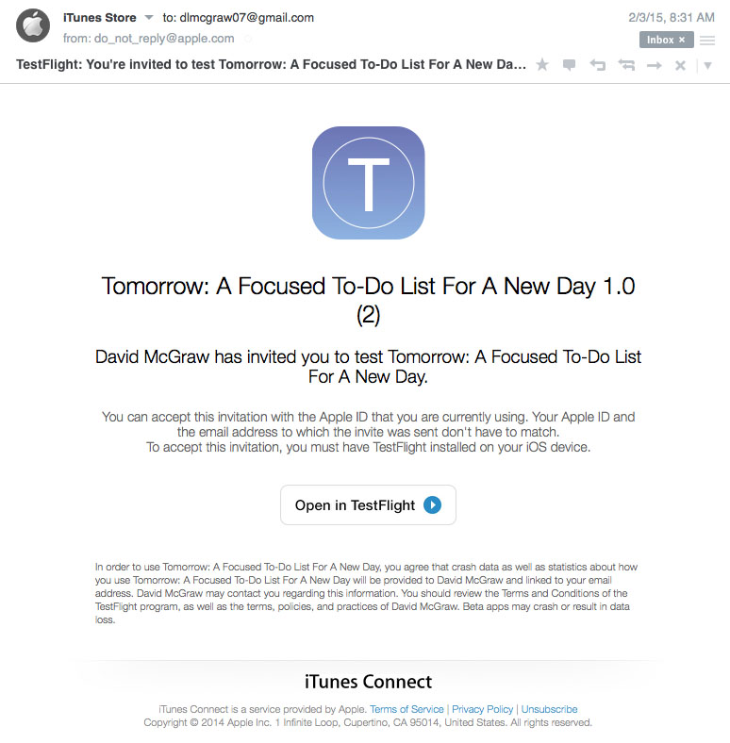

**TestFlight: You’re invited to test E-Verify**

**E-Verify**

Mobile E-Verify Developer has invited you to test E-Verify.

# 4.0 Apple TestFlight Feedback Tool

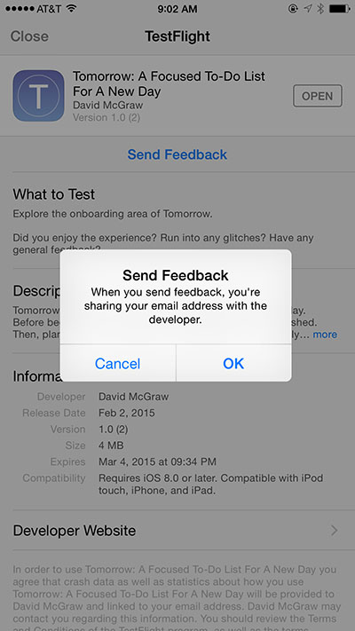

1. Case processing estimate was drawn from the June 11, 2015 Supporting Statement for E-Verify which was published in accordance with the Paperwork Reduction Act. A copy of the statement can be found at <http://www.regulations.gov/#!documentDetail;D=USCIS-2007-0023-0048>.