Collaboration Tool
Grantee Test Script
OMB Control No. 1615-0121
Expiration Date 03/31/2018

You have been randomly selected from the group of Citizenship and Integration Grant Program grantees to participate in a new opportunity with OoC-Grants Division. Your participation is voluntary. In an effort to improve services, make contact easier between grant recipients and program managers, and create streamlined processes, we are testing an electronic communication tool. We are asking that you take approximately 30 minutes of your time to log on to the program tool and test the functionality of the program as described in the attached script. The Grants Division would appreciate your organization provide any feedback you may have in order to ensure a high-quality product is delivered to all grant recipients.
This test script provides a step-by step process for using Chatter, and submitting a Service Issue Item via the Collaboration (communication) Tool. It would be preferable if you utilized the Chatter function to submit questions or difficulties as you go through the script, but if you are unable to do so due to functional or program issues, please document the issue using the UAT tracking sheet and email the document to CitizenshipGrantProgram@uscis.dhs.gov after you finish testing the tool.

Paperwork Reduction Act Statement: An agency may not conduct or sponsor an information collection and a person is not required to respond to a collection of information unless it displays a currently valid OMB control number. The public reporting burden for this collection of information is estimated at 30 minutes per response, including the time for reviewing instructions, completing and submitting the form. Send comments regarding this burden estimate or any other aspect of this collection of information, including suggestions for reducing this burden, to: U.S. Citizenship and Immigration Services, Grants Division, Office of Citizenship, 20 Massachusetts Ave, Washington, DC 20529. OMB No. 1615-0121. Do not return the completed form to this address.

Grantee Usability Testing for the Salesforce-based,
OoC Collaboration Tool

Logging-in
Log onto: https://citizenshipgrants.uscis.gov/login using the Username and Password provided by USCIS.

Log-in screen
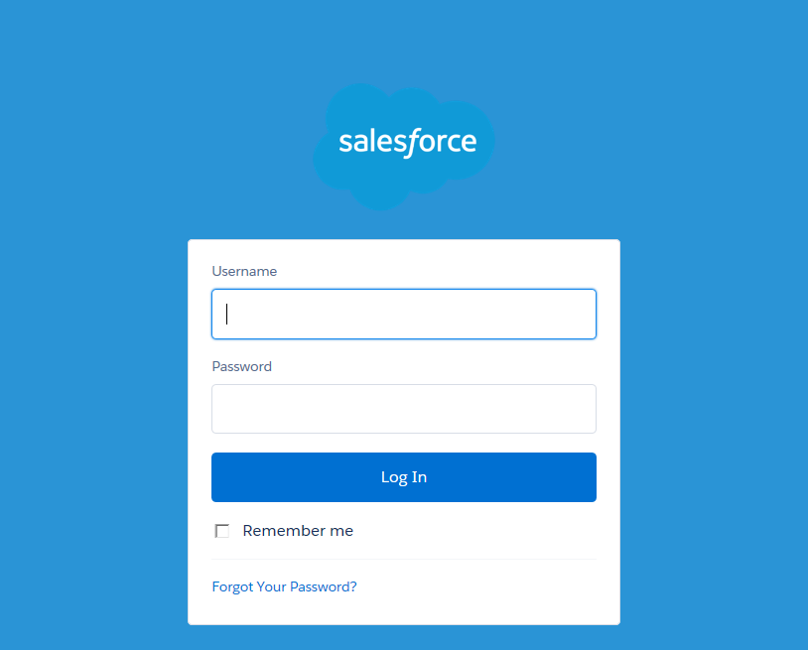

Test One
The process for seeing chatter and joining groups within chatter:
Visibility and Access to Chatter Groups
Description of Function to Test | As a Grantee, I will be able to see and access all chatter groups  As a Grantee I will have the ability to join chatter groups in the CRM system.
Test Steps | Description | Actual Results
Step 1 | Click “Groups” tab
Step 2 | Click “Active Groups”
Step 3 | Navigate to any public group and click “Join”
Step 4 | Navigate to any private group and click “Ask to Join”
Step 5 | For any public group that you joined, verify that you are a member of the group under the “Membership” column
Step 6 | For any private group that you requested access to join, verify that you have requested access under the “Membership” column
Expected Results | Be able to join all public chatter groups. Be able to request access to private chatter groups.

Joining a Chatter Group (Steps 1-6)
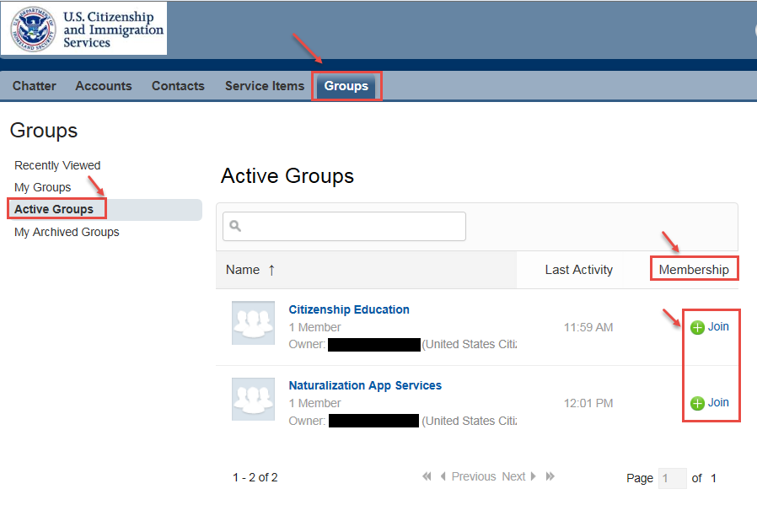

Test Two
This provides the directions for posting a comment or idea to chatter to begin a discussion:

Post to Chatter
Description of Function to Test | As a grantee, I should have the ability to post a file to the Chatter community
Test Steps | Description | Actual Results
Step 1 | Click the Chatter tab
Step 2 | Click the “File” link
Step 3 | Click the “Upload a file from your computer” link
Step 4 | Click the “Choose File” button
Step 5 | Browse to the file you would like to post and click the “Open” button
Step 6 | Click the Service Type Number link for a Service Type
Step 7 | Click the “Share” button
Step 8 | Verify that the file has been uploaded
Expected Results | Successfully be able to post a file of less than 2 GB in size to a Community

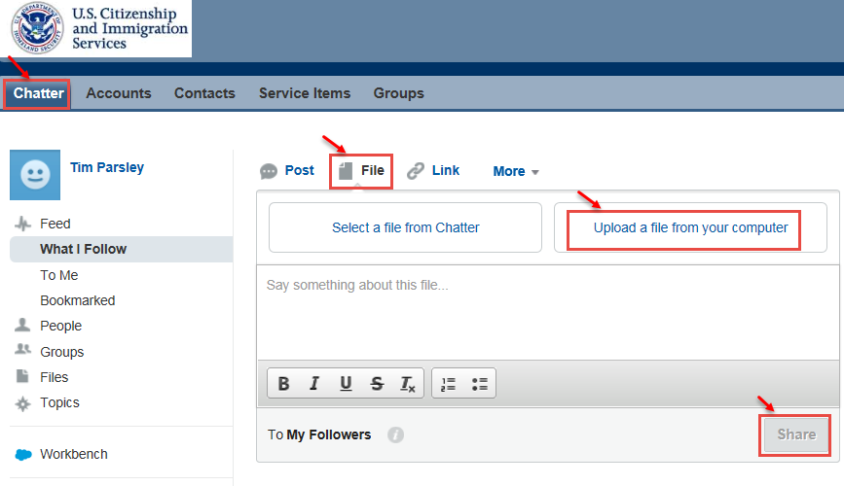
Posting in Chatter (Steps 1-8)
Test Three
This process allows a user to submit a service request:

Submitting a Service Request
Description of Function to Test | - As a Grantee I should be able to submit a Service Item to route my questions to the PO  - As a Grantee the following fields will be required when creating an service request: Type, subject, description Fields on a case: Account Name/ Contact Name/ Subject/ Description  - As a Grantee, I will have the following options to select from when creating a Service Item: Citizenship Instruction / Naturalization Applications Services / Chatter Group Creation / Quarterly Report / Other
Test Steps | Description | Actual Results
Step 1 | Click the “Accounts” tab
Step 2 | Click the link for the Account Name
Step 3 | Click the “New Service Type” button in the Service Types section
Step 4 | Verify that Contact Name and Account Name are pre-populated with the user’s credentials
Step 5 | Populate all of the required fields to the following:  - Type: Ensure that all of options are visible: Citizenship Instruction / Naturalization Applications Services / Chatter Group Creation / Quarterly Report / Other  - Subject  - Description
Step 6 | Click “Submit” button to be taken to the newly created Service Type
Step 7 | Verify you are on the “Service Type has been submitted” page
Step 7 | Verify the Priority is “Medium”
Step 9 | Click “Accounts” tab and select your account
Step 10 | Navigate to the Service Types related list and verify the service type you created is present.
Expected Results | Your Service Type has been successfully created and is visible in your queue.

Clicking on the Accounts Tab (Steps 1-2, 9-10)

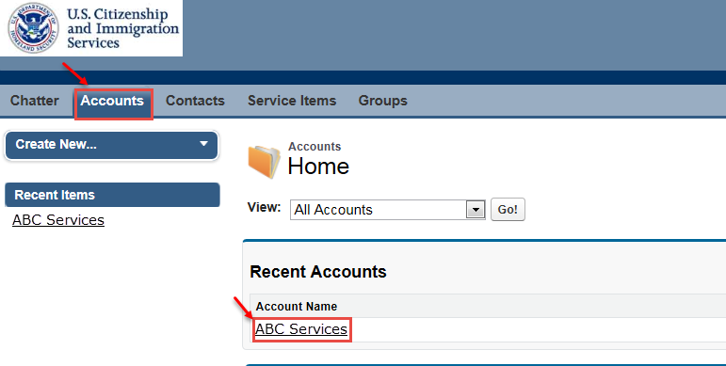

Clicking on the New Services Button (Step 2)
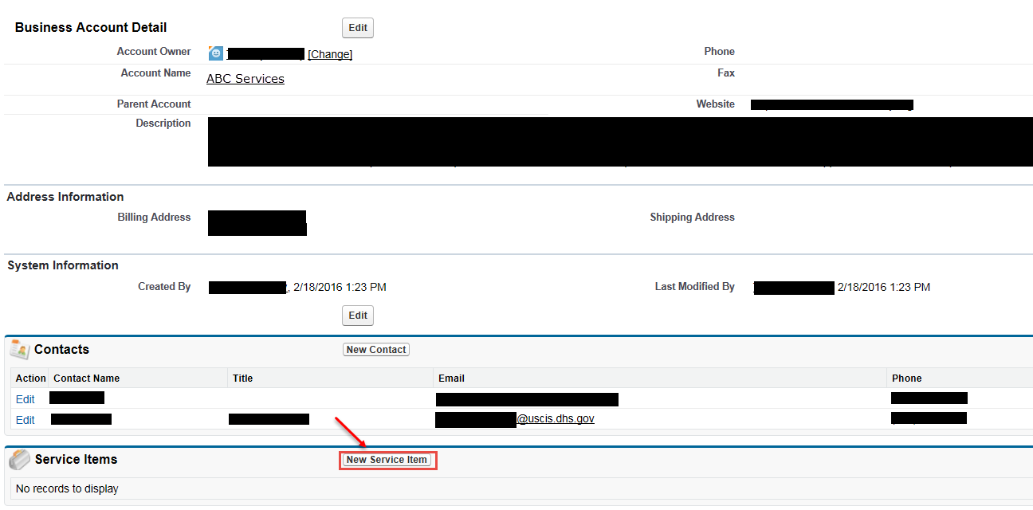

Creating a Service Item (Steps 3-7)

